**It's a little bit leave it**

How the next generation of artists are responding to Brexit and see their future.

When the decision wasn’t yours, but the impact will be life-long... we discuss the concerns of younger people across the north. This group will address the findings of the Next Generation UK commissioned by The British Council and carried out by Demos which surveyed young people across the country on their views about their future in the world and that of the UK’s following the EU referendum, addressing the findings and recommendations through interviews, spoken word and discussions. Hosted by spoken word artist Joe Hakim and young people from The Warren Project Hull.

**Joe Hakim – Chair**

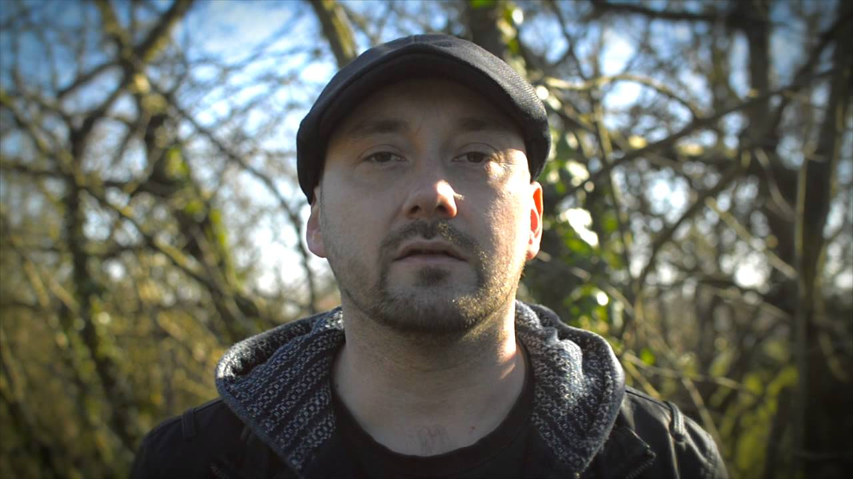

Joe lives and works in Hull.

As a performance poet, he’s performed at venues and festivals around the UK, including Latitude, Big Chill and Edinburgh Fringe Festival.

He was co-host and organiser of WRITE TO SPEAK, a series of spoken word events and workshops that took in place at Hull Truck Theatre from 2009 to 2013.

In 2016 he toured and performed with LIFE, a Hull-based punk four-piece band, performing on the UK leg of the Slaves European tour.

In January 2017 he travelled to Trinidad with The Roundhouse and Wrecking Ball Press as part of the TALKING DOORSTEPS project, assisting in the delivery of workshops and helping to forge international links between spoken word organisations and projects.

In addition to this, he is currently in the first year of a part-time MA in Creative Writing at Hull University, and works three days a week as a pawn-broker/Western Union agent.

**Jack Foster** **- Panellist**

Jack Foster is from North Hull Estate.

Jack was one of the first members of the **Warren Spoken Word Collective**, taking part in the **Talking Doorsteps** project with the **Roundhouse** and **British Council**, culminating in an appearance at **BBC’s Contains Strong Language** festival.

In addition, Jack has performed at Hull’s **Freedom Festival**, **Kardomah 94**, the **Big Music Project** in Islington, and has supported local bands such as Killer of Kings.

Jack is currently part of the **ILM** group, working at the **Warren** within the music department.

**Andrew Gooch - Panellist**

Andrew Gooch is from East Hull, and is a writer, actor and poet.

As well as writing performing his own work at Hull’s **Freedom Festival** and **BBC**’s **Contains Strong Language**, Andrew is also a member of **Northern Lights Drama**, and has performed in plays at **Hull Truck theatre**.

Films of his poems have appeared on the **BBC Arts** and the **British Council** websites.

His work includes writes short-stories, poems and articles, and he is currently working on his first novel.

**Jodie Langford - Panellist**

Jodie Langford lives and works in Hull.

Jodie began writing and performing as part of **Arts Celebrating Equality** at the **Warren**. Since then she has risen to be one of the most distinctive voices in Hull’s burgeoning youth spoken word scene.

She has performed at **BBC Contains Strong Language** festival, and her work has been featured on the **BBC Arts** and **British Council** website.

She has also performed at the **Freedom Festival**, at Canary Wharf with **UK Youth,** the **Hull Trinity** festival, and **One World Hull**.

She is currently in her last year at college, and works as a technician at various music events around Hull.

**Frank Mathers - Panellist**

Frank Mathers manages to combine writing and performing poetry with an extensive career supporting and working in Hull’s music scene.

He has worked as a stage hand/tech crew with **Freedom Festival, Humber Street Sesh**, and **53 Degrees North**, and has also worked as artist liaison and host for events such as **Gig in the Gardens, Three Minute Heroes** and **Hull Trinity Festival**.

As a poet and performer, he has appeared at **Freedom Festival** and **BBC’s Contains Strong Language**, and has appeared in films for the **British Council** and **BBC Arts**.

Frank is currently studying theatre/stage tech, and continues to play a key role in **Warren’s Spoken Word Collective**.

**Emily Morrison**

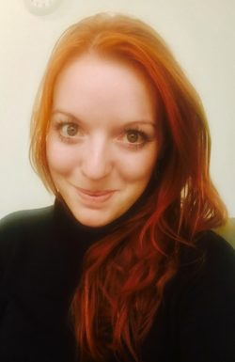

Emily Morrison manages the global research portfolio at the British Council which includes governance of the British Council’s research strategy and policy for evaluation. Emily is a graduate of University College London (UCL) and has worked in Higher Education at King’s College London and UCL in a professional and research capacity. Prior to working in academia, Emily worked on projects in education, the arts and social development in Kosovo, in Europe and within the UK. Her own research looks at arts practice as a research methodology, and the role of creative practice and culture in education and social settings, drawing from experience as a theatre practitioner and as a researcher. Emily joined the British Council in 2015 to build the new research and evidence strategy for the British Council under the direction of Professor Jo Beall, which has involved working across the British Council’s global regional network to build capacity within research internally and with external research organisations, to share knowledge and evidence, and to strengthen key research series within international development, education, the Arts, and working with young people in conflict and post-conflict settings. This includes the flagship Next Generation series capturing the voice, aspirations and attitudes of young people worldwide at key moments in society.

**Emma Hardy MP**

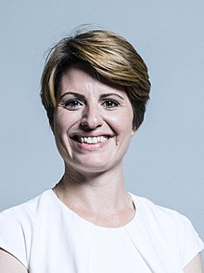

**Emma** Ann **Hardy** is a British Labour Party politician, elected as Member of **Parliament** for Hull West and Hessle at the 2017 general election. She is a member of Hessle Town Council focusing on NHS and education. **Hardy** is a member of Labour's National Policy Forum and was an education union employee.