Hello!

I am delighted to welcome you to Hull & East Yorkshire for **Epicycle.**

**Firstly, some practical information about your visit:**

**Accommodation**:

Ibis Hull, Osborne Street, Hull HU1 2NL

This is on box B1 in your map.

**Site**: West Park, Walton St, Hull HU3 6HU

This is on box B4 on your map.

**Food:** Your breakfast is served in your hotel.

Lunch and dinner are served at the 1904 Lounge in KCom Stadium, West Park, Walton St, Hull HU3 6HU

|  |  |  |
| --- | --- | --- |
| **Date** | **Lunch Time** | **Dinner Time** |
| Wednesday 9th August | 1pm | 8pm |
| Thursday 10th August | 1pm | 8pm |
| Friday 11th August | 1pm | 10pm |
| Saturday 12th August | 1pm | 11pm |
| Sunday 13th August | 1pm | 11pm |
| Monday 14th August | 1pm |  |

**Contact List:**

Assistant Producer Hull 2017 – Lily Mellor +44(0)7740557720

Producer Hull 2017 - Hannah Williams Walton  +44(0)7500838553

Executive Producer Hull 2017 – Katy Fuller   +44 (0)7771 764656

Production Manager Hull 2017 – Adam Long  +44(0)7754 728316

**Hull & East Yorkshire** is a vibrant destination with great diversity. Here you can discover maritime heritage, breath-taking countryside and a dramatic coastline, along with a great cultural offer.

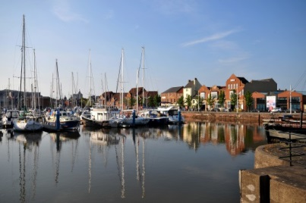As I’m sure you are aware the historic waterfront city of **Hull** is the **UK City of Culture** in 2017**.** Our spectacular programme delivers artistic excellence and events on a scale never seen before in the city.

Hull’s **eight free museums** contain an abundance of treasures including everything from fine art to whale bones! **The Deep** visitor attraction which tells the story of 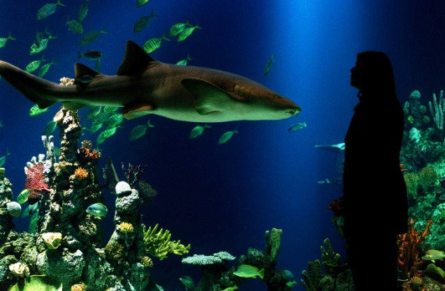the world’s oceans, is home to over 3,500 fish, sharks, rays and penguins and shouldn’t be missed. Plus the city provides a wealth of shops, restaurants, theatres and attractions for you to explore. Head to the area around **High Street** in the Old Town to discover cobbled streets, historic pubs roman mosaics, vintage transport and a woolly mammoth!

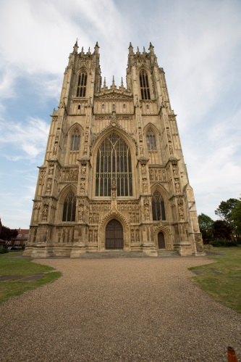If you have the opportunity to explore our area further the traditional English market town of **Beverley** is just a 25 minute drive away or less than 15 minutes by train. The quaint cobbled streets are home to an array of cafes, pubs, shops and restaurants, as well as the weekly Saturday market offering local goods and produce. At the magnificent Beverley Minster you can enjoy over **1000 years of history** all under one roof.

Discover the **Yorkshire Wolds** by foot, car, cycle, or on horseback. This superb scenery is the inspiration for some of artist **David Hockney’s** major work.

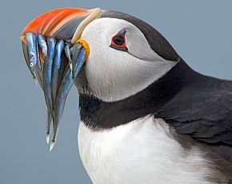**Bridlington** our classic **seaside** resort boasts award winning beaches and a hive of activity along the historic harbour where Olde Worlde pubs, antique shops and tea rooms rub shoulders with art galleries and the Spa Theatre. A few miles north of Bridlington you’ll find a cliff-top RSPB nature reserve home to 200,000 nesting seabirds, including puffins!

I hope this visit whets your appetite and that you’ll come back to the area with your friends and family soon. To find out more about Hull and East Yorkshire visit our website **visithullandeastyorkshire.com**

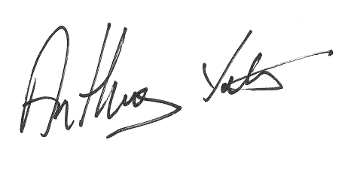I hope that you have a pleasant and enjoyable visit.

Anthony Yates

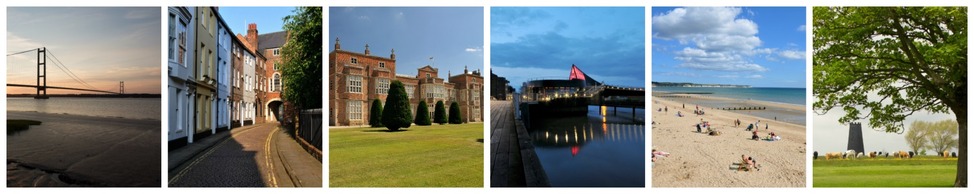Visit Hull & East Yorkshire Tourism Manager