**VOICE RECORDER STEP-BY-STEP GUIDE**

The below is a step-by-step guide for how to use the voice recorder, to feedback after your shift, if this is your preferred method.

* Pick one of the phones
* To turn on: click the top button (small button) on the right side of the phone
* The screen should light up
* Swipe up the screen from bottom to top and key pad should appear
* Enter 2017 and ✓
* You should then be on the main screen
* If you can’t see an app called VoiceDrop swipe the screen to the right  
  
* Click on this icon and you should see a time counter as below, but with 00:00:00  
  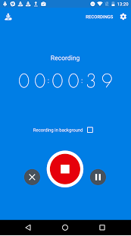
* To record your feedback hit the red button that will have the image of a microphone
* Deliver your feedback using the prompt cards provided to help you
* When you have finished hit the red stop button
* You will then see the following screen  
  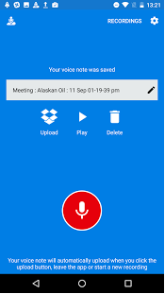
* Hit the Upload button that looks like an open box
* It’s the ready for the next person.