Working Title: Philip Larkin Exhibition

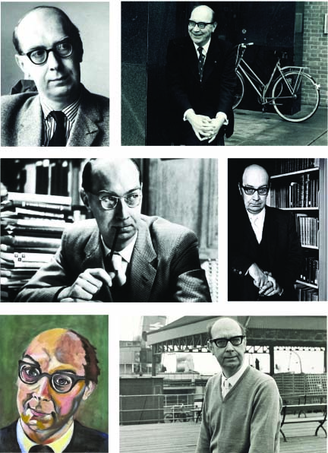

Provisional Costs and Programme - Draft Proposal 1

**Understanding of the Brief**

In May 2017 and as part of the Hull UK City of Culture celebrations, it is proposed to present an exhibition on Philip Larkin, poet, librarian, novelist, jazz critic and photographer at the Brynmore Jones Exhibition Centre, University of Hull.

The planned exhibition will look at the life and work of the poet and will draw upon research material and exhibits from the Hull History Centre archive. The exhibition will also include information and contributions from a number of sources including The Philip Larkin Society and the University of Hull.

It is the aim of the exhibition to present a definitive exhibition with an accompanying publication.

**Content**

The exhibition will examine the life and work of Philip Larkin supported by a number of exhibits from the vast range of images, archival materials, and available information. The story will be presented in a series themes interpreting the many facets of a complex and compelling character.

The themes will include a number of interpretation processes including the following:

* Photographic images
* Interpretation graphic panels
* Audio/visual presentations
* Electronic / multimedia interactives
* Tactile interactives
* Showcasing of exhibits and archive materials for display

The exhibition will follow a didactic approach and allow visitors the time to investigate and discover many of the known and not so well known aspects of the poet’s life. The exhibition will occupy the entire display area (approx.150m/sq.) of the Brynmor Jones Exhibition Centre.

**Other considerations:**

* The team will work closely with the 2017 Culture Committee to observe consistency of design and consideration of the established event media identity for 2017.

**Client requirements:**

* Client to provide all text and narrative information (including a copy writer if required) and supply of all image/origination (including copyright fees as necessary).
* Client to be responsible for all applications which require listed status planning or advertisement consent. Ian Goodison Design Consultancy will assist the client with the applications as necessary.

**Optional:**

* Within the scope of the works IGDC will be happy to discuss additional interpretation ideas for development outside the scope of the brief if required.

**Approach**

**It is the intention to progress the project in consultation with the exhibition interpretation team, building a team of consultants as the project develops.**

The following points show the intended design development of the project underpinned with a project cost plan:

1) Start-up meeting

An initial start-up meeting and subsequent meetings with the project team to exchange ideas views on the project development.

2) Programme

To initially build the project around a detailed work programme developed in consultation with the interpretation team and other commissioning bodies as necessary.

IGDC believe that a detailed programme with time indicators allocated to deliver tasks will give structure to the project and highlight issues that may arise in the course of development.

3) Initial design proposals

To take key elements from the brief and develop initial design proposals which would also form the basis of a consultation document. Work will also begin on developing the text and images for the information exhibition interpretation and catalogue.

4) Consultation

The process of consultation is a key factor in assisting and steering the ideas developed in the initial design proposal in a positive forward direction. It is the intention to provide an adequate timescale within the project to seek the views/ comments from user groups and other bodies through a proposed framework of planned sessions.

5) Final design proposals

To review the comments and feedback generated from the initial design discussions and from consensus of opinions to produce an amended document as final design proposals for the display interpretation. This will be issued for approval to move to the next stage. Work will be reviewed on the development of the text and images for the information/interpretation.

6) Design development

This is the stage where the final proposals are developed for final presentation.

7) Client approval

To finalise sign off from client and associated approvals

8) Commissioning

To commission manufacturers to plan process and build exhibition displays and associated items.

9) Delivery and Installation

To manage, report and monitor the delivery and installation of the exhibition displays.

12) Cost Plan

Throughout the life of the project and at key stages I will assist in developing a cost plan that will adhere to the budget needs and engineered as necessary to keep the project within the agreed project finance.

**Finance**

*The following cost are based on an assumption of the provision services initially discussed with the client team that will be further explored in the development of*

*the design brief:*

Graphic images to perimeter walls £4,280.00

Graphic Interpretation Panels £1,680.00

Housing structures for Interpretation Panels & Graphics £6,600.00

5no interactive units

* 2 monitor displays £2,880.00
* 1 Multimedia interactive £4,200.00
* 2 small mechanical interactives £3,600.00

1no Costume case and mannequin (Hire 2 months) £2,455.00

7no plinth showcases for archive material (Hire 2 months) £6,525.00

Installation of above items £3,600.00

Breakdown and removal of exhibition £1,500.00

Sub Total £37,320.00

**Project Value £37,320.00**

Exhibition /Graphic Design Fees (includes all expenses)

• Project management for the delivery for design services.

• Attendance of a number of project meetings at site for

interpretation and project development.

• Design and development of initial design proposals

• Design and development of final design proposals

• Artwork and ‘mock-ups’ for exhibition graphics

• Artwork and detailed drawings for exhibition structures and

graphics

• Provision of material samples

• Attendance for on-site installation £ 8,584.00

**Project Total £45,904.00**

Additional Item:

**Replacement of existing roller blinds with blackout (Provisional Sum) £ 2,000.00**

*(Design Day rates for work falling outside the scope of work £250.00)*

**Programme**

* IGDC would recommend a total project timescale of 43 weeks and estimate a 24 week provision for research, interpretation, audio and visual briefs to include the development of the interpretation script for the exhibition and catalogue and inclusion of objects and archive materials.
* Curatorial/design team meetings to review and progress and development could be arranged at the end of each month over the 24 week period.
* Design development of 19 weeks to include design development, production and install for **1May 2017**
* January/February 2016 is allocated for finalisation of funding decisions therefore project planning could begin as early as **1 March 2016.**
* The following table is indicative of anticipated milestones and deadlines for the latest start date **1June 2016**

|  |  |  |  |  |  |  |  |  |
| --- | --- | --- | --- | --- | --- | --- | --- | --- |
|  | **Research/ Interpretation**  **brief** | **Object selection/**  **preparation** | **Archive**  **selection/**  **preparation** | **Audio**  **brief** | **Visual**  **brief** | **Design**  **process** | **Production/**  **installation** | **Opening** |
| **Jun16** | **Begin process**  **1 June 2016** |  | **Begin process**  **1 June 2016** |  |  |  |  |  |
| **Jul16** |  |  |  |  |  | **Begin 1st update**  **Meeting**  **30 Jul** |  |  |
| **Aug16** |  | **Begin process**  **1 Aug 2016** |  | **Begin process**  **1 Aug 2016** | **Begin process**  **1 Aug 2016** | **2nd update**  **Meeting**  **28 Aug** |  |  |
| **Sep16** |  |  |  |  |  | **3rd update**  **Meeting**  **30 Sep** |  |  |
| **Oct16** |  |  |  |  |  | **4th update**  **Meeting**  **30 Oct** |  |  |
| **Nov16** | **Complete by**  **28 Nov 2016** | **Complete by**  **28 Nov 2016** | **Complete by**  **28 Nov 2016** | **Complete by**  **28 Nov 2016** | **Complete by**  **28 Nov 2016** | **5th update**  **Meeting**  **30 Nov** |  |  |
| **Dec16** |  |  |  |  |  | **Initial**  **Designs** |  |  |
| **Jan17** |  |  |  |  |  | **Final**  **Designs** |  |  |
| **Feb17** |  |  |  |  |  | **Prod/Dwgs**  **Artwork** |  |  |
| **Mar17** |  |  |  |  |  |  | **Production** |  |
| **Apr17** |  |  |  |  |  |  | **Production**  **On site 3 days 28-30** |  |
| **May17** |  |  |  |  |  |  |  | **Opening**  **1 May 2017** |

**IGDC** (Ian Goodison Design Consultancy) - Draft 1 - 22/12/15