**[John Clay](https://www.facebook.com/john.clay.752?fref=gs&hc_ref=ARQMdSBxAMnbR5Mg1SBOmlz93Exn91YHXoNNxo_0L0QLk4JEn5CSk78BtVG2gPyPIBY&hc_location=group)**

Well done to all involved, this was a superb show and thankfully about time that something like this was done to honour not only Hulls, but one of the worlds greatest guitar talents...long overdue but well worth the wait

[**Lisa Hockney**](https://www.facebook.com/lisa.hockney?fref=gs&hc_ref=ARSrWlpzx4Or_bp5bwIENC2YwqeF9nvyUFlUWeluGYWQ68f6bdeTXWkNecRyza-Bo0o&hc_location=group)

Id just like to say a big thank you to all the staff at the mick Ronson turn and face the strange concert,thank you for making our son & grandsons Oscar 'Bowie' a special night which he will remember,he said on the way home he wants to play mick ronsons guitar😊, thank you from Oscars mum xxx

[**Julie Oxburgh**](https://www.facebook.com/julie.oxburgh?fref=gs&hc_ref=ARQxewIyMA0Vebk9-mOwUwNmH3WXP2HgA3Tr3EJxD7kJPXTLqdayAhgvjrCRc8iA4iA&hc_location=group)

Last night's show was just amazing. What a fantastic night. The 3 of us who went were blown away. It was funny, emotional, the music and musicians were brilliant. I could watch it over and over. Well done everyone involved.x

[**Steve Brown**](https://www.facebook.com/profile.php?id=1044857926&fref=gs&hc_ref=ARSFIgbj9J6oDIoYBe5kK_QmBrS_KXqy0-R9pH5V6otFxYUJXUDvVM8eG-RLaO25mnc&hc_location=group)

Fantastic show last night. Didn't know what to expect but we were blown away by the quality of the music and production of the whole gig and memorabilia. Should go to the West end next

[**Debbie Vaughan**](https://www.facebook.com/debbie.vaughan.71?fref=gs&hc_ref=ARQSi-3qKNFHpYs3zw6j09WbUHHmWMPlduq5GHEjAopFId9eZrl6zU-qUx1IB5_J54Q&hc_location=group)

What a fantastic show you put on! You have made me a very happy lady, finally seeing Mick's story told, and so beautifully. Thank you from the bottom of my Ronno loving heart   
I do hope this show 'goes on tour'!

[**Sarah Rowland**](https://www.facebook.com/sarah.rowland.104?fref=gs&hc_ref=ARRcSAFM41hcRHwuy7mtuE3vTJ57KWiuZO5FUoQgLnVLvF3iVIrsiJHYS88kn3jF5Bs&hc_location=group)

Tonight's show was absolutely fantastic! Well done to everyone involved! Educational, energetic and emotional. Never seen anything like it. Truly great.

[**Ian Spencer**](https://www.facebook.com/ian.spencer.3150?fref=gs&hc_ref=ARTHGHHKcgy44pyk66gi_YqlsIaDHk88vt_1KjTtfR0b8s6kRiqeqAue-ZNwnpPJlrQ&hc_location=group)

Excellent and often quite moving show. Top quality sound. Fabulous. Thanks to all involved. And I had my pic took with 'that' guitar..... had to be done. Sore throats now from singing along at the end

[**Maurice Houlden**](https://www.facebook.com/maurice.houlden?fref=gs&hc_ref=ARSrCAnTBh-Pmd5rm1hMcdihyTVatd9hO8JiZTqCyzGXj4kVDrwh5BywPzh2A7J5MqQ&hc_location=group)

Absolutely stunning tonight!!! I thoroughly enjoyed it from the stories to the music it was amazing!! Thank you!!!   
You did Mick Ronson proud!!!

[**Paula McIntosh**](https://www.facebook.com/paula.mcintosh3?fref=gs&hc_ref=ARQY9IX-9yDHHJoyoSE7eBiOYiForhwaQHRtwNTZByXKHaea1jHGR2Ria7Ub-vK_P1A&hc_location=group)

Thoroughly enjoyed the show! Absolutely brilliant ! Funny, moving, great Hull memories and, of course, fantastic music

[**Mick Penn**](https://www.facebook.com/mick.penn?fref=gs&hc_ref=ARSzmYFKcLFI7vJnVUnviDcm7a0Mnn9Z7rh0U1IdBbpzvPSl6sXBsmi2_6ZzRyPgn1Y&hc_location=group)

Thanks to everyone involved in the show - the writers and creators, the performers, the off stage crew, the organisers, the volunteers who helped the event go smoothly, Mick's family and friends and the people of Hull over the years without who it would never have happened. It was a magnificent event last night and if you are doing it again, I'm going along again

[**Sarah Byrne**](https://www.facebook.com/Sagsb?fref=gs&hc_ref=ARTOJSeCP0mHMO1_J0DMIjqpKZgpH_S8KHsNRBwl03OeH8RNgcySy75RH0aqPrOy2IE&hc_location=group)

Still in awe at some of the people I have had the privilege to meet by being a City of Culture Volunteer thanks to this absolutely awesome event!  
It was an honour and now I can proudly say "I played a part (albeit a very small part) in that"   
Huge Congratulations to everyone on stage and also to those behind the scenes - I've just got one word to say .........  
FAN-BLOODY-TASTIC!!!!

[**Paul Shallcross**](https://www.facebook.com/pshallcross1?fref=gs&hc_ref=ARQZC_UPiHclmGnTgqF7jxCMLEThrzGhncJLYWEB7WGOwFmxj1haSdPm_dC32GMp7vM&hc_location=group)

Just back from the Freedom Centre having seen such a memorable tribute to a truly Hull guitar great - Mick Ronson which stirred so many memories. Have to thank all those involved for putting together such a comprehensive pastiche of the man and his musical times. The band and narrators put together a great selection of those classic Bowie/Ronson musical pieces and anecdotes to highlight Ronno's great career. Thanks again you guys for many memories shared especially John Cambridge, Ched and John Bentley. Finally one simple request TAKE THIS SHOW ON THE ROAD & BRING IT BACK HOME NEXT YEAR!!!

[**Mika Kenningham-James**](https://www.facebook.com/mikasmonkey?fref=gs&hc_ref=ARQs_E20VYBzkeM69iSFqQIeHXwoeAjVpFXcE_prvcNNnkj_5C85WvmSFUT2RdTzDr4&hc_location=group)

Thanks for a wonderful show yesterday, family crisis meant I didn't get to see any of the exhibition before or after, which I'm sad about, but I've seen other people's pictures.  
I got goosebumps and smiled so much my face ached. It felt like I was transported into his life and got to go on his journey.  
I hope one it gets shown to a bigger audience as it so deserves it. Well done to everyone involved, it's made a lasting impression on me.

[**Ann Jeffrey**](https://www.facebook.com/ann.jeffrey?fref=gs&hc_ref=ARS7ioXJl0-JkcszC9Z7w5sqcl-OudJB4tNppgVEOG-__ZyC4rR0FGJd3o0msPq_Lm4&hc_location=group)

A massive congratulations to all involved in Turn And Face The Strange, absolutely brilliant show and really well put together, we were there last night and enjoyed it so, so much, well done!!

[**Diane Anderson**](https://www.facebook.com/diane.morfitt?fref=gs&hc_ref=ARTK7B2XxMT9kJHYwFtLNshutu__99-p1MEINq5i_3615vLil0oWECaTBw1Xvej8Ies&hc_location=group)

Would like to say a huge thanks to everybody that came for drinks tonight at The Duke of York. Was nice seeing you all and again. A massive well done to all who was involved in such an amazing event!!! So proud of you Dad (Les Morfitt) and you certainly have met some amazing people xx

[**Hilary Dickinson**](https://www.facebook.com/hilary.dickinson?fref=gs&hc_ref=ARTYnay_TlV6-hx9vuRspGlMuDcFLa4VpeGVTFahj_P7QWdEf1p9IC1vFedjS2r3fm8&hc_location=group)

Absolutely loved the show tonight made us laugh,cry,sing and dance hope it goes to a wider audience soon many thanks to everyone who made it possible!!

[**Hayley Morfitt**](https://www.facebook.com/hayley.morfitt?fref=gs&hc_ref=ARSYY-H9XKJAuMTpbvJ59f_OTPhzXIl_GnbajXcSxY17ZoEdAwJKkLs70Lm-220QNN4&hc_location=group)

Absolutely amazing night from start to finish. Was an amazing experience. And after years of hearing some names I finally got to put faces to them. Fantastically organized and some awesome artwork would like to see more for sale maybe on here if possible. Happy to be involved with something so memorable

[**Alice Manning**](https://www.facebook.com/alicemanning13?fref=gs&hc_ref=ARRcgnyuM3qul7zlRZSwA1SHlD78UbSU2en3mKQnTsDUb7Xv-6IP3H-ki8U8GgZgTco&hc_location=group)

So happy I finally made it to Hull! What a fantastic show it was and lets hope we see more of it in the future. Nice to meet you in the flesh [Les Morfitt](https://www.facebook.com/les.morfitt?fref=gs&hc_location=group)

[**Beatrice Heslin**](https://www.facebook.com/beatrice.heslin.5?fref=gs&hc_ref=ARS8j_JWKSAqyendsXu7Ph0T9CoyzxkOE2X5VQhHjOIOQtftsoVLao7wwDY0VPAzbiw&hc_location=group)

Finally got to visit Hull, and fell in love with it. Plus everyone is so gentle and friendly - even the young people who are on the streets (sadly) are polite when asking for some spare change.  
if I had not got interested in Mick Ronson's contribution to music I would never have visited this lovely old city. Seems like Mick is still a force for good.

[**Sara Captain**](https://www.facebook.com/sara.captain.9?fref=gs&hc_ref=ARSEj2EqGWx-dH5Gu0GSkqnSMeEL4N2lMPq94QOGXLC4bBxhaTRd51_hWL6i-NpcVi8&hc_location=group)

Huge thank to everyone who created and participated in this incredibly moving and exciting show. It really made one feel how Mick lives on in his music and in the love that of all those who knew him have for him...This was truly truly a wonderful show that deserves being seen my many more people. A labor of love - talent, heart, professionalism, a great team and of course amazing music and storytelling. Thank you for creating it and for the opportunity to show my paintings in the exhibition- a real honor to be involved!

[**Ian Strongman**](https://www.facebook.com/ian.strongman.7?fref=gs&hc_ref=ARS_Xo6TUMJvvRTNGnG3elp8F7uEKH2DMd9apmbHQdwsD6gF9IFhm0sHu_xjOlOulVE&hc_location=group)

Just arrived home after a great 24 hours in Hull. Thank you to everyone involved in Turn & Face The Strange, which we found to be a truly moving experience. The music & stories were absolutely superb and the show was a great tribute to Ronno.

[**Stephen Watson**](https://www.facebook.com/stephen.watson.1614?fref=gc)

Went to the exhibition today,it's excellent.lots of exhibits and information.Go see it if you get the chance**.**

[**Tim Chapman**](https://www.facebook.com/MarkTimothyChapman?fref=gs&hc_ref=ARQ10lTX--3kM-53iInT8Vaaggvkms2AnhQqQ1PZ5Sn_O2bZhS4R5Z2hl1Ot2Uk1HFE&hc_location=group)

Totally fab performance. Well done all. A real tribute to the inimitable Mr Ronson.

[**Kat Webb**](https://www.facebook.com/kat.webb.98?fref=gs&hc_ref=ARRTGmx08VWfiRIHCFZ_i7fDXNmk0sFksAsJZhGoiUyaJYiLT5BlYB8cVOhZVWHd92Y&hc_location=group)

To everyone involved in Turn and Face the Strange. Thank you so much for the brilliant time you gave myself and [Mark Painter](https://www.facebook.com/mcpainter?fref=gs&hc_location=group) on Tuesday and Wednesday when we were in Hull. You were so generous with your time and made our visit feel so special, I can't thank you enough. The show was amazing, such a fitting tribute to Mick Ronson, his life, his talent, his genius and his legacy. I'm sure the show has gone from strength to strength over the week.. Wishing you all the very best for the last day of the run and I look forward to seeing the show again, when it returns

[**John Clay**](https://www.facebook.com/john.clay.752?fref=gs&hc_ref=ARTYJe2g7buVf-4qd3AaaIfS16I0f4Ph3HsQD_68A-RCfUtpWRsAjXi3HyOlTUO0tFA&hc_location=group)

Well done to all involved, this was a superb show and thankfully about time that something like this was done to honour not only Hulls, but one of the worlds greatest guitar talents...long overdue but well worth the wait

[**Joanne Walker**](https://www.facebook.com/joanne.walker.946?fref=gs&hc_ref=ARTuvxwRUT81WThXZCt1e7WDHG0f8tLaziRdPRZgPnl2JXvKR8NTAs2cr6NrE8wmuuA&hc_location=group)

Absolutely fantastic. Well done to everyone involved, you were all amazing.

[**Alan Bold**](https://www.facebook.com/profile.php?id=100005603617797&fref=gs&hc_ref=ARQQ3GitlIqYwM9ET3QpbNqj1pAglSoO5oCOT2Vsjgy2osgVoj-JAH2D4RReSSWRvMQ&hc_location=group)

Had a great day visiting the memorial and then seeing   
the show, really enjoyed it and got to see some great friends again. Well done to all involved in bringing the show together.

[**Ian Brown**](https://www.facebook.com/ianb59?fref=gs&hc_ref=ARRGdYXm3lrz-mT1pIQkql91-Hzd0jlMyXde3ZU00ef9Bg7LK66eCyW_DT6uxGbsYoU&hc_location=group)

What a show, funny, sad, musically brilliant. Hat's off to all those involved.

[**Sarah Uney**](https://www.facebook.com/sarah.uney?fref=gs&hc_ref=ARQSDAd9ZmwRql2eBeP6WdtNJqMjFp-9jzbaUBJrGWqbr71pUW6kmIobCUPaZpMofHA&hc_location=group)

Thank you so much to absolutely everyone involved in this beautiful event. It truly was magical. Special thanks to Mick and Maggi.   
Loved it. Xx

[**Steve Jones**](https://www.facebook.com/profile.php?id=100004130950383&fref=gs&hc_ref=ARRP4dkWZzdj8j5eSke5VQ3XGX5zpqD5DUxKEKhWaV_yQ6yX1Qz3z6UiXUvAGYUz4uE&hc_location=group)

A brilliant celebration of all things Ronson. So I'm disappointed to hear that the brilliant mural of mick in the what was the mick Ronson cafe has now been white washed over.

[**Mandy Chatterton**](https://www.facebook.com/mandy.chatterton.9?fref=gs&hc_ref=ARTNrPhYqMWWrR5RSZoTBz6K9UjU3FVJRCU2c1NYIqMvj2g_38TsZl-8N4YJXVWL1nM&hc_location=group)

Really enjoyed the show last night. Thanks and congratulations to all involved!

[**Jonathan Appleton**](https://www.facebook.com/jonathan.appleton.984?fref=gs&hc_ref=ARQzTfui25J96L-KR8X9_dC91g2MMKNpY29cSoYYSDNZEiViRzS5xfUOoP1ZXXU46Q0&hc_location=group)

Congratulations to Garry Burnett, Kay Ralph, Rupert Creed and all involved in this wonderful show! Fantastic evening, great to be involved

[**Anna Dinsdale**](https://www.facebook.com/anna.dinsdale1?fref=gs&hc_ref=ARS2W_4pwxnY3mLo4ofaWJpnS6BrMhYPHM5PnQ0YZ3zkMJ3_1ksWVMnIh-VnarnWk5M&hc_location=group)

No words can express the pure joy I got from this evening well done everyone involved much love there tonight x

[**Kath Stabler**](https://www.facebook.com/kath.stabler.7?fref=gs&hc_ref=ARQM-F_zFBSd1To_R-YIdvVIrYl32fGgyDjALO4ywbeb2HsbA2Ym5fcdGKsaZgcRZgI&hc_location=group)

When to see the show last night. Fantastic. The guitar playing by Ched Cheesman was incredible. By far one of the best shows I have seen in ages. Well done to all concerned

[**Ian Spencer**](https://www.facebook.com/ian.spencer.3150?fref=gs&hc_ref=ARQ5IJF3ODArXEZdETLNuaafBVOqfoanL1LSNDIToqJaiRoL1D82BN-VZ8pNJ26TIjI&hc_location=group)

Excellent and often quite moving show. Top quality sound. Fabulous. Thanks to all involved. And I had my pic took with 'that' guitar..... had to be done. Sore throats now from singing along at the end.

[**Diane Anderson**](https://www.facebook.com/diane.morfitt?fref=gs&hc_ref=ART9X5PK_mUT_-GPQqDxaT1qQALY_DfEVE7YnSTrBPvoVcCnFuKR6PZMhFb4DWIfZMA&hc_location=group)

Absolutely amazing night!!! You have all done yourselves, Mick Ronson and Hull proud. Was a pleasure watching Ched again after all these years. Thankyou Kay, Steve and [Les](https://www.facebook.com/les.morfitt?fref=gs&hc_location=group). And everybody else involved.

[**BBC Look North (East Yorkshire & Lincolnshire)**](https://www.facebook.com/BBCLookNorth/?ref=gs&hc_ref=ARTKEmq-lmVGaPL-42n6h_4aTShkHjXu7FgsxZhpmS2MXOnm8mIRQan4GeM53AxLV9w&fref=gs&hc_location=group)

Mick Ronson, Hull legend and Bowie guitarist, has been immortalized in a new multimedia play for Hull 2017

[**Garry Burnett**](https://www.facebook.com/burnett.garry?fref=gs&hc_ref=ARRjzeyaoixHkKnDWhXD4b7SN5p9dOqtTdyEroZiFfEj5IP9te07er17yLyjv5NQOSU&hc_location=group)

I'm so proud of everyone connected with this project, it's been an amazing 18 month journey from proposing the idea to seeing it realised and what a great privilege to work with such committed and professional people. Dedicated to Micks mum, Minnie Ronson who sadly passed earlier this year I think we have produced something she would have loved

[**Maurice Houlden**](https://www.facebook.com/maurice.houlden?fref=gs&hc_ref=ARTiSc5RalZBn2FKukOqXaTh9Yvb7q82yb6uK_L9eX6oZOD8xmoP8_iy9FvG-edQ7p8&hc_location=group)

Absolutely stunning tonight!!! I thoroughly enjoyed it from the stories to the music it was amazing!! Thank you!!! You did Mick Ronson proud!!!

[**Christina Puplett**](https://www.facebook.com/christina.puplett?fref=gs&hc_ref=ARSMVoiZewroO-1YOqvkJYL-LFRyGsBBZ4VgCQliXv1wFu4DR0JNddfZEh_So2vdCmU&hc_location=group)

Just got back from The Freedom Centre.....what a wonderful show.....band where awesome and the wonderful interesting stories had me laughing and in tears......thoroughly enjoyed this event....was a wonderful tribute to the great man......Please can we hold this event every year

[**Paula McIntosh**](https://www.facebook.com/paula.mcintosh3?fref=gs&hc_ref=ARQDImnzFLbP2UKYStW4H0xXYlGgQpZXBVdWYupazRMhJswzCZtLJxFz-WEFjGxn7Sc&hc_location=group)

Thoroughly enjoyed the show! Absolutely brilliant! Funny, moving, great Hull memories and, of course, fantastic music!

[**Linda Johnson**](https://www.facebook.com/linda.johnson.96780?fref=gs&hc_ref=ARTUgCXgVmzh0q3jh30QuMrIU7X-BQyvYW2LpxYQFksZwpEOV3hjWT-LD-oKeUnownc&hc_location=group)

Brilliant night last night , well done to all involved

[**Catherine Muller**](https://www.facebook.com/catherine.muller.9889?fref=gs&hc_ref=ARSXWPKdl18I5-lAmytkauGQNsMUeHa9QM7gFh6zoVSqYu8GASbakyp1fD7CxHyywcI&hc_location=group)

Amazing show Rupert and everyone involved, well done x

[**Geraldine Hunt**](https://www.facebook.com/geraldine.hunt.378?fref=gs&hc_ref=ARRWbZYTwW5X2wMFfZfNzIN_axnx0xFqSQ9zUd2nrVD7av5e3mRn-LR1_S7jO6mAl60&hc_location=group)

Went to the performance last night-I didn't really know what to expect-it was fabulous. The whole performance came across as so natural and 'unstaged'-well done everyone concerned-if I could get more tickets I would go again!

[**Kerry Davies**](https://www.facebook.com/kerry.davies.7771?fref=gs&hc_ref=ARQIp_iypuP7hHjqDLd6Tmcg8w7wYyzjkL7Dk5wZrJdyvPk6lXkgrQrTUrXhaUba1Yk&hc_location=group)

Thank you to everyone involved in 'Turn and Face the Strange'. It is a brilliant tribute to Mick Ronson and a great celebration of his life and music.

[**Jan Crutchfield**](https://www.facebook.com/jan.crutchfield?fref=gs&hc_ref=ARRLXorrHSmet0aGR8b4Bf0ZXu7mYQIWulxoygkqyudxzjzwQS7Ihk6VXL8XhYO95MY&hc_location=group)

Hope everyone is having a great time celebrating Mick!! Wish I were there. I am in spirit

[**Tim Chapman**](https://www.facebook.com/MarkTimothyChapman?fref=gs&hc_ref=ARTXacHS_X8aeDVOOH9IRzbeqrzk-PitnCVJP7fjvWcdg8xWoD5DqDjh8kGyFhTo0mw&hc_location=group)

Totally fab performance. Well done all. A real tribute to the inimitable Mr Ronson.

[**Phil Edwards**](https://www.facebook.com/phil.edwards.92?fref=gs&hc_ref=ARSlrHHS2WXFvoWvNhyGS-OWrD1R9MvB6RW7Fu-hzEuZOVPuz6GlNQycEuKx8wVTJeU&hc_location=group)

Final rehearsals, 3 grown men with goosebumps & tears in their eyes including me these boys are superb , can you guess the song , don't worry I'm not going to say

[**Cecile Piverotto**](https://www.facebook.com/cecile.piverotto?fref=gc)

So excited- our dream come true thanks to all of you

[**Lynn Wise**](https://www.facebook.com/lynn.wise.56?fref=gc)

An amazing show, one I'll never forget! And now your wonderful

[**Bev Loram**](https://www.facebook.com/bev.loram?fref=gc)

Well Keith, I intended to do a post for you, but I'll add it on to here. Thank you so much for bringing Mick's music so beautifully alive. You were amazing, I can't tell you how much I enjoyed hearing you play. And that solo on Moonage! Wow!

[**Bryan Mason**](https://www.facebook.com/bryan.mason.984?ref=br_rs&hc_ref=ARS5K7TkgFO3T-s7S7uInhbieSZVNLwjiMDBmct-4Q3WaKS0KLzBsPVUnfoV6g4do-0&fref=nf)

Turn & Face the Stranger the Mick Ronson show, what a great afternoon, everyone should be proud. It was entertaining, fun, sad and great music. The guitar playing, wow, three existing band members playing as in their twenties not 70ish, talent still there. Worth taking the show on the road.

[**David Roberts**](https://www.facebook.com/profile.php?id=100021526761615&hc_ref=ARS8qfMHes-TM-MIrcAUq_RqnqqTF4Bv3u_1wfAgjGhHmTBRR7VuKclzogsJsyQBB50)

Just got back from Hull went to see Turn And FaceThe Strange , the life story of Mick Ronson ,The Spider With The Platinum Hair , wow ,it was an amazing piece of work , emotional , funny , brilliant and educational absoluittly well done to Garry Burnett, Ruper Creed , and everyone involved , [Les Morfitt](https://www.facebook.com/les.morfitt?fref=mentions) , [Phil Edwards](https://www.facebook.com/phil.edwards.92?fref=mentions) met so many amazing people and friends , its never dull in Hull

[**Kristian Eastwood**](https://www.facebook.com/kristian.eastwood?fref=gs&hc_ref=ARTcW6J-2qCwKKKFViVQP-gIoB3kVH4sw9yaO6oF5KF7qY-wUyK7QM98v_XQcCK1Plw&hc_location=group)

Twas an amazing honour to be part of the show.

And all though it was for someone I didn't personally know.

I was surrounded by people that knew him well.

And listened intently at the stories they'd tell.

An absolute honour to witness each night.

The best dudes around to tell it right.

with the humongous honour to sing in the show.

And try to bring justice to these songs we all know.

As I sat on that stage and looked around.

There were girls sorting lights, and dudes manning sound.

Volunteers by the bucket were all about.

And plenty of bar staff dishing beers out.

An amazing exhibition, that was too cool for school.

With a painted up scooter to make die hard fans drool.

We had artists and authors, and fans from abroad.

Sold out each night just proves Mick was adored.

A string quartet who didn't put a foot wrong.

Rachael and Bobby both smashing their song.

John Bentley on bass who grooved out cool strums.

And Cambridge was mega, and nailed his drums.

Mr ched Cheesman my good ole friend.

Melted my face off with solos no end.

And of course our narrators who delivered each night.

They created and wrote, a show out of sight.

We had super dad dancing with tank top man.

And at every single show was a number one fan.

If Iv forgotten anybody, then I need a spanking.

But I can't forget the lady who had to sign language wanking!!

I met the lovely Joachim, Ronno's son.

And singing with Maggie was so much fun.

All in all it was mega, an amazing time.

Let's do it again, but next time, more wine

[**Lynn Wise**](https://www.facebook.com/lynn.wise.56?fref=gc)

An amazing show, one I'll never forget! And now your wonderful poetry too, thank you!

[**Bev Loram**](https://www.facebook.com/bev.loram?fref=gc)

Thank you, really loved your voice

[**Rupert Creed**](https://www.facebook.com/rupert.creed.5?hc_ref=ARRbA_rp1WF-yeFZLRfWS9H0WWu8lJXMpkQzIHgVOENshI_sf0tPSdofzvNk9kwIpTc)

Great to have Mick Ronson's sister Maggi and his son Joachim, all the way from Sweden, at the performance of Turn and Face the Strange tonight

[**Sara Captain**](https://www.facebook.com/sara.captain.9?hc_ref=ARSib0f_37Ee3xAn2UjFcbyus0Lqb38TaBFECadUdgd9uvCByRQb5rJVhDdn9BmPUKM)

And tomorrow calls my name but I don't want to go...Bye Bye Hull I love you - it's been a Hullova weekend, emotional, fun, unforgettable! I truly love Hull - a city to be proud of - full of lovely, warm and welcoming people. Thanks Deena Joyce, Petrovics Adrienn Julianna for sharing these two days with me - thanks Vivien Roome and Simon for your great company and incredible helpand support... and wonderful that Alan Bold, Jimster Draper and Carmel Gleed you all were there to see this amazing show and celebrate the great Mick Ronson! Thank you everyone who made Turn and Face the Strange possible, Garry Burnett for giving me the opportunity to exhibit my paintings - Rupert Creed Les Morfitt and Ed...... the amazing volunteers, Tracey Taylor for those precious tickets... and all the amazing musicians of course... all the people who seemed to enjoy my paintings and who supported my art - would love to mention everyone by name but it would be too long. you were all great. Please take the show forward...!

[**Steve Williams**](https://www.facebook.com/steve.williams.7712826?hc_ref=ARQ44iNlV6w4n4RA6eozenX4pQJpUWJVANu4Awhwh9b-33S9G7LVY2zv5a9FXpPeOPU&fref=nf)

Jammin' good with Brian and 'Gilly' (Karen)... In Hull yesterday ... for the Mick Ronson - Turn & face The Strange tribute...first time we have been back in Hull since 1997...

Garry Burnett - a truly fantastic effort .. putting this together you and your team did an amazing job 👍 thank you for your kind hospitality ... The smiles the laffs the tears.

Les Morfitt and Phil Edwards thank you also for making the day run very smoothly pleasure meeting you ... and all the tall short people and all the somebody people who were there yesterday... who made it so memorable... Thank you...

Final thanks to Brian and Karen ... Every time we meet whether here in UK or over in your neck of the woods...we can just pick up where we left off... here's to the next one - safe trip back tomorrow guyz - This Is For You!

PS - thanks for the tissues.

[**Mike Anderson**](https://www.facebook.com/profile.php?id=100002427640383&fref=ufi)

Well done Les by all accounts been a fantastic week and a true tribute to Mick, so sorry health stopped me from coming along to join all the preceedings would loved to have been involved... But GREAT job to all concerned hope this is not gonna be the last of the Mick stuff

[**Sarah Wellburn**](https://www.facebook.com/sarah.ritmo?hc_ref=ARQpJvADogHe3A5oPhDOZ1eFiASZbdaWkyDFa1V5qPcxqlBzoBD55kmmvwCX6w3UmqQ)

Great Ronno exhibition before the gig tonight. The whole evening was fantastic - thank you [Rupert](https://www.facebook.com/rupert.creed.5?fref=mentions), [Garry](https://www.facebook.com/burnett.garry?fref=mentions), [Keith](https://www.facebook.com/keith.cheesman.7?fref=mentions), [Les](https://www.facebook.com/les.morfitt?fref=mentions) and all involved in this brilliant production? Very emotional at times, it was an amazing tribute to the great man

[**Diane Payne**](https://www.facebook.com/dianeepayne?fref=ufi)

So lovely to meet you Les! It's been challenging to remember names and acknowledge everyone involved. I enjoyed every minute!

The best dudes around to tell it right.  
with the humongous honour to sing in the show.  
And try to bring justice to these songs we all know.  
As I sat on that stage and looked around.  
There were girls sorting lights, and dudes manning sound.  
Volunteers by the bucket were all about.  
And plenty of bar staff dishing beers out.  
An amazing exhibition, that was too cool for school.  
With a painted up scooter to make die hard fans drool.  
We had artists and authors, and fans from abroad.  
Sold out each night just proves Mick was adored.  
A string quartet who didn't put a foot wrong.  
Rachael and Bobby both smashing their song.  
John Bentley on bass who grooved out cool strums.  
And Cambridge was mega, and nailed his drums.  
Mr ched Cheesman my good ole friend.  
Melted my face off with solos no end.  
And of course our narrators who delivered each night.  
They created and wrote, a show out of sight.  
We had super dad dancing with tank top man.  
And at every single show was a number one fan.  
If Iv forgotten anybody, then I need a spanking.  
But I can't forget the lady who had to sign language wanking!!  
I met the lovely Joachim, Ronno's son.  
And singing with Maggie was so much fun.  
All in all it was mega, an amazing time.  
Let's do it again, but next time, more winehttps://static.xx.fbcdn.net/images/emoji.php/v9/feb/1/16/1f377.png

The best dudes around to tell it right.  
with the humongous honour to sing in the show.  
And try to bring justice to these songs we all know.  
As I sat on that stage and looked around.  
There were girls sorting lights, and dudes manning sound.  
Volunteers by the bucket were all about.  
And plenty of bar staff dishing beers out.  
An amazing exhibition, that was too cool for school.  
With a painted up scooter to make die hard fans drool.  
We had artists and authors, and fans from abroad.  
Sold out each night just proves Mick was adored.  
A string quartet who didn't put a foot wrong.  
Rachael and Bobby both smashing their song.  
John Bentley on bass who grooved out cool strums.  
And Cambridge was mega, and nailed his drums.  
Mr ched Cheesman my good ole friend.  
Melted my face off with solos no end.  
And of course our narrators who delivered each night.  
They created and wrote, a show out of sight.  
We had super dad dancing with tank top man.  
And at every single show was a number one fan.  
If Iv forgotten anybody, then I need a spanking.  
But I can't forget the lady who had to sign language wanking!!  
I met the lovely Joachim, Ronno's son.  
And singing with Maggie was so much fun.  
All in all it was mega, an amazing time.  
Let's do it again, but next time, more wine

**‎**[**Rachael Jarvis**](https://www.facebook.com/rachael.jarvis2?hc_ref=ARTivVevjwBsOe3XNyy_YQouE3QoG4hgHQs6dbWYN4gMzms0Ri_P16qeihS89HGVDVc&fref=nf)**‎**

I think it's safe to say we've all been so overwhelmed and humbled by the amazing feedback we are getting about the show. I've felt so privileged to be part of it and to share the stage with such great people. There are so many people to thank but the whole team really came together to create something quite special and without just one of us doing our part it wouldn't have been what it was. I really hope you all enjoyed it much as we have. Thank you all so much for your kind words and we hopefully will see you again! Special thanks to [Garry Burnett](https://www.facebook.com/burnett.garry?fref=mentions) for asking me to be part of this amazing experience. We did it Garry, your dream became a reality

**‎**[**Garry Burnett**](https://www.facebook.com/burnett.garry?hc_ref=ARSL7Dhh-ODVY6E2QJqseEUnT84sRDTLH0kKTSFNpPQih5iSpOfQFhK-yUmU3Itwr4U&fref=nf)**‎**

I'd just like to say publicly a huge thank you to all the City of Culture Volunteers who have helped with the show this week. They have been magnificent, welcoming, vigilant and thorough and it has helped the artists and producers to be able to focus on delivering a wonderful performance, relatively stress free! Thank you xx

[**Kay Ralphs**](https://www.facebook.com/kay.ralphs?hc_ref=ARSG2t9AexnAlhdaLF4-FQs2aODdibjLzujBCVtQnZ1hTHTslW0JY2vJaPZyL76Gjv0)

I've just managed to catch up on the wonderful comments on here. Amazing plaudits- Thank you for taking the time to comment- very much appreciated. (helps our reporting too ha)  
So many people to thank who have helped to make this show a phenomenal success.... you know who you are... sincere thanks to you all. (Too many to list but if you want to know.... contact me ha)  
Humbled by your comments.... until next time.... hope to see you again!!??!! Xx

‎**Bobby Joyce‎**

So... here's my take on everything....

I've played music for over 20 years but it's never been my job or profession, always just a hobby, so I was flattered when Keith Cheesman asked me to be involved in the show. I really didn't know what to expect but from the start I found that everyone involved was doing it for the same reason - not financial gain or boosting their status - just purely out of sheer love and respect for Michael Ronson. And because of that everyone just pulled together without fuss or ego, just to make it work.

The staff at the freedom centre and the city of culture volunteers looked after us marvellously and I thank them all for that.

The band - Ched Cheesman, John Cambridge, John Bentley, Kristian Eastwood, Rachael Jarvis, Elliot Jarvis, Bethany Nicholson, Emily Tomlinson, Gracie Burnett is the best I've ever had the privilege to play with.

The tech crew did a superb job under sometimes difficult circumstances.

Pat Pretorius helped us massively.

Anna Bean whose video projections I never got to see (due to them being behind me whilst on stage) but I'm told they were brilliant.

The writers Garry Burnett and Rupert Creed created a fantastic show that flowed seamlessly and stirred every emotion.

The audiences reciprocated the affection for Mick and gave us real appreciation. And to see so many people travel from far and wide to attend the show was unbelievable.

Kay Ralphs was the backbone of everything.

Les Morfitt, Phil Edwards, John Bird and Christine who worked tirelessly as did many others that I have forgot to name

Also the signer who on Thursday night had us giggling like schoolkids when she had to sign "wanking, wanking, wanking, wanking"

If there is anyone else I've forgotten I apologise but please know everyone involved is truly valued.

Having Mick's family attend and approve of our efforts was the icing on the cake

All in all I'm thrilled to have been a part of the project and thank everyone who was involved with or attended the show for their contribution. I was only twelve when Mick passed away and it was only a few years after then I actually became aware of who he was and where he came from, but this experience has left me feeling like he has become a friend, I could maybe even earn the right to refer to him as Michael. He deserves celebrating and I hope this is just the start of that celebration.

Bobby x

[**Kay Ralphs**](https://www.facebook.com/kay.ralphs?hc_ref=ARQumJUqhDdr35_M81grmlbIVMTL9sS8F_Wj_KSrxM9l8BX9pC0p5_l5cl_EP9bOUyM&fref=nf)

It was a phenomenal success- what a fabulous team we have/had. Thanks to all of you. Until next time.... x

[**Garrison Lane**](https://www.facebook.com/Number10Angel?hc_ref=ART5XSzp-fYgQCVN_6IB3iZwmrIVGqb2bsZjwmF9ZIu4ICxzS_iSfvwer2kDgvfDC3I&fref=nf)**‎**

What a great weekend. First visit to Hull and it won't be the last. It's a great city. Friendly, helpful people. From the taxi driver who was also a very good tour guide to the guy at the Freedom Centre (I think he owns the beautifully painted scooter) who couldn't do enough to help us when we visited the exhibition on Friday afternoon. As for the show, we were blown away. Ronno's story was told brilliantly, both verbally and musically. The musicianship and the sound were spot on. Very well done all.t on in every way, I can now put faces to John and Ched. It was a privilege to be there and something we'll never forget. Just discovered Rupert's videos from Saturday evening and can pick out our group. A lovely memento, thanks Rupert. Big thanks to the people of Hull and in particular to everyone involved in creating and delivering Turn And Face The Strange. You should all be very proud of yourselves. We'll be back, definitely

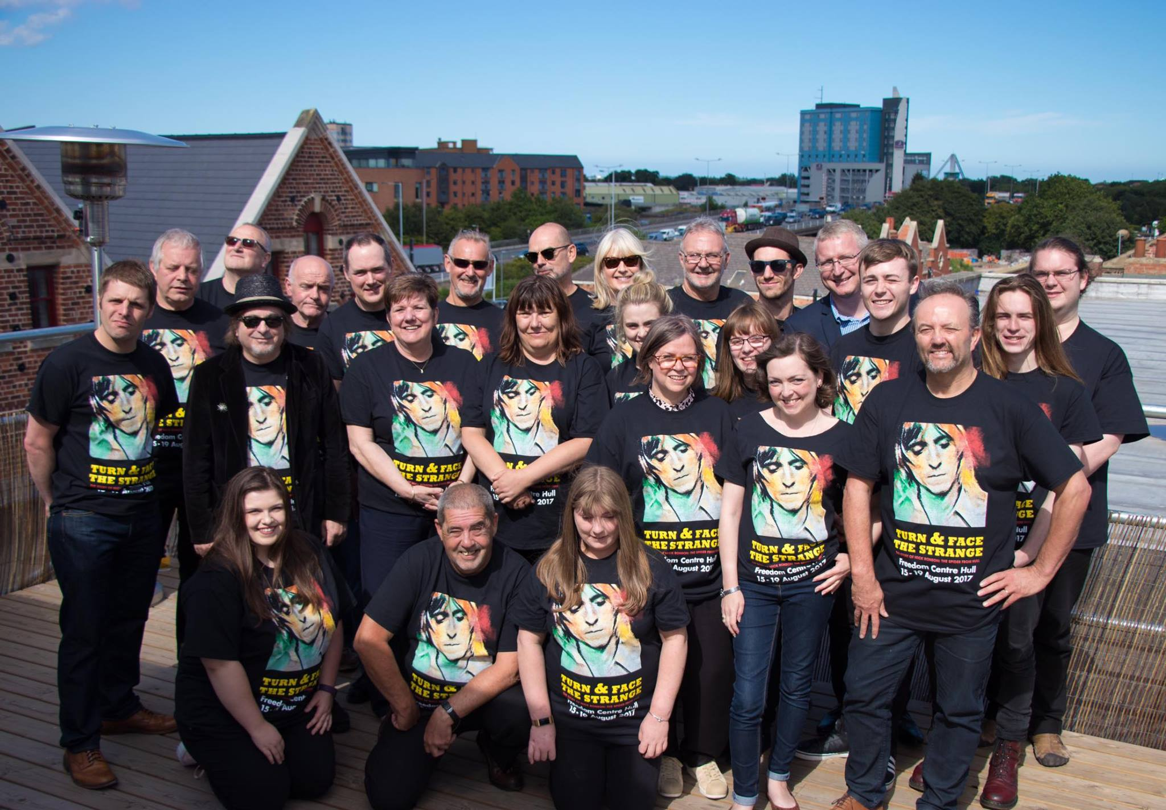

[**Maggi Ronson**](https://www.facebook.com/maggi.ronson?hc_ref=ARQ2h7M4mcLbH3HUlkQqYs6X3TQtIxbV1_BklW2CsI_jX4LMfdXogUbr6bEIDjqUeyo)

Thank you to every single person involved in Turn and face the strange... it would not have happened without everyone's contribution.   
You really did Michael proud!  
Performing in the part of Hull where we grew up with nearly everyone from Hull organizing and taking part to 'make it happen' made the show extra special.   
An amazing experience was had by us all. Thank you for celebrating the life of my very special brother in 'Hulls City of Culture Year' and thank you for dedicating 'Turn and face the strange' to Michaels recently deceased Mum Minnie Ronson who had lived nearly all her life in East Hull.   
Perfect!

[**Ian Brown**](https://www.facebook.com/ianb59?fref=gs&hc_ref=ARQ-KNCKXz6fbfhwsw4r1b2JDFOjd9ebK3zhJiGvPXOD9lX9AcvgU7p1w7ANU1sqKkI&hc_location=group)

But who was Tank Top man? Lol

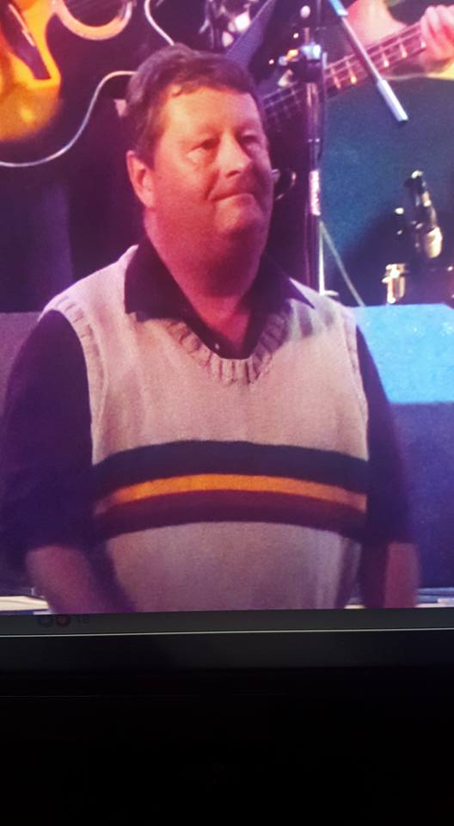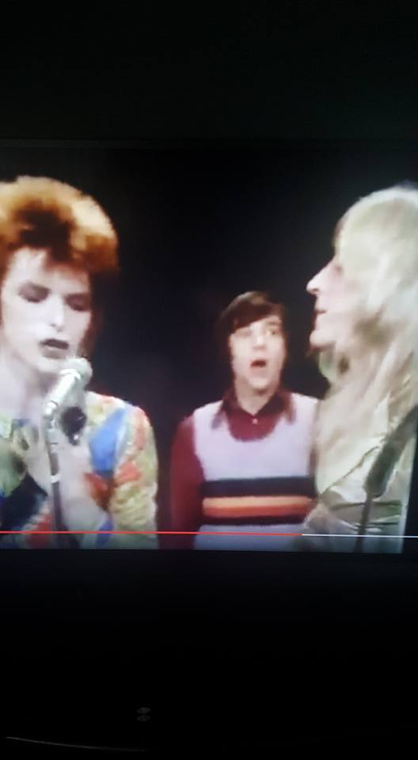

**‎**[**Elizabeth Carter**](https://www.facebook.com/elizabeth.carter.925602?hc_ref=ARRGNMHUKYD3o34YtGtKh_xNsS2kQrulgwlrWMVFiQICEKH5omYRqqf3qGATNSrZigQ&fref=nf)

A brillaint show tonight! Well done to everyone involved. You did Mick proud!! And I got to hold his Guitar. Such an amazing tribute.

The best dudes around to tell it right.  
with the humongous honour to sing in the show.  
And try to bring justice to these songs we all know.  
As I sat on that stage and looked around.  
There were girls sorting lights, and dudes manning sound.  
Volunteers by the bucket were all about.  
And plenty of bar staff dishing beers out.  
An amazing exhibition, that was too cool for school.  
With a painted up scooter to make die hard fans drool.  
We had artists and authors, and fans from abroad.  
Sold out each night just proves Mick was adored.  
A string quartet who didn't put a foot wrong.  
Rachael and Bobby both smashing their song.  
John Bentley on bass who grooved out cool strums.  
And Cambridge was mega, and nailed his drums.  
Mr ched Cheesman my good ole friend.  
Melted my face off with solos no end.  
And of course our narrators who delivered each night.  
They created and wrote, a show out of sight.  
We had super dad dancing with tank top man.  
And at every single show was a number one fan.  
If Iv forgotten anybody, then I need a spanking.  
But I can't forget the lady who had to sign language wanking!!  
I met the lovely Joachim, Ronno's son.  
And singing with Maggie was so much fun.  
All in all it was mega, an amazing time.  
Let's do it again, but next time, more winehttps://static.xx.fbcdn.net/images/emoji.php/v9/feb/1/16/1f377.png