Map Reference | Image | Date damage recorded | Damage recorded | Required Works & preferred contractor | Quote | Comments
1 | 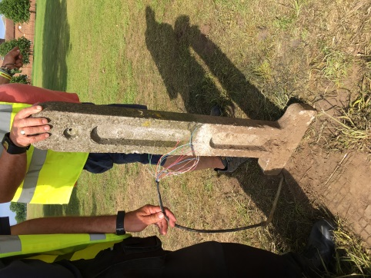  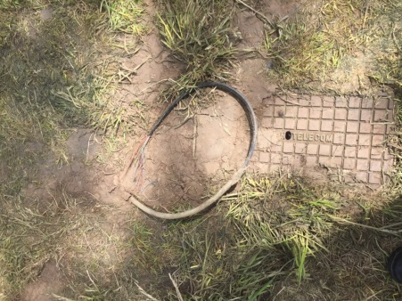 | 27.05.17 | BT line in to the house/house Fire and Burglar alarm system/ cottages/ Tea Room severed and left on the ground with concrete support thrown in fence line | BT | Awaiting report back from BT to see if there is a cost as they are seeing it as wilful damage | Gary (BC) spoke to Mike on Saturday morning via phone to explain this could potentially be a hazard but was easily solved by re locating 4 bins nearby around it – mike said thanks for the solution and it was being sorted but the next time they got there it had been ripped out.
2 | 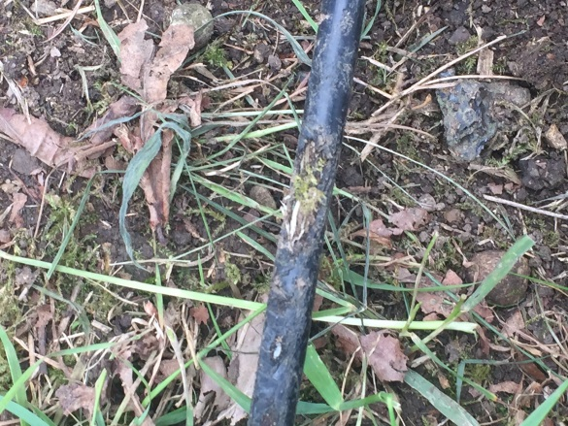 | 01.06.17 | BT line run over and outer casing removed – until the BT engineer visits we are not sure if this will require a full replacement cable | BT | Awaiting report from BT | This cable was clearly marked on the site plan and was situated on the top of the fence the fence was subsequently cut by unknown persons and the cable placed on the floor and driven over
3 & 14 | 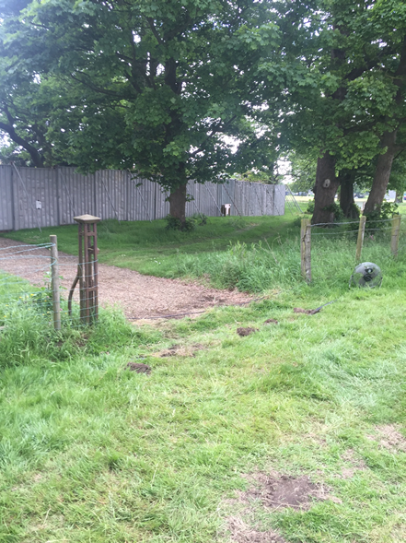 | 01.06.17 | Random panels of fencing just cut out, some have been used as vehicle runs others just for steward access | Roche | Awaiting Quote | Because of the way these have been cut the area cannot be re tensioned at a suitable level for livestock this amounts to about 180m of fencing that needs replacing needlessly
4 | 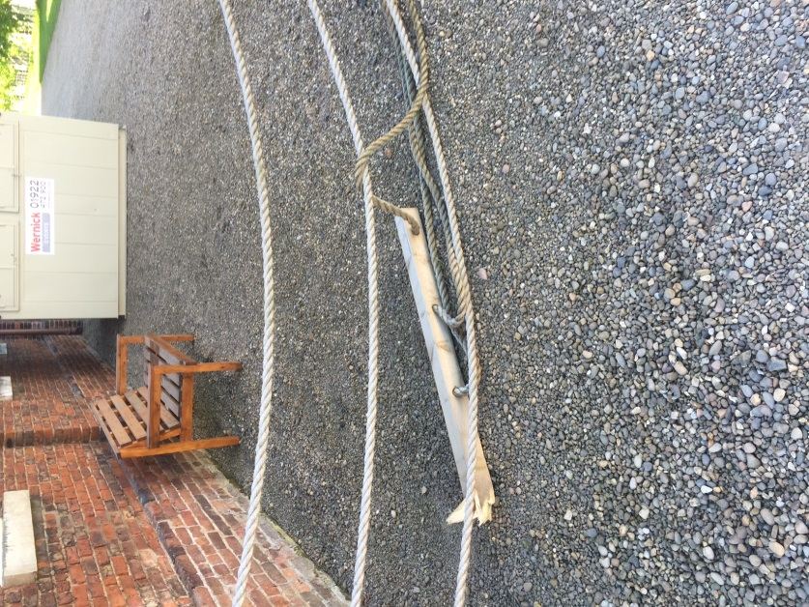 | 01.06.17 | Wooden fence posts snapped off at ground level | BC Estate | Awaiting Quote
5 | 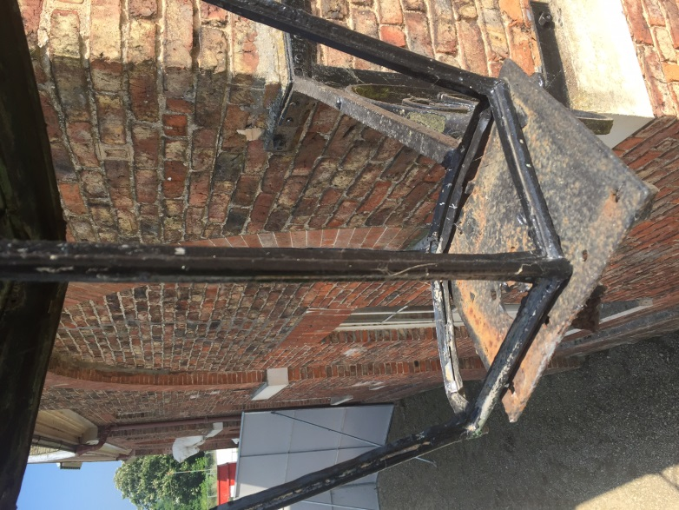 | 25.05.17 | Antique Carriage lamp fitting hit by articulated lorry trailer and knocked off the fittings | BC estate to discuss the matter with the estate blacksmith as the fitting needs re fabricating and the metal fixings replaced.  This fixing has never had glass installed so no need to replace | Awaiting Quote | This was reported to the site office when it happened and Mike has the name of the company that did the damage.
6 | 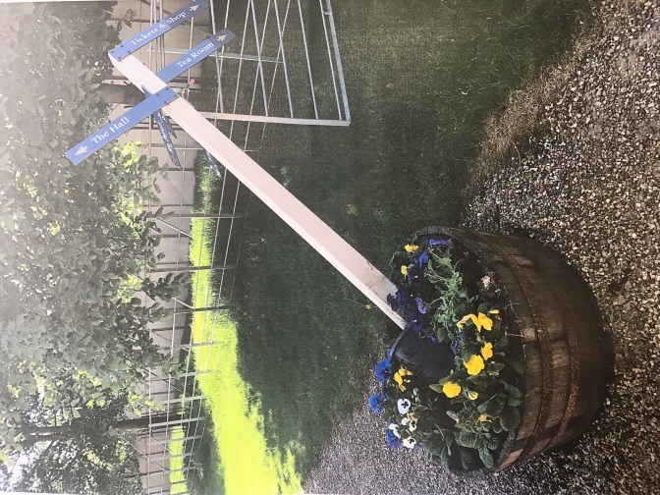 | 01.06.17 | Planter in front of the café (no vehicle area) crashed into at speed by a buggy | BC Estate – emptying, concrete re setting and re planting  Signpost repair | Awaiting quote from BC re planting re setting  Signage company re Finger post arms
7 |  | 25.05.17 | Car park membrane and surface badly damaged due to being used as a bone yard for large amounts of trackway stock. | Roche - Awaiting cost | Awaiting Quote | This was only laid this year ago at a price of £12,000  BC staff had to stop trucks spinning wheels in this area and creating further damage
8 | 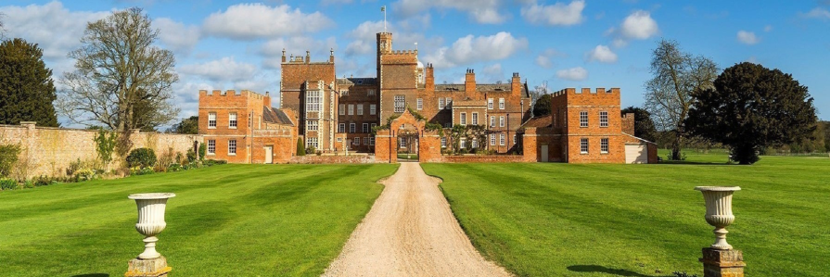 | 25.05.17 | Ornamental Urns and bases removed for Guest area | BC – Staff time cost to replace and build brick plinths | Awaiting cost
9 |  | 25.05.17 | Blocked drain due to lorries digging up the shale | HT Speaking to East Riding council re use of gulley sucker | F.O.C hopefully
10 | 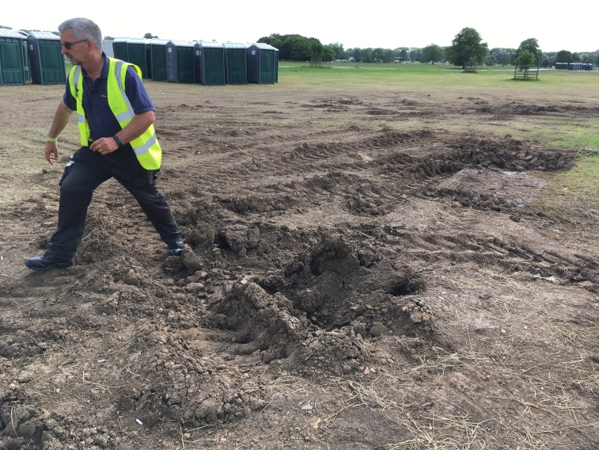  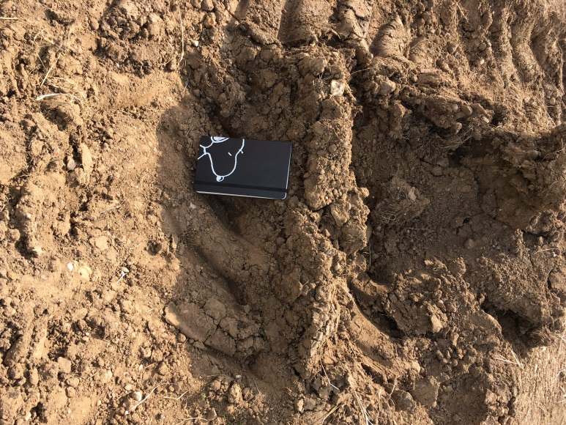 | 24.05.17 | 10 x 10 metre area to the south side of the Red stage deeply rutted and in need of being re seeded.  Dick T explained that exactly the same thing happened last year with this contractor and his instruction had been to lay trackway for 2017  A contractor twice flattened the area only for the work to be undone and further damaged on pull out | BC – add top soil and re seed.  BC staff time cost | Awaiting Quote
11 | 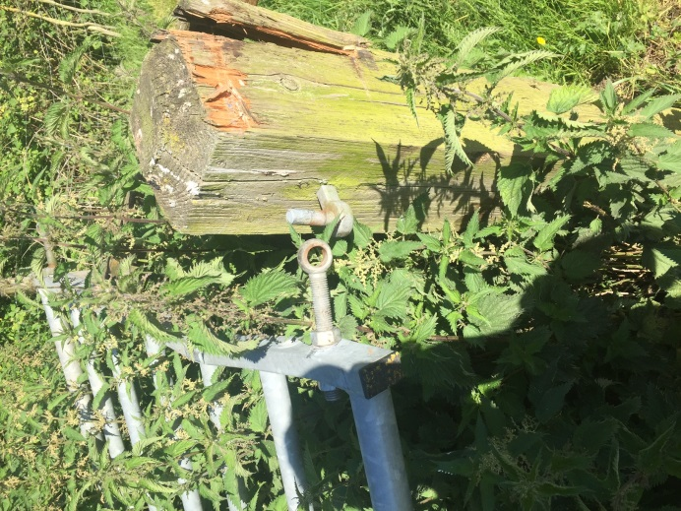  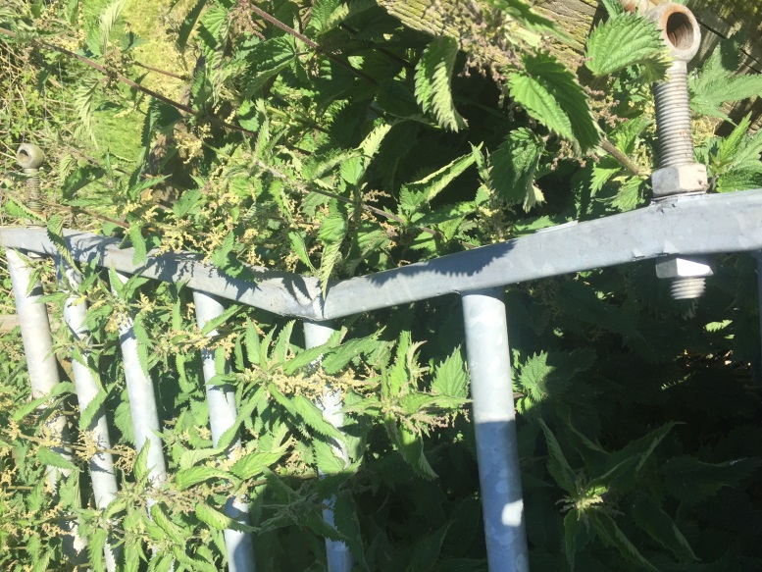 | 01.06.17 | Metal cattle gate completely taken off the hinges and bent so that it is no longer fit for purpose. The gate was thrown into the hedgerow and not reported till found by a member of BC staff.  Fence post knocked out of fittings and needs replacing | BC/Roche? | TBC
12 | 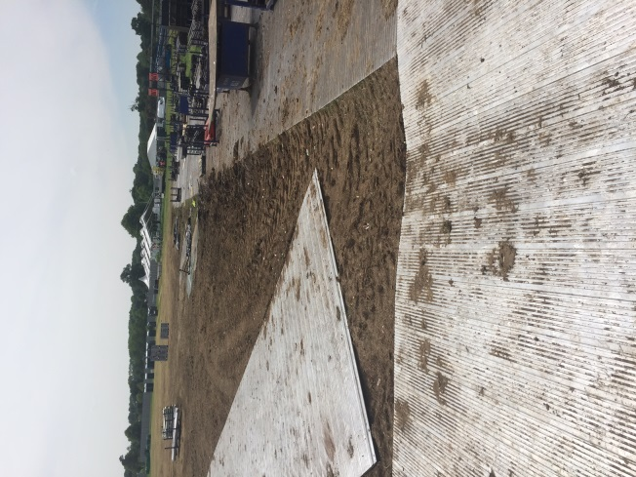   | 01.06.17 | Poor use of Trackway In front of Main Stage resulting in significant rutting  Nick witnessed crews on de rig doing circular turns to the side of the trackway pads on de rig | BC ground staff to review at meeting with Natural England
13 | 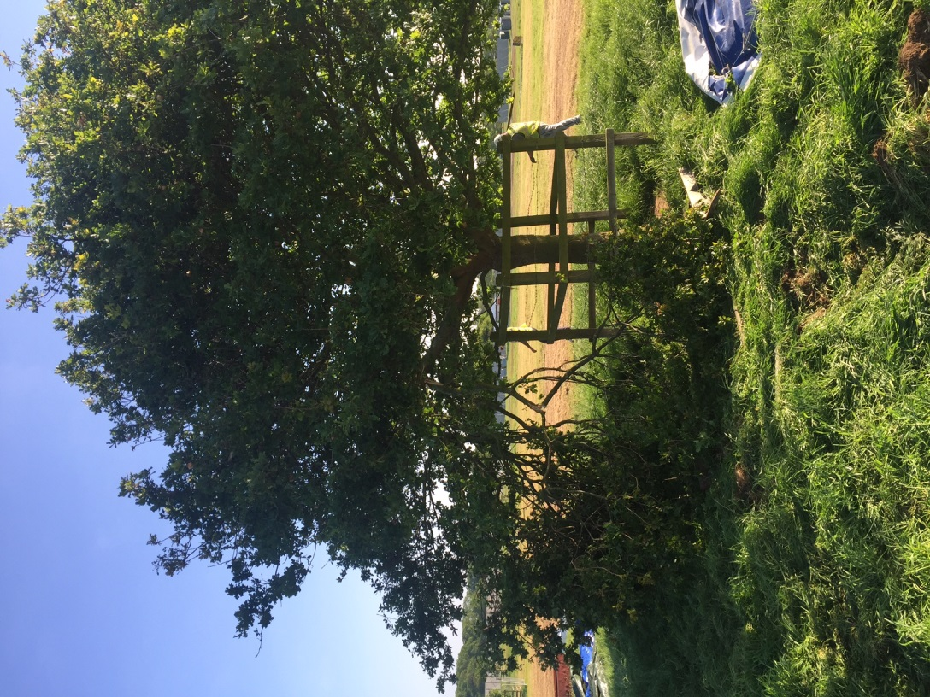 | 01.06.17 | Support from the red tent stage dropped on the Air crash memorial tree breaking off a significant branch  Mike reported this as soon as it happened | BC Staff to remove branch | Damage noted and reported
14 | See point 3 for details
15 | 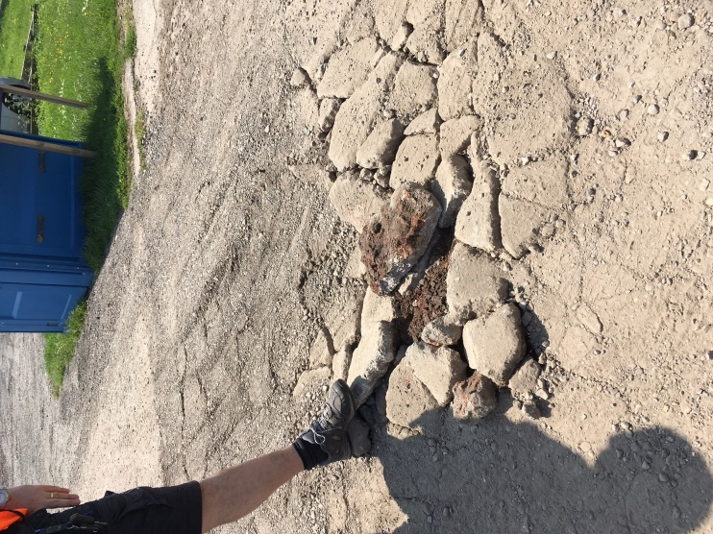 | 27.05.17 | Concrete slope into second car park smashed in a 5 x 5m area | Roche supplying quote whole area needs digging up and re laying | Awaiting Quote | Mike aware
16 |  | 01.06.17 | Blue toilet waste left in the grass | After inspection already fading clean water no waste matter | Complete
17 |  | 01.06.17 | 8 x holes in the main front lawn that have been caused by the stabiliser legs for the guest cabin | BC – top soil fill required | BC Staff time
18 | 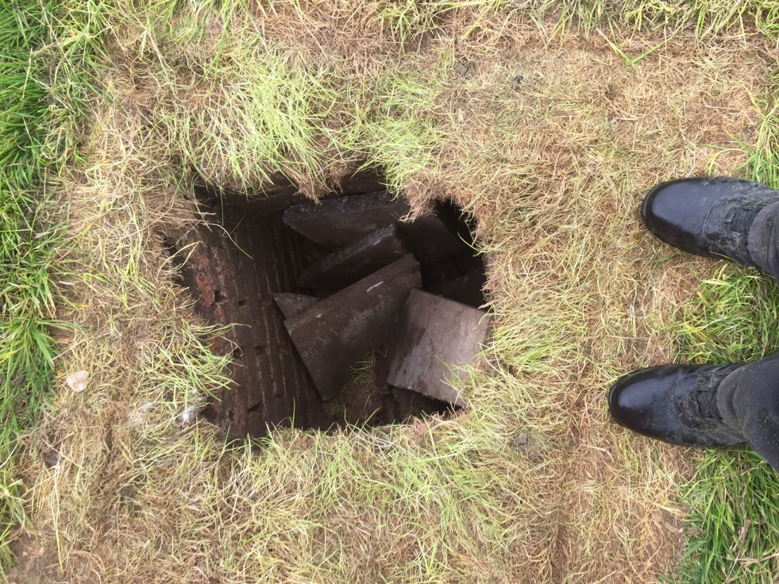 | 01.06.17 | Concrete man hole cover broken by teleporter during the de rig of the main walkway area | Roche | Awaiting Quote
19 |  | 01.06.17 | Front drive cattle grid need some small welding repairs due to articulated lorry driving over restricted route | Black smith / Roche fence welder | Awaiting Quote | This is the lorry that had to be turned whilst we were at the table top event at the hall
20 | 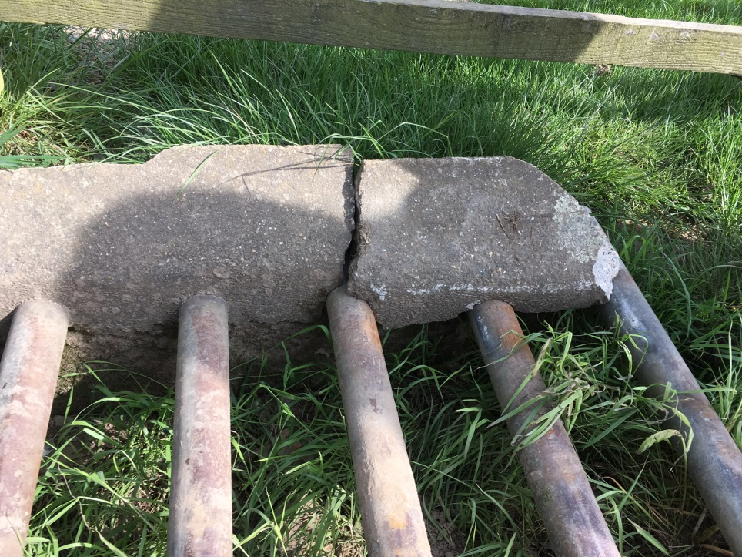 | 01.06.17 | Cattle grid footings broken due to late laying of trackway panel | Roche/BC? | Awaiting Quote
21 | 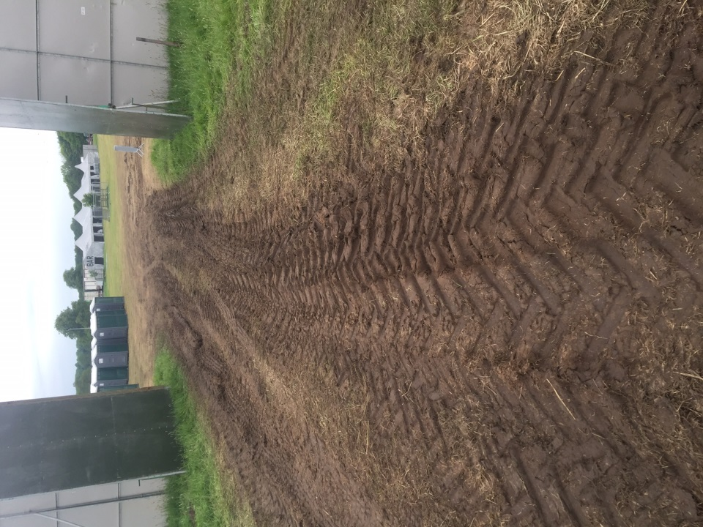  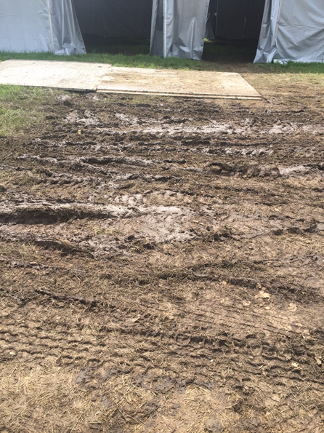 | 01.06.17 | Vehicles not using trackway entry’s | BC ground staff to review at meeting with Natural England
22 |  | 01.06.17 | Production B exit ramp melting and breaking up  In the worst area the delve is 3 inches deep. | Roche | Awaiting Quote
23 | 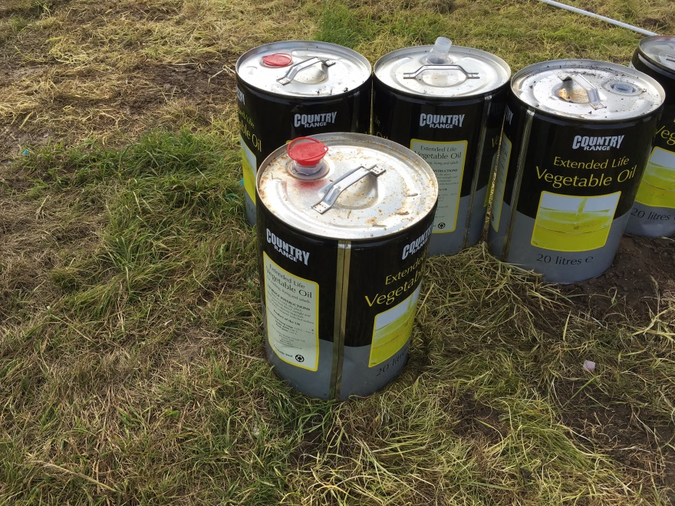  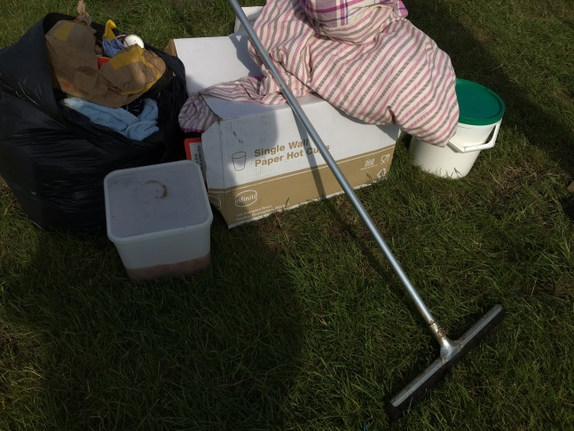  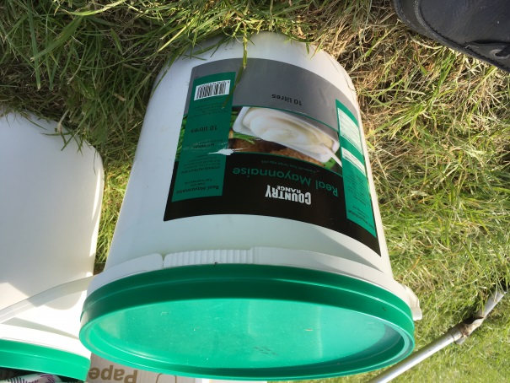 | 01.06.17 | Catering waste including oil left to the rear of the staff catering area – including mayonnaise that had been left in the sun and is rancid | Cleansing team final clean Sunday/Monday | Final inspection Tuesday | Noted not one catering unit had left waste only BBC catering

