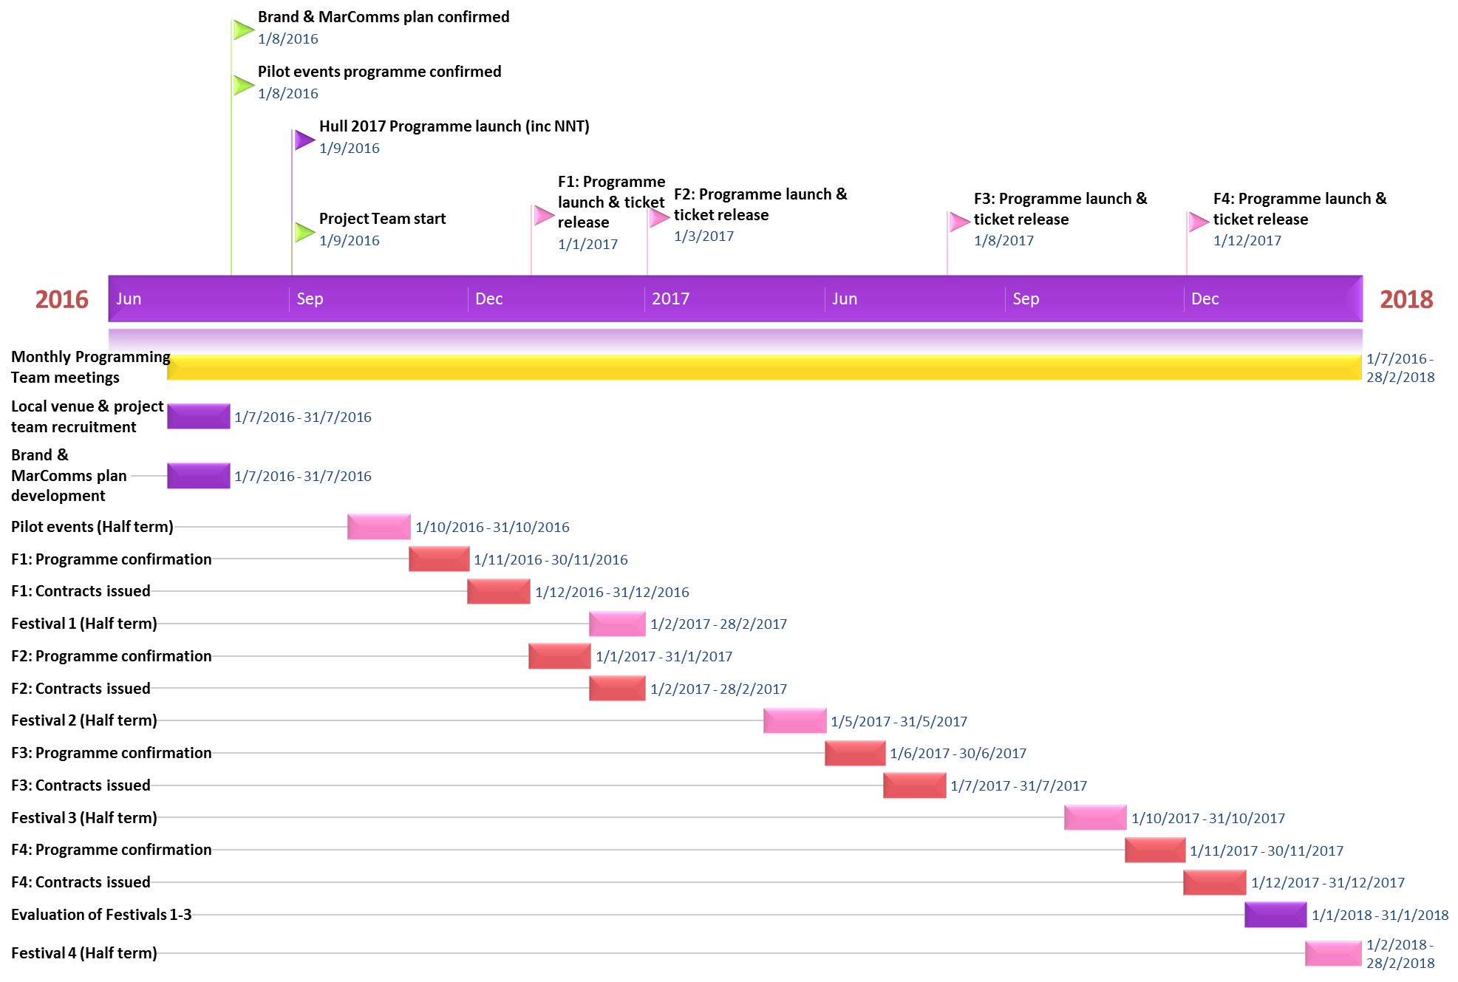

**NETWORK NEIGHBOURHOOD TOURING**