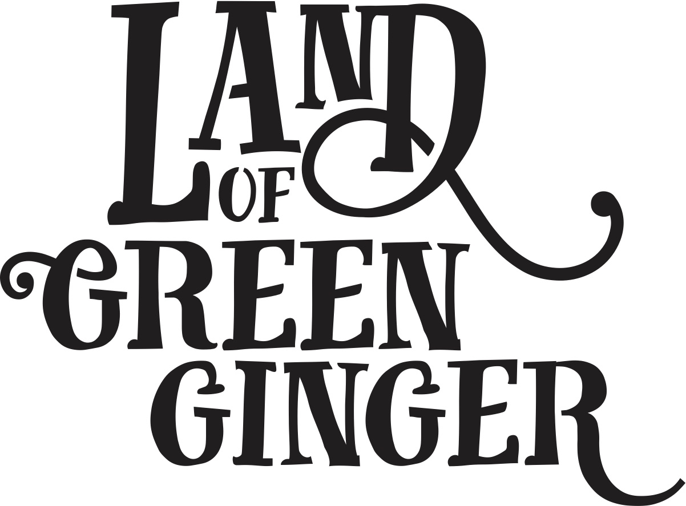

**PRESS RELEASE**

* The seventh act of wanton wonder, this book tells the stories of the mysterious Land of Green Ginger and the stories of the local people it touched. It is a record of Hull UK City of Culture 2017 as lived by the residents of the city and as informed by their imagination and creativity.
* Throughout the year Hull 2017’s ground-breaking community engagement project, Land of Green Ginger, invited Hull’s residents to immerse themselves in a magical citywide story, inspired by and celebrating the spirit of Hull.
* Limited edition print which will be sent out to schools and households in Hull. One per household
* Line about illustrator Katy Riddell and Big Malarkey festival?
* Include a line about not reselling the book?
* For more information please see website here:

**WEBSITE FAQS**

1. **When will I receive my copy of the LOGG book?**  
   Books will be delivered to all households within the Hull boundary between the 15th and 22nd June 2018
2. **Where can I buy a Land of Green Ginger Book?**  
   Books are limited edition. One per household in Hull. Books are not available to purchase separately.  
   L*and of Green Ginger Merchandise will be available at The Big Malarkey Festival 23rd – 24th June at East Park* ??
3. **Why did I receive the Land of Green Ginger Book?**

For the seventh act of wanton wonder from the Land of Green Ginger, limited edition books are being delivered to every single household in Hull.

1. **Why wasn’t a Land of Green Ginger Book delivered to my house?**Households outside the Hull catchment area are not eligible for a copy of the book.
2. **How can I get another copy of the Land of Green Ginger Book?**Books are limited edition. One per household in Hull. Books are not available to purchase separately.
3. **I don’t want to keep my copy of the Land of Green Ginger Book, how can I return it?**
4. **Why hasn’t my school received a crate from the Land of Green Ginger?**

**TEAM INBOX**

If you are getting in touch with a query about the Land of Green Ginger’s latest act of Wanton Wonder, please refer to the FAQs found on our website here:

**TIMELINE**

|  |  |
| --- | --- |
| 15/06/2018 | Announcement of the books arriving at Hull household |
| 15/06/2018 | Twitter announcement that Katy is the LOGG illustrator |
| 15/06/2018 | Press release to reference live drawing by LOGG illustrator Katy Riddell at Big Malarkey Festival Saturday 23rd and Sunday 24th June  **Q&A with Katy and Chris Riddell**  **10am, Sunday 24 June**  Illustrator, Katy Riddell speaks about her work to date in this engaging conversation with her father - award winning illustrator, Chris Riddell. Since graduating from Manchester Metropolitan University with a BA Hons in Illustration and Animation, Katy has worked on a number of commissions including *Pongwiffy* by Kaye Umansky, *Midnight Feasting*by A.F. Harold and *Ever After*at the Oxford Story Museum. Katy has most recently been working on an exciting project for Hull, which will be announced just before the festival. Come along to find out more!   **Illustrating Workshop with Katy Riddell**  **11am, Sunday 24 June**  **Ages 7-12**  Join Katy Riddell in an interactive illustrating workshop, inspired by her most recent project. In this 45 minute drop-in session Katy will give participants the opportunity to learn how to work closely with a story to bring its characters and settings to life. |