

**Where Do We Go From Here?**

**Volunteer Briefing Pack**

**1. Introduction**

Thank you for volunteering for Where Do We Go From Here? An exciting installation that will bring light and life to the Old Town through December and into the first week of January. Your role as a Where Do We Go From Here volunteer is crucial to the success of the project!

There are three important elements to your role as a Where Do We Go from Here volunteer:

1. **Wayfinding and directing visitors to the installation sites**
2. **Hosting visitors, providing information & explaining what the installation is about**
3. **Initiating a conversation and gaining responses to the question ‘Where Do We Go From Here?**

These briefing notes will prepare you with all the essential information you need to know in advance of your shift.

If you have any more questions you can speak to the Where Do We Go From Here Team from Hull 2017 when you see us during your shift!

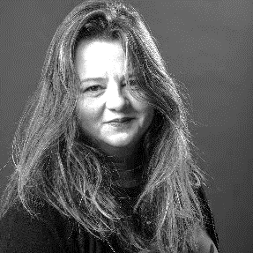 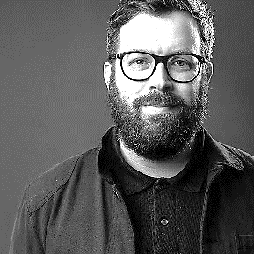 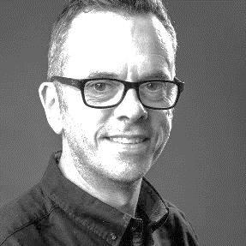

Niccy Hallifax Sam Hunt Chris Clay

**Executive Producer Executive Producer Technical Director**

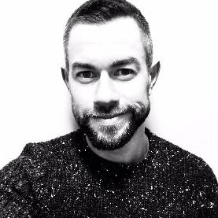 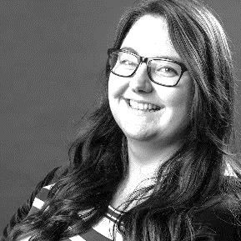 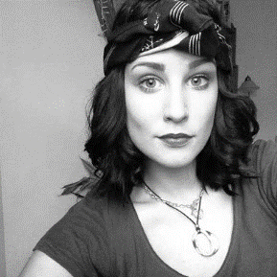

Haitham Ridha Laura Beddows Kate West

**Event Manager Event Manager Trinity Market Curator**

***We look forward to working with you!***

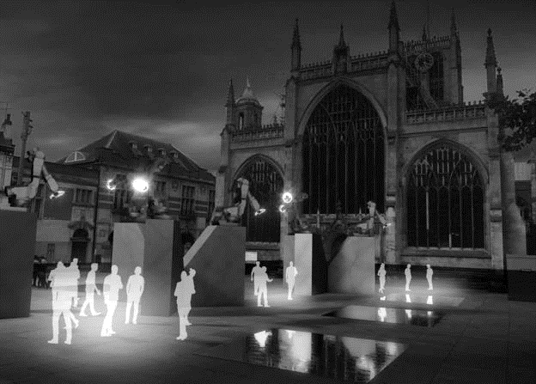**2. What is Where Do We Go from Here?**

Where Do We Go from Here? is a ground-breaking kinetic artwork created by the

award-winning Jason Bruges Studio that uses light, robotics and sound to create a unique immersive experience in the streets of Hull's historic Old Town, one that also asks questions of the viewer.

The scale of Jason Bruges Studio's artwork set against the medieval layout of Hull's streets creates a visually stunning piece of art unlike anything ever seen in a public space before. It is designed to build on Hull's reputation as a place where the surprising happens and globally significant art is commissioned and displayed.

Placed on specially created plinths, the robots throw, reflect and exchange light, illuminating familiar, overlooked and unexpected corners of Hull's night-time streets, creating a new urban journey, of spectacle and discovery. As Hull heads into 2018 following a momentous year for the city, Where Do We Go from Here? propels us into a future that is as yet unknown, but full of possibility.

Jason Bruges Studio's thrilling mix of art and technology embodies key themes for Hull as it reflects on an extraordinary year of change, not just for the city, but globally. At a time of political uncertainty at home and abroad, it also asks important questions: What kind of place do we want to live in? What role should culture play? Where do we go from here?

The title of the commission, Where Do We Go From Here?, is a deliberate provocation designed to get individuals reflecting upon their city's future. It invites everyone to take part in a timely conversation about art, culture and society. With robotics at its heart, Where Do We Go From Here? also speaks to the ambitions of the city as technology and innovation supersede old industries to meet the demands of the 21st century.

*Where Do We Go From Here? runs daily from 1 Dec to 7 Jan (excl. 25 & 26 Dec) from 17:00 to 21:00.*

**3. The Installation Sites**

There are four main installation sites across the Old Town – Beverley Gate, Trinity Square, Museum Quarter and Wilberforce House:

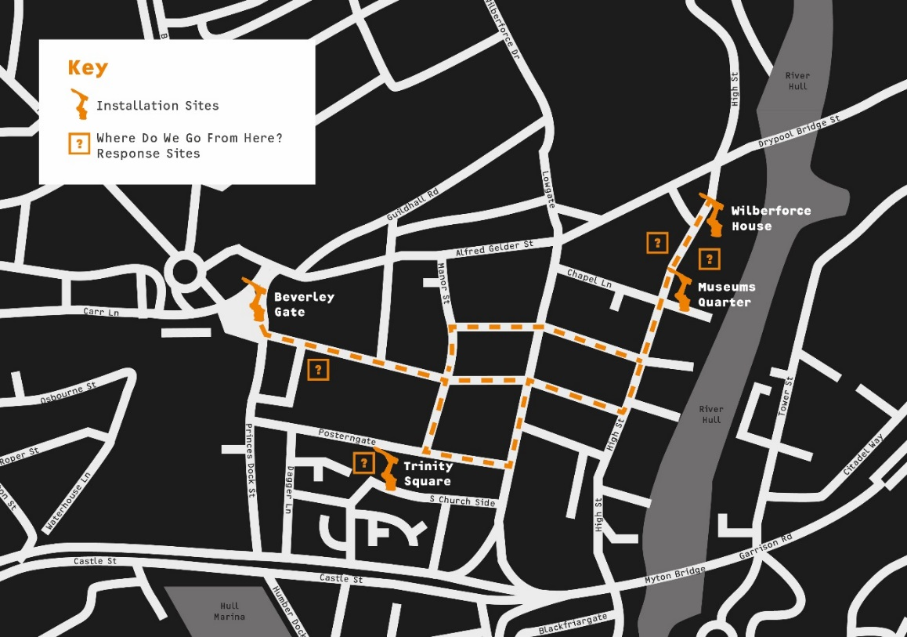

**The Gatekeepers – Beverley Gate**

Marking Beverley Gate, the historic entrance to the city, now Hull's Old Town, the six gatekeeper robots have been designed to draw in visitors with light signals close to the waters of Princes Quay and visible from Queen Victoria Square and Whitefriargate. This installation was designed specifically for this location, because of its historical significance. Taking inspiration from navigation beacons and maritime signaling devices, the robots are a modern interpretation of them, which communicate and act as an entrance to the other installations around the Old Town.

**An Inquisitive Acquaintance – Trinity Square**

Trinity Square has historically been an important public space in Hull's Old Town and has recently been extensively redeveloped, enhancing it as a key destination in the heart of the city. The nine robots here present a choreographed performance composed of light and sound, which is focused at the audience. It is a playful encounter that encourages the viewer to explore the relationship between the light and sound, the square's reflecting pools and the architecture around it. You are encouraged to pass between the plinths and ponder the question: *Where do we go from here?*

**Collaboration – Museum Quarter**

In the garden setting of the Streetlife Museum, five robots awaken from their old factory mode to perform together and demonstrate intelligence through collaboration. The robots will pass light beams between each other and form large moving objects in space. This piece is fast and dynamic and is best viewed from a distance.

**Conversation - Wilberforce House**

Curiously hidden behind the walls of the enclosed garden at the entrance to Wilberforce House, a conversation between a robot and Wilberforce plays out. Peeking through the gate, or catching glimpses of the robot revealing itself above the wall, the audience can observe the gesturing that is created through light and shadow. At a site of historical significance, to Hull and the nation, this reflective piece asks the question: *Where do we go from here*?

**4. The Where Do We Go From Here Artist – Jason Bruges Studio**

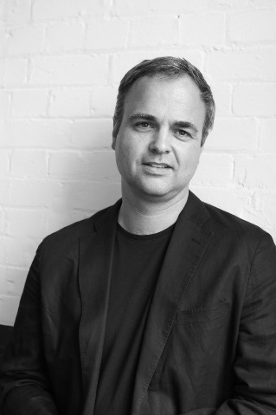

Jason Bruges Studio has become internationally renowned for producing innovative installations, interventions and ground breaking works. This practice involves creating interactive spaces and surfaces that sit between the world of architecture, site specific installation art and interaction design. Considered a pioneer of this hybrid in-between space, Jason has subsequently paved the way for a new genre of design studios, artists and designer-makers.

He is passionate about creating site-specific pieces that engage people with their environments. Jason Bruges trained as an architect at Oxford Brookes University and the Bartlett School of Architecture, (UCL). He worked with Foster + Partners for three years before moving to Imagination to become a Senior Interaction Designer.

In 2002 Jason set up his own practice and now works with a talented team of people to develop and deliver interactive projects worldwide. The studio comprises of an experienced team of architects, artists, lighting designers, industrial designers and visualisers as well as specialists in electronics, programming and project management.

**5. Interaction with the Public**

A crucial element of the installation and an important part of your role as a support volunteer is to interact with visitors and collate responses to the question ‘Where Do We Go From Here?’

In order to obtain worthwhile responses we must first facilitate a conversation.

**5.1 What is facilitation?**

To facilitate is defined by the Oxford Dictionary as ‘Make (an action or process) easy or easier’. Thus, facilitation in the context of ‘Where Do We Go From Here?’ is to help stimulate and manage the conversation with members of the public visiting the event. You will guide people in discussing the question ‘Where Do We Go From Here?’, determining what this question means to different individuals, and aiming to maximize their time and energy by keeping the conversation about this topic on track.

As a facilitator your role will also be to encourage as many different types of people to participate in some way, shape, or form. This includes approaching people of different ages, genders, backgrounds, and abilities. In doing so, you will help ensure that we get to hear as many voices as possible in the stories and opinions coming back.

**5.2 Top tips for effective facilitation:**

To be a good facilitator, please keep in mind the following when speaking to individuals:

**Value people and their ideas:** The question ‘Where Do We Go From Here?’ is likely to mean different things to different people, and we’re interested to hear all of these ideas.

**Be objective:** Although you may have your own opinion on the question, your role at the event is as a facilitator. This means you should take a neutral stance, remove your own personal views from the discussion, and focus on gathering as much information from the individual / group about their thoughts as you can.

**Think quickly and logically:** To explore individuals’ thoughts and ideas effectively, it is important to respond with open-ended questions, encouraging people to provide clarification, give reasons for what they say, and think about their role in achieving their ideas in the future.

**Communicate clearly:** try to only ask one question at a time and use simple English to make the conversation as easy and accessible as possible.

**Be prepared:** before starting your shift for ‘Where Do We Go From Here?’ think about the “who, what, why, and where” of the event, i.e. who will you be interviewing; what will you be talking about; why are you talking about it; and where will the conversations take place? Practice with members of your family, friends, and other volunteers to get into the habit of talking about this question, understanding different viewpoints, and thinking on the spot.

|  |  |
| --- | --- |
| GOOD PRACTICE | BAD PRACTICE |
| Introduces themselves  Speaks slowly  Gives interviewee good attention  Makes eye contact  Asks open-ended questions  Values answers given by interviewee  Explore answers in further detail  Talks clearly  Keeps questions focused | Acting like they’re ticking off a list  Speaking quickly  Question wording is complicated  Little eye contact made  Uses mainly closed questions  Distracted  Challenges interviewee’s answers  Doesn’t explore reasons for answers  Gives examples of other interviewee answers – this is “leading”, i.e. other opinions are used to influence the way someone answers |

**5.3 Open-ended questions vs. closed-ended questions**

An open-ended question is designed to encourage a full, meaningful answer using the subject's own knowledge and/or feelings. Open-ended questions tend to be more objective and less leading than closed-ended questions.

Open-ended questions typically begin with words such as "Why" and "How", or phrases such as "Tell me about...". Often they are not technically a question, but a statement which implicitly asks for a response.

Closed-ended questions can be answered with “Yes” or “No,” or they have a limited set of possible answers.

**DO** use OPEN-ENDED QUESTIONS

**AVOID** using CLOSED-ENDED QUESTIONS

**5.4 Guide to facilitating ‘Where Do We Go From Here?’**

In terms of facilitating conversations for ‘Where Do We Go From Here?’ aim to think about following a simple four-step process:

**CONTEXT:** “Tell me what the question ‘Where Do We Go From Here?’ means to you?”

**OPINION:** “So, based on your understanding of the question, ‘Where Do We Go From Here?”

**REASONS:** “I’m interested in what you said about [x], can you tell me more about why you think that?

**NEXT STEPS:** “How do you think that we can get to that point?” and / or  
“What will you do to make that happen?”

**5.5 Feeding back**

The map below shows ‘Response Sites’ where we collect answers to the ‘Where Do We Go From Here?’ question. On the official ‘Where Do We Go From Here’ Map, there is a tear off slip where visitors can write their responses and then post through the letterbox on the door of the former Lush building on Whitefrigate. In the Museum Quarter there will be a stock of paper tags where people can write their responses to the question and tie these to railings around the installation, these will then be collected at the end of every shift. On the High Street opposite the Museum Quarter there will be an outdoor blackboard where visitors will be encouraged to write their responses to the question. iPads will also be used to collect answers on the High Street and at Trinity Square.

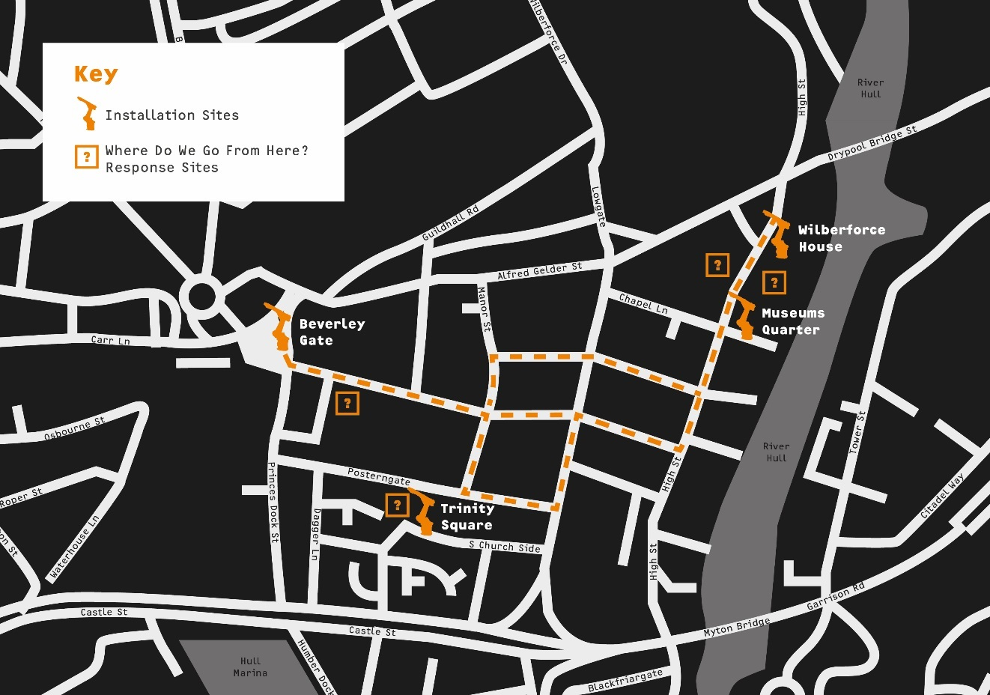

At the end of your shift you will return to the Volunteer base and here you will find a ‘Download Zone’. A variety of feedback methods will be provided in this zone, so that we can get a sense of the conversations you had with members of the public during your shift. You may find it useful to carry a notebook with you during you shift to note down some reminders.

The feedback methods provided will include:

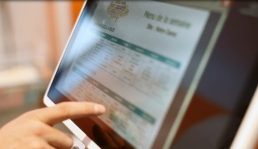

- iPads, loaded with a short Survey Monkey questionnaire

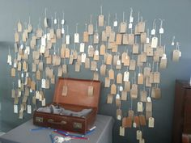

- Feedback wall



- Dictaphone / iPad, to provide a verbal digest

To support the feedback task, we’ll provide some prompt cards in the zone (with a series of questions) to aid your recall.

**6. Shift Information**

**6.1 Volunteer Base**

The volunteer base will be in the former Argos building, King William House, Market Place, Hull, HU1 1RS

This is the meeting point for all shifts where briefings will take place and meal packs will be distributed. Toilets are available in the building and there will be somewhere safe to leave bags.

You are welcome to use the base during your breaks and hot drinks will be available throughout.

**6.2 Shift Locations**

There are designated points across the Old Town where we would like volunteers to be positioned.

These include at the four installation sites – Beverley Gate, Trinity Square, Museum Quarter and Wilberforce House. There will also be volunteers positioned at response sites on Whitefrigate and the High Street, and wayfinding positions on the main routes through the old town on Silver Street and Bishops Lane.

During your four-hour shift, the intention is that you will move around the sites, and the plan for this will be agreed during the briefing at the start of your shift.

**6.3 Shift Times and breaks**

The shifts are the same for the full period from 1 December to 7 January. Report time at the former Argos building is 16:30 where a briefing will take place, and route positioning and break times will be agreed. The installation finishes at 21:00 each night when all volunteers should return to the Argos building to sign out and to record any feedback received.

**And finally…**

As 2017 comes to a close, we hope you enjoy being involved in one of the most exciting and thought-provoking additions to the Hull UK City of Culture Programme, at a time when we all start to consider **Where Do We Go From Here?**

