Appendix 14:
Walk and Talk Group Analysis

  - Introduction
The aim of the CCT to generate an emotional response in audiences for ‘Made in Hull’ inspired an additional piece of audience research during the live delivery of the event from 1-7 January 2017.
    - Methodology
In order to capture emotional response to the event, live as audiences were experiencing it, a series of five ‘Walk and Talk’ groups took place.
The pre-recruited groups of Hull and East Riding residents on the final two nights of the event were recruited by fieldwork agency, Information by Design (IbyD). They recruited participants using contact details provided within the Citywide Residents Survey 2016 and baseline research undertaken by Hull 2017 in 2016. All individuals who had provided permission to be contacted about further research were contacted and ask to complete a screener survey, to ensure a mix of post code areas, ages, genders and participation levels in arts and culture, and representation of those self-identifying as disabled.
The five groups were as follows:
- Guided Tour with local historian Paul Schofield (Wednesday 4 January, 6pm): researchers joined a pre-booked guided group tour of ‘Made in Hull’ by Paul Schofield. 8 individuals took part in the research.
- Guided Tour with writer Rupert Creed (Thursday 5 January, 4pm): researchers joined a pre-booked guided group tour of ‘Made in Hull’ by Rupert Creed with staff from some of Hull 2017’s partners (East Riding of Yorkshire Council, Yorkshire Water and KWL). 10 individuals took part in the research.
- Hull Residents - 55+ years (Friday 6 January, 5pm): researchers led a pre-recruited group of Hull residents aged over 55 years. 10 individuals took part in the research, and represented a mix of Hull post code areas.
- Hull Residents – 16 to 54 years (Saturday 7 January, 4pm): researchers led a pre-recruited group of Hull residents aged 16-54 years. 12 individuals took part in the research, and represented a mix of Hull post code areas.
- East Riding Residents (Saturday 7 January, 6pm): researchers led a pre-recruited group of East Riding residents. 13 individuals took part in the research, and represented a mix of Hull post code areas.
The ‘Walk and Talk’ groups involved a mixed research methodology:
- Smartphone Survey: a short and simple quantitative survey was developed to capture participants’ demographic information, and their emotional response to each of the installations visited. The survey focused on Robert Plutchik's theory of eight primary bipolar emotions - joy (happiness) versus sadness; anger versus fear; trust versus disgust; and surprise versus anticipation. At each installation participants were asked to select which installation they were witnessing, and to then pick anything from 1 to 8 emotions to share how they felt during the experience. A template of the Smartphone Survey is provided as Appendix 15.
- Vox pop style interviews: in-between each installation the two researchers accompanying the group recorded short vox pop style interviews with participants to explore participants’ emotional response in more depth.
  - Respondent Profile
    - Demographic Profile
In order to take part in the Smartphone Survey, participants were asked to complete some basic demographic information.
A total of 53 participants took part in the Smartphone Survey. The tables below provide a breakdown of the post code areas covered by all participants and broken down by group. This shows a good spread of representation across both Hull and East Riding residents.
HU2 was the only post code area in Hull not represented amongst participants, with HU5 and HU6 having the highest proportion of representation.
When looking at the composition of each group:
- The guided tour with Paul Schofield was almost exclusively made up of East Riding residents;
- The guided tour of partner staff with Rupert Creed was evenly split between Hull and East Riding residents, with a good spread of post code areas represented in each local authority area;
- Within each of the pre-recruited Hull resident groups there was a good spread of Hull post code areas in each of the two groups – HU6 being most highly represented in the 55+ years group, and HU5 in the 16-54 years group;
- Within the pre-recruited East Riding resident group, there was a good spread of post code areas represented.
Table X: Post Codes of Participants
POST CODE AREA | NAME OF AREA | NO. OF PARTICIPANTS
HU1 | Hull City Centre | 2
HU3 | Hull, Spring Bank | 2
HU4 | Hull, Anlaby Common, Anlaby Park, Gipsyville | 4
HU5 | Hull, The Avenues | 7
HU6 | Hull, Dunswell, Orchard Park, Greenwood | 6
HU7 | Hull, Bransholme, Kingswood, Sutton-on-Hull, Wawne | 3
HU8 | Hull, Garden Village, Ings, Longhill, Sutton-on-Hull | 2
HU9 | Hull, Drypool, Victoria Dock, Marfleet, Preston Road, Greatfiled, Bilton Grange | 2
HU10 | Anlaby, Kirk Ella, West Ella, Willerby | 6
HU13 | Hessle | 5
HU15 | Brough | 3
HU16 | Cottingham | 4
HU17 | Beverley | 5
DN14 | Goole | 2

Table X: Post Codes of Participants by Group
GROUP | POST CODE AREA | NAME OF AREA | NO. OF PARTICIPANTS
Guided Tour  Paul Schofield  Wednesday 4 January | HU6 | Hull, Dunswell, Orchard Park, Greenwood | 1
Guided Tour  Paul Schofield  Wednesday 4 January | HU10 | Anlaby, Kirk Ella, West Ella, Willerby | 1
Guided Tour  Paul Schofield  Wednesday 4 January | HU13 | Hessle | 2
Guided Tour  Paul Schofield  Wednesday 4 January | HU17 | Beverley | 3
Guided Tour  Paul Schofield  Wednesday 4 January | DN14 | Goole | 1
Guided Tour  Rupert Creed  Thursday 5 January | HU4 | Hull, Anlaby Common, Anlaby Park, Gipsyville | 2
Guided Tour  Rupert Creed  Thursday 5 January | HU5 | Hull, The Avenues | 2
Guided Tour  Rupert Creed  Thursday 5 January | HU7 | Hull, Bransholme, Kingswood, Sutton-on-Hull, Wawne | 1
Guided Tour  Rupert Creed  Thursday 5 January | HU10 | Anlaby, Kirk Ella, West Ella, Willerby | 2
Guided Tour  Rupert Creed  Thursday 5 January | HU16 | Cottingham | 1
Guided Tour  Rupert Creed  Thursday 5 January | HU17 | Beverley | 2
Hull Residents  55+years  Friday 6 January | HU1 | Hull City Centre | 1
Hull Residents  55+years  Friday 6 January | HU3 | Hull, Spring Bank | 1
Hull Residents  55+years  Friday 6 January | HU5 | Hull, The Avenues | 2
Hull Residents  55+years  Friday 6 January | HU6 | Hull, Dunswell, Orchard Park, Greenwood | 3
Hull Residents  55+years  Friday 6 January | HU7 | Hull, Bransholme, Kingswood, Sutton-on-Hull, Wawne | 2
Hull Residents  55+years  Friday 6 January | HU8 | Hull, Garden Village, Ings, Longhill, Sutton-on-Hull | 1

GROUP | POST CODE AREA | NAME OF AREA | NO. OF PARTICIPANTS
Hull Residents  15 – 64 years  Saturday 7 January | HU1 | Hull City Centre | 1
Hull Residents  15 – 64 years  Saturday 7 January | HU3 | Hull, Spring Bank | 1
Hull Residents  15 – 64 years  Saturday 7 January | HU4 | Hull, Anlaby Common, Anlaby Park, Gipsyville | 2
Hull Residents  15 – 64 years  Saturday 7 January | HU5 | Hull, The Avenues | 3
Hull Residents  15 – 64 years  Saturday 7 January | HU6 | Hull, Dunswell, Orchard Park, Greenwood | 2
Hull Residents  15 – 64 years  Saturday 7 January | HU8 | Hull, Garden Village, Ings, Longhill, Sutton-on-Hull | 1
Hull Residents  15 – 64 years  Saturday 7 January | HU9 | Hull, Drypool, Victoria Dock, Marfleet, Preston Road, Greatfiled, Bilton Grange | 2
East Riding Residents  Saturday 7 January | HU10 | Anlaby, Kirk Ella, West Ella, Willerby | 3
East Riding Residents  Saturday 7 January | HU13 | Hessle | 3
East Riding Residents  Saturday 7 January | HU15 | Brough | 3
East Riding Residents  Saturday 7 January | HU16 | Cottingham | 3
East Riding Residents  Saturday 7 January | DN14 | Goole | 1

Age
There was a good mix of age groups across all the groups, with the youngest participant being in the 11-15 age category and the oldest 75+ years. The 40-44 and 45-49 year age groups (34%) were the most highly represented, most closely followed by 55-59 and 60-64 years age groups (26%).
When looking across groups:
- The guided tour with Paul Schofield was the most diverse in terms of age, with the maximum number of participants in an age group being 2;
- The guided tour with Rupert Creed was the least diverse in terms of age, with the majority of all participants aged 40-49 years;
- The Hull residents group (55+ years) was a good spread of age groups over the age of 55 years;
- The Hull residents group (16-54 years) was a good spread of age groups, though the majority were aged 45-49 years;
- The East Riding residents group was a good spread of age groups, though the majority were in the 40-44 and 55-59 age groups.
Figure X: Age of Participants
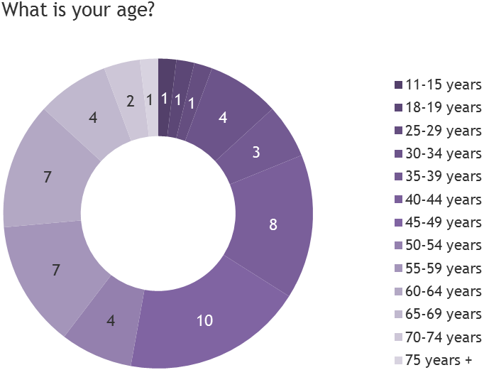
Figure X: Age of Participants by Group
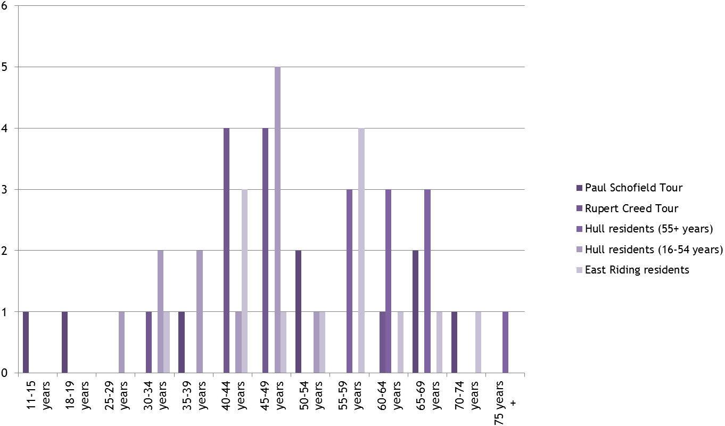

Gender
There were a greater number of female participants than males (60% vs. 40%) overall. Looking at group level, both of the guided tours had an even split. The skew to female participants was therefore the result of the pre-recruited groups of both Hull and East Riding residents.
Figure X: Gender of Participants
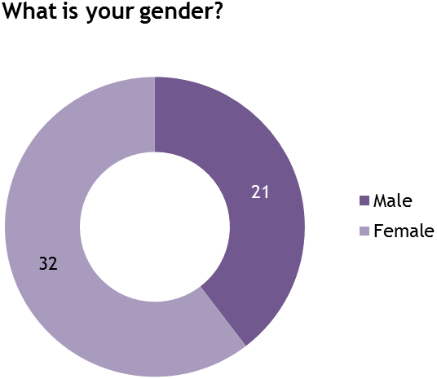
Figure X: Gender of Participants by Group
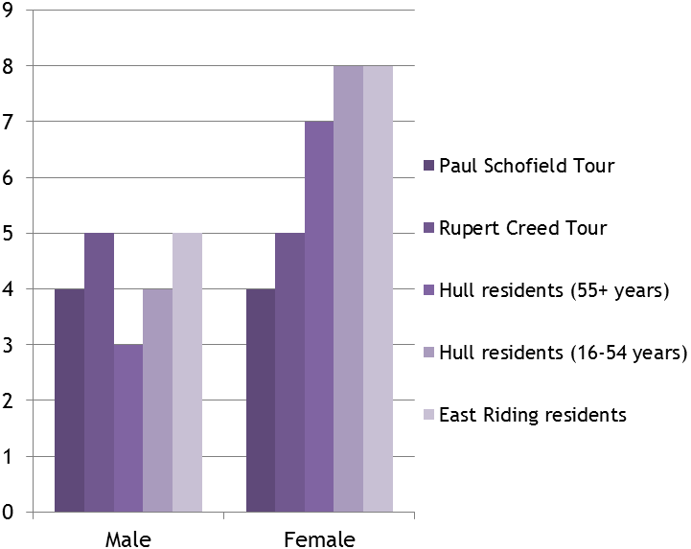
Disability
The majority (47, 89%) did not self-identify as disabled. 4 participants (8%) stated that ‘Yes – limited a little’ in response to the question ‘Are your day-to-day activities limited because of a health problem or disability which has lasted, or is expected to last, at least 12 months?’. 1 (2%) stated ‘Yes – limited a lot’ and 1 (2%) preferred not to say.
At group level, all of the participants in the guided tour groups had 0 participants self-identify as disabled. The majority of participants that self-identified as disabled were in the Hull residents (16-54 years) group.
Figure X: Disability by Group
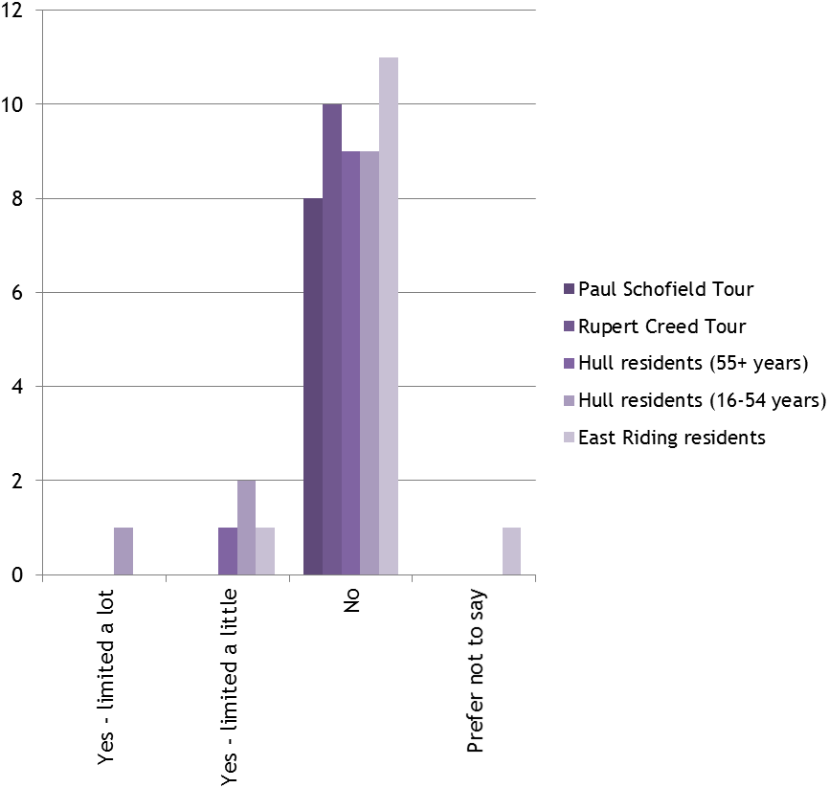
Ethnicity
All but one participant said they were ‘White: Welsh / English / Scottish / Northern Irish / British. The one participant who selected Other (but did not specify ethnicity) was part of the Rupert Creed guided tour group.

  - Emotional Response
As the groups all completed the ‘Made in Hull’ experience taking slightly different routes, the data from the Smartphone Survey has been reorganised to combine all the responses for each installation together.
There are a few things to note in relation to the Smartphone Survey:
- The participants in each group had varying levels of familiarity with Smartphone technology, and some experienced difficulties in moving through the survey.
- The researchers were able to help where people became stuck, but this relied on the participant flagging any problems with the researchers.
- The high volume of attendance at the event meant that a few participants in the Hull and East Riding residents groups got separated from their group, meaning that they may not have made it to all of the installations.
- Hullywood Icons (at Queen Street) was not always operating during the Walk and Talk groups, so has only been rated by those groups that saw it.
- Vantage Point (at Humber Street) was not operating on the nights and / or times of the Walk and Talk Groups, so has not been rated by the groups.
As a result of the challenges listed above, the number of responses to each installation varies. A column has been added to each to show the total number of participants that responded to the installation – Whitefriargate and Queen Street received the least participant responses across the seven installations seen.
    - Overall Reponses
Joy, surprise and anticipation were the three principal emotional responses experienced by participants throughout their ‘Made in Hull’ experience:
- Happiness was selected in response to the installations 173 times;
- Surprise was selected in response to the installations 168 times;
- Anticipation was selected in response to the installations 134 times.
All three emotions were selected by at least 6 participants at each of the sevens installations.
Disgust, anger and fear were the three emotional responses least experienced by participants throughout their ‘Made in Hull’ experience:
- Disgust was selected in response to the installations 4 times;
- Anger was selected in response to the installations 14 times;
- Fear was selected in response to the installations 19 times.
Table X: Emotional Responses by Installation Location
INSTALLATION SITE | HAPPI-NESS | FEAR | ANTICI-PATION | DISGUST | SADNESS | ANGER | SURPRISE | TRUST | TOTAL
Queen Victoria Square | 48 | 9 | 30 | 0 | 30 | 6 | 35 | 13 | 53
Whitefriargate | 22 | 0 | 13 | 0 | 4 | 0 | 23 | 1 | 35
Zebedee’s Yard | 31 | 2 | 25 | 0 | 5 | 0 | 29 | 1 | 50
Scale Lane | 6 | 3 | 16 | 0 | 34 | 8 | 21 | 2 | 50
High Street Underpass | 8 | 4 | 12 | 4 | 4 | 0 | 22 | 0 | 43
The Deep | 40 | 1 | 31 | 0 | 7 | 0 | 26 | 13 | 49
Queen Street | 18 | 0 | 7 | 0 | 0 | 0 | 12 | 2 | 24
TOTAL | 173 | 19 | 134 | 4 | 84 | 14 | 168 | 32

Figure X: Emotional Responses by Installation Location
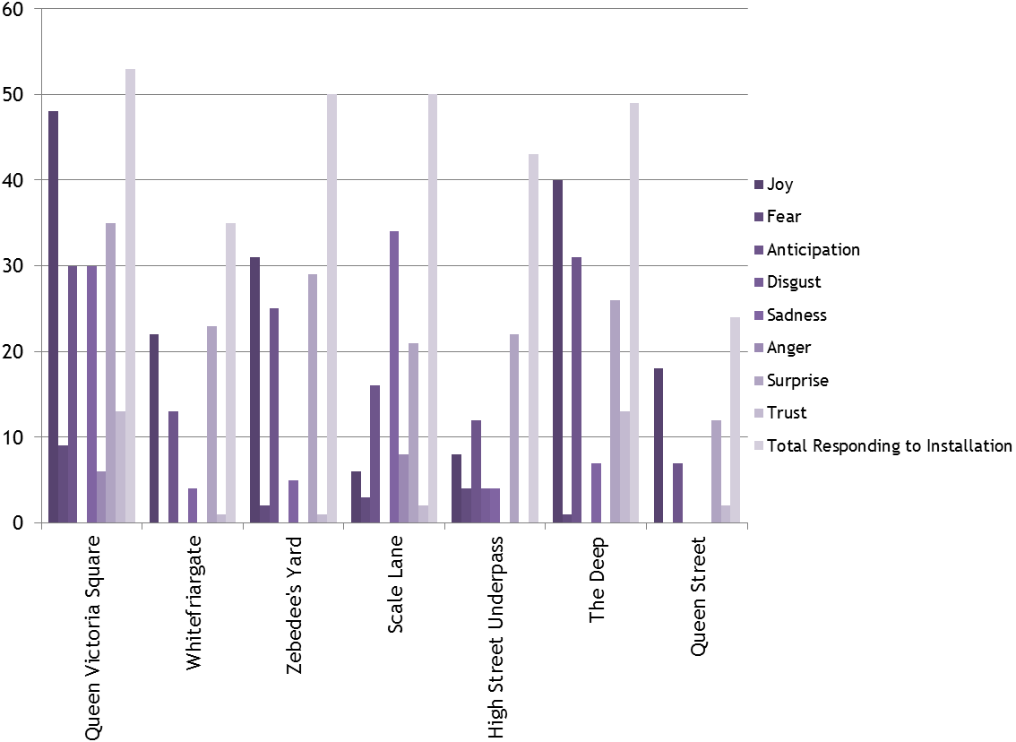
Disgust was only selected in response to one of the installations – Embers at High Street Underpass; anger at two of the installations – We Are Hull at Queen Victoria Square and (in) Dignity of Labour at Scale Lane; and fear at five of the installations - the exceptions being the various installations on Whitefriargate, and Hullywood Icons at Queen Street.
The following sections will look at each installation site in isolation and pull in additional data gathered via the Vox Pop style interviews.
    - Queen Victoria Square - We Are Hull by Zsolt Balogh
Queen Victoria Square generated one of the most varied range of emotional responses of all the installations, with 7 of the 8 emotions listed being selected by participants. The only emotion not selected was disgust.
The principal emotions experienced at this installation were happiness, surprise, sadness and anticipation:
- Happiness was selected by 48 of 53 participant responses (91%);
- Surprise was selected by 35 of 53 participant responses (66%);
- Sadness was selected by 30 of 53 participant responses (57%); and
- Anticipation was selected by 30 of 53 participant responses (57%).
In exploring these responses in more depth, the Blitz, Triple Trawler Tragedy, Hull Fair and We Are Hull finale seemed to resonate most with audiences. It was noted how individually these elements made an impression, but also how different they were to one another in the emotional reaction people had.
‘I think seeing the fire and the flames coming out of all the buildings and then further on, highlighting the Hull Fair, the juxtaposition of those two, going from real lows to real highs and just being able to see it on all three buildings was pretty awesome.’
‘The bit which stood out for me was the air raid first of all, and that made me feel sad because I’ve got family connections when that happened and family being bombed out and so on. And then the next bit I guess which really sticks in my mind is Deano’s goal at Wembley, two thousand and eight. And I wanted to cheer again – I still can’t believe it went in.’
‘I suppose the bits during the Blitz were particularly impressive to me because I had a walking tour earlier with Mike Coverly who covered the history of the Blitz, so it kind of had a resonance with me in that sense. But just the end bit as well with the montage of ‘We Are Hull’ it was very powerful. That bit really got me...Just the coming together, you know?’
‘I think the air raid with the bomb dropping there – the sound just resonates around the square, it really got quite into the heart. Yeah I think it makes you feel incredibly emotional.’
‘The trawler. The sea and the trawlers. I cried.’
‘Well for me it’s the fisherman. It really puts a lump in your throat that’s for sure. My mum cried at it yesterday. Yeah it’s quite emotional that bit, but I think it’s brilliant. All of it.’
‘And the trawlers – unbelievably emotional. I mean really. You know the falling of the figures. That was incredible. It affected me a lot. Yeah I really enjoyed it. I liked the ending where it was really hopeful with all the lights and the streamers and the fireworks. It was brilliant. Really enjoyed it.’
‘Well you could go through it all, but the triple trawler bit, every time, it’s so poignantly done with the bodies and they turn into stars. It’s such a big powerful thing that we then went on and did.’
‘I think the ‘we are Hull’ as well, because Hull gets too much outside sort of bad publicity. And it’s wonderful. That’s what we are, we are Hull.’
‘I think it was very clever the way they’ve done the sad and then they bounce into the fair, it’s very much an up and down with your emotions all the way through it. And then going towards the end with the wind farm and the wind turbine bit – very strong for the future. And then the We Are Hull.’
Some audience members expressed their amazement of just how much history was presented within the piece – more than they realised existed.
‘I think the build up, it was the build up at the end. And when it finished, that was the strongest really. It was just a bit surprising that there was that much. I didn’t know there was that much, it was interesting to see.’
‘A lot of it I remembered, a lot of it I didn’t, but a lot of the stories I’ve heard about, some of the bits I didn’t know anything about. I thought it was good.’
‘It’s a complete mixture of emotions to be honest. At first when it starts you go ‘aw wow look at this, it’s absolutely amazing’ and you think ‘wow’ from start to finish, but as it goes through going through all the different stories and different phases in the life span of Hull, you start to bring out happiness, you start to bring out sadness, surprise. Like for me, there’s quite a lot of things in mind from Hull- we know about the bombing, we know about the fishing and the aspects of that, but we don’t read much more into rebuilding and what comes after those big events that happened. So yeah it’s good.’
Others highlighted how the installation had brought the history they already knew about to life. Many people had grown up hearing about these significant moments in Hull’s story, but the installation had helped them to feel it.
‘I think for me it’s more of the historical elements, you know the ones that happened before my time? I think those ones because those are quite a lot of the stories that we grow up on living on Hull and to have it depicted on the walls is absolutely brilliant.’
‘I guess the trawler bit was really sad, because it is so cold tonight, and just thinking about them out there when it was so cold.’
‘The trawler bit. My granddad was and my step-dad was a fileter. So he used to tell the stories of the fishermen’s wives and I didn’t really understand it when I was little.’
‘I said to someone else – it’s probably a thousandth of what they felt, but it was kind of frightening watching the wartime bits. And you think, crikey if that’s what it was like and we’re just watching a film of it, and you’ve got like the rumble, you can feel all the vibrations, you thought hell! It was really powerful that bit. You know, I think that was probably the bit that stuck with me the most I think.’
For many people, the experience of the installation brought back memories that they recounted – either memories they had experience directly, or those that they had been told by family members or friends.
‘Well, my Dad’s not here anymore but he was born in 1923, and the house opposite took a direct hit, and the horse, which was the milkman’s horse was in my Dad’s back garden, and that got killed. So yeah, I think they had to move out the house and it got knocked down…So yeah, that brought it home that where I’m stood now it was a lot different. Because there used to be a museum I was told, that held beautiful artefacts and it took a direct hit and was all lost. Same as the Zoological, didn’t they used to have a Polar Bear in the Zoological off Spring Bank? That used to be a zoo and I think that got bombed as well.’
>‘You always looked forward to [Hull Fair]. Always rained, always cold.’
>’I remember one year when I went as a kid there was bare-knuckle boxers when I went when I was a kid, and I’m thinking really?! It was colourful Hull Fair. And there used to be a man who was a chicken as well wasn’t there – oh there was everything there!’
>’Oh the shows and the weird people….you can’t do that now but it used to… Yeah like the woman with the beard and the man with three legs and all that.’
>’Yeah there used to be the goldfish in a bag and all sorts! All those days are gone. And they outside bingo when you could go win a kettle.’
It also made people reflect of the City and what it has been through and how this has made it the place that it is today – in essence how these historical happenings have changed the very fabric of the City.
‘The thing is, it reminds you that Hull was a great place before it got blown to bits, and I think Hull in a lot of ways has struggled, certainly architecturally to try and get back. Because when you look around Hull, it’s all very different, it’s lost a lot of the original beauty of its buildings and what’s left is quite a lot of 60s monstrosities, which I’m pleased to say they’re trying to get rid of more and more of them and move on.’
‘I find it very emotional. I think the bombing especially because I was born in fifty three, so growing up in the fifties, we used to play on the bombed building sites because it was only until late fifties early sixties that Hull started being rebuilt. And we had all these kind of matchbox type sixties buildings that they’ve been pulling down these past few years.’
‘Yeah I think it does provide that sort of connection with the history of the city doesn’t it, and the tragedies that the city has gone through.’
On a more fundamental level, some audience members were impressed by the technological aspects of the installation and its overall presentation using a mixture of art forms, which were seen to up the intensity of the artwork.
‘Spectacular imagery and very, very well executed, the whole thing is very good. And the music and sound add to the emotional tensions that you get, and the music is also very, very good in the way it builds up towards the end – it’s super.’
‘Blown away. It was just awesome. The music was very powerful. Graphics were just amazing.’
There was also an overwhelming sense of pride among those watching this installation. It was seen as an art work that spoke of Hull coming together and people being proud of the City and what it has achieved.
‘It’s part of our identity isn’t it. It’s nice that all of a sudden, people from Hull are proud of being from Hull. That sounds strange but I do think it’s ignited a latent pride, a dormant pride.’
‘That moment when they say we’ve got City of Culture, amazing! My eyes fill up every single time. It’s such an emotional moment, you just think ‘wow, we did it.’
Then there were those that were just overwhelmed by the whole thing.
‘And then I’m just left with a sense of wonderment at the…it’s making me cry…the success of it all. It’s great.’
‘It was pretty amazing, I don’t really know if I’ve got the words right now. I’m kind of sad I won’t get to see it again. Pretty amazing yeah.’
    - Whitefriargate - Various by Various Artists
Whitefriargate generated a more limited range of emotional responses than Queen Victoria Square, despite being made up of a number of installations. Overall, 5 of the 8 emotions listed were selected by participants. However, two of these only received a few selections. The emotions not selected were disgust, fear and anger.
The principal emotions experienced at this installation were surprise, happiness and anticipation:
- Surprise was selected by 23 of 35 participant responses (66%);
- Happiness was selected by 22 of 35 participant responses (63%);
- Anticipation was selected by 13 of 35 participant responses (37%).
The particular strengths of the installations on Whitefriargate linked to the personal stories that they told, whether the direct experiences of those still living, or living peoples’ memories of those who have passed away.
‘I think it was a good insight into Hull and the past. Just seeing the normal people of Hull just doing their thing just like everybody else.’
>‘I liked the Swift Caravans because I know the chap who’s speaking in that.’
>’Yeah the caravan one was good how they set it out. Something different. Not what you normally see, how you see the people actually in there. It’s all different.’
‘And it was really nice to hear actual people’s stories, that was really nice. I liked those.’
‘(Pauline’s gift shop) Next door but one to Sainsbury’s. (Did you go in a lot?) I didn’t to be honest, it’s just one of those things that when you walk past – because I live in that area of town you see, always have done since I moved to Hull. It’s just one of those things that you just took for granted, and then when she died… it’s incredibly sad really. I taught her granddaughter, and I know Roland a little bit and so yeah, it’s a fixture and fitting really of Princes Avenue.’
The approach of using empty shops, using visuals, film and audio recordings to tell stories was praised for its accessibility.
‘It’s all different ways of getting the information across that you don’t normally see. Not just text to read, it’s stuff to see and look at and watch.’
‘It’s nice to see the shop windows filled, and using the spaces we’ve got rather than leaving them empty. And just interesting bits.’
The empty shop housing the history of Hull’s two rugby teams sparked a lot of conversation and reflection. Many memories were brought to light among audiences – remembering matches they had gone to, family members’ passion for their team, and debating the rivalry that exists between the supporters.
‘It’s just part of the city isn’t it. You live it, you love it. You know, it’s there. Just looking at the shirts, we’ve got all the shirts and all the memorabilia there. Happy memories.’
‘Yeah, very much happiness, happy memories. I mean it’s happiness and sadness I suppose, in some respects, going back to the days of Roger Millward, just departed and such, when you know both were really high-flying teams. They are now but I suppose it was going back twenty to thirty years ago.’
‘I used to teach at Salthouse Junior High, and Phil Low, his mother was the chief cook there, so of course when it was Hull battling Hull, we were dressed in red the whole day before, we weren’t allowed to do anything else because it was definitely going to be her lad’s team that won, so you were drawn into it even when you wanted to be or not.’
‘Well I remember once when the black and whites, they were going to Wembley or something, and I was working over the other side and one of the staff said to me ‘well at least Hull’s there’ and he was utterly disgusted that I said that. And I said well don’t you want them to win? And he said ‘no’. And they were Hull people! But that’s right, Hull isn’t one city, it’s too cities. It’s divided by the River Hull.’
The installation of the rugby teams was not the only one to spark memories in people.
‘I really enjoyed the caravanning, it reminded me of my childhood going caravanning. I really enjoyed that.’
One audience member, reflecting on the Invisible Flock piece, Reflections, which showed Hull people sat on a bench looking out at the audience, spoke of how calming she found it.
‘It’s a bit surreal, you kind of feel…like I was just stood there and staring, I’m a people person and I like standing and looking at people. You just get so…it’s like a curtain comes down and you feel so calm about things. Just looking. I don’t know I just got a tingle.’
Preston Likely’s Amuse Agents was also enjoyed by audience members for the humour and fun it brought to the street.
‘I love some of the signs in the window (amuse agents), so funny.’
‘The newsagents one is a bit interesting, it’s funny.’
    - Zebedee’s Yard - 105+dB by Invisible Flock
Zebedee’s Yard generated a similar range of emotional responses to Whitefriargate. Overall, 6 of the 8 emotions listed were selected by participants. However, three of these only received a few selections. The emotions not selected were disgust and anger.
The principal emotions experienced at this installation were happiness, surprise, sadness and anticipation:
- Happiness was selected by 31 of 50 participant responses (62%);
- Surprise was selected by 29 of 50 participant responses (58%);
- Anticipation was selected by 25 of 50 participant responses (50%).
The installation was seen to be particularly powerful in translating how being on the pitch must feel for the players, which was very different to the experience of being in the crowd. Some reflected on how it was possible to pick out individual voices and how if you moved within the space the experience changed.
‘There’s a sound that comes from all around you. You don’t really hear everything like if you were playing on the pitch. That’s what they must be experiencing from every quarter. In fact, it makes you wonder how they can communicate with each other. More to the point, it makes you understand why the manager’s shouting as hard as he can trying to pass instructions when there’s deafening sound like that.’
‘You hear individual voices when you went round rather than just being in the middle it’s just a noise.’
‘Yeah you can really hear everything. But then someone’s shouting and you think, who’s said that? But yeah I think it’s really weird.’
‘And all of a sudden you think there’s someone behind you, which is great.’
‘That was excellent, I mean when I thought about it, to me it was the sort of surprise. I think I mentioned earlier on, getting all that noise from all corners and it really was like being in a stadium. In fact in some respects it’s like being on the pitch, because you’re getting it from all sides.’
‘I think the thing that did surprise me most was the way in which you could pick out individual voices.’
The sound and sheer volume of the crowd when the match reached crescendo moments, were something that many audience members found exciting.
‘When I heard them singing ‘Come on you Ull’, you know that chant ‘Come on you Ull’. And also the roar - that’s when they’ve scored a goal or just missed a goal or missed an opportunity. I think that was the surprise of that.’
‘The sounds, the sound of the goals is absolutely fantastic. You could feel it.’
‘The one that’s missing on the emotions is elation. Happiness doesn’t cut it really. Certainly that’s the feeling. It’s like primitive isn’t it. That’s very very authentic I would say.’
‘I just thought it was like spine tingling. I just thought it was… I just felt so elated. Just like every time they cheered I just got a spine tingle. You feel so good. And I’ve never been to a football match before. I’m not a massive fan but I’m a support. But I can’t imagine what the fans would feel like if they went in there.’
‘I just got spine tingles every time they cheered. And my hair just tingled, I just felt so happy. Just a good place to be if you close your eyes you definitely feel like you’re in there, you feel it.’
‘Eighty thousand people singing and shouting, the noise is incredible. You can feel it as well, do you know what I mean? You don’t just hear it you feel it.’
‘In there we’re all smiling, every single one of us had a smile on our face. You can’t help it.’
As with the rugby installation on Whitefriargate, this installation was particularly powerful in making people reflect on their love of sport and the game, and what being a fan means.
‘Oh fantastic! I’ve had counselling, cold turkey everything (on being a football fan). I’ve just written a long poem today about it – trying to recover from the West Brom result.’
‘Yeah because Nikki was at the match so she said “Just wait a minute, just wait a minute, we’re gonna score”, and we were stood right near the speaker and was like woah! But that’s amazing because as somebody who goes to watch the football, to kind of almost feel that from what would essentially be a player’s point of view was amazing. Because how loud we got because we scored that goal. Because it sort of went quite quiet because you’ve got the Newcastle fans chanting, and then all of a sudden that – it was like “yaay”.’
‘It just brought back a lot of memories of childhood, so it was exciting and it reminded me of my dad more than anything.’
For those who were not football fans the reaction was split. Some still had an emotional response to the piece, just because of the build-up of tension it crated, whilst for others they focused on what it brought to mind.
‘That just sounded like a different language altogether! It was good though. We were just waiting, there was a lot of anticipation there.’
‘I think to be quite honest, all it did was… I thought – can you imagine when like a group of medieval people were going to do battle? Like primeval really isn’t it.’
‘I think there’s something quite uplifting – you know, thousands of men I guess they mainly are, signing or chanting in unison.’
‘I guess you didn’t know what was coming next in a way. I guess because there was no visual clue as to what was going to happen. Because I guess if you were there, you’d be expecting stuff because of what was happening, whereas that, you didn’t know what was going to happen next.’
    - Scale Lane - (in) Dignity of Labour by MakeAMPLIFY
Scale Lane generated a similar range of emotional responses to Queen Victoria Square, with 7 of the 8 emotions listed being selected by participants. As with Queen Victoria Square, the only emotion not selected was disgust.
The principal emotions experienced at this installation were surprise, sadness and anticipation:
- Sadness was selected by 34 of 50 participant responses (68%);
- Surprise was selected by 21 of 50 participant responses (42%);
- Anticipation was selected by 16 of 50 participant responses (32%).
A number of audience members talked of how they struggled to know exactly what the piece was about. However, even without this knowledge they still picked up the emotion put across by the piece.
‘The first word I said to my wife was that it was extremely poignant. Absolutely.’
‘Quite sad really, I think it was a bit sad. Like disappearing people wasn’t it. I’m not sure.’
‘For me, there was a lot of separate images that I thought were quite powerful, like the building of the wall which was… the idea you were building a wall on a wall, was quite clever. And the idea that towards the end and the main figure breaks through that wall. And clearly the theory that there’s sort of a sense of alienation early on in the video, particularly when you see the pictures of all of the people in a row right at the beginning. So yeah I mean I just might be misinterpreting it entirely, but for me it’s a sort of sense of alienation, a sense of distance. And there’s a very interesting part at the end you know when they’re taking all their stuff off – that was quite interesting. And then by taking whatever clothes they had on, there was nothing left underneath them, which I thought was really... Again, was that some sort of nod at identity and what is your identity, and do you exist without the uniform you wear, and is there anything underneath?’
‘I don’t know it’s quite hard really to put my finger on it. It’s not negative is it, but it’s quite down, it seems to be quite downbeat, you know like as in the decline of industry into like joblessness and that kind of thing.’
With the guided tours, where the installation’s concept was shared; or where people had independently found out about the concept of the piece, audience members stated that they understood it in a way they had not previously.
‘It was very poignant wasn’t it? It was really, really….you don’t think the youngsters can feel like that. It was as if, especially in that one little bit where he was like.. picking him up and then he was getting down and then picking him up...It’s really sad.’
‘When he explained what it was, I got it. Because when I watched it I just went ‘I don’t get it’…I wasn’t quite too sure what it was supposed to depict, but now when Rupert explained, I actually get it.’
‘It’s really still quite poignant, because you know, when you’re watching it and you can see the fact that they’re applying for jobs and applying for jobs, and I know it’s called ‘Dignity of Labour’, it’s all about that you know, almost…I don’t know if this is the right word but almost like finding your worth in finding a job. You know, looking for a job, you can’t get a job, and then you know because really, how do you feel and how do you react when you’ve not got a job? I think you can feel very lonely, very isolated. I thought it was different. I thought it was one of those things that I wouldn’t normally understand, but I do, I can get it, and I can get where the artist is coming from with it.’
‘I watched it all the way through once, but I didn’t know that I was understanding it properly. It’s very interesting but then I read about it – you know they’ve been doing a lot of those online interviews, and I read that afterwards and that really brought it home. It’s all local people and their stories, and I hadn’t fully understood that when I was watching it, so it’s quite interesting reading that afterwards. And maybe other people are better to go on the website and finding out more.’
The installation seemed to be very effective in making audience reflect on the story being told, and the struggle being faced by young people in the City, comparing that to their own experiences in some cases.
‘I think we’ve all been there. Not just looking for jobs, but we’ve all been there in times of our lives, and we’ve all been down, so you can relate to people who are down. It’s like ‘don’t stay down, get yourself up, there will be people around that will help you get up’. And it’s that, there is people there to help you.’
‘And sometimes because of the city it’s hard for [young people]. It’s hard when there’s other things – it’s all out of their control isn’t it? And that’s sad because they want to be there doing things and everything seems to be against them doesn’t it.’
‘I remember the eighties when everybody was unemployed, and it did bring back memories ad I suppose that’s what they want to show.’
‘That was just good but quite sad. But then it gets you annoyed. Because, I don’t know, occupation and things around here to me means that kids do have trouble getting jobs and that gets you angry.’
‘If you’ve been unemployed or you are unemployed, that idea of queuing or that never ending senseless toil. It’s very clever. Because at first you’re thinking ‘what?’ and then you realise.’

‘Yeah, the hours you put in, the dole queue going down. People just going out there getting jobs in production just to make ends meet. It’s like individualism as well isn’t it, it’s all quite different. I could see it was all quite moving.’
As with the We Are Hull installation in Queen Victoria Square, the production value of the installation was also praised by audience members.
‘Also, stunning to look at, just from a purely visual point of view.’
    - High Street Underpass - Embers by Jesse Kanda
High Street Underpass generated a varied range of emotional responses. Overall, 6 of the 8 emotions listed were selected by participants. However, three of these only received a few selections. The emotions not selected were anger and trust.
Surprise was the principal emotion experienced at this installation, though anticipation and happiness were selected by a relatively significant number of participants:
- Surprise was selected by 22 of 43 participant responses (51%);
- Anticipation was selected by 12 of 43 participant responses (28%);
- Happiness was selected by 8 of 43 participant responses (19%).
The majority of feedback from audience members on this installation linked to a perceived disconnect between the different elements of the piece, and also with the expectations people had of what they would experience.
‘And I think they should have put the same rave music, more appropriate music, because it just kind of like conflicted. It kind of like distracted from whatever message they were trying to give.’
‘It was very, very confusing. I don’t think... It looked as if it hadn’t been really thought through because the images were a little bit obscure. The music with the images didn’t match, the music on top of that didn’t match and personally, we walked away after five minutes. I think a lot of people did. I just don’t think it…we were expecting a sort of nineties kind of music themed thing and it wasn’t. A lot of people were disappointed.’
‘As I say, I was expecting it to be a bit like going into a nightclub and sort of anticipating what your generation lived through for nightclubs and everything. And again, we actually left after about five minutes, so... a bit disappointed with that one I think.’
People also stated that they just did not really emotionally connect with the piece, which they felt was caused predominantly by having no personal connection to the content or the time.
‘That was just a bit odd. Maybe if you’d been there in the nineties – which we weren’t. We were too old even for that.’
‘I think for a certain age group it will bring back a lot of memories, but I think I’m just a bit too young for that sort of thing. I thought, I don’t know…The lighting didn’t really do anything for me. I understood the relevance of the location, I thought the location was good for it, definitely. I think it could have been a little bit better to be honest.’
Yet, even where there was a personal connection to this time period, it did not always resonate.
‘It was part of my past and I still didn’t get…It didn’t take me back. It just seemed a bit seedy as well. I don’t know I just thought...I wouldn’t say it’s not well done but it just doesn’t fit in with everything else I don’t think at all.’
This was not the case with all audience members, however. Some did find some interest within the art work, and in some cases the personal connection to that time did generate some reminiscence.
‘Disturbing. It was just like they had no control over what they were doing.’
‘It kind of takes you back to your twenties, you know when acid music was on. I’ve never been to a rave before, but if I went to a rave I’d probably just stand there, like I stood then and think ‘what’s this all about?’ and I probably wouldn’t feel that emotion, you know what some people do, because they’re probably tripping or something. I don’t know. You know, you need to be on something to be in it.’
‘It’s like we said, we were just laughing because people were either sat there, or they’re dancing. That was it, you either sat or you danced. When I used to go, it was either sitting or dancing, that was it.’
‘The one under the Underpass was just really like… I said to him, I said, ‘I hope this wasn’t filmed when I were clubbing’. And he was like ‘Was it really that embarrassing?’, and I was like, ‘yes!’. But it is, it really takes your breath away. All of it, I can’t even tell you.’
    - The Deep – Arrivals and Departures by
The Deep generated a similar range of emotional responses to Whitefriargate. Overall, 6 of the 8 emotions listed were selected by participants, though only 1 participant selected fear. The emotions not selected were disgust and anger.
The principal emotions experienced at this installation were happiness, surprise, sadness and anticipation:
- Happiness was selected by 40 of 49 participant responses (82%);
- Anticipation was selected by 31 of 49 participant responses (63%);
- Surprise was selected by 26 of 49 participant responses (53%).
The installation was particularly effective in communicating with audiences about the diversity of people who have come to and passed through Hull in recent history. Many reflected on how Hull is often seen as lacking in cultural diversity, but this piece seemed to challenge that perception.
‘I just loved the kind of multi-cultural-ness of it. I’m not sure that kind of comes out of the other ones really. And it being quite an inclusive place. Yeah I liked that one because it felt very inclusive and kind of upbeat. And I think, you know people think Hull is quite an insular place, but it is really diverse actually - it’s not as diverse as other places, but in terms of people coming through the docks and stuff.’
‘Yeah it was interesting to see everything that you don’t know about really. Like all of the immigrants that we’ve had, you just think of the main ones like a lot of people have come from Pakistan and Poland and stuff like that, but you never realise they’re from everywhere. You just kind of generalise them. It’s quite bad but everyone does it. But it makes you think, people are from everywhere.’
‘Yeah they talk about Hull being the end of the road, but actually, it’s the beginning. A lot of people I know have been talking to this lady here, lots of people born here travelled all over the country and all over the world, and eventually come back and settle back here. So this has been a bit nostalgic for me, like a walk down memory lane, you know some of the different things that were portrayed meant a lot.’
The level of change that has taken place within the City, in terms of its people; and how different cultures link to different decades, trade and commerce was eye opening to people.
‘Amazing just to see the changes that have taken place. And the waves of change.’
‘The music right at the end, it really got me. Very emotional right at the end. You just think how important it is for Hull to have this import and export and how we’ve grown over the centuries. You know, not just being one little port but being from a global point of view. And people don’t appreciate how much export and import Hull actually does until you actually see something like that. It just brings it home to you really. Makes you feel so proud that we as a port can do so much. The logistics. It’s very emotional.’
‘It was good, I didn’t realise that so many people came from so long ago from so many different countries.’
Some audiences made a personal connection to the pieces also, linked to their family or particular memories linked to the hymn Those in Peril on the Sea.
‘I saw my mother’s maiden name come up so it’s interesting isn’t it when you see someone come up that you know. It was good, interesting. Because it is all about people coming and going isn’t it. Yeah it’s just nice to get a reminder.’
‘I thought it was lovely, because I’ve got relatives that came from Russia and Poland. And everybody has, if you go back 3 or 4 generations, most people came from somewhere else. And now we’re all here and some go on elsewhere. It’s just lovely.’
‘And one of the most significant things is the music, the one hymn ‘Those in peril on the sea’ we used to sing that often in our school assemblies, because of course with the trawler-men going out to sea and so many tragedies, we used to sing it often, so when that music came on it just took me back to those days. So powerful, definitely.’
The way that the art work put names to the faces of those who had been part of Hull’s history was particularly powerful. The combination of the two things together seemed to heighten the story being told for audiences.
‘The Deep I think is incredibly emotional. It’s just real people, real names, real faces. It just tells the story, absolutely mesmerising.’
Equally, the closing message showing everyone joined together and moving towards the future was not lost on audiences, especially given the political context of the time.
‘You know when they’re all coming together, holding hands and everyone’s united. And they all start singing perils at the sea. I think it’s everyone coming together and it’s just like one big teamwork. You know, just like one big thing and we all get each other, we all understand each other, we all get what we want to do through trade. Show people what we can do really.’
‘It was great to be honest, just like, especially because the subject is such a negative subject at the minute about immigration, and I feel like obviously with Brexit and all that sort of stuff, people like, it’s nice to see a positive spin on immigration and something like an argument that’s been put across – basically were all immigrants anyway regardless. So it’s quite nice little spin on it to be honest, I thought it was a positive message and really well put together.’
‘The music right at the end got me and I like the bit where all the people came together and held hands. It was quite united. It was almost like it’s one big teamwork, one big team, we’re all in it together, doing this amazing thing. It’s just awesome.’

As with We Are Hull in Queen Victoria Square and (in) Dignity of Labour at Scale Lane, the production quality of the art work was praised by some.
‘It was very clever as well the way they got the graphics for the transition from whaling to fishing and you know the sort of waves of different history and culture that’s affected the place, particularly towards the end of sort of multi-cultural ways it came in. It’s quite interesting, it’s almost like, it seems waves of change have affected the town over the centuries.’
‘I like how they mixed the old and the new as well. You’ve got that story going right through and the theme going through but also right at the end pulling that together with sort of looking to the future. But also with the seafarers hymn to pull it together right through with the history of it being a dock city.’
‘It was amazing to see the journey that Hull’s come on. But art-wise as well, it’s good to see how they’ve picked out the different grids in the Deep and stuff. They’ve done that quite a lot in a lot of the projections. How they put it together is really really good. I found that bi more interesting than the actual story.’
    - Queen Street – Hullywood Icons by Quentin Budworth
Queen Street received approximately half the total responses of the installation, for reasons highlighted in the introduction to this section. It was also the installation to receive the most limited range of emotional response, with 4 of the 8 emotions listed being selected by participants. The emotions not selected were fear, disgust, sadness and anger.
The principal emotions experienced at this installation were happiness and surprise, most closely followed by anticipation:
- Happiness was selected by 18 of 24 participant responses (75%);
- Surprise was selected by 12 of 24 participant responses (50%);
- Anticipation was selected by 7 of 24 participant responses (29%).
This installation was particularly praised for being fun and enabling Hull’s residents to get involved.
‘I thought that was quite fun, especially because you know it’s people from here as well and everyone’s got involved in that.’
‘Awesome, I love the Hullywood one, we’re doing one back at the University, we’re going to do a few of them. I think I’m doing Weird Science, Jurassic Park or Honey I Shrunk the Kids.’
    - End of Experience
At the end of the experience group members were asked to explain what the overriding feeling was that they were left with as a result of attending ‘Made in Hull’.
The overwhelming response was pride, most closely followed by , as shown in the word cloud and quotes below.
Figure X: Overriding Feeling Having Experienced ‘Made in Hull’

‘Just really, really proud of the city and what we’ve done.’
‘I think, really proud of what they’ve achieved.’
‘I think pride. It’s quite nice to actually be from somewhere that is like this.’
The more detailed comments made by audiences linked to the fact that ‘Made in Hull’ had made them look at their city differently.
‘The main thing is that we’re looking up now. I’ve been coming since I was a little girl down here, and you don’t look up and see all the beautiful architecture.’
‘There’s things you just walk past normally. Until it’s actually pointed out to you and someone says ‘oh, look at this’. And then you see it. You always walk past it but never realise it was there.’
‘I like the city hall being Hull Fair because it was really incongruous. Because it’s normal kind of a formal, scary, impressive place.’
Others talked of their excitement and joy at just seeing the City Centre so animated and full of people on a night time, when usually it is so quiet, and the atmosphere of positivity and friendliness.
‘You’d think it would be deserted, but it’s chocka block, like rush hour coming into Hull on the evening.’
>‘Well I mean I’ve never seen scenes in town like this. It’s surreal.’
>‘Nobody has I don’t think!’
‘This has just been so fantastic, I’ve never seen the city centre so busy. Especially in the middle of winter. So yeah, this one in Victoria Square is fantastic. Absolutely fantastic yeah.’
‘Really just how many people have come out and people have managed to get round, good organisation with the stewards and everything and the people – there’s generally a good feeling about the place. It’s really positive. There’s nobody being naggy or aggy with people, it’s just you walk along. People with prams are brave people!’
‘Yeah it’s just got a real buzz about it, it’s really good.’
There was a sense of anticipation also, with people excited to see what would come next. ‘Made in Hull’ definitely seems to have set the bar high for the year, but there is also a realism that not everything can be on that scale. It has, however, given people belief and promise that the year will be a success.
‘The things we’ve seen so far, I hope they just continue. I mean it can’t be on this scale, you don’t expect marvellous things every night, but I think some of the things have been…you know, you’re excited for what’s coming next.’
‘It gives you a feeling that there’s a lot more to come. Anticipation is the feeling I’m left with. Yeah, there’s a lot more gone on than I realised, you can see how much effort’s gone into it as well.’
‘I had optimism, because it’s all been very jolly and it’s all been very exciting and quite upbeat and very positive about the future.’
‘What a week really. And it’s only week one!’
‘Just really excited now to think what might come in 2017. I hope they live up to it – I’m sure they will, but I think everybody wants to know what’s next.’
‘Excitement of what’s to come. Looking forward to it all.’
Others talked of their feeling that this really will change how people think about the city.
‘Ace, seriously ace. Just the city itself. Honestly, at my age you hear so much about it and you live through so much of it…but it always upsets me I think, people’s perception of this city…There’s a lot of passion in this city and I think this – this is only the first week isn’t it? It’s gonna leave a massive, massive legacy for the city, and an enormous demand for culture as well.’
Reflection on the history of the City was also profound with some audience members, who enjoyed seeing it interpreted in a modern way.
‘Bit nostalgic, because there’s so much history.’
‘And it’s a good mix of modern and history and creativity. It’s really good blend of it all, excellent.’
‘Nostalgia. So looking back about the past.
Others reflected on the art itself and their own understanding of what they had seen. Even where they did not necessarily understand on hundred percent of the concept, interest was sparked and desire to find out more and explore. It seems that a cultural appetite has therefore been awakened.
‘I’m not really sure what a lot of them are about because they get quite deep don’t they. I think they’re supposed to be thought provoking and you want to see, to watch them again. I think there’s a message there and sometimes I get it and sometimes I’m thinking ‘I’m not quite sure what that was about’. They’re not bad, they’re just different.’
‘Oh it’s fabulous. It’s excellent. Because when you think culture you think ‘what’s that all about’ but then you come and watch it all, you can actually sort of relate to it. It’s very good yeah.’
The way the event was laid out within the City was also recognised as successfully having introduced people to places they did not previously know about. This was even true of local residents, not just visitors.
‘It seems to be working for people who don’t know Hull as well. They seem to be coping with walking through – because it’s quite a way and people are going round, and I think it’s amazing that people are then getting to see different bits. Even local people… I heard somebody say ‘I didn’t know this was here’, meaning the stage where we’ve just been, but if you don’t happen to go that area, you know? Or just for whatever reason you haven’t been to events, at least you’ve seen it now haven’t they, and they might go onto other things. So I think it’s very good.’

