**Hull 2017: LGBT50 Series, August 2017**

**Audience Survey Report**

**Results of a telephone survey (+online)**

**Summary Report v1.0**

**August 2017**

|  |  |
| --- | --- |
| **Prepared by:** | **Marketing Means (UK) Ltd.** |
| **For:** | **Hull City of Culture 2017** |

|  |  |
| --- | --- |
|  | |
|  | |  |  | | --- | --- | |  |  | |

CONTENTS

CONTENTS 2

Executive Summary 4

1. Introduction 5

1.1 Background and objectives 5

1.2 Method and sample recruitment 5

1.3 Arrangement of this report 6

1.4 Author and publication 6

1.5 Presentation of percentage results in this report 6

2. Demographics 8

2.1 Gender, Age and Ethnicity 8

2.2 Employment Status and Disability 9

2.3 LGBT community 9

2.4 Home Location 10

2.5 Group size and Age profile 10

3. Attendance at LGBT50 event(s) 11

3.1 Events attended from the LGBT50 programme 11

3.2 Agree/Disagree with statements about the LGBT50 event(s) attended 12

3.3 Thoughts and feelings 13

4. Other events and activities 14

5. Your visit 15

5.1 Reason for visit 15

5.2 Other arts and cultural events or activities 16

5.3 Main purpose of visit 17

5.4 Have you previously been to Hull? 18

5.5 How frequently do you visit Hull? 19

5.6 How frequently do you think you will visit Hull in future? 20

5.7 As a visitor, how satisfied are you with the following? 21

5.8 Length of stay to attend LGBT50 or Pride? 22

5.9 Accommodation during visit 22

5.10 Spending 23

**APPENDIX 1 – Survey Questionnaire**

**APPENDIX 2 – Verbatim listings of comments made by interviewees**

Executive Summary

* This report gives the results of a telephone and online survey of 254 audience members of the LGBT50 series events which took place in July 2017 and formed part of the Hull City of Culture 2017 programme.
* To help understand attendees’ opinions of the event, Hull 2017 volunteers recruited potential interviewees from the people that attended these events, and provided Marketing Means with contact details for 182 people.
* Marketing Means’ telephone interviewers completed telephone interviews with 90 attendees between 31st July and 8th August 2017. To this total were added a further 164 completed questionnaires submitted directly to Hull 2017 by respondents who had given their email addresses when attending the LGBT50 events. This enabled overall results in this report, from the full sample of 254, to be quoted with a 95% Confidence Interval of no more than ±6.1%.
* **DEMOGRAPHICS:** 
  + Just over 40% of respondents were aged under 50, and 61% were female. Nearly all (95%) were White-British.
  + Just over two-thirds (68%) of the interviewees were in employment, while 22% were retired. Just under two in 10 (17%) of those interviewed had a long-term limiting health problem or disability.
  + Almost seven out of 10 respondents lived in Hull (68%).
  + Most groups (57%) included at least three people, with 15% including seven or more.
  + Nearly all those living in Hull (93%) intended to attend or take part in other events and activities programmed for Hull UK City of Culture 2017.
* **Events attended from the LGBT50 programme:** *'A Duckie Summer Tea Party'* was the highest attended event amongst respondents with 68% having attended, followed by *'Pride in Hull'* (57%) and *'I Feel Love'* (53%).
* **Statements regarding events attended:**  Those scoring 9 or 10 was highest for the statement *‘You would come to something like this again’* (89%), followed by *‘It had something to say about the world in which we live’* and *‘It is important that it’s happening here in Hull’* (87% for both).
* **Thoughts and feelings:** 78% of respondents felt their thoughts and feelings had changed either a bit or a lot as a result of attending the LGBT50.
* **Reason for visit:** Excluding Hull residents, just under two thirds (65%) outlined their visit to Hull on the day(s) they attended LGBT50 was mainly due to the event.
* **Previously been to Hull:** Nearly all (95%) who were not Hull residents had been to Hull previously. Almost half (47%) outlined they had been to Hull more than six times a year and over six in 10 (63%) intended to visit more than six times per year in the future.
* **Visitor satisfaction:** More than eight in 10 non-Hull residents were satisfied with all six aspects. Nearly all (98%) were satisfied with the *‘Overall value for money’* and 96% were satisfied with the *‘General visitor welcome’*. Highest levels of dissatisfaction (6% for both) were with the *‘Quality of accommodation’* and ‘*City centre signposting’*.

1. Introduction

1.1 Background and objectives

* LGBT50 was a programming of events taking place in Hull during July 2017. These events celebrated the 50th anniversary of the partial decriminalisation of homosexuality in the UK.
* Hull City of Culture 2017 (Hull 2017) commissioned Marketing Means to conduct a follow-up telephone survey with audience members who had attended one or more of the events which made up the LGBT50 series.
* The aim of the research was to measure audience awareness, motivation and reaction to the event as well as capturing demographic details of survey participants to assess differences in reactions between different types of people.

1.2 Method and sample recruitment

* The questionnaire to be used in the survey was designed initially by Hull 2017, and reviewed by Marketing Means to ensure that it best suited the telephone survey approach that would be adopted. After the final changes were agreed between Hull 2017 and Marketing Means, the content was signed off and Marketing Means programmed the telephone version ready for use by its team of telephone interviewers. We provide the questionnaire at Appendix 1 of this report.
* To obtain a list of audience members to contact, given that the events were free, non-ticketed performance and exhibitions open to all, Hull 2017 deployed a team of volunteers to recruit audience members.
  + These volunteers performed the key task of asking audience members whether they would be willing to take part in a post-event telephone interview to assess their opinions of what they had seen and experienced.
  + For those who agreed, the volunteers recorded name, telephone number, email address (in some cases), and other demographic information.
  + Hull 2017’s project team sent the final list of 182 unique recruits, with telephone numbers, to Marketing Means for the telephone fieldwork to commence 31st July 2017.
* Hull 2017 requested that a 95% confidence interval of no more than ±5% should be achieved for the survey results. Based on tentative estimates of attendees across all events in the region of 20,000 this would have required a total of approximately 375 interviews to be completed. The total of 182 recruits provided for the telephone survey clearly did not allow this total to be reached.
  + Marketing Means conducted the telephone interviewing predominantly between 3:30pm and 8pm, making up to seven calls to each number at different times and on different dates until a definite outcome was reached for each one (interviewed, refused, unavailable for interview during the fieldwork period, wrong number etc.). At the end of the process, 90 people had been interviewed.
  + In addition, Hull 2017 hosted an online version of the survey questionnaire and invited audience members who had given only their email address to volunteers to take part in the survey via this method. By 8th August 2017, 164 people had taken part in this way. Their responses were added to the telephone interview dataset to give the final total of 254 interviews.
  + For the telephone fieldwork, the breakdown of call outcomes is shown at Table 1. After removing the ‘deadwood’ of wrong/inactive numbers, this gives an overall response rate of 90/174 = **52%**, and it should be noted that only 3 of those called actively refused to take part, representing just 2% of the total recruited.

**Table 1: Call outcomes among sample issued to Marketing Means**

|  |  |
| --- | --- |
| **Call outcome** | **TOTAL** |
| Total unique numbers issued | 182 |
| Wrong/inactive number/ Details not correct | 8 |
| Not tried (quota full) | 0 |
| Respondent suggested calling back at a later date – no success | 1 |
| Called 7 times – no interview or refusal | 80 |
| Called fewer than 7 times - no interview or refusal | 0 |
| Refused to participate | 3 |
| **Interviewed** | **90** |

* Our view is that weighting the data is unnecessary in this case given the relatively small sample size and the response rate (52% for telephone survey) and so present all results in this report as unweighted.

1.3 Arrangement of this report

After the Executive Summary and this Introduction, we provide a commentary on the research results, based around charts and summary tables to set out the key findings.

At the end of the report, we provide a reference copy of the survey questionnaire in Appendix 1, followed by listings of verbatim comments made by respondents in Appendix 2.

The full detailed cross-tabulations of results are available in a separate spreadsheet.

1.4 Author and publication

Marketing Means produced this report in August 2017. Any press release or publication of the findings of this survey requires the approval of the author/ Marketing Means.

Approval would only be refused if it were felt that the intended use would be inaccurate and/or a misrepresentation of the survey findings.

1.5 Presentation of percentage results in this report

**‘Valid’ responses**

Unless otherwise stated, the results are given as a percentage of the total overall valid responses.

**Rounding**

The percentage figures quoted in most of the charts and tables in the report have been rounded either up or down to the nearest whole number % value. In some cases, these rounded values do not total exactly 100% for ‘single choice’ questions due to that rounding of the figures in each discrete category.

**Significance testing and “Statistically significant differences”**

All of the % results quoted in this report, and calculated for the different sub-groups of respondents as set out in detail in the accompanying cross-tabulations, have been subjected to significance testing, based on two-sided tests with significance level .05 (i.e. 95% confidence level).

The **Confidence Level** tells us how sure we can be of a result. It is given as a percentage, representing how often the true percentage of the population who would pick a particular answer lies within the confidence interval. The 95% confidence level means we can be 95% certain; the 99% confidence level means we can be 99% certain. Most market research reports, including this one, use the 95% confidence level.

The **Confidence Interval** (often referred to as the ‘margin of error’) is the +/- figure often shown in the small print of published results from surveys or opinion polls quoted in the media. For example, if the confidence interval is ±4% and 53% percent of a sample picks a particular answer, we can be "sure" to some extent (see next paragraph) that if we had asked the question of the entire relevant population then between 49% and 57% would have given that answer.

When we put the Confidence Level and the Confidence Interval together, we can say using the example above that we are 95% sure that the true percentage results for the population would lie between 49% and 57%.

N.B. Quoted Confidence Intervals almost invariably refer to % results of close to 50% of a sample giving a particular answer. Where a result is much higher or lower than 50%, the Confidence Interval on that result is reduced.

The size of the sample, or sub-group, also affects the size of the 95% Confidence Interval. Given a perfectly random and representative sample from a population of approximately 20,000 (tentative estimate of attendees in this case), the 95% Confidence Interval varies according the number of interviews completed, for example:

|  |  |  |  |  |
| --- | --- | --- | --- | --- |
| **Sample size** | **254** | **375** | **500** | **1,000** |
| 95% Confidence interval | ±6.1% | ±5.0% | ±4.3% | ±3.0% |

In this report, when we refer to “**statistically significant differences**” between sub-groups, we mean that the statistical test used has indicated that the figures are sufficiently different, i.e. by more than the 95% Confidence Interval, to be considered statistically significant. The 95% Confidence Interval is not quoted in each case because, as we have noted above, it varies greatly according to the % results to a question, and the number of people answering that question.

N.B. Due to the relatively large confidence interval of ±6.1%, very few significant differences were evident in the survey results, and so notes on significant differences between sub-groups are rare in this report.

2. Demographics

This section sets out the characteristics of the sample of 254 respondents who took part in the telephone and online surveys (no replies/prefer not to say are omitted from calculations and total numbers below).

## 2.1 Gender, Age and Ethnicity

The sample profile achieved in the survey by age, gender and ethnicity is shown in Table 3 below.

**Table 3. Profile of interviewed sample by Gender, Age and Ethnicity**

|  |  |  |
| --- | --- | --- |
|  | **N** | **%** |
| ***AGE GROUP:***  **TOTAL**  16-24  25-34  35-44  45-54  55-64  65-74  75+ | **240**  5  24  32  74  73  26  6 | **100%**  2%  10%  13%  31%  30%  11%  3% |
| ***GENDER:***  **TOTAL**  Male  Female  Transgender  Gender non-conforming  Other | **230**  69  141  2  0  18 | **100%**  30%  61%  1%  0%  8% |
| ***ETHNIC BACKGROUND:***  **TOTAL**  White - English/ Welsh/ Scottish/ Northern Irish/ British  Other | **241**  229  12 | **100%**  95%  5% |

## 2.2 Employment Status and Disability

The sample profile achieved in the survey by employment status and disability is shown in Table 4 below.

**Table 4. Profile of interviewed sample by Employment Status and Disability**

|  |  |  |
| --- | --- | --- |
|  | **N** | **%** |
| ***EMPLOYMENT STATUS:***  **TOTAL**  Employed (FT or PT)  Self-employed  Unemployed  Government scheme – employ training  Looking after family/home  Unable to work  Retired  Student | **239**  140  23  4  1  10  6  52  3 | **100%**  59%  10%  2%  0%  4%  3%  22%  1% |
| ***DISABILITY/ LIMITING CONDITION:***  **TOTAL**  Yes – limited a little/a lot  No | **242**  40  202 | **100%**  17%  83% |

## 2.3 LGBT community

Table 5 below outlines whether attendees identified themselves a s a member of the LGBT community.

**Table 5. Profile of interviewed sample by whether identified as member of LGBT community**

|  |  |  |
| --- | --- | --- |
|  | **N** | **%** |
| ***Member of LGBT community:***  **TOTAL**  Yes  No  Sometimes | **236**  80  149  7 | **100%**  34%  63%  3% |

## 2.4 Home Location

The sample profile achieved in the survey by location is shown in Table 6 below. Just over two thirds (68%) of respondents lived in Hull the remaining 32% did not.

**Table 6. Profile of interviewed sample by Location**

|  |  |  |
| --- | --- | --- |
|  | **N** | **%** |
| ***LOCATION:***  **TOTAL**  Live in Hull  Do not live in Hull | **247**  167  80 | **100%**  68%  32% |

## 2.5 Group size and Age profile

Table 7 below sets out group sizes and age profiles of the group.

**Table 7. Profile of interviewed sample by Group Size**

|  |  |  |
| --- | --- | --- |
|  | **N** | **%** |
| ***GROUP SIZE (including respondent):***  **TOTAL**  One or two  Three or four  Five or six  Seven or more | **241**  103  71  32  35 | **100%**  43%  29%  13%  15% |
| ***GROUPS INCLUDING ANYONE IN SPECIFIED AGE GROUP:*** | | |
| **TOTAL**  0-2 yrs  3-5 yrs  6-10 yrs  11-15 yrs  16-17 yrs  18-19 yrs  20-24 yrs  25-29 yrs  30-34 yrs  35-39 yrs  40-44 yrs  45-49 yrs  50-54 yrs  55-59 yrs  60-64 yrs  65-69 yrs  70-74 yrs  75+ yrs | **237**  6  12  13  11  6  18  31  38  35  41  59  57  86  50  39  19  16  9 | **100%**  3%  5%  5%  5%  3%  8%  13%  16%  15%  17%  25%  24%  36%  21%  16%  8%  7%  *4%* |

3. Attendance at LGBT50 event(s)

In this section, we look at which events respondents attended and how they rated them.

## 3.1 Events attended from the LGBT50 programme

All respondents were asked to outline which of the events they had attended.

**Chart Q1. Which of the following events did you attend from the LGBT programme?**

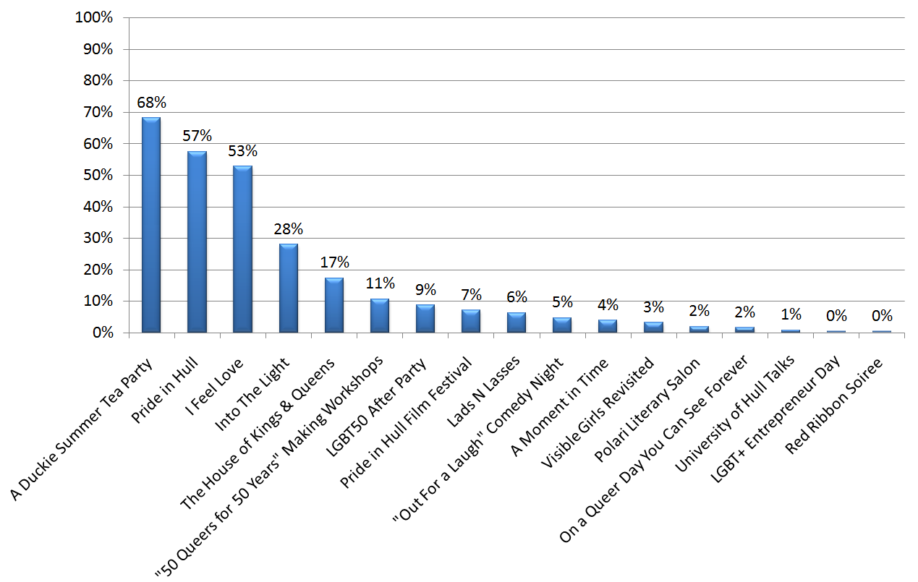

***Base: 254***

* Over half of respondents had attended ‘A Duckie Summer Tea Party’ (68%); ‘Pride in Hull’ (57%) and ‘I Feel Love’ (53%).
* Significantly greater proportion of Male respondents had attended the following events: Lads N Lasses (13%) and LGBT50 After Party (22%) compared with Females (5% and 4% respectively).
* Significantly greater proportion of those respondents who live in Hull attended ‘Pride in Hull’ (68%) compared with non-Hull residents (39%).
* Significantly greater proportion of those respondents who identified themselves as being a member of the LGBT community attended the following events: ‘Pride in Hull’ (66%); The Houses of Kings & Queens (28%) and LGBT50 After Party (20%) compared with those who did not: (54%, 15% and 4% respectively).

## 3.2 Agree/Disagree with statements about the LGBT50 event(s) attended

All respondents were asked whether they agreed or disagreed with particular statements with regards the events they had attended.

**Chart Q2. Agree/Disagree with statements regarding events attended**

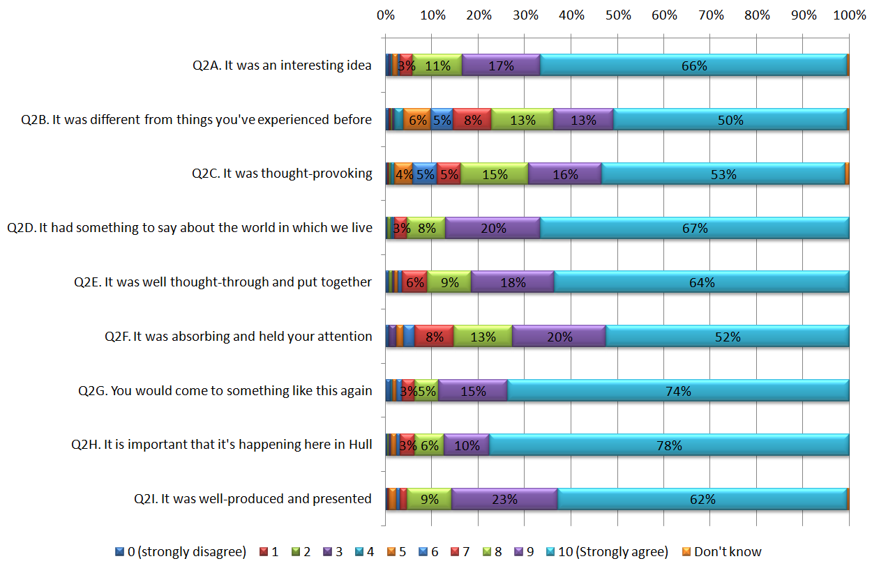

Base

254

253

254

253

254

254

252

253

254

* 83% of respondents agreed strongly (scoring a 9 or 10) that the event(s) they had attended was/were an interesting idea, only 3% scored 6 or less.
* 63% of respondents agreed strongly (scoring a 9 or 10) that the event(s) they had attended was/were different from things they had experienced before, 15% scored 6 or less.
* 68% of respondents agreed strongly (scoring a 9 or 10) that the event(s) they had attended was/were thought provoking, 11% scored 6 or less.
* 87% of respondents agreed strongly (scoring a 9 or 10) that the event(s) they had attended had something to say about the world in which we live, only 2% scored 6 or less.
* 81% of respondents agreed strongly (scoring a 9 or 10) that the event(s) they had attended was/were well thought through and put together, only 4% scored 6 or less.
* 73% of respondents agreed strongly (scoring a 9 or 10) that the event(s) they had attended was/were absorbing and held their attention, only 6% scored 6 or less.
* 89% of respondents agreed strongly (scoring a 9 or 10) that they would come to something like this again, only 4% scored 6 or less.
* 87% of respondents agreed strongly (scoring a 9 or 10) that it’s important that it is happening in Hull, only 3% scored 6 or less.
* 85% of respondents agreed strongly (scoring a 9 or 10) that the event(s) they had attended was/were well produced and presented, only 3% scored 6 or less.

## 3.3 Thoughts and feelings

All respondents were asked whether they felt their thoughts and feelings about their life or their future had changed as a result of attending LGBT50.

**Chart Q3. Thoughts and feelings changed?**

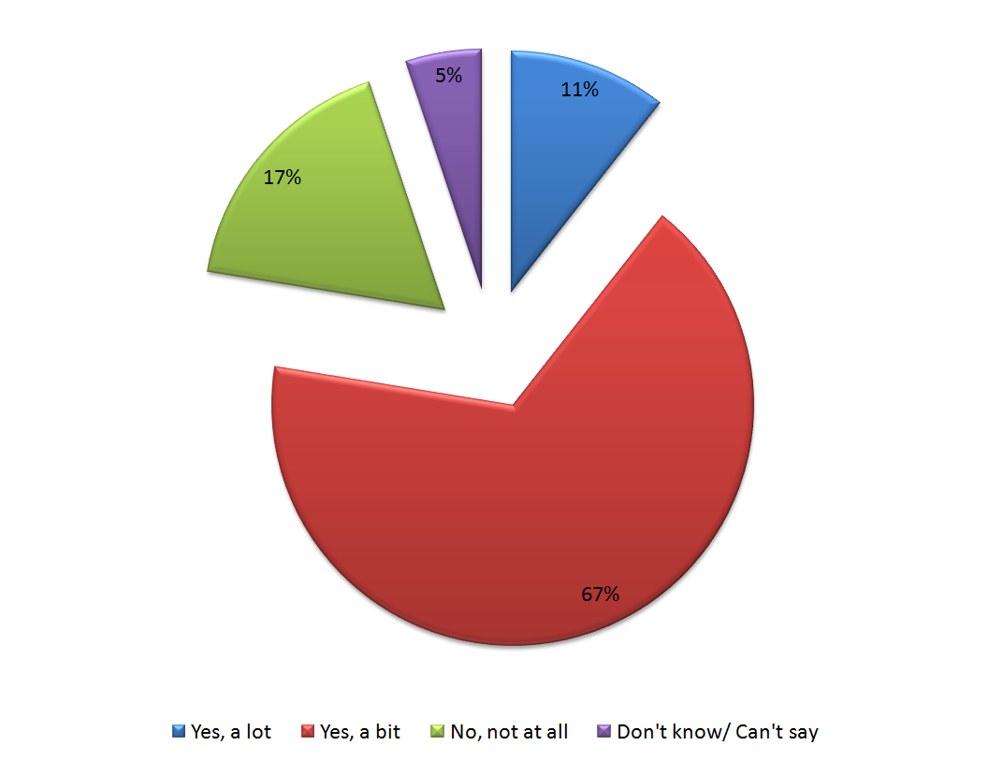

***Base: 254***

* 11% of respondents outlined that their thoughts and feelings about their life or their future had changed a lot as a result of attending the LGBT50, a further two thirds (67%) outlined their thoughts and feelings had changed a bit.

A full list of verbatim comments on how respondents thoughts and feelings had changed are available in Appendix 2.

4. Other events and activities

All Hull residents were asked whether they planned to attend or take part in other events and activities programmed for Hull UK City of Culture 2017.

**Chart Q6. Are you planning to attend or take part in other events and activities?**

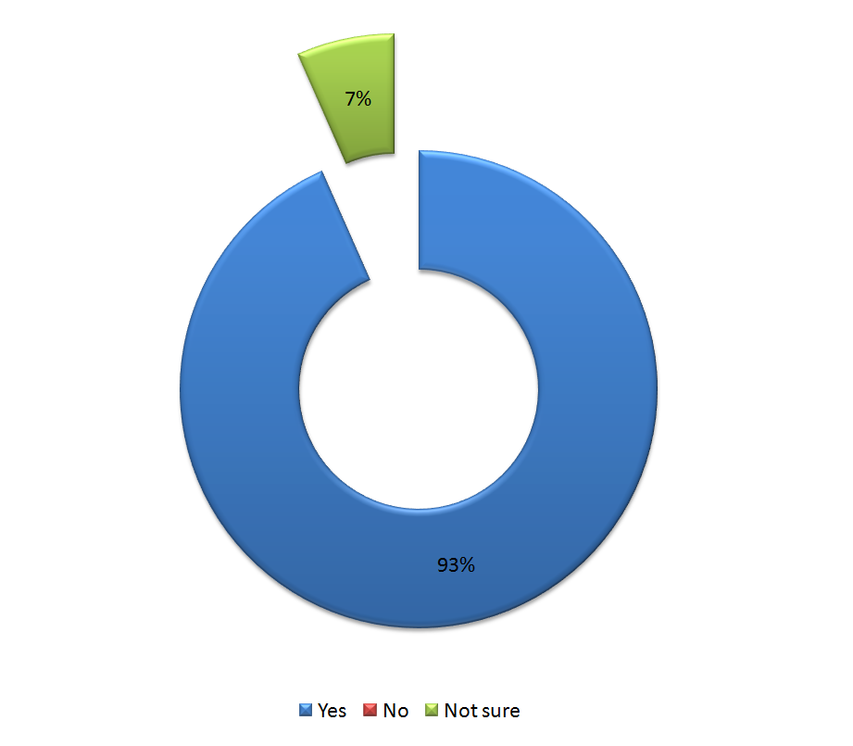

***Base: 166***

* 93% of Hull residents outlined that they are planning to attend or take part in other events and activities programmed for Hull UK City of Culture 2017, the remaining 7% were not sure. No resident responded with no.

5. Your visit

## 5.1 Reason for visit

All respondents who were not Hull residents were asked whether their visit to Hull on the day or days they attended LGBT50 was due to the event.

**Chart Q7. Was your visit to Hull on the day or days you attended LGBT50 mainly, partly or not at all due to that event?**

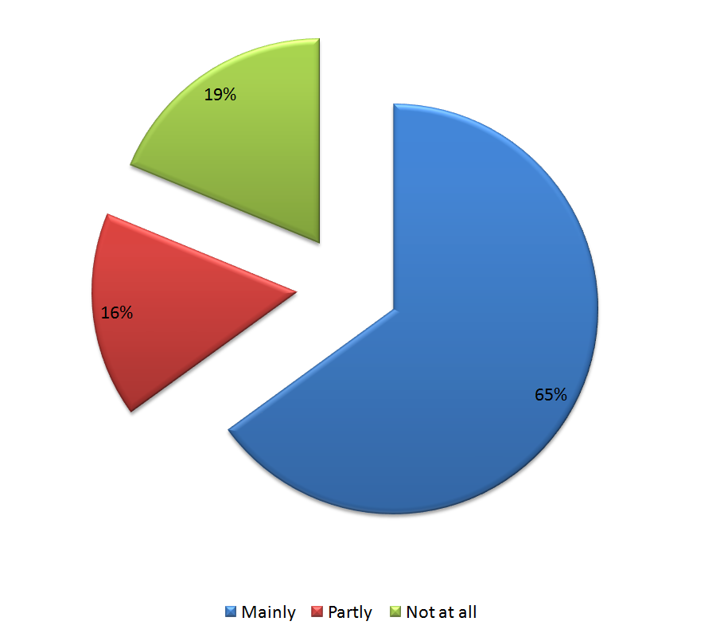

***Base: 80***

* Just under two thirds (65%) of non Hull residents outlined that their visit to Hull on the day or days they attended LGBT50 was mainly due to that event. 19% outlined that their visit was not at all linked to the event.

## 5.2 Other arts and cultural events or activities

All respondents who were not Hull residents were asked how many other arts and cultural events or activities they attended or taken part in or planned to attend/take part in during their visit.

**Chart Q8. Other arts and cultural events or activities**

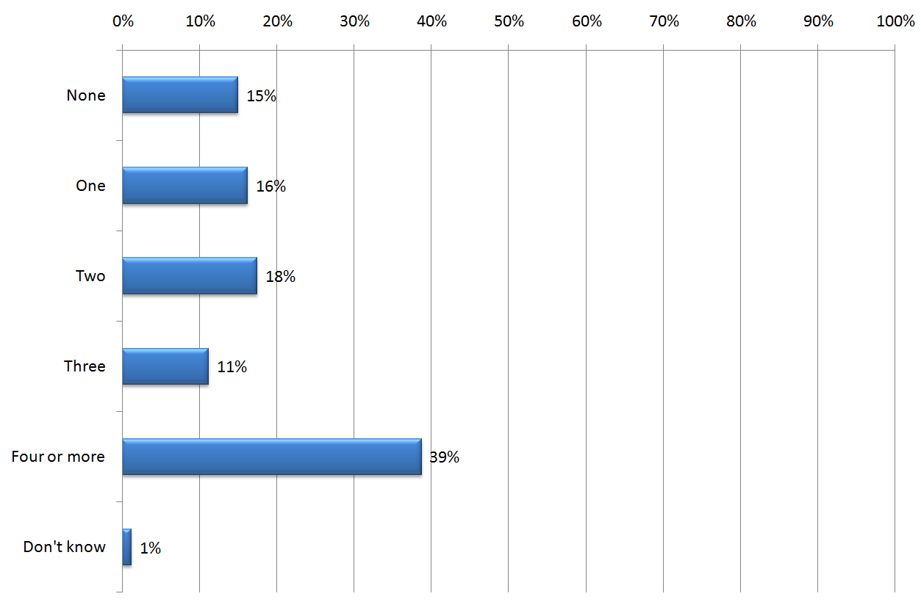

***Base: 80***

* Half of non Hull residents (50%) outlined that they had or planned to take part in 3 or more other art and cultural events or activities during their visit.
* 15% of non Hull residents outlined they have not or do not plan to do any other art and cultural events or activities during their visit.

## 5.3 Main purpose of visit

All respondents who were not Hull residents were asked when they attended an event as part of LGBT50, what was the main purpose of their visit to Hull.

**Chart Q9. Main purpose of visit**

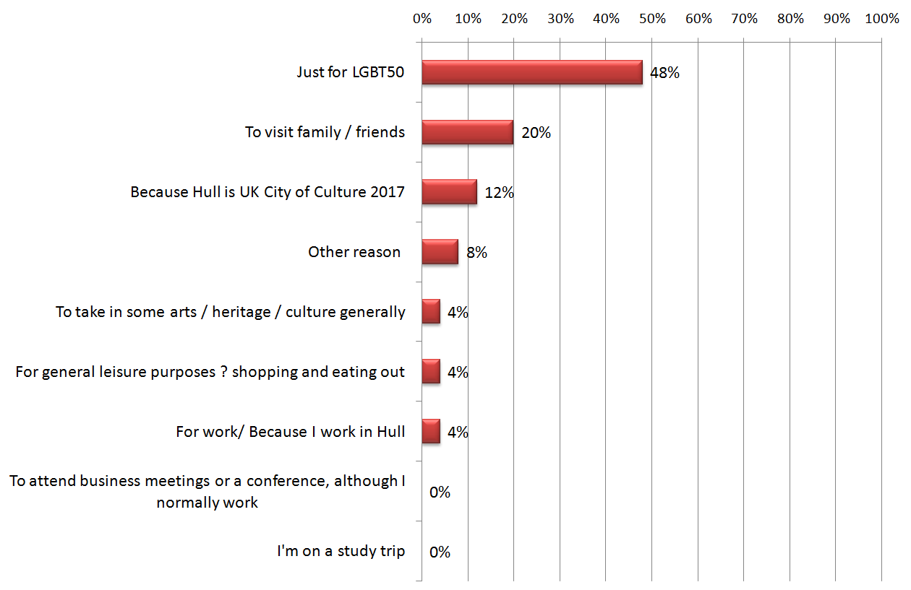

***Base: 25 (note this question was not asked in the online version of the survey)***

* Nearly half of non Hull residents (48%) who responded outlined that the main purpose of their visit was just for the LGBT50.

## 5.4 Have you previously been to Hull?

All respondents who were not Hull residents were asked whether they had been to Hull before coming to LGBT50.

**Chart Q10. Previously been to Hull**

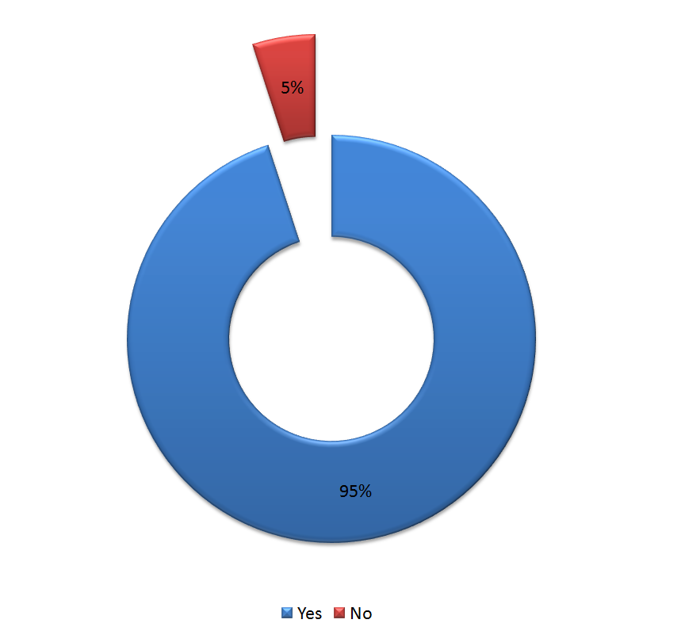

***Base: 80***

* 95% of non Hull residents outlined they had been to Hull before coming to LGBT50.

## 5.5 How frequently do you visit Hull?

All respondents who were not Hull residents and had visited Hull before LGBT50 were asked how frequently they visit Hull.

**Chart Q11. Frequency**

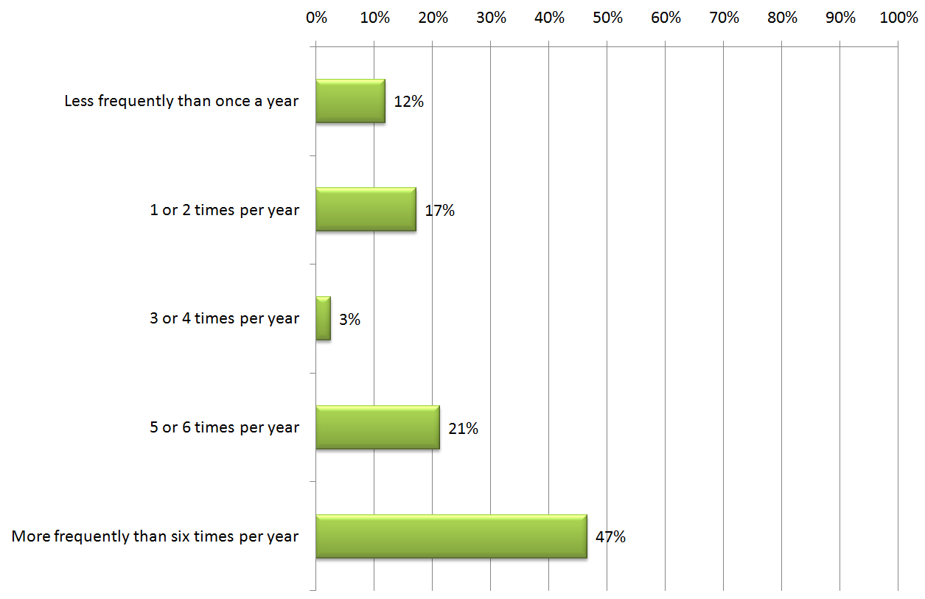

***Base: 75***

* Nearly half (47%) of non Hull residents who had visited Hull previously had done so more than 6 times per year.
* Significant difference between those employed who visited more than 6 times a year (36%), compared with those who were unemployed/retired/student/other (64%).

## 5.6 How frequently do you think you will visit Hull in future?

All respondents who were not Hull residents were asked how frequently they think they will visit Hull in the future.

**Chart Q12. Future frequency**

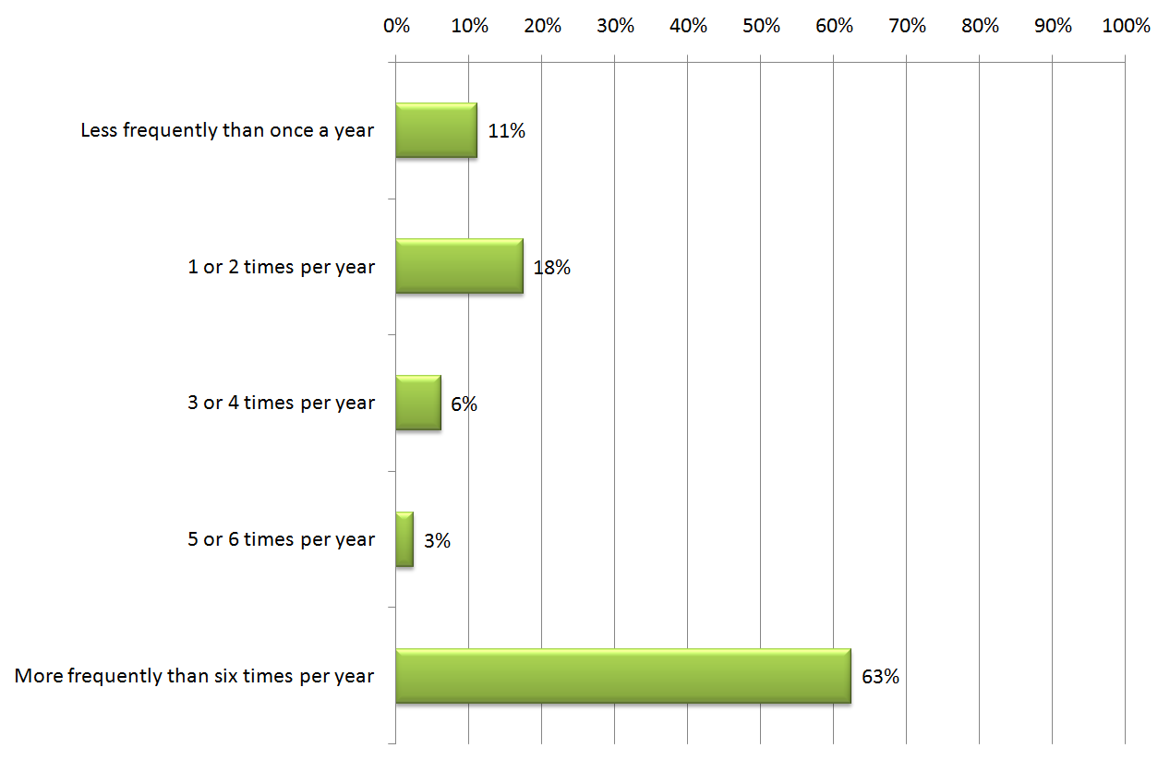

***Base: 80***

* 63% of non Hull residents outlined they would visit Hull more frequently than 6 times a year in the future.
* Significant difference between Males who outlined they would visit more frequently than 6 times a year in the future (34%) compared with Females (77%).
* Significant difference between those who identified themselves as a member of the LGBT community who outlined they would visit more frequently than 6 times a year in the future (30%) compared with those who are not (76%).

## 5.7 As a visitor, how satisfied are you with the following?

All respondents who were not Hull residents were asked how satisfied they were with the following as a visitor.

**Chart Q13. Visitor satisfaction**

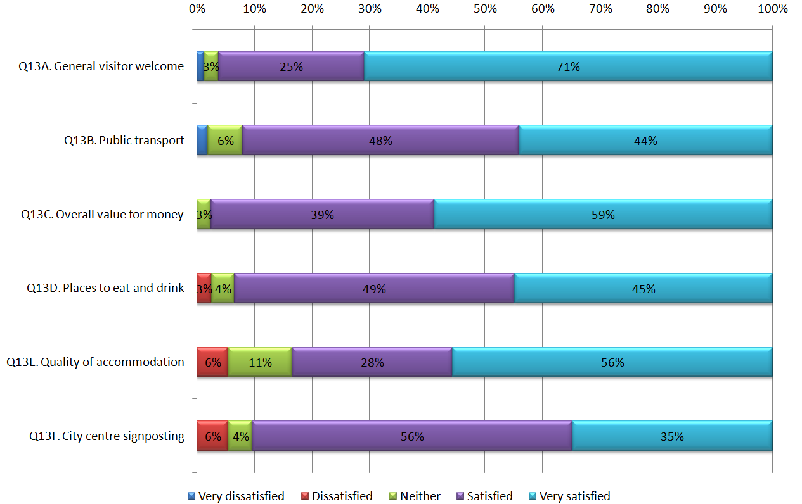

Base

72

36

76

80

50

79

* 96% of non Hull residents were satisfied/very satisfied with the general visitor welcome, only 1% were dissatisfied/very dissatisfied.
* 92% of non Hull residents were satisfied/very satisfied with public transport, only 2% were dissatisfied/very dissatisfied.
* 98% of non Hull residents were satisfied/very satisfied with overall value for money, nobody was dissatisfied/very dissatisfied.
* 93% of non Hull residents were satisfied/very satisfied with places to eat and drink, only 3% were dissatisfied/very dissatisfied.
* 83% of non Hull residents were satisfied/very satisfied with quality of accommodation, only 6% were dissatisfied/very dissatisfied.
* 90% of non Hull residents were satisfied/very satisfied with city centre signposting, only 6% were dissatisfied/very dissatisfied.

## 5.8 Length of stay to attend LGBT50 or Pride?

All respondents who were not Hull residents were asked did they visit just for the day, or did they stay overnight when they attended LGBT50 or Pride.

**Chart Q14. Day visit or overnight**

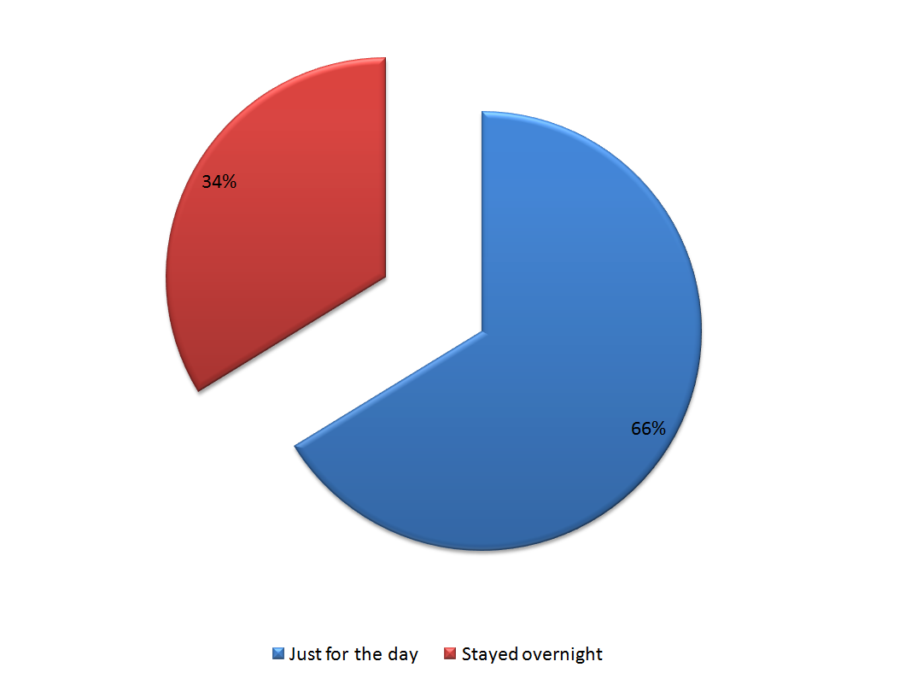

***Base: 80***

* Nearly two thirds (66%) of non Hull residents outlined they had only visited just for the day, the remaining 34% stayed overnight.
* Of those who stayed overnight (27), they spent on average 3 days and 3 nights in the area.

## 5.9 Accommodation during visit

All respondents who were not Hull residents were asked how much they spent personally on accommodation in Hull overall as part of their visit.

* Of those who stayed overnight and responded (26): 38% spent zero on accommodation; 19% spent less than £100 and the remaining 42% spent £100 or more.
* Of those who stayed overnight and responded (27): 59% stayed in a hotel, 33% stayed with friends/family and the remaining 7% stayed in other accommodation.

## 5.10 Spending

All respondents were asked how much they estimate they spent on themselves and others during their visit to Hull.

**Chart Q18. Spending**

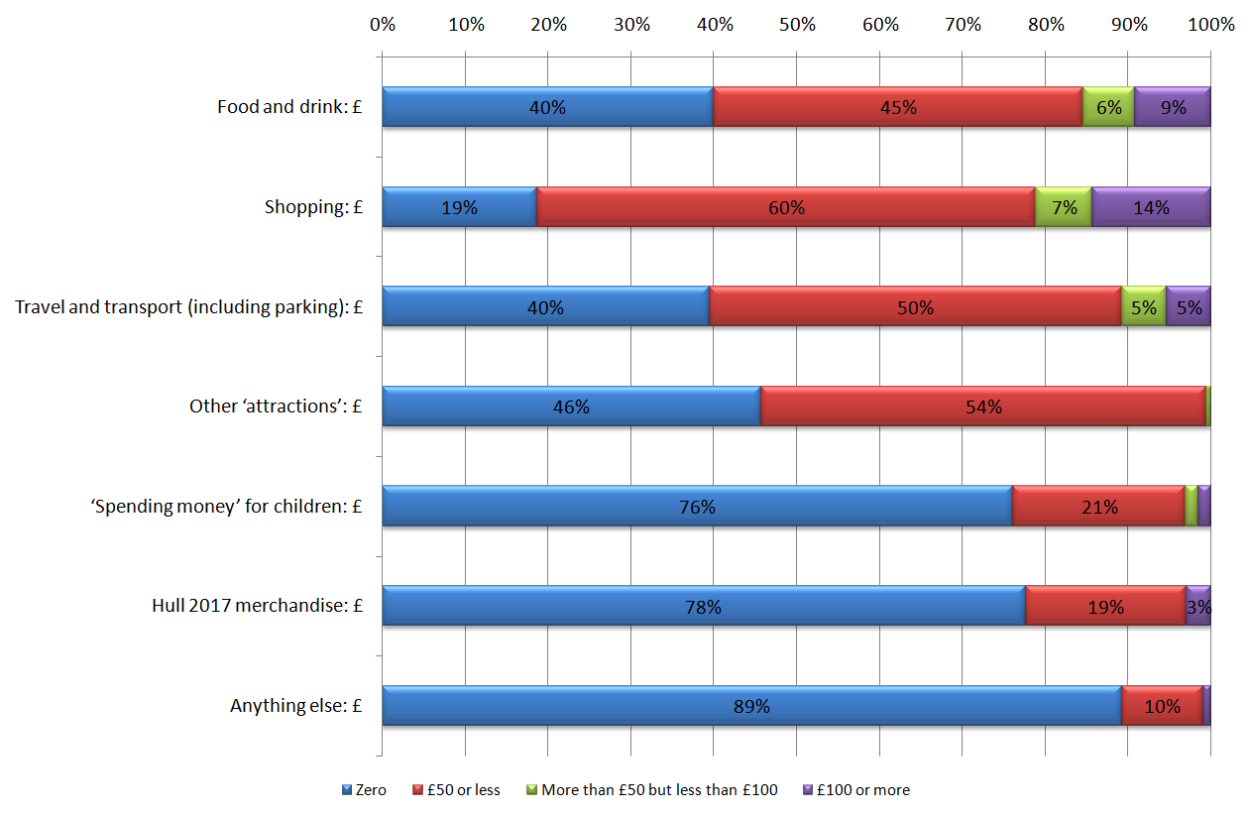

Base

103

134

130

175

167

203

175

* 45% of respondents outlined they spent £50 or less (not zero) on food and drink during their visit and 15% outlined they spent over £50.
* 60% of respondents outlined they spent £50 or less (not zero) on shopping during their visit and 21% outlined they spent over £50.
* 50% of respondents outlined they spent £50 or less (not zero) on travel and transport (including parking) during their visit and 11% outlined they spent over £50.
* 54% of respondents outlined they spent £50 or less (not zero) on other attractions during their visit and 1% outlined they spent over £50.
* 21% of respondents outlined they spent £50 or less (not zero) on spending money for children during their visit and 3% outlined they spent over £50.
* 19% of respondents outlined they spent £50 or less (not zero) on Hull 2017 merchandise during their visit and 3% outlined they spent over £50.
* 10% of respondents outlined they spent £50 or less (not zero) on something else during their visit and 1% outlined they spent over £50.

Appendix 1: Survey Questionnaire

**HULCUL003 - HULL 2017 LGBT50 events**

**Q1. Which of the following events did you attend from the LGBT50 programme?**

**READ OUT EVENT NAMES IN TURN, WAITING FOR THEM TO ANSWER BEFORE GOING ON TO THE NEXT.**

**Tick all that apply.**

|  |  |
| --- | --- |
| "50 Queers for 50 Years" Making Workshops (Throughout June and July, at 95 Jameson Street) | [ ] |
| A Moment in Time (22nd-29th July, Various locations) | [ ] |
| Pride in Hull (22nd July, Queens Gardens) | [ ] |
| Lads N Lasses (24th July, Fruit) | [ ] |
| Pride in Hull Film Festival (25th July, Various locations) | [ ] |
| University of Hull Talks (24th and 27th July, University of Hull | [ ] |
| "Out For a Laugh" Comedy Night (26th July, Kardomah 94) | [ ] |
| LGBT+ Entrepreneur Day (26th July, Kardomah 94) | [ ] |
| The House of Kings & Queens (From 27th July, Humber Street Gallery) | [ ] |
| Polari Literary Salon (27th July, Kardomah 94) | [ ] |
| On a Queer Day You Can See Forever (27th July, Humber Dock Street) | [ ] |
| Red Ribbon Soiree (28th July) | [ ] |
| A Duckie Summer Tea Party (29th July, Queen Victoria Square) | [ ] |
| Into The Light (29th July, Queen Victoria Square) | [ ] |
| I Feel Love (29th July, Hull City Hall) | [ ] |
| LGBT50 After Party (29th July, Fuel) | [ ] |
| Visible Girls Revisited (From 7th July, Artlink) | [ ] |

**Q2. On a scale of 0-10, where ‘0’ is ‘Strongly disagree’ and ‘10’ is ‘Strongly agree’, how much would you disagree or agree with the following statements about the LGBT50 event or events that you attended?**

**Read out statements in turn, waiting for them to answer before going on to the next.**

**IF THEY ATTENDED MORE THAN ONE EVENT, AND HAVE DIFFERENT VIEWS FOR EACH, ASK: Please could you give me your opinion based on your overall impression of the events?**

|  |  |  |  |  |  |  |  |  |  |  |  |  |
| --- | --- | --- | --- | --- | --- | --- | --- | --- | --- | --- | --- | --- |
|  | 0=Strongly disagree | 1 | 2 | 3 | 4 | 5 | 6 | 7 | 8 | 9 | 10=Strongly Agree | Don’t know/ Can’t say |
| It was an interesting idea | O | O | O | O | O | O | O | O | O | O | O | O |
| It was different from things you’ve experienced before | O | O | O | O | O | O | O | O | O | O | O | O |
| It was thought-provoking | O | O | O | O | O | O | O | O | O | O | O | O |
| It had something to say about the world in which we live | O | O | O | O | O | O | O | O | O | O | O | O |
| It was well thought-through and put together | O | O | O | O | O | O | O | O | O | O | O | O |
| It was absorbing and held your attention | O | O | O | O | O | O | O | O | O | O | O | O |
| You would come to something like this again | O | O | O | O | O | O | O | O | O | O | O | O |
| It is important that it's happening here in Hull | O | O | O | O | O | O | O | O | O | O | O | O |
| It was well-produced and presented | O | O | O | O | O | O | O | O | O | O | O | O |

**Q3. Have your thoughts and feelings about your life or your future changed as a result of attending LGBT50?**

**READ OUT OPTIONS**

|  |  |
| --- | --- |
| Yes, a lot | O ***– ASK Q4*** |
| Yes, a bit | O ***– ASK Q4*** |
| No, not at all | O |
| [DON’T READ OUT] Don’t know/ Can’t say | O |

**Q4. How have your thoughts and feelings changed?**

**TYPE IN BELOW**

|  |  |
| --- | --- |
|  | ________________________________________  ________________________________________ |

**Q5. Do you live in Hull?**

|  |  |
| --- | --- |
| Yes | O – **ASK Q6 THEN GO TO Q18** |
| No | O – **GO TO Q7** |
| Refused to say | O |

**Q6. Are you planning to attend or take part in other events and activities programmed for Hull UK City of Culture 2017?**

|  |  |
| --- | --- |
| Yes | O |
| No | O |
| Not sure | O |

**Q7. Was your visit to Hull on the day or days you attended LGBT50 mainly, partly, or not at all due to that event?**

|  |  |
| --- | --- |
| Mainly | O |
| Partly | O |
| Not at all | O |

**Q8. During this visit to Hull, how many other arts and cultural events or activities have you attended or taken part in, or do you plan to attend or take part in?**

|  |  |
| --- | --- |
| None | O |
| One | O |
| Two | O |
| Three | O |
| Four or more | O |
| Don’t know | O |

**Q9. When you attended an event as part of LGBT50, what was the main purpose of your visit to Hull?**

**DO NOT READ OUT ANSWERS - Select one answer only**

|  |  |
| --- | --- |
| Because Hull is UK City of Culture 2017 | O |
| To take in some arts / heritage / culture generally | O |
| To visit family / friends | O |
| To attend business meetings or a conference, although I normally work outside Hull | O |
| I’m on a study trip | O |
| For general leisure purposes – shopping and eating out | O |
| For work/ Because I work in Hull | O |
| Just for LGBT50 | O |
| Other reason (TYPE IN BELOW) | O __________________ |

**Q10. Have you been to Hull before coming to LGBT50?**

|  |  |
| --- | --- |
| Yes | O – **ASK Q11** |
| No | O – **GO TO Q12** |

**Q11. On average, over the course of a year, how frequently do you visit Hull?**

**READ OUT OPTIONS IF NECESSARY**

|  |  |
| --- | --- |
| Less frequently than once a year | O |
| 1 or 2 times per year | O |
| 3 or 4 times per year | O |
| 5 or 6 times per year | O |
| More frequently than six times per year | O |
| Don’t know/ Refused | O |

**Q12. Based on your experience during this visit, how frequently do you think you will visit Hull in future?**

**READ OUT OPTIONS IF NECESSARY**

|  |  |
| --- | --- |
| Less frequently than once a year | O |
| 1 or 2 times per year | O |
| 3 or 4 times per year | O |
| 5 or 6 times per year | O |
| More frequently than six times per year | O |
| Don’t know/ Refused | O |

**Q13. As a visitor to Hull, how satisfied are you with the following?**

**Read out statements in turn, waiting for them to answer before going on to the next.**

**If they say 'Satisfied' or 'Dissatisfied' check whether they mean 'VERY' or not.**

|  |  |  |  |  |  |  |
| --- | --- | --- | --- | --- | --- | --- |
|  | Very dissatisfied | Dissatisfied | Neither satisfied nor dissatisfied | Satisfied | Very satisfied | Not applicable/ Don't know |
| General visitor welcome | O | O | O | O | O | O |
| Public transport | O | O | O | O | O | O |
| Overall value for money | O | O | O | O | O | O |
| Places to eat and drink | O | O | O | O | O | O |
| Quality of accommodation | O | O | O | O | O | O |
| City centre signposting | O | O | O | O | O | O |

**Q14. Did you visit just for the day, or did you stay overnight when you attended LGBT50 or Pride?**

|  |  |
| --- | --- |
| Just for the day | O ***– GO TO Q18*** |
| Stayed overnight | O ***– ASK Q15*** |

**Q15. During your visit, at the time you attended LGBT50, how many nights in total did you stay in the area, and how many days in total?**

**TYPE IN BELOW**

|  |  |
| --- | --- |
| Number of days: | ________________________________________ |
| Number of nights: | ________________________________________ |

**Q16. Please could you tell me how much you spent personally on accommodation in Hull overall as part of your visit (to the nearest £)?**

**TYPE IN BELOW. TYPE ZERO IF THEIR ACCOMMODATION WAS FREE, BUT LEAVE BLANK IF THEY DON’T KNOW OR PREFER NOT TO ANSWER**

|  |  |
| --- | --- |
| £ spent on accommodation: | ________________________________________ |

**Q17. What type of accommodation did you stay in?**

**READ OUT LIST IF NECESSARY. Tick all that apply.**

|  |  |
| --- | --- |
| Bed and Breakfast | [ ] |
| Guest House | [ ] |
| Hotel | [ ] |
| Self-catering | [ ] |
| Friends/family | [ ] |
| Static caravan | [ ] |
| Touring caravan | [ ] |
| Camping | [ ] |
| Other – please specify below: | [ ] |
| Refused to say | [ ] |

***[ASK EVERYONE]* We are asking the following questions to measure the impact that arts and cultural events have on the economy of Hull. We understand that this information is of a sensitive nature, but if you are willing to share it with us, it will be greatly appreciated by Hull 2017.**

**Q18. How much do you estimate you spent on yourself and others with you on the following things during your visit to Hull, when you attended LGBT50?**

**READ OUT EACH CATEGORY BELOW, AND TYPE THE ANSWER FOR EACH.**

**TYPE '0' OR 'Zero' IF THEY SPENT NOTHING, BUT LEAVE BLANK IF THEY DON’T KNOW OR PREFER NOT TO ANSWER.**

|  |  |
| --- | --- |
| Food and drink: | ________________________________________ |
| Shopping: | ________________________________________ |
| Travel and transport (including parking): | ________________________________________ |
| Other ‘attractions’: | ________________________________________ |
| ‘Spending money’ for children: | ________________________________________ |
| Hull 2017 merchandise (e.g. Mugs, t-shirts): | ________________________________________ |
| Anything else: | ________________________________________ |

**[READ OUT] The final questions are just to collect a little bit of information about yourself. This helps us confirm that we’re representing the views of all of the different types of people who attended the event, to let us see whether different types of people have different opinions, and for Hull 2017 to demonstrate to their funders whether they are meeting their promise to programme events that appeal to a broad range of people.**

**You don’t have to answer all of these questions, and please be assured that your answers will not be linked to your name or telephone number when we analyse the data.**

**Q19. Please could you tell me your postcode?**

* **IF THEY ASK WHY: This will be used for evaluation purposes only, to map the audience for this project.**
* **IF THEY DON'T WANT TO TELL YOU THEIR FULL POSTCODE, ASK THEM TO GIVE YOU AT LEAST THE FIRST HALF AND THE FIRST DIGIT OF THE SECOND PART, e.g. "HU1 7".**
* **IF THEY LIVE OUTSIDE THE UK, JUST ASK FOR THE COUNTRY THAT THEY LIVE IN AND TYPE THAT IN BELOW.**
* **TYPE "REF" IF THEY REFUSE.**

|  |  |
| --- | --- |
| Postcode: | ________________________________________ |

**Q20. Which of the following best describes your employment status?**

***READ OUT OPTIONS, AND SELECT ONE ANSWER ONLY***

|  |  |
| --- | --- |
| Employed / working full or part time | O |
| Self-employed | O |
| Unemployed | O |
| On a government scheme for employment training | O |
| Looking after family / home | O |
| Unable to work | O |
| Retired | O |
| Student | O |
| Prefer not to say/ Refused | O |

**Q21. Are you ...? [READ OUT ONLY IF NECESSARY]**

|  |  |
| --- | --- |
| Male | O |
| Female | O |
| Transgender | O |
| Gender non-conforming | O |
| Other (please describe - TYPE IN BELOW) | O_____________________________ |
| [DON’T READ OUT] Prefer not to say/ Refused | O |

**Q22. Do you identify as a member of the LGBT community?**

|  |  |
| --- | --- |
| Yes | O |
| No | O |
| Sometimes | O |
| Prefer not to say | O |

**Q23. How would you describe your ethnic background?**

***DON'T READ OUT LIST UNLESS IT HELPS TO CLARIFY THEIR ANSWER. CODE ONE ANSWER ONLY.***

|  |  |
| --- | --- |
| White - English/ Welsh/ Scottish/ Northern Irish/ British | O |
| White – Irish | O |
| White - Gypsy or Irish Traveller | O |
| White – Polish | O |
| White - Any other White background [TYPE IN BELOW] | O ___________________________ |
| Mixed/multiple ethnic groups - White and Black Caribbean | O |
| Mixed/multiple ethnic groups - White and Black African | O |
| Mixed/multiple ethnic groups - White and Asian | O |
| Mixed/multiple ethnic groups - Any other Mixed/multiple ethnic background [TYPE IN BELOW] | O __________________________ |
| Asian/Asian British - Bangladeshi | O |
| Asian/Asian British - Indian | O |
| Asian/Asian British - Pakistani | O |
| Asian/Asian British - Chinese | O |
| Asian/Asian British - Any other Asian background [TYPE IN BELOW] | O __________________________ |
| Black/African/Caribbean/Black British - African | O |
| Black/African/Caribbean/Black British - Caribbean | O |
| Black/African/Caribbean/Black British - Any other Black/African/Caribbean background [TYPE IN BELOW] | O ___________________________ |
| Arab | O |
| Any other ethnic background [TYPE IN BELOW] | O ___________________________ |
| Prefer not to say/ Refused | O |

**Q24. Which of the following age groups do you fall into?**

|  |  |
| --- | --- |
| 16 – 17 | O |
| 18 – 19 | O |
| 20 – 24 | O |
| 25 – 29 | O |
| 30 – 34 | O |
| 35 – 39 | O |
| 40 – 44 | O |
| 45 – 49 | O |
| 50 – 54 | O |
| 55 – 59 | O |
| 60 – 64 | O |
| 65 – 69 | O |
| 70 – 74 | O |
| 75 + | O |
| [DON’T READ OUT] Prefer not to say/ Refused | O |

**Q25. Are your day-to-day activities limited because of a health problem or disability which has lasted, or is expected to last, at least 12 months?**

***IF 'Yes', CHECK WHETHER THEY ARE LIMITED A LITTLE OR LIMITED A LOT.***

|  |  |
| --- | --- |
| No | O |
| Yes- limited a little | O |
| Yes - limited a lot | O |
| [DON’T READ OUT] Prefer not to say/ Refused | O |

**Q26. How many people, including yourself, were in your group at the LGBT50 event(s)?**

**Please enter in a numerical format, i.e. ‘2’ as opposed to text format ‘two’.**

|  |  |
| --- | --- |
|  | ________________________________________ |

**Q27. Including yourself, how many people were in your party at the Longhill Burn event in each of the following age categories? *READ OUT THE CATEGORIES., AND WRITE THE NUMBER OF PEOPLE IN EACH BOX.***

|  |  |
| --- | --- |
| Age 0-2 | ________________________________________ |
| Age 3-5 | ________________________________________ |
| Age 6-10 | ________________________________________ |
| Age 11-15 | ________________________________________ |
| Age 16-17 | ________________________________________ |
| Age 18-19 | ________________________________________ |
| Age 20-24 | ________________________________________ |
| Age 25-29 | ________________________________________ |
| Age 30-34 | ________________________________________ |
| Age 35-39 | ________________________________________ |
| Age 40-44 | ________________________________________ |
| Age 45-49 | ________________________________________ |
| Age 50-54 | ________________________________________ |
| Age 55-59 | ________________________________________ |
| Age 60-64 | ________________________________________ |
| Age 65-69 | ________________________________________ |
| Age 70-74 | ________________________________________ |
| Age 75+ | ________________________________________ |
| Prefer not to say/ Refused | O |

**Q28. Would you be happy for Hull 2017, the University of Hull or their official evaluators to contact you to take part in future research?**

***CODE 'NO' IF THEY ARE UNCERTAIN.***

|  |  |
| --- | --- |
| Yes | O |
| No | O |

**Q29. Please could you give me some contact details for yourself?**

***GO THROUGH THE BOXES BELOW.***

**IF THEY ARE CONCERNED, TELL THEM: Please be assured that your details will not be used for any purposes other than for asking you to take part in future research.**

|  |  |
| --- | --- |
| Name: | _________________________ |
| Email address: | _________________________ |
| Telephone number (TYPE ‘Same’ IF THEY SAY THE NUMBER YOU’RE CALLING ON): | _________________________ |

**That's all of the questions that I have. Thank you for your time today.**

**Just to confirm, my name is (....) and I've been calling today from Marketing Means, an independent research agency, on behalf of Hull City of Culture 2017.**

**If you'd like to check that this survey is a genuine piece of research, I can give you either our own number or the Market Research Society's phone number. Do you need either of those numbers?**

**IF YES:**

**Marketing Means =0800 849 8014**

**Market Research Society number = 0500 39 69 99**

Appendix 2: Verbatim listings of comments made Q4

**Q4 – How have your thoughts and feelings changed?**

* You didn't realise about the history of the area in which we live in. I was a bit ignorant really beforehand.
* Yes I've met some lovely people and although I've always been understanding and have empathy for members of LGBT community I still recognise there's an ongoing need to still change attitudes in some parts of our society.
* We were overwhelmed with the whole concept of the day, bringing everyone together with events in QVS and the tea party, was quite enjoyably emotional, who would have thought this time last year we would have been having a tea party cared for by the volunteers in waiters/s outfits, having tea, scones and cream, sharing this enjoyable, happy experience with others and the dancing on the Queen Victoria monument.
* Very respected about other people’s gender
* Understand more about inclusion and importance of all members of society being allowed to grow and shine their way without prejudice from others
* They were very interesting events, informative and amusing, the crowd participation and the lovely people hosting the event really inspired me.
* They have reaffirmed my feelings about the LGBT50 community and given a feeling of positivity generally about LGBT50 and its place in Hull
* The younger generation seem to be more accepting.
* The whole event was liberating.
* The struggle in the past and what needs to happen for the future
* That the law changed within my lifetime and how difficult it must have been for people to express their love
* That after all everyone has done to change LGBT law/rights in the past, I should allow myself to be me.
* Take experiences into everything I do, will challenge prejudice more strongly
* Such a lot of fun, with friendly talent.
* Stop and think why
* Seen many diverse people all getting on so well together and feel more hopeful that people in general are becoming more accepting of difference by the way it was celebrated
* Seeing more open and accepting than I might have considered before.
* Seeing how it was 50 years ago and hoping that all the love and joy will last.
* Reminder of the fight for equality and justice for LGBT people. That we have come far, but that there is still more to do.
* Realisation that we are lucky in Britain
* Raised awareness. Feeling more affirmed.
* Positive hope for the future
* Positive - feel welcomed
* Not really about the however I have found out much about the history over the acceptance over the last 50 years and found out about various icons locally and nationally
* No
* Need to be more active in the community
* Need the world to do more so people recognise this
* My thoughts have changed because I am more aware of the meaning of LGBT50.
* My perception of the event was heart warming to see
* My eyes have been opened to the scrutiny that LGBT community used to get and what has happened following decriminilisation.
* My daughter has just married her female partner and this would have been legally impossible I have thought about their relationship much more.
* My awareness of LGBT50 culture and history has been raised by the event as has my awareness of the culture and history of Hull itself.
* Much more aware of the struggle in the past for LGBT
* More understanding of the struggles of others.
* More understanding
* More positive about myself
* More awareness of the various nuances in gender and sexuality. Will try and be even more sensitive in terms of use of pronouns etc.
* More aware of the struggles faced by LGBT communities around the world
* Me and my wife got married recently, it was thought provoking and inspirational for us.
* Made me think the gay community be the same as us
* Made me more aware of the struggle in the past, thankful how times have changed
* Made me more aware of the challenges people face in society.
* Made me more aware how different it was over 50 years ago
* Made me feel more supported in my community.
* LGBT community is more visible and accepted
* Kings and queens made me reflect on issues abroad
* Just to realise how hard it can be for LGBT people and how far things have come
* Just that I know people who would have been criminalised in my youth.
* Just been more aware of the LGBT community and the people who are out there.
* It's nice to see all the support that everyone has for the LGBT community, and make me feel a lot more confident in the future for being accepted etc
* It was really interesting to hear the history of the last 50 years, my son is involved with LGBT50 and this has helped him a lot. LGBT50 should continue in Hull in the years to come as well as other cultural events.
* It was nice to see different people attending the event who were not necessarily involved with LGBT50.I am in a same sex marriage with 2 young children and the event made me feel more positive about my relationship.
* It was good for pride to be so visible and so well promoted this year. Makes me feel more confident that, going forward, LGBT rights and safety will continue to improve
* It reminds me how far we've come. The sacrifices those before me have made for my community.
* It makes you open your eyes a little bit more
* It makes me think that these events should happen more because it makes people think what the world should be like, there should be less prejudice.
* It made me very proud to come from Hull and realised what an amazing city we are for putting on such a wonderful week where everyone from all walks of life felt like one big happy family
* It made me reflect on my youth in the 1960s when the law was repealed I was 14, and I now realise that I probably had friends who could have been criminalised.
* It has made me even more aware of how important it is to be a totally inclusive society all the time not only for part of the year. Alongside the inspiring stories of individuals and the openness and joy of the event there is obviously still extreme prejudices against LGBT members of society and this is heartbreaking. It has made me more conscious of the fight to keep this open perspective and conversation developing in the future.
* It has given me a better awareness of how things have changed since the 60s and a better awareness of the better connection with people that exists nowadays. My daughter is disabled and was fully accepted at the events.
* IN A POSITIVE WAY I FELT MORE PEOPLE ARE MORE ACCEPTING NOW
* I've learnt a lot about the history of gay life. I am straight myself, I thought I knew a lot but I realised that wasn't the case. It was lovely to see everyone come together.
* I'm less judgmental and helped my 12yo to see there was nothing wrong with LGBT
* I would now support more Gay Rights, and I feel more positive.
* I was moved by the bigotry some have to go through.
* I was amazed at the amount of people lining the route to the Parade, and how many people were visibly enjoying themselves there and at other events. Many of these events felt like a night out anyway and not a specific LGBT one - felt more mainstream!
* I understand a lot more about the culture
* I think that the events made Hull a more interesting place and they have broadened my outlook about Hull, my husband died in May and these events have been good for me and I hope they continue into the future.
* I think that I have realised how difficult it has been for LGBT people in the past and how much more we still need to do to get tolerance from everybody. I think it was an extremely positive week of celebrations.
* I think people are becoming more accepting
* I should think before I speak.
* I run a company which combats isolation and we have an open equality programme. I recognise that the equality process which started with LGBT50 50 years ago is still continuing, in the same way that the equality process with my anti isolation company is still evolving.
* I learnt to appreciate how much more it is accepted now in society compared to those who had to hide it years ago (this was due to the dance and speech at Victoria square)
* I knew Hull was an accepting place but I didn't know to what extent. It was very educational.
* I just feel that little bit prouder of being part of the LGBTQ+ community.
* I have more compassion towards the people from the LGBT50 community, I feel more for them. The events were really enjoyable, we enjoyed joining in with the dancing.
* I feel that there is a more accepting feel to the city.
* I feel much more confident about expressing myself in public as a result if attending
* I feel more tolerant regarding the LGBT50 community.
* I feel more tolerant and open minded. It was lovely to see all types of genders, all together. It made me ask myself why do we have a gender?
* I feel more proud living somewhere that accepts these types of events and way of life. It has made me happier about living here.
* I feel more optimistic about the general population and their ideas around tolerance and acceptance. There are good people out there and most media/TV/newspapers seem to focus on the depressing it was nice to see such joy!
* I feel heartened that people seem far more accepting of people different to them than they were when I was a child.
* I didn't really know the history behind the changes; it made me want to read more about it.
* I did not have an understanding of the history of the legislation surrounding LGBT50 but I do now.
* I appreciate much more the need for tolerance and understanding, and that there is a long way to go with this.
* I am pleased to be a guy man, I can be myself more than ever before.
* I am more aware of how isolated some people feel
* I am going to more of the LGBT50 events and more general events of Hull 2017. It was a brilliant event. I have no prejudices.
* I am 50 this year. Such a lot has changed in my life time. Still loads of progress to make.
* I always thought that everybody has a life and that as long as it does not interfere with others it is ok for them to do that. They were fun events and we really enjoyed them, they were so big and thought provoking.
* I always had strong views on society not understanding what gay people had to endure in the past
* I always enjoy coming to Pride events in Hull
* Hull lacks a proper queer representation for most of the year.
* Have a lot more respect for the LGBT+ community
* Greater understanding of diversity, just how broad that spectrum is! Understand the word 'pride' better and what it means to many of my friends.
* Good to see LGBT becoming accepted as a social norm
* From just pink to rainbow!
* Felt I need to be more aware of issues around LGBT
* Feel proud. Want to get more involved in my local community. Thank you!
* Feel more validated as a gay man. Proud of the reaction of Hull people.
* Exhibition showed a different side of sexuality that I haven't seen before.
* Didn't realise how bad things used to be with regards to attitudes towards gay people.
* Despite having attended Pride in previous years, I was pleasantly surprised to see how many people in Hull were out and proud. I also thought more about the impact on people of all ages from the changes in the law.
* Broadened my understanding of all LGBTQ people
* Better understanding of LGBT people and the struggles they face.
* As a straight chap it was an excellent way for me to show support.
* As a person of 67 years I am now more aware of how deeply hurt those people have been hurt by society are and I hope very much that this will not happen in the future. I did not realise how many people there were who are not actually different, they were not able to be themselves. The advertising of events was not very good.
* As a mature trans woman I find the interest and the support about so moving its time, keep it up Hull and Britain.
* As a heterosexual person, I'd never attended a gay-majority or gay-friendly event before because I thought I'd feel awkward/out-of-place at a 'gay' event. I really enjoyed myself & in future I wouldn't avoid an event because it was advertised as gay-friendly or LGBTQ+. In future if I want to go to an event then I'll go regardless of how it is promoted.
* Amazed at how many people lined the route and the welcome that we got from them which was a surprise.
* Always been open-minded, but it was lovely to see people of the LGBT community feel comfortable and safe enough to be themselves and show affection for one another. It's amazing how far the LGBT community has come and struggled, but I think there's still a long way to go to achieve further acceptance and equal rights.
* All enjoyable
* Accepting people for what they are.
* A lot has changed in 50 years, it was represented well in the event that I attended in Hull.
* A lot for the good
* 50 Queers made me think about arts and crafts, made me think about doing something similar. The historical side about Hull became more clear after the LGBT event. The icons of the 50 Queers broadened my knowledge.