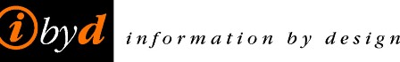

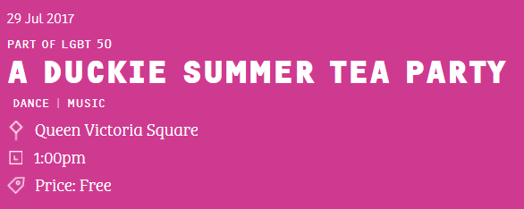

**HULL2017 CITY OF CULTURE**

**A DUCKIE SUMMER TEA PARTY**

**AUDIENCE ESTIMATES**

**METHOD**

Six counting points were utilised in Queen Victoria Square and counted between the hours of 12:00 noon and 6:00 pm.

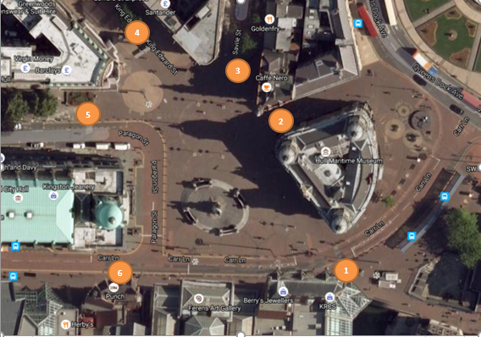

**AUDIENCE ESTIMATES**

The audience estimates for each hour are shown below.

The total audience estimate for the six hour period is **43,133**

**Information by Design**

**4 August 2017**