Show me the money!
14:45 – 15:30 at C4DI Theatre
Susannah Simons - 0773 648 1163
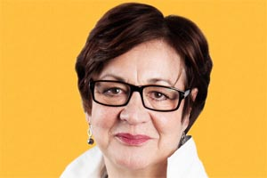 Director Arts and Outreach for Canvas, an Arts Council England funded project
Dominic Gibbons- 07730 488153
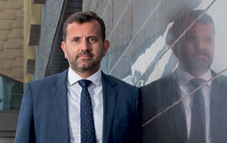 Managing Director of Wykeland Group
Francesca Hegyi - ?
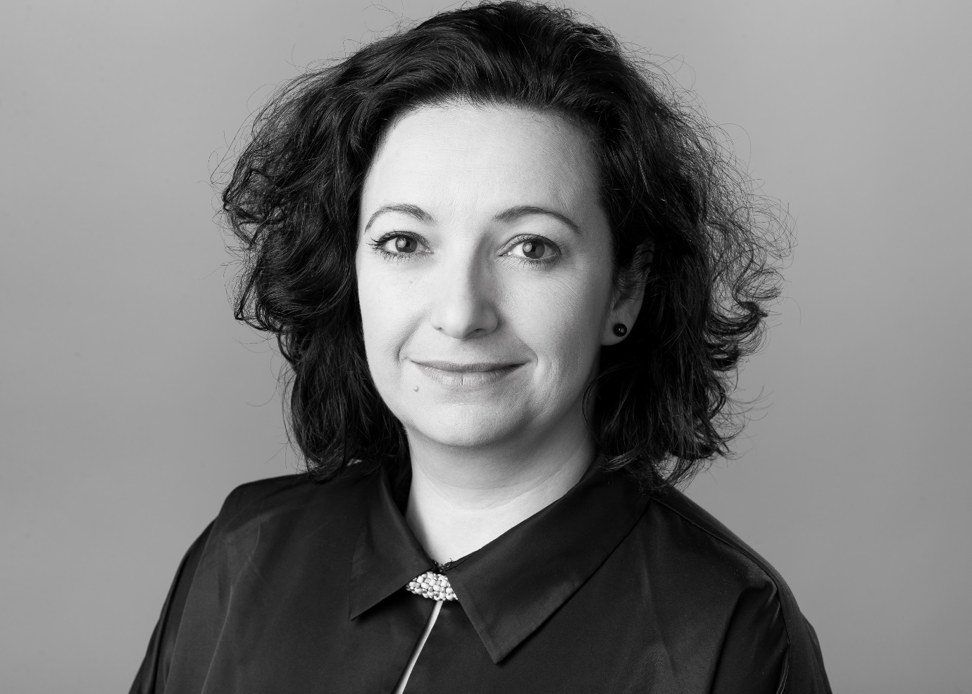 Executive Director Hull 2017
Pat Connor - 07710 304053
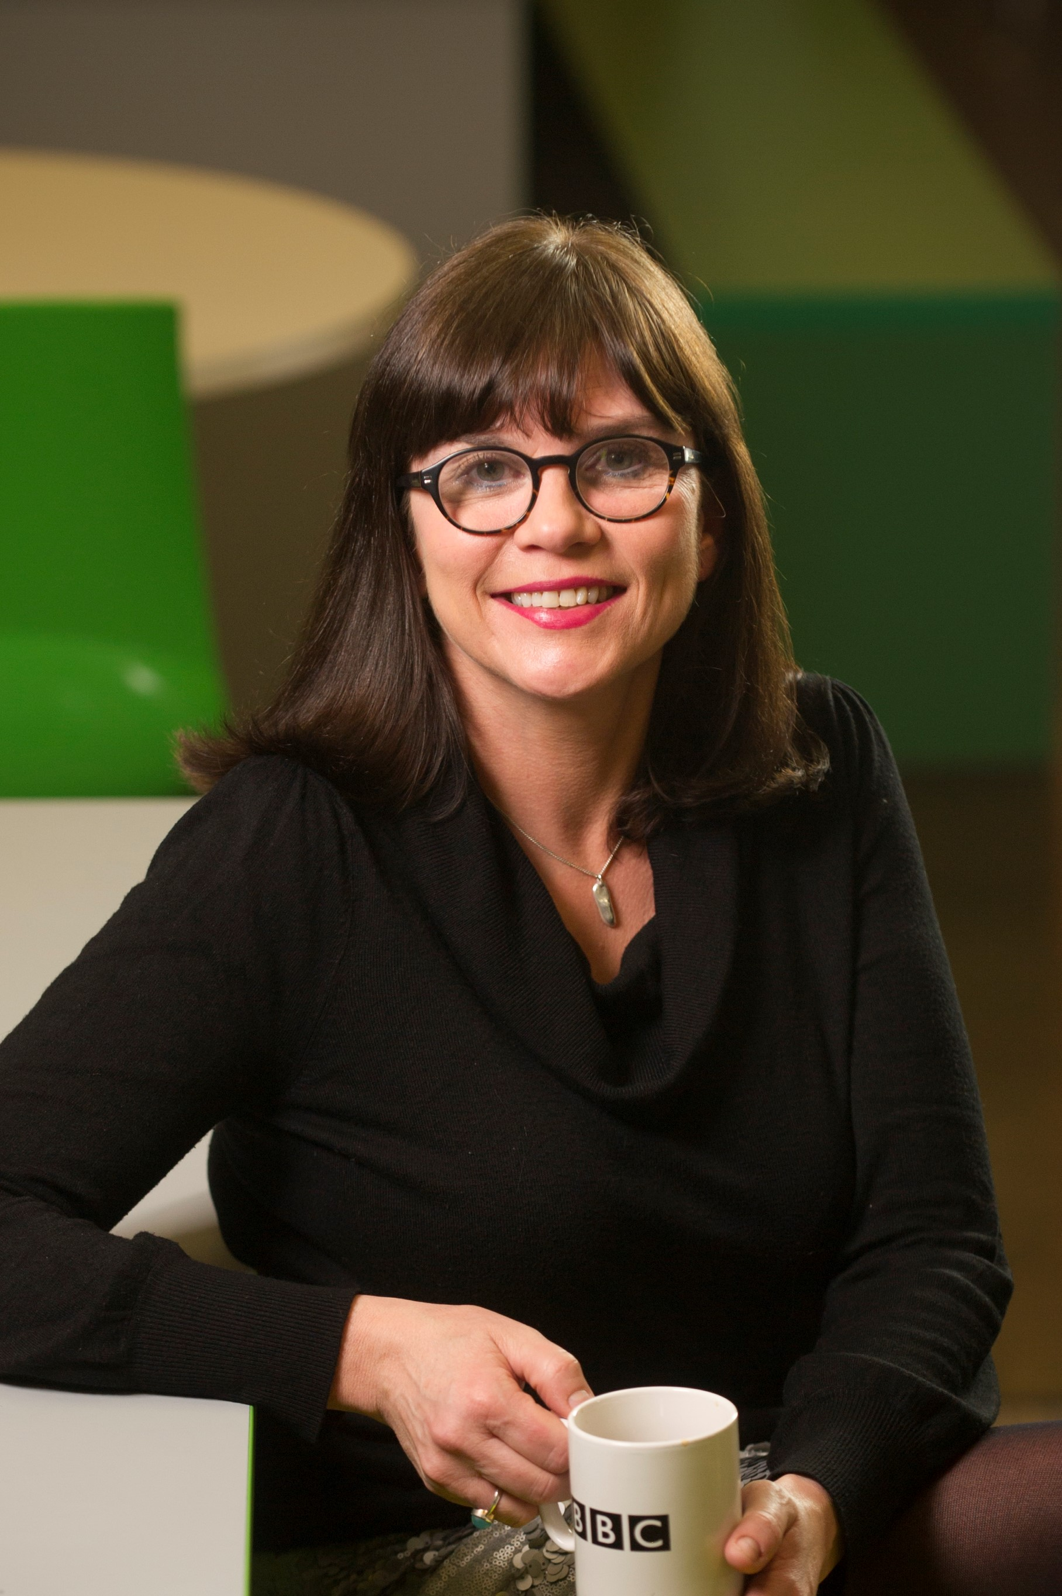 Head of BBC Development & Events, UK & Director, BBC South West
Dr Kevin Moore - 078500 99467
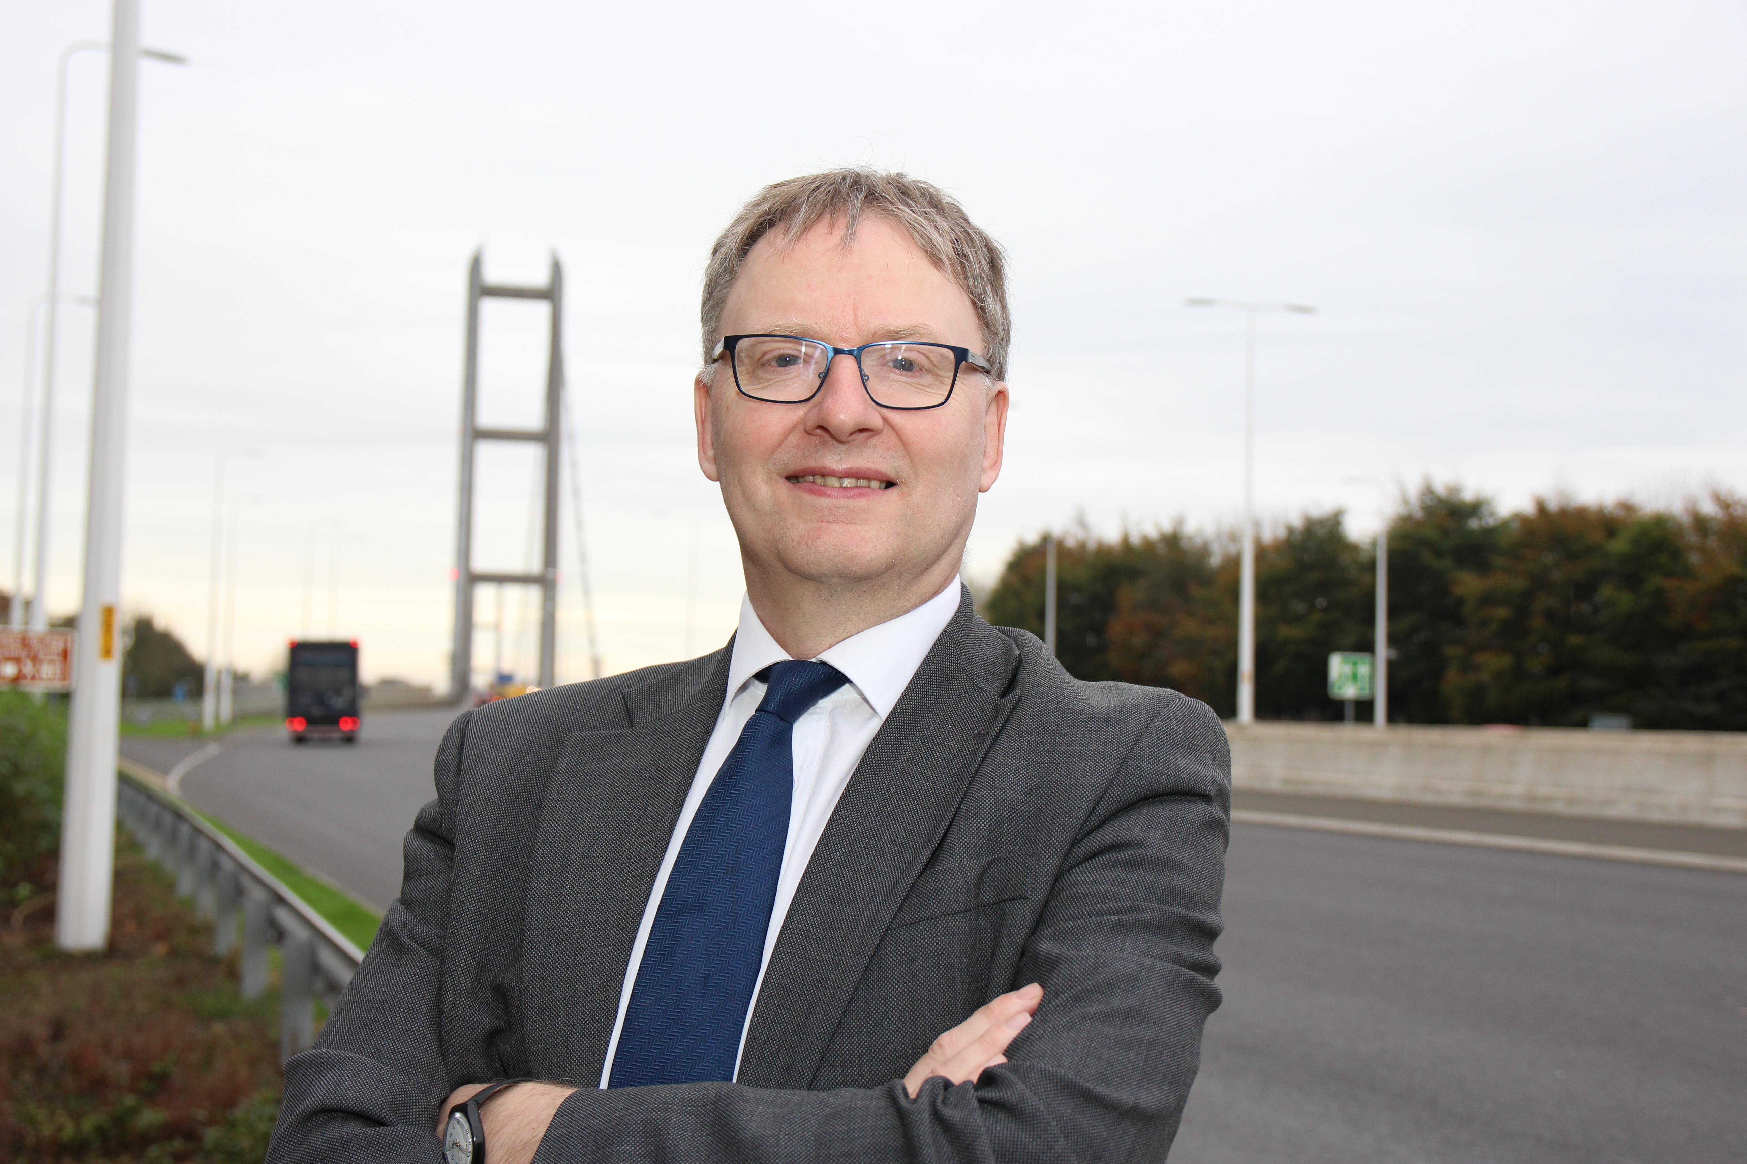 Chief Executive at Humber Bridge

