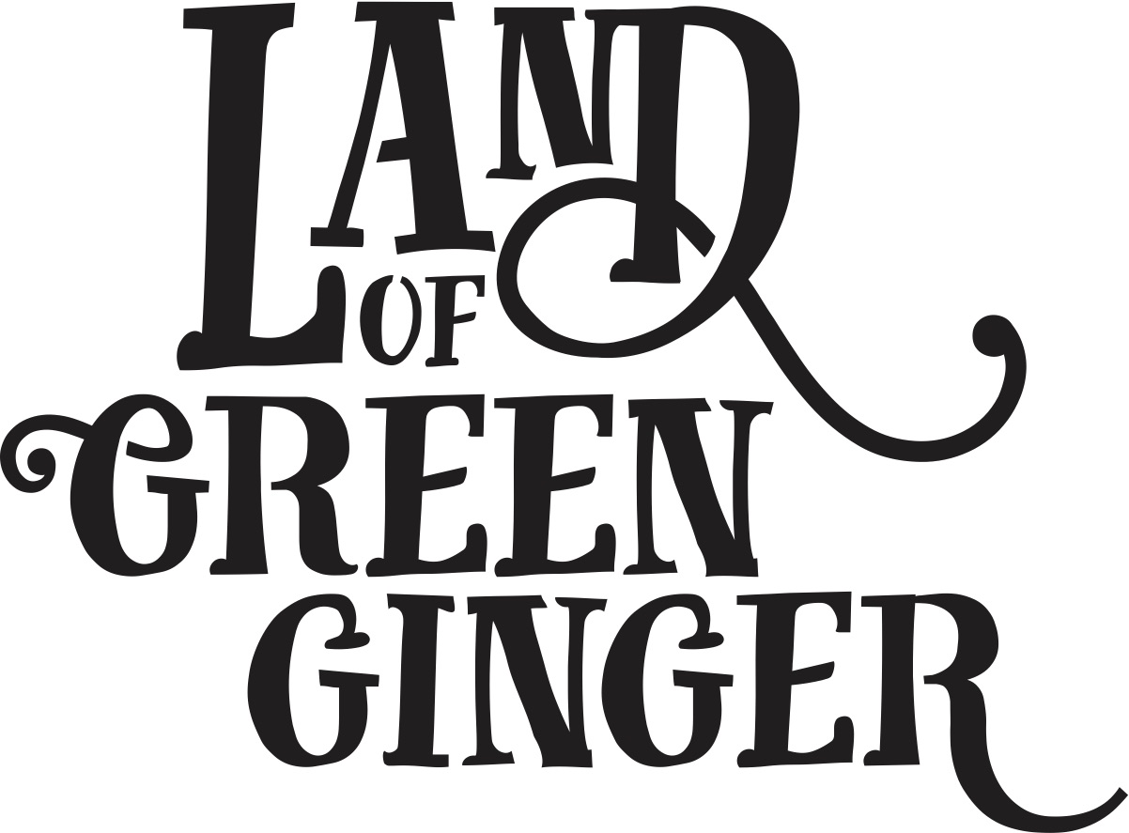

**Book**

**Project Plan**

**Summary**

Throughout the year Hull 2017’s ground-breaking community engagement project, Land of Green Ginger, invited Hull’s residents to immerse themselves in a magical citywide story, inspired by and celebrating the spirit of Hull.

In 2018, the Land of Green Ginger story will culminate in a seventh Act of Wanton Wonder – a beautiful book.

The Land of Green Ginger book will tell the stories of the project, the narrative as it took place and the stories of the local people it touched. It will be the record of City of Culture as lived by the residents of the city and as informed by their imagination and creativity.

This project plan outlines the formats, timescales and budget for delivery of the Land of Green Ginger book.

**Style**

260x210mm *(the same size as “hello hull” magazine)*

60 pages

300gsm outer cover

120gsm inners

Full colour throughout.

Special finish on cover.

PUR bound.

**Distribution**

On Thursday 14 June crates containing books will be delivered to schools across Hull and a mass storytelling moment will take place in every school.

In the week following (Friday 15 – Friday 22 June) books will be delivered to every house in Hull via Royal Mail.

**Quantities**

x118,500 for postage to reach every home in Hull.

X6,500 extra books printed for schools distribution and Big Malarkey.

**Total 125,000**

**Print Timescales**

The book will be distributed to schools in the week of 11 June and a mass storytelling moment will take place in all schools on Thursday 14 June.

The following week books will be distributed across the city and a a live launch-type activity will take place at The Big Malarkey Festival weekend on Saturday 23 and Sunday 24 June 2018.

To ensure the book is printed ready for delivery in the week of 11 June, the following deadlines will be in place:

|  |  |  |
| --- | --- | --- |
| **Date** | **Action** | **Lead** |
| W/C 29 January | Request for initial sketch submissions from contacted illustrators | Maddie, Illustrators |
| W/C 5 February | Initial sketches submitted by contacted illustrators | Maddie, Illustrators |
| W/C 12 February | Illustrator shortlisting | Maddie & Katy |
| W/C 12 February | Illustrator appointed | Maddie, Katy, Illustrator |
| W/C 12 March | First draft manuscript complete | Katy |
| W/C 12 March | Draft manuscript and full brief delivered for illustrator to start work | Maddie, illustrator |
| W/C 26 March | First draft sketches complete, feedback given | Illustrator |
| W/C 26 March | Final manuscript complete and submitted to illustrator | Katy |
| Friday 6 April | Confirm booking with Royal Mail | Marketing lead |
| Friday 13 April | Quantity of books for print decided and addendum for print and Royal Mail drawn up | Marketing lead |
| Friday 27 April | Printing booked. | Marketing lead |
| Thursday 3 May | Final illustrations complete.  Illustrations, manuscript and design brief submitted to designer. | Illustrator  Marketing lead |
| Friday 4 May | Design returned for proofing.  Feedback | Designer |
| Friday 4 May | Artworking complete | Designer |
| Friday 4 May | Book sent to print. | Marketing lead |
| Thursday 31 May | Print complete. Delivery of 118,500 books to Royal Mail. | Printers |
| Friday 1 June | 6,500 delivered to Hull 2017 (TBC) for schools distribution | Marketing lead |
| Thursday 14 June | Schools activity | Producing |
| Friday 15 June | Royal Mail delivery of books | Royal Mail |
| Saturday 23 – Sunday 24 June | Moment at The Big Malarkey Festival | Producing |

**Project Timescales**

In order to create special moments around the release of the book, we plan to do the following:

* Delivery of a crate per primary school across Hull containing a number of books with an activity for schools to participate in e.g. time capsule, filling crate with memories to inspire Acts of Wanton Wonder for future generations
* A mass storytelling moment in schools across Hull on Thursday 14 June
* Schools activity using crate
* A door to door distribution to 40,000 households across the city
* Special door to door distribution in certain areas – costumed volunteers, interesting delivery vehicle, music
* Live drawing by LoGG illustrator at Big Malarkey Festival
* Performers at Big Malarkey with LoGG book giveaways and craft activities??

**Actions**

**Book**

* Book writing
* Illustration
* Design
* Print
* Distribution plan:
  + Door to door through Bluestorm
  + Volunteers??

**Schools**

* Get into schools to introduce the Land of Green Ginger storytelling moment
* Coordinate delivery of schools moment
* Coordinate making of crates
* Collection and storage of 70 crates
* Writing of schools crate activity
* Making of scrolls/information sheets to go with crates
* Delivery of crates to schools
* Writing of schools story
* Writing workshops in schools for National Writing Day 27 June
* Arrange special crate deliveries – horse and carriage, etc.

**Big Malarkey**

* Source performers
* Contract performers
* Brief performers and develop “script”
* Source costume
* Illustration for giveaways
* Design of giveaways
* Print of giveaways
* Arrange illustrator live drawing
* LoGG craft activities?? Tie in with parade?
* Crate installation at festival

|  |  |  |
| --- | --- | --- |
| **Date** | **Action** | **Lead** |
| W/C 29 January | Request for initial sketch submissions from contacted illustrators | Maddie, Illustrators |
| W/C 5 February | Initial sketches submitted by contacted illustrators | Maddie, Illustrators |
| W/C 12 February | Illustrator shortlisting | Maddie & Katy |
| W/C 12 February | Illustrator appointed | Maddie, Katy, Illustrator |
| W/C 26 February | First draft manuscript complete | Katy |
| W/C 26 February | Draft manuscript and full brief delivered for illustrator to start work | Maddie, illustrator |
| W/C 26 March | First draft sketches complete, feedback given | Illustrator |
| W/C 26 March | Final manuscript complete and submitted to illustrator | Katy |
| Monday 16 April | Quantity of books for print decided and addendum for print/delivery drawn up | Marketing lead |
| Monday 30 April | Final illustrations complete.  Illustrations, manuscript and design brief submitted to designer. | Illustrator  Marketing lead |
| Monday 30 April | Printing booked. | Marketing lead |
| Wednesday 2 May | Design work complete. Designer begin artworking. | Designer |
| Monday 7 May | Artworking complete | Designer |
| Monday 7 May | Book sent to print. | Marketing lead |
| Monday 7 May | Distribution company booked. | Marketing lead |
| w/c 11th June | Print complete and delivered to distribution agency for delivery to homes from Friday 15 June | Printer/ Distribution agency |
| Ws/C 11 and 18 June | Distribution | Distribution agency |
| Wednesday 20 – Sunday 24 June | Moment at The Big Malarkey Festival |  |