You’re only here for the Culture
11:00 – 11:45 at Fruit
John Harris
 Guardian journalist and author
Pete Massey
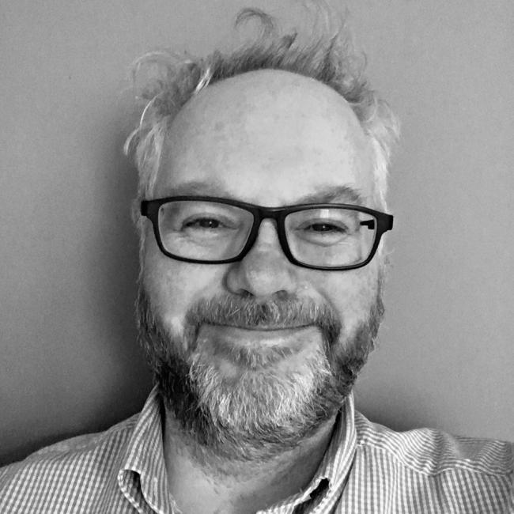 Arts Council England (Director North)
Chris Baldwin
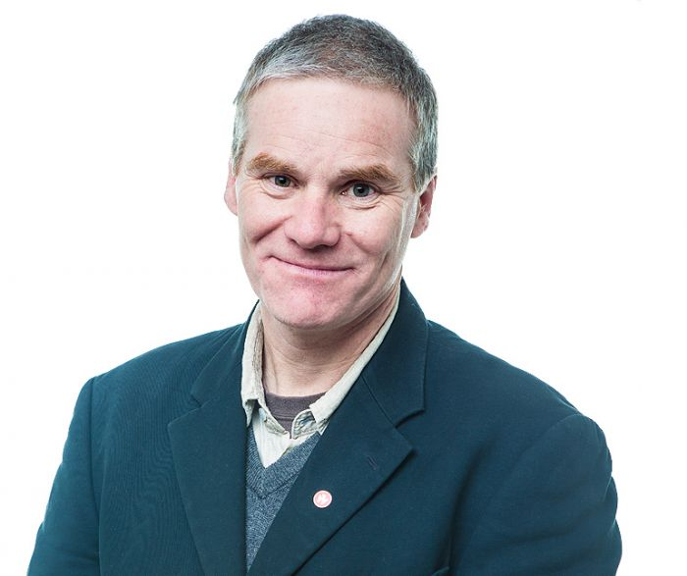 Creative Director: Galway 2020: European Capital of Culture
Paula Murray
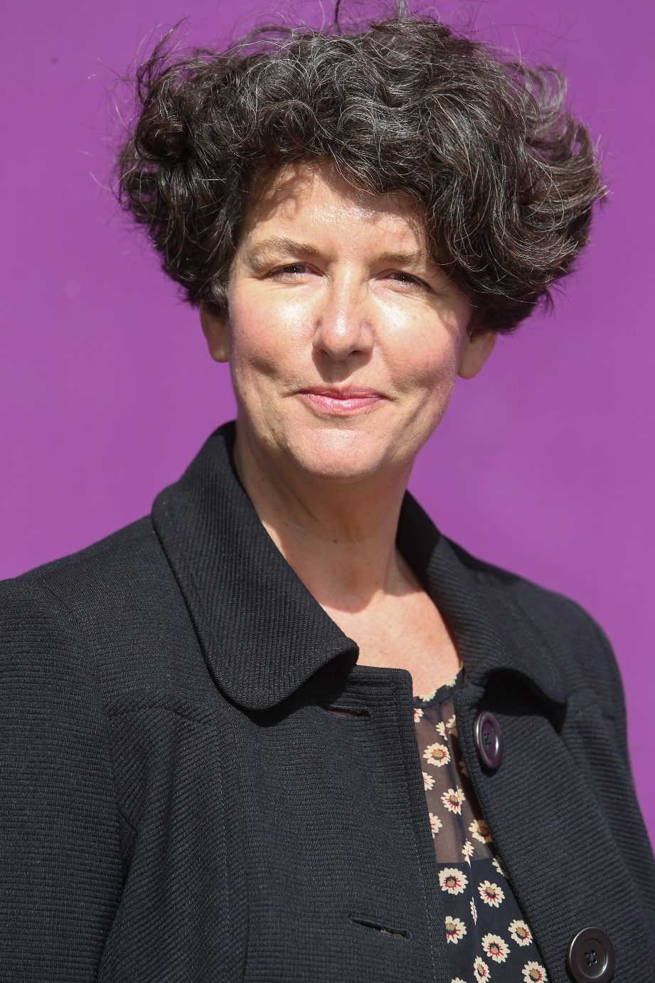 Creative Director at Croydon Council

Shona McCarthy
 Chief Executive of the Edinburgh Festival Fringe Society
Martin Green
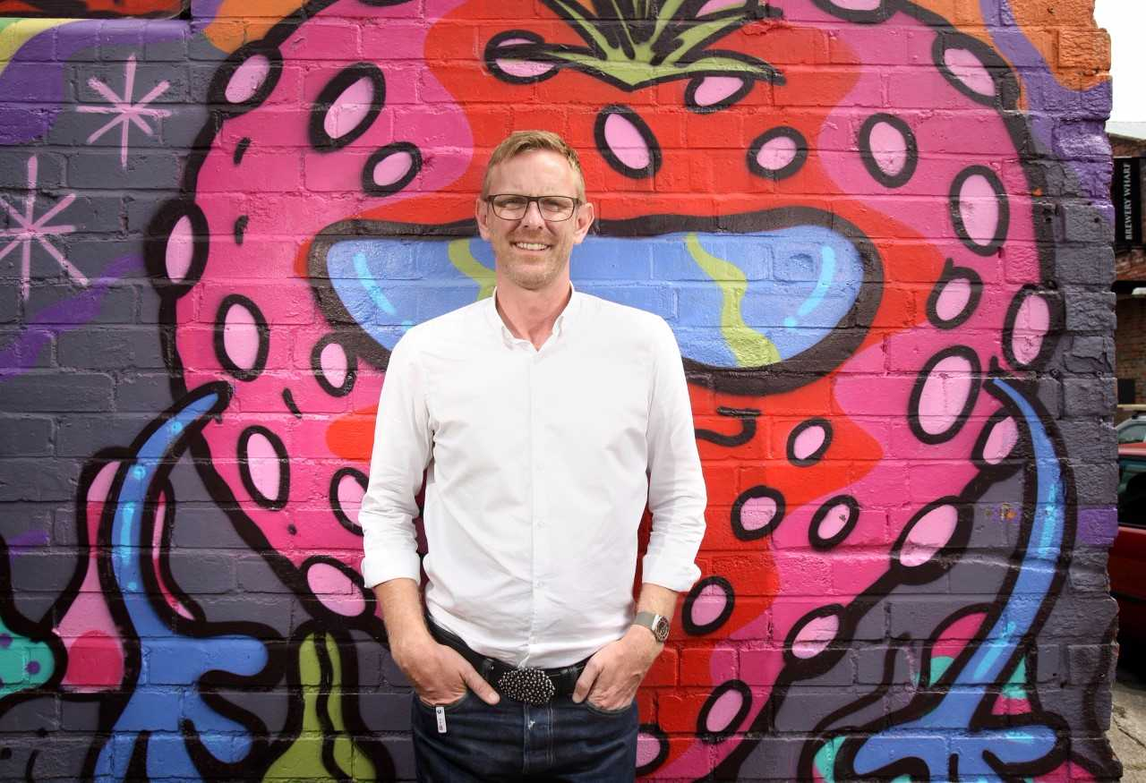 Chief Executive & Director, Hull: UK City of Culture 2017

