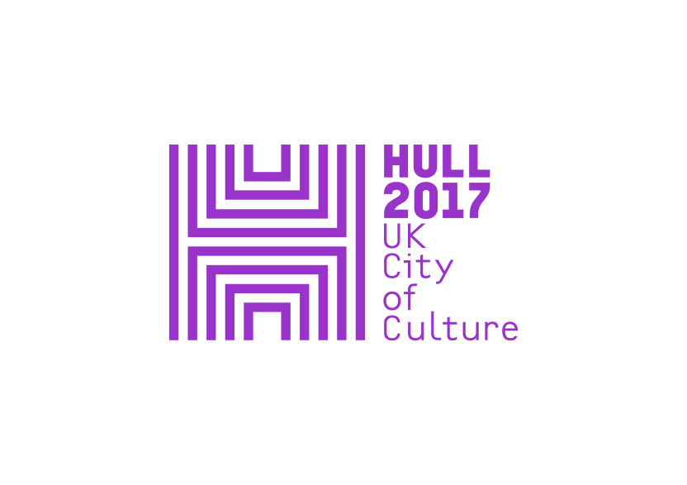

**PRESS RELEASE**

**Wednesday 29 March 2017**

**HULL UK CITY OF CULTURE 2017 and THE DEEP present**

**LOOK UP: *Washed Up Car-go*by Chris Dobrowolski**

**29 March to 4 June, The Deep**

**Look Up** is a year-long programme of temporary artworks commissioned by Hull UK City of Culture 2017, specifically made for Hull’s public spaces and places, co-curated by Andrew Knight and Hazel Colquhoun.

Hull 2017 is co-commissioning a number of ***Look Up*** artworks in partnership with The Deep. Each artwork will be very different, and will take place within different seasons of the Hull 2017 programme. All have taken as their inspiration and starting point, the work, people and location of *The Deep*.

*Washed Up Car-go*, the first of these co-commissions at The Deep, has been created by artist Chris Dobrowolski, who studied at Hull School of Art and Design. It consists of three cars, each containing a small section of beach, placed in the car park of The Deep. With this work, Dobrowolski aims to highlight the disposable culture of mass consumption, recreating the high tide and line of debris and pollution washed ashore within these specially modified cars.

Featuring material gathered from the Humber and Holderness Peninsula, plastic marine animals and video projections as the core of his new installation*,* Dobrowolski revisits a common theme to his work in playing on the notion of real and unreal.

*Washed Up Car-go* looks at environmental concerns around plastics and our oceans, asking us to question the life cycle of a product once bought, used and disposed of.

While studying in Hull, Chris spent most of his time building different vehicles in which to escape Hull. He’s somehow come full circle, and for Hull 2017 offers up a piece that works with the fabric of Hull’s shoreline and touches on pollution, consumerism and the traditions of maritime art.

*Washed Up Car-go* is produced by Artsadmin.

**Artist Chris Dobrowolski** said, ‘Often with conceptual art there is a clear line between where art is supposed to finish and real life starts.  At The Deep I saw the amazing spectacle of the main tank - an artificial under sea environment that gives a sense other worldliness and wonder. The contrast in grandeur between that and the car park has chimed with my ongoing theme of real and unreal’

**Louise Kirby, Operations Manager from The Deep** said, ‘We are delighted to launch the first of three installations which have been co-commissioned with Hull2017. Chris’s work is really inspiring and through this installation, we hope to further The Deep’s own message about plastic pollution and what you can do to combat this ever growing problem.’

**Sam Hunt, Executive Producer for Hull UK City of Culture** said, ‘Chris Dobrowolski’s Washed Up Car-go is a characteristically subversive look at one of the world’s significant and growing ecological issues, taking visitors to The Deep by surprise and luring them through this playful installation to consider major issues around our consumption of plastic.’

*Look Up* is a year-long programme of temporary artworks commissioned by Hull UK City of Culture 2017 and made for Hull’s public spaces and places, co-curated by Andrew Knight and Hazel Colquhoun.

This ambitious programme will respond to, and reveal in new and surprising ways, Hull’s remarkable architecture, streets and public spaces.

To date *Look Up* has brought Nayan Kulkarni’s ***Blade***, which has now been removed from Queen Victoria Square, and Michael Pinsky’s ***The City Speaks*** which will remain in place on Hull’s Tidal Surge Barrier until the end of the year.

During seasons two and three, *Look Up* sees commissioned works popping up in shopping centres, train stations, car parks, streets and public squares, by artists including Bob & Roberta Smith, Tania Kovats, Claire Morgan and Claire Barber.

*Look Up* has been developed in partnership with a number of organisations and companies including The Deep, GF Smith, Hull School of Art & Design and Royal Institute of British Architects (RIBA).

**-Ends-**

For press information, please contact:

Susie Gray or Clair Chamberlain at The Corner Shop PR

[susie@thecornershoppr.com](mailto:susie@thecornershoppr.com) /07834 073 795

[clair@thecornershoppr.com](mailto:clair@thecornershoppr.com) / 020 7831 7657

For general information about Hull UK City of Culture 2017, please contact;

Ben McKnight – [ben.mcknight@hull2017.co.uk](mailto:ben.mcknight@hull2017.co.uk) / 07718 100 793.

**Notes to Editors**

**VK02 GKF**

This car uses music from Carl Orff’s *O Fortuna – Carmina Burana* which is based on a poem that is basically a complaint about band luck. ‘Fortuna’ or fate is that unfair effect that rules both gods and men in Roman and Greek mythology.

In the film you can see on the sail of the raft of toys is a copy of the classical painting *The Raft of the Medusa* by Théodore Géricault. This depicts the true story of a wreck of a French frigate off the coast of Senegal in 1816. Of 150 sailors only 10 survived, and Géricault’s painting is all about that hope and fate placed on these sailors.

**EK52 UDP**

In Greek mythology Sirens were dangerous mermaid-like creatures who would lure sailors towards dangerous rocky coastlines by using enchanting music and singing.

The music used in the film is called *Lass Mich die Tafel dir Bereiten* (roughly translated as ‘let me prepare for you’) from the opera written by Carl Orff called *Die Kluge*, meaning ‘wise girl’. The lyrics follow the story of the girl preparing dinner, setting the table and inviting someone to eat. She sings about how she makes the fish with herbs and spices and that it’s all turned out well. In the context of this piece about Sirens she is enticing someone over … but this time they are the dinner.

In the car you can also see a copy of *Ulysses and the Sirens* by Herbert James Draper, which is held in the local Ferens Art Gallery on Queen Victoria Square.

**Y194 LPP**

The music used is Carl Orff’s *Da Himmlische Leben* which is roughly translated as ‘This Heavenly Life’. The words describe an idyllic, decadent and easy lifestyle featuring, amongst other things, fish jumping out of the water just to be eaten – which Chris has contrasted to our easy, consumerist lifestyles of today.

The piece features a small section of Peter Paul Rubens' painting *The Union of Earth and Water* where a male creature is blowing into a conch, mimicking the music coming out of the conch shells in the car.

**Chris Dobrowolski**

Chris Dobrowolski is a British artist and maker whose practice combines kinetic sculpture, storytelling and performance. He studied Fine Art in Hull but, when he first got there, he built a boat from driftwood to try to escape. Chris has since made a series of fully functioning vehicles in a similar vein, including a pedal car, a flame-throwing tank, a hovercraft and even an aeroplane. The way he makes things has a deliberate “knocked up in the garden shed” aesthetic and each vehicle and escape attempt has its own story attached. Over the years, Chris has retold and refined these stories for theatre audiences.

Dobrowolski’s work is humorous and entertaining with every piece having an elaborate autobiographical backstory. He has exhibited and performed widely, creating installations, film and performances for galleries and a variety of public spaces as diverse as Dunstable library in Bedford, a second hand shop in Vlaardingen, Holland and Ferens Gallery in Hull.

His recent work includes solo exhibitions at Wimbledon Art College, London and &Model, Leeds, the acclaimed performance presentations All Roads Lead to Rome and Antarctica, based on his role as Visiting Artist with the 'British Antarctic Survey' (both produced by Artsadmin). His work has recently been acknowledged and celebrated with the publication of a major book, ‘ESCAPE' published by Jardine Press in 2014.

[**http://www.cdobo.com/**](http://www.cdobo.com/)

**Hull UK City of Culture 2017**

**Hull UK City of Culture 2017** is a 365 day programme of cultural events and creativity inspired by the city and told to the world. Hull secured the title of UK City of Culture 2017 in November 2013. It is only the second city to hold the title and the first in England.

**Divided into four seasons**, starting with **Made in Hull**, this nationally significant event draws on the distinctive spirit of the city and the artists, writers, directors, musicians, revolutionaries and thinkers that have made such a significant contribution to the development of art and ideas.

Hull 2017’s second season, **Roots and Routes**, runs from April to June and explore Hull’s unique place as a gateway to Europe and one of the world’s busiest ports. Its maritime history and global connections inspire the stories of the city; this season of work will also celebrate Hull’s international links, including Rotterdam, Reykjavik and Freetown.

**Freedom** runs from July to September. Building on the legacy of Hull-born anti-slavery campaigner William Wilberforce MP, *Freedom* will explore the concept of freedom in all its many forms. The final season, **Tell the World** will run from October to December.

The Culture Company was set up to deliver the Hull 2017 programme and is an independent organisation with charitable status. It has raised £32 million, with over 70 partners supporting the project, including public bodies, trusts and foundations and local and national businesses. The National Lottery has contributed more than £10m of this funding, making the National Lottery the largest single funding body of Hull 2017.

Key contributions are coming from: **Host City** – Hull City Council; **Principal Partners** - Arts Council England, BBC, Big Lottery Fund, East Riding of Yorkshire Council, Heritage Lottery Fund, KCOM, KWL, Spirit of 2012, Yorkshire Water and the University of Hull; **Major Partners** –Associated British Ports, Arco, BP, the British Council, British Film Institute, Green Port Hull, Hull Clinical Commissioning Group, MKM Building Supplies, P&O Ferries, Paul Hamlyn Foundation, Sewell Group, Siemens, Smith & Nephew and Wykeland Group.

Hull 2017’s International Partners are: Aarhus, Denmark, which is European Capital of Culture 2017; Reykjavik, Iceland; Rotterdam, The Netherlands; and Freetown, Sierra Leone (twinned with Hull). These relationships are reflected in a number of events throughout the year.

For information go to [www.hull2017.co.uk](http://www.hull2017.co.uk) Follow us on Twitter @2017Hull Instagram @2017hull Facebook HullCityofCulture