**PRSF NEW MUSIC BIENNIAL**

**HULL**

**29th JUNE to 2nd JULY 2017**

**ARTIST PACK**

**ARTIST**: Dark Star and James McVinnie

**ARTIST CONTACT (Mobile number):** TBC – PROMOTER TO CONFIRM

Management - Robin Pasrich - robin@giantmenmanagement.com - +44 7930 548922

Agent - Andy Duggan - andyduggan@primarytalent.com

**VENUE**: City Hall

[Address](https://www.google.com/search?biw=2400&bih=1217&q=www+fruitspace+co+uk+address&stick=H4sIAAAAAAAAAOPgE-LWT9c3LDOyTMpKK9GSzU620s_JT04syczPgzOsElNSilKLiwFSWNTXLgAAAA&sa=X&ved=0ahUKEwiT5cTKt7jUAhUlKMAKHZ4BA-AQ6BMIowEwEA): Hull City Hall, Queen Victoria Square, Carr Lane, Hull, Hu1 3RQ

[Phone](https://www.google.com/search?biw=2400&bih=1217&q=www+fruitspace+co+uk+phone&sa=X&ved=0ahUKEwiT5cTKt7jUAhUlKMAKHZ4BA-AQ6BMIpgEwEQ): direct no??

**LOADING IN FROM:** Paragon Street (Pink Dot)

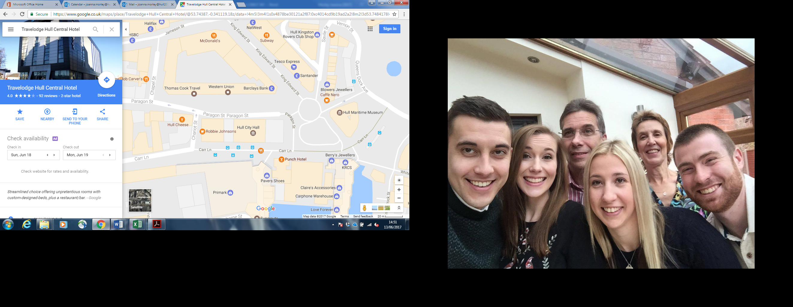

**PARKING REQUIREMENT and LOCATION:**

TBC – PROMOTER TO CONFIRM

**PERSONNEL**

**STAGE MANAGER (Primary contact show weekend only):** David Howard - 07774 729096

**PRODUCTION MANAGER:** Gareth Hughes – 07733112272

**PRODUCTION ASSISTANT**: Joanna Morley – 07725 942808

**VENUE CONTACT**: Tony Evans (Technical)/Lorna (FOH)

**DATE AND TIME OF PERFORMANCE: Saturday 1st July 18:00 (45mins)**

**PRODUCTION SCHEDULE:**

|  |  |  |
| --- | --- | --- |
| ***THURSDAY 29 JUNE*** |  |  |
| NO ACCESS TO MAIN HALL | AFTER PERFORMANCE 23:00 - 02:00 | Stage extension |
| STAGE EXT (23:00 - 02:00) | DAY | Set up dressing rooms |
|  | DAY | Dressing and branding |
|  | PM | OB truck into Paragon Street - |
|  | DAY | Volunteer briefing with Stage Manager |
|  |  |  |
| ***FRIDAY 30 JUNE*** |  |  |
| 06:00 - 00:00 (ACCESS) | 06:00 - 11:00 | Tech in - ALL |
|  | 09:00 | Piano tuning - Main Hall |
|  | AM | 84 lit music stands |
|  | 10:30 | BBC radio 3 onsite - set up |
|  | 12:00 | BBC Phil load in |
|  | 12:00 | 2x crew 4 hour call - BBC load-in |
|  | 14:15 - 17:15 (16:45) | BBC Phil rehearsal |
|  | 18:00 | Box office on site |
|  | 18:15 | Doors |
|  | 18:45 | Simon Holt - BBC Phil - PERFORMANCE |
|  | 19:30 | FINISH |
|  | 20:30 | Doors |
|  | 21:00 | Mica Levi PERFORMANCE |
|  | 21:45 | FINISH |
|  | 22:00 - 23:00 | James McVinnie - access to organ - rehearsal |
|  | 22:00 - 23:00 | Reset for Errolyn Wallen |
|  |  |  |
| ***SATURDAY 1 JULY*** |  |  |
| 08:00 - 00:00 (ACCESS) | 09:00 | Piano tuning - Mortimer and Main Hall |
|  | 10:00 - 13:00 | Errollyn Wallen - Artists arrive and rehearsal - Hall |
|  | 13:00 | Box office on site |
|  | 13:30 | DOORS - Main Hall |
|  | 14:00 - 14:45 | Errollyn Wallen - PERFORMANCE |
|  | 15:00 - 17:30 | Reset main hall - Dark Star in and rehearsal |
|  | 15:30 | Rehearsal Dark Star |
|  | 17:30 | DOORS |
|  | 18:00 - 18:45 | James McVinnie - Dark Star PERFORMANCE |
|  |  |  |
| ***SUNDAY 2 JULY*** |  |  |
| 08:00 - 20:00 (ACCESS) | 09:00 - 16:00 | Main Hall - Residencies |
|  | 13:00 | Doors - Main hall - Super Group |
|  | 13:30 | PERFORMANCE - Super Group |
|  | 14:00 - 20:00 | Derig and clear |
|  |  |  |
| ***MONDAY 3 JULY*** |  |  |
|  | AM | Materials back to storage |
|  | AM | Piano off site |

|  |
| --- |
|  |
|  |

**TECHNICAL**

**Sound**

**FOH Control**

1 Yamaha M7CL-48

**Speaker System**

8 L Acoustics - ARCS

6 L Acoustic ARCS - ARCOUPL

2 Ratchet Strap (Black) - 5.5m 2T

2 L Acoustic SB218

1 Camco Amp Rack for L Acoustics

1 BSS 366 Omnidrive Compact Plus

**Monitor System**

6 Wedge Monitor 15" + 2"

1 Camco Amp Rack for L Acoustics

2 BSS Minidrive FDS-334

**Microphones**

1 Shure Beta 52

2 Audio Technica AT4050SM

1 Sennheiser e906

2 Shure SM58

4 DPA 4060-BM Miniature Microphone - Microdot

4 DPA DAD 6001 XLR 48 volt adapter

4 DPA MHS 6005 Mic Holder for Strings

4 Studiospares Active DI

1 Microphone Stand (Kick Style)

6 Microphone Stand - Tall

2 Shure ULXP Beta58 Handheld Radio System - CH38

**Other Equipment**

1 63A 3-Phase Mains Distro #2

1 Multicore System 1 - 48-way 70m

1 48-Way Stagebox & Line System

1 63A 3-Phase Cable 22m

1 48-Way 70m Multicore

**Staff**

1 Engineer - FOH

1 Engineer - Systems

**Lighting**

**Material**

1 Avolites Tiger Touch Pro Console

3 Martin Atomic 3000 Strobe

**Staff**

1 Engineer – Lighting

**RIDER:**

The promoter must provide a hot, quality, 3-course meal for 3 people. Or a buyout

of £15 / €15 / $20 per person (in the correct notes please!)

Backstage catering:

24 x Beer. Quality local beer preferred. Important – please ensure they are kept ICE cold.

1 x 1L Bottle of Jack Daniels OR Appleton’s Rum

6 x Cans / bottles of ginger beer

12 x Water. Small bottles at room temperature

6 x Soft drinks. Assortment of Diet Coke / Fanta / Sprite

Bread. Fresh pitta or baguette.

Dips. Houmous / Tzatziki / Alioli

1 x Jar of Honey

3 x Fresh Lemons

1 x Kettle - or access to boiling water

1 x Bucket of ICE

2 x Hot Pizza (IMPORTANT) Delivered to the dressing room directly after the performance.

**BACKLINE**:

|  |  |  |
| --- | --- | --- |
| **BACKLINE** | 4x tables for electronics - 50cm x100cm | CITY HALL |
|  | 4x Single tier keyboard stands | STS |

**ACCREDITATION**

David & Alice Porter (Directors)

Steve & Sam Shaw (Directors)

Peter & Lorraine Boardman (Directors)

Wes Zepherin (Director)

Kirsty & Gary Halliday (Marketing)

Ben Pugh (Production)

Artistic Personnel: Band- Aiden Whalley, James Young. TM - Robin Pasricha