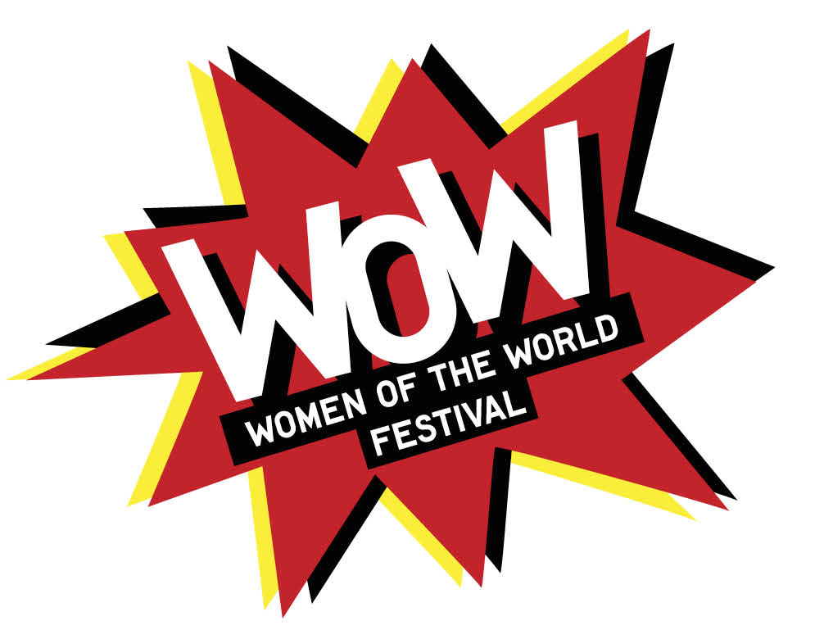Hull Circle of Friends

**Different things the Circle of Friends can do**

* Attend meetings
* Host a mini think in (share questions with members of team or friends.
* Facilitate an engagement project.
* Resources – knowledge, time, etc.
* Gather people who should be involved in a think in.
* Host an event/activity at the festival
* Be involved with mentor programme.

**September**

**Test the questions**

The Thinkins are currently being planned during October through to November.

We’re currently working out the best way to facilitate the Thinkins and gather information to feed into the planning and programming of WOW. There are a number of different questions that could be asked as the warm up questions, which we would ask you to test with your colleagues and groups.

These questions are designed as conversation starters. The hope with the questions is that they will provide data for the programming team to factor into the WOW festival but they will also get people talking about celebrating women and also start conversations about the challenges that people of Hull are interested in talking about.

Please pick a set to ask your colleagues or groups and remember to note the answers to feed back to the team.

You can either print the questions and note the answers please see below, or write them straight into the form below. You can write the answers as briefly as you need to don’t worry about trying to capture the person’s whole answer, we’re looking for ideas and name suggestions.

Once you have the answers please feel free to answer some the questions about how easy it was to facilitate the questions – or if you have a better suggestion of a question note it down.

Then please email the scanned sheet or dates to [wow@2017.co.uk](mailto:wow@2017.co.uk) by Monday 26th September.

**Some tips**

The best way to facilitate these questions is to explain that it is a little exercise that will only take 5-10 minutes. There are no right and wrong answers and that they can add or change their answers if they would like.

I’ve found asking the questions to groups of between 2-5 works really well as people inspire other answers and suggestions. However, we are really interested in what works in your circles – did you find one on one questions easier, or was it better to ask larger groups?

Depending on your time you may find it better to ask these questions and take your time to allow the conversation, it just worth noting key words. When you feel the answers have been answered then it’s time to move on to the next one. If you get participants who experience brain freeze it’s good to move on and ask another question. Part of the reason we’re testing the questions is to see which ones induce brain freeze.

Set One

* Who’s your favourite female personality at the moment?
* What bothers you as a woman of the world in 2017?
* If you could give your 16 old self some advice what would it be?
* What’s your guilty pleasure/what do you do for pleasure?

Set Two

* Who’s your favourite female performer at the moment?
* What news stories about challenges facing women in the UK bother you at the moment?
* What fun things would you like to do at a WOW event?
* What do you want to be when you grow up?

Set Three

* What would your super power be?
* What global stories about women bother you at the moment?
* What skill would you like to learn in 2017?
* Who’s your Hull heroine?

Set One

|  |  |
| --- | --- |
| Question | Responses |
| Who’s your favourite female personality at the moment? |  |
| What bothers you as a woman of the world in 2017? |  |
| If you could give your 16 old self some advice what would it be? |  |
| What’s your guilty pleasure/what do you do for pleasure? |  |

**Notes**

Which questions were easily answered?

Which ones need more work?

Any better question suggestions?

|  |  |
| --- | --- |
| Question | Responses |
| Who’s your favourite female performer at the moment? |  |
| What news stories about challenges facing women in the UK bother you at the moment? |  |
| What fun things would you like to do at a WOW event? |  |
| What do you want to be when you grow up? |  |

**Notes**

Which questions were easily answered?

Which ones need more work?

Any better question suggestions?

|  |  |
| --- | --- |
| Questions | Responses |
| What would your super power be? |  |
| What global stories about women bother you at the moment? |  |
| What skill would you like to learn in 2017? |  |
| Who’s your Hull heroine? |  |

**Notes**

Which questions were easily answered?

Which ones need more work?

Any better question suggestions?

**Thinkins**

We’d like to know which Thinkins you would like to attend, we will email you the dates and times if you could let us know which ones you would like to attend?

Tuesday 11th October Freedom Centre Preston Road 10am – 3pm

Wednesday 12th October Hull University 1pm – 6pm

Monday 17th October Pave 7.45pm – 10pm

Wednesday 19th October Asda Mount Pleasant 12 -9pm

Friday 21st October Raynors Hessle Road 4pm to 7pm.

**Goody Bags**

We’re hoping to distribute goody bags at the larger Thinkins, these goody bag would contain information about the WOW event and potentially other nice things. What would you like including in the goody bags?