**1 -- Reading lamp**

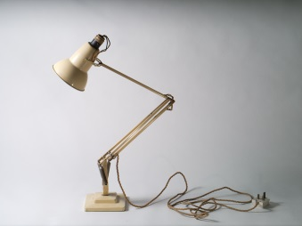

**The anglepoise lamp, invented by British designer George Carwardine in 1932, concentrates a directed funnel of illumination on to a small area. Together with the windowscape outside and the hiss of a gas fire, the lamp symbolises for the young Larkin the joy of self-possession. His imagination seeks release in a 'padlocked cube of light'. In 'Livings II' he redirects the lamp, now huge and ambiguous, outwards at the reader, as the speaker tends his mythic lighthouse, 'Guarded by brilliance'. But as Larkin's inspiration faded lamplit solitude turned to simple loneliness. In ‘Vers de Société’ (1971), he deserts its private space for the 'forks and faces' of public social intercourse:**

**The time is shorter now for company,**

**And sitting by a lamp more often brings**

**Not peace, but other things.**

**Beyond the light stand failure and remorse**

**Whispering *Dear Warlock-Williams: Why, of course—***

**The lamps inside the Old Fools' heads have slipped into the hands of others as they falter into dementia. Nameless familiar figures appear to them, 'Setting down a lamp, smiling from a stair, extracting / A known book from the shelves.' The lights may be on, but there's nobody at home.**

**2 -- Trunk**

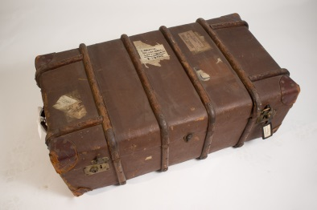

**One end of this substantial ribbed and riveted trunk bears a glued label reading: 'BELFAST Passenger's luggage in advance'. But, judging by the remnants of other glued labels, it had seen service during Larkin's student days before it was put to service transferring his effects across the Irish Sea in October 1950 – and then back again five years later. The bold label glued on the top reads:**

**LARKIN**

**HOLTBY HALL.**

**COTTINGHAM**

**E. YORKS.**

**This University-owned house was Larkin's first perching point in Hull in 1955. Later, when he was living in his high-windowed flat he graduated to a smart leather-framed address tag attached by a strap to the left front clasp. It reads: 'Larkin 32 Pearson Park Hull'. Perhaps this stylish piece of luggage-furniture dates from his sojourn in Oxford during his work on the *Oxford Book of Twentieth-Century English Verse* in 1970-1.**

**3 -- Larkin’s spectacles**

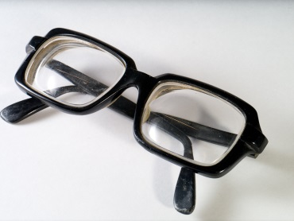

**It was a significant moment in the history of poetry when on New Year's Day 1942 Larkin received official notification that his medical condition had been graded at IV. He would be exempt from military service. Consultant Ophthalmologist, Colin Vize, has recently analyzed spectacles from various phases of the poet's life and concludes that 'less than 1% of the population exhibit short-sightedness of the magnitude experienced by Larkin'. It seems, even, that Larkin may have been right after all to attribute his mysterious collapse at a University’s Library Committee meeting in March 1961 to a mis-prescription for his new spectacles.**

**Do the 'out of reach' light-filled vistas in such poems as 'High Windows' and 'Here' owe something perhaps to Larkin's acute, lifelong myopia?**

**Larkin appears to be wearing these thickly-framed rectangular bifocals in the iconic photographs taken by Fay Godwin in 1974. One of them was used for the cover of *Required Writing* in 1983, at which time the poet wrote to the photographer that he had made Faber promise never to use the photographs in the series which made him look like the Boston Strangler. Faber nevertheless chose one of these very images for the cover of Martin Amis's selection of Larkin's poetry in 2011, compounding the insult by showing just one sinister, bespectacled eye at the bottom left corner of the back dustwrapper.**

**4 – Monica’s spectacles**

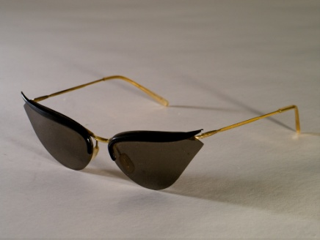

**By all accounts, Monica Jones had a keen, sometimes even unnerving dress sense. One student taught by her in the 1950s recalls that she wore 'pretty pastel shades when her topic was the Romantics; severe flowing black when she spoke about tragedy'; she wore tartan for her Macbeth lecture. Later when she came to live with Larkin in Hull she cut a striking figure in her flamboyant cape. A member of the library staff recalls: 'You couldn't miss her bright colours.' These sunglasses, worn on holidays in Scotland and Sark are redolent of the 'sophisticated' film-star culture of the 1960s.**

**5 -- Typewriter**

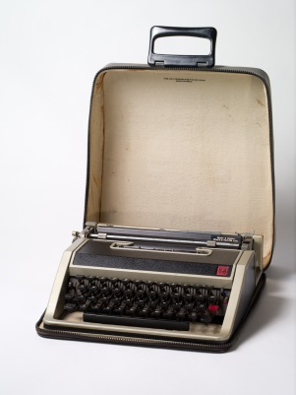

**Those of us of a certain age will remember fondly this De Luxe version of the celebrated Olivetti Lettera 32, on which we typed our student essays in the 1960s, and embarked on the formalities of adulthood, laboriously adjusting our application forms round the barrel, so that the responses would be positioned horizontally between the lines (which they never were). It was manufactured in Spain to an Italian design, and like the BMC mini it has an iconic status, with its futuristic silver-grey, black-banded case and moulded plastic finger-friendly keys. Best of all, it was 'portable'.**

**The young Larkin typed his first truly Larkinesque poems, the 'Sugar and Spice' sequence in 1943, on a heavy archaic machine with circular metal keys. He used a two-banded ribbon so that he could shift between red and black, and inserted three sheets of carbon paper to produce a limited edition of four copies. No doubt he welcomed the advent of the more convenient, lightweight technology of the Lettera. On the other hand, with a charming archaic sense of etiquette, he would apologise to his more intimate correspondents when he sent them typed letters rather than more 'sincere' holographs.**

**6 -- Newland Park letter-writing paper**



**Writing on his familiar 32 Pearson Park notepaper in February 1974, Larkin told Judy Egerton about the property he had just bought: 'an utterly undistinguished little modern house in *Newland Park* (Plus ça change, plus c'est la même parc). I can't say it's the kind of dwelling that is eloquent of the nobility of the human spirit. It has a huge garden – not a lovely wilderness (though it soon will be) – a long strip between wire fences – oh god oh god […] So Larkin's Pearson Park Period ends, & his Newland Park Period commences.'**

**Shortly afterwards, in April, the cruellest month, he began his 'final' poem, 'Aubade'.**

**7 -- Blank workbook**



**Larkin outlived his inspiration, and during his career seems, almost uniquely among poets, to have explored every poetic opportunity to the limits of his sensibility and genius. Consequently this blank manuscript book does not have quite the evocative power it would possess had it belonged to John Keats or Wilfred Owen. But it has its own eloquence. The blankness of these pages seems a deliberate choice. We may recall 'Forget What Did':**

**Stopping the diary**

**Was a stun to memory,**

**Was a blank starting […]**

**And the empty pages?  
Should they ever be filled  
Let it be with observed  
  
Celestial recurrences,  
The day the flowers come.  
And when the birds go.**

**8 -- Frog**

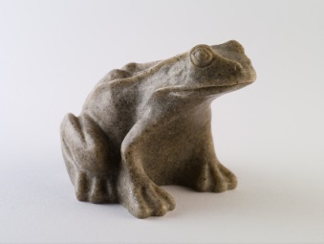

**Larkin was no naturalist and did not distinguish between toads and frogs when, in the years following the publication of 'Toads' and 'Toads Revisited', he surrounded himself on desk-top and mantelshelf with symbols of the toad work, in stone, plastic or glass. He even had a large wickerwork wastepaper basket in the shape of a toad with a gaping mouth. This particular lugubrious but elegant frog, with its air of longsuffering stolidity, expresses something of Larkin's ambiguous attitude towards the animal, and towards the work which it symbolises:**

**No, give me my in-tray,**

**My loaf-haired secretary,**

**My shall-I-keep-the-call-in-Sir:**

**What else can I answer,**

**When the lights come on at four**

**At the end of another year?**

**Give me your arm, old toad;**

**Help me down Cemetery Road.**

**He would have been delighted by the plague of variegated toads that occupied Hull during the Larkin25 celebrations in 2010.**

**9 -- Lenses**

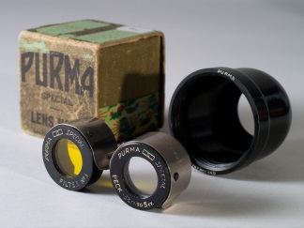

**Larkin took photography seriously. Among his effects in Newland Park were three cameras, a light meter, a tripod and several lenses. In his early years in Hull he took responsibility for the annual Library staff photograph, using a delayed shutter release, so that he himself could be in the shot. Some of the most familiar photographs of the poet, gazing into a puddle on the library building site, standing beside a monument in Spring Bank cemetery, looking out of a train window at the rain, were taken under his direction, though other people clicked the shutter. Some of his photographs could be called experimental: Maeve Brennan half-hidden behind reeds, the library staff seen in bird's eye view from his office window.**

**He valued the 'faithful and disappointing' immediacy of photography in recording everyday life. In 'Lines on a Young Lady's Photograph Album' he celebrates the way the album preserves 'a real girl in a real place / In every sense empirically true.' He described his poetry in similar terms: 'there's not much to *say* about my work. When you've read a poem, that's it. It's all quite clear what it means.' However, as this technological paraphernalia suggests, there is more conscious artistry than he cares to admit in his interventions between subject and audience, in both his photography and his poems.**

**10 -- Puncture outfit**

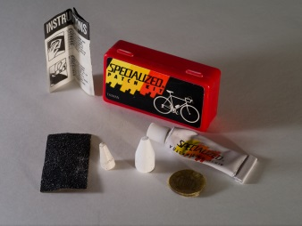

**Who of us now recalls the exasperating ritual? – levering the inner tube out of its rigid casing, pumping it up, immersing it in a bowl of water, and watching to see where bubbles betrayed a puncture; then roughening the rubber with emery paper to ensure the glue would take properly before carefully positioning the patch. And it never, ever worked! But perhaps Larkin had the knack, since his puncture kit has clearly seen much use.**

**Larkin developed a taste for cycling in the days before the motor car took over all roads. In August 1939, at the age of 17 he spent a week cycling with his father between Radstock, Glastonbury and Ilminster in Somerset. Sydney's diary proudly records: 'Philip's cyclometer indicated that we had ridden 162 miles.' Shortly after his arrival in Hull, in April 1956, the poet set off on a typically aimless exploration. Arriving too late at Victoria Pier to catch the ferry to New Holland, he enjoyed a lunch of beer and biscuits in the Minerva Hotel, then cycled round the dock area 'a good bit'. Eventually he 'got out on the west side of Hull', and tried to find Tranby Croft. 'But I got lost, & tried to photograph lambs instead: but as soon as I approached two a sheep lifted its head and said something, & they ran away to her.'**

**11 -- Beatrix Potter: Peter Rabbit**

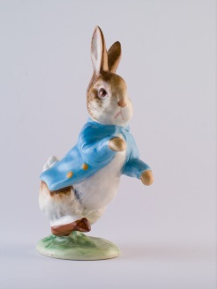

**Philip and Monica shared an intimate Beatrix Potter language. He addresses her as 'Forepaws', 'Ears' or 'Bun' and adorns his letters in the 1950s and 60s with charming sketches of a rabbit in a skirt: watching cricket under a parasol, playing croquet, or sleeping under a huge mushroom in the rain surrounded by slugs and dangling spiders. In his late poem, 'The little lives of earth and form', he reflects with some profundity on this sentimentalism:**

**And this identity we feel  
– Perhaps not right, perhaps not real –  
Will link us constantly;  
I see the rock, the clay, the chalk,  
The flattened grass, the swaying stalk,  
And it is you I see.**

**Nevertheless when he realised in 1951 that he was sharing his flat with a mouse he commented: 'not very nice! This depresses me rather – Beatrix Potter's all very well in print but ...' The dying animal of his poem 'Myxomatosis', in its invisible trap in the middle of a soundless field, occupies a harder world than that of Peter Rabbit:**

**You may have thought things would come right again**

**If you could only keep quite still and wait.**

**12 -- Concave shaving-mirror ('Send No Money')**

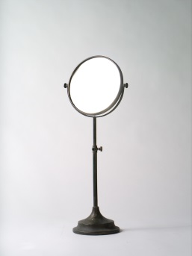

**If one looks into the concave side of this adjustable mirror, every pore and blemish is magnified to an alarming extent. Did Larkin perhaps recall the image presented to him by this mirror as he shaved when he wrote his fortieth birthday poem 'Send No Money' in 1962?**

**Half life is over now,  
And I meet full face on dark mornings  
The bestial visor, bent in  
By the blows of what happened to happen.**

**What does it prove? Sod all.**

**13 -- Plaque from the toilet: PREPARE TO MEET THY GOD**

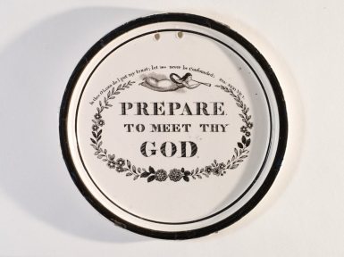

**In May 1975 Ted Hughes gave a reading at Hull University. Larkin commented: 'He filled our hall and got a great reception. I was in the chair, providing a sophisticated, insincere, effete, and gold-watch-chained alternative to his primitive forthright leather-jacketed *persona*.' Sometime afterwards Larkin positioned a framed photograph of this event above the cistern of his downstairs toilet. Radiating shamanic sexual magnetism, Hughes stands mid-stage, while the poet-librarian sits inscrutably at a table to the side.**

**High on the wall opposite this image Larkin hung this antique ceramic plate, a reminder perhaps that we not infrequently go to meet our maker with our trousers about our ankles. Even his toilet was a Larkinesque creation.**

**14 -- Umbrella**

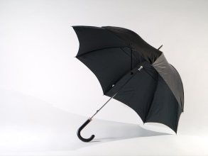

**Larkin was jealous of his private space, an aspect of his personality dramatized by former Politics student and later screenwriter, Neville Smith, in a story told to Roger McGough. Waiting for a bus in the rain on Cottingham Green, Smith attempted to gain shelter under Larkin's capacious umbrella with the words: 'I did enjoy *The North Ship*'. Larkin looked down at him and said: 'If you think you can begin a conversation in order to share my umbrella you've got another think coming', and pressed the catch so that the umbrella folded close around his head. It would be nice to believe that this piece of comic stage-business really happened.**

**15 -- Cigarette cards: Cricketers**

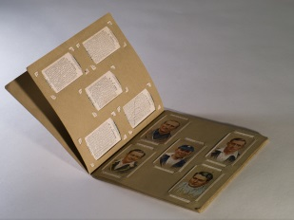

**Larkin attributed 'the slight scholarly stoop in my bearing today' to his boyhood habit of searching for cigarette cards of 'Famous Cricketers' in Coventry gutters. He was an enthusiast for cricket throughout his life, as a spectator rather than participant. His friend Ansell Egerton, City Editor at the *Times*, would send him tickets and he and Monica would take the Egertons out to dinner annually during the Lord's Test Match. In 1974, together with Harold Pinter, Egerton proposed Larkin for membership of the MCC.**

**In his poetry, cricket makes a memorable appearance in the glimpse of 'someone running up to bowl' in 'The Whitsun Weddings'. Apart from that however, it appears only in 'Sugar and Spice', written when he was 20 in 1943. In the exquisite final poem of the sequence the motifs of the girl's school story become a metaphor for life itself. An eloquent fourth-former, alone in the lengthening shadows of the outfield after the end of the Old Girls' match, juxtaposes childhood present with adult future:**

**Wenda, Brenda, Kathleen and Elaine**

**Have flattened down the long grass where they've lain,**

**And brownlegged Jill has left her hat,**

**For they have gone to laugh and talk with those**

**Who've played the Old Girls' match out to its close.**

**She delicately elides the generations: girls and old girls; the game of cricket; the game of life.**

**16 -- Paisley handkerchief with four knots: a hat for holidays and cricket.**

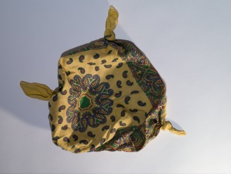

**What more potent image of the informal English holiday spirit could one find than this Paisley handkerchief, made into a makeshift sunhat by knots tied in its four corners? Did Larkin wear it perhaps while mowing the lawn in the D. H. Lawrence T-shirt he bought in Nottingham when he opened an exhibition of books and manuscripts by the great novelist in 1980?**

**17 -- Pencils**

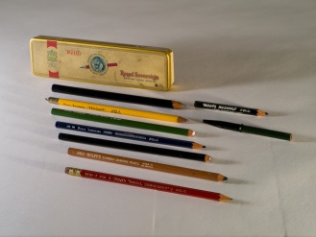

**For Larkin writing itself was an enjoyable, sensuous experience. Following his father's discriminating taste he favoured a soft 2B Royal Sovereign pencil, and it is this that he used to write the poems in his workbooks. But he could be adventurous. He frequently refers to the new pen or pencil he is using in writing a letter, or the colour of the paper, and in his 1940s fiction he experiments with the recently-patented biro. When the Larkin Society cleared his effects from 105 Newland Park in 2003 his old school case came to light, in which, among Cash's name tags and bottles of ink, was this collection of nine different Royal Sovereign and Wolff's pencils of different thicknesses and hardness, most of them well used.**

**18 -- Combined corkscrew and bottle-opener**

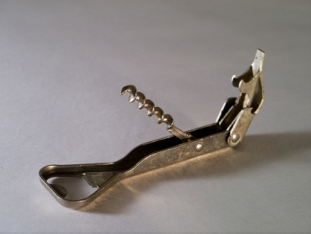

**In his youth Larkin socialised in pubs over a pint (or many pints) of beer. But as he grew older he turned to harder drinking, with Monica Jones or on his own. In a letter to Monica in 1968 he complained that it was such 'an *angry* time. When left to oneself irritation begins to ferment like some neglected juice! Only drink releases me from this bondage.'**

**Towards the end 'dead' drinks became a metaphor of his lost youth. In 'Love Again' the poet contemplates: 'The drink gone dead, without showing how / To meet tomorrow'. In 'We met at the end of the Party', all of the glasses are dirty and all of the drinks are dead. It is appropriate enough, perhaps, that his last completed poem, 'Party Politics', first appeared in a special issue of *Poetry Review* in 1984 devoted to 'Poetry and Drink'.**

**19 -- Ashtray**

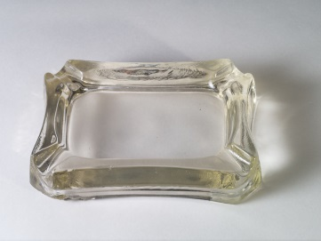

**Larkin died of cancer of the oesophagus exacerbated by lifelong addictions to cigarettes and alcohol. In 'Essential Beauty' (1962) the 'Platonic essences' of cigarette advertisements are celebrated and at the same time bitterly satirised:**

**… and dying smokers sense**

**Walking towards them through some dappled park   
As if on water that unfocused she   
No match lit up, nor drag ever brought near,   
Who now stands newly clear,   
Smiling, and recognising, and going dark.**

**It would be fascinating to know whether Damien Hirst's masterpiece, 'The Acquired Inability to Escape', which includes just such an ashtray as this, would have broken through Larkin's dislike of *avant* *garde* experiment.**

**Towards the end, as public awareness of the dangers of smoking increased, Larkin made unsuccessful efforts to break himself of the habit. In 1984, he wrote to Amis that he would decline the laureateship: 'the thought of being the cause of Ted's being buried in Westminster Abbey is hard to live with. "There is regret. Always, there is regret." Smoking can damage your bum.'**

**20 -- Matches**

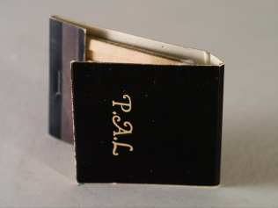

**In his review of Motion's biography in 1993 Alan Bennett expressed disillusion that the poet whose initials had seemed to suggest that he was our intimate 'pal' had been revealed to have so many unpleasant qualities. Larkin always treated his name as a valuable possession. In the mid or late 1950s he pasted thirty-five carefully numbered versions ('Philip Larkin', 'Philip Larkin Esq') into his diary, cut from envelopes, each written by a different correspondent: from his mother to John Betjeman and Pamela Hansford Johnson. In the 1960s he stopped signing fine notices in the library when he realised that students were offending simply in order to obtain his signature. At some point, no doubt with a certain self-irony, he commissioned these smartly-designed book-matches with their ornate lettering on a glossy black background. No doubt James Bond would have used similar personalised matches with the initials JB.**

**21 -- Bow tie**

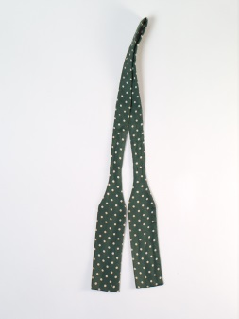

**Larkin dressed with a certain independent flair. Maeve Brennan comments in her memoir that he seemed an exotic when he arrived in Hull in 1955, in his 'sports jacket, corduroy trousers, socks in vivid plain colours, and often a pink shirt, which we considered very daring'. Like his father he affected silk bow ties. In contrast the two other men on the Library staff both wore 'the customary dark, pin-striped suits'.**

**22 -- British Rail Catering tie (Centenary of Railway Catering.)**

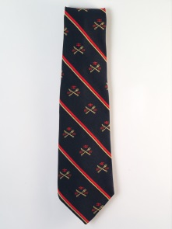

**The inventory of effects recovered from 105 Newland Park in 2003 following Monica Jones's death includes 123 ties, some declaring allegiances, some merely stylish or flamboyant. Some are worn and stained, others are brand new and still in cellophane wrappers. It seems that Larkin never threw a tie away. This particular tie came to him under unusual circumstances. He wrote in a letter to Winifred Bradshaw in 1979: 'My latest tie commemorates the centenary of railway catering (1879-1979). I admired it in a bar & the chap took it off and gave it to me. Can't think when I shall wear it – visiting Betjeman, perhaps. It's really quite a smart tie. It's only when you get close you see it's crossed knife & fork, BR arrows, sausage rolls rampant & so on.'**

**23 -- National Trust tie**

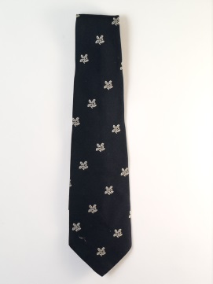

**Many of Larkin's ties declare ideological allegiances. A green tie showing a Celtic harp, for instance, hung in his wardrobe alongside a Red Hand Defenders tie. He had a Library Association tie, an MCC tie, and a tie showing the bear and ragged staff emblem of Warwickshire. His beloved Beatrix Potter had left most of her estate to the National Trust, and this was a cause dear to his heart. 'Going, Going (1972), commissioned by a Government Working Party on 'The Human Habitat', could be seen as his 'National Trust poem': 'And that will be England gone, / The shadows, the meadows, the lanes, / The guildhalls, the carved choirs'.**

**24 -- Assorted labelled champagne corks**

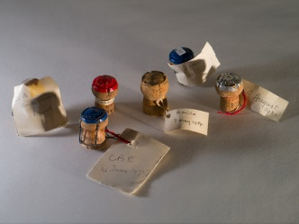

**When Larkin and Monica Jones travelled to Hamburg in 1978 to collect his 'Shakespeare Prize', they gleefully raided the hotel mini-bar for half-bottles of champagne, since the Toepfer Foundation was bearing their expenses. Here we see the relics of other intimate celebrations *à deux.* One cork is labelled 'CBE 14 June 1975'. The cork labelled '28th Anniversary lunch' may possibly commemorate their first meeting; in which case it dates to 1976. A third cork bears the date of his sixtieth birthday: '9 August 1982', a fourth that of her 62nd birthday: 'Monica 7 May 1984'. Betty Mackereth, Larkin’s secretary at the Library, recollects calling at 105 Newland Park on the poet's birthday in the early 1980s, bearing a bottle of champagne. Monica possessively cut the interloper out of the celebration by proposing a toast 'To Oxford Firsts!'**

**25 -- Mortar board**



**Larkin had an ambiguous attitude towards academe. He resented Monica Jones's long 'holidays', and in 'Toads' he lists lecturers among those who dodge the toad work by living on their wits. Jake Balokovsky is not a good advertisement for the academic profession. Moreover Larkin deplored the idea of 'studying' poetry. Nevertheless he worked in an academic environment all his life, and after he was awarded a professorship in 1982 he was consistently addressed as 'Professor Larkin' within Hull University. He greatly relished the honorary degrees which, by the time of his death, he had collected in large numbers. Even when Monica Jones was convalescing from shingles in 1983, he took time to make a quick trip across the Irish Sea for the award of an Honorary DLitt from the New University of Ulster.**