**PRSF NEW MUSIC BIENNIAL**

**HULL**

**29th JUNE to 2nd JULY 2017**

**ARTIST PACK**

**ARTIST**: Brian Irvine

**ARTIST CONTACT (Mobile number):** 07841650383

Tour Co-Ordination: Brian Carson 078 8158 7620

Technical Contact: Chris McCorry 077 5203 0905

**VENUE**: Guildhall

### [Address](https://www.google.com/search?biw=2400&bih=1217&q=www+fruitspace+co+uk+address&stick=H4sIAAAAAAAAAOPgE-LWT9c3LDOyTMpKK9GSzU620s_JT04syczPgzOsElNSilKLiwFSWNTXLgAAAA&sa=X&ved=0ahUKEwiT5cTKt7jUAhUlKMAKHZ4BA-AQ6BMIowEwEA): The Guildhall, Alfred Gelder Street, Hull HU9 9TA

### Phone: 01482 613017

**LOADING IN FROM:**

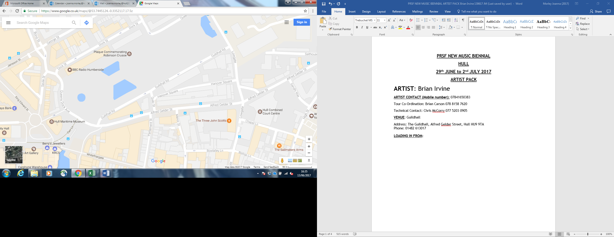

**PARKING REQUIREMENT and LOCATION:**

TBC – PROMOTER TO CONFIRM

**PERSONNEL**

**STAGE MANAGER (Primary contact show weekend only):** Hanna Lutkin - 07709 351209

**PRODUCTION MANAGER:** Gareth Hughes – 07733112272

**PRODUCTION ASSISTANT**: Joanna Morley – 07725 942808

**VENUE CONTACT**: ??

**DATE AND TIME OF PERFORMANCE: Sunday 2nd July 18:45 (45mins)**

**PRODUCTION SCHEDULE:**

|  |  |  |  |
| --- | --- | --- | --- |
| ***SATURDAY 1 JULY*** |  | |  |
| 16:00 - 20:00 (ACCESS) | 16:00 | | Access to Banqueting Hall |
|  | 16:00 - 19:00 | | Stage and Power in |
|  |  | |  |
| ***SUNDAY 2 JULY*** |  | |  |
| 09:00 - 00:00 (ACCESS) | 09:00 - 14:00 | | LX and Sound in |
|  | 14:00 - 17:00 | | Brian Irvine - Rehearsal |
|  | 17:30 | | Box office on site |
|  | 18:15 | | Doors |
|  | 18:45 | | Brian Irvine - PERFORMANCE |
|  | 19:30 | | Clear |
|  | 19:30 - 00:00 | | Derig |
|  | |
|  | |

**TECHNICAL**

**Sound**

**FOH Control**

1 Yamaha LS9-32

**Speaker System**

2 L Acoustic 115XT

4 Powerdrive 44BE Speaker Stand

2 L Acoustics - SB18

2 L Acoustics LA8

**Delays**

2 L Acoustic MTD108A

1 NL4 Speakon Cable 4mm 15m

2 NL4 Speakon Cable 4mm 25m

2 NL4 Speakon Coupler

**Monitor System**

6 Wedge Monitor 15" + 2"

1 Camco Amp Rack for L Acoustics

2 BSS Minidrive FDS-334

**Microphones**

1 Shure Beta 52

2 Audio Technica AT4050SM

1 Sennheiser e906

2 Shure SM58

4 DPA 4060-BM Miniature Microphone - Microdot

4 DPA DAD 6001 XLR 48 volt adapter

4 DPA MHS 6005 Mic Holder for Strings

4 Studiospares Active DI

1 Microphone Stand (Kick Style)

6 Microphone Stand - Tall

**Other Equipment**

1 63A 3-Phase Mains Distro #2

1 63A 1-Phase Cable 10m

2 Multicore System 2 - 48-way 50m

1 48-Way 50m Multicore

1 48-Way Stagebox & Line System

**Staff**

1 Engineer - FOH

**Lighting**

**Material**

1 6 Channel DMX Lighting Desk

4 Alu LED Par RGBW 18x 8W - 40deg

2 3m Lighting Stand

**Staff**

1 Engineer – Lighting

**Power Cabling & Pipe and Drape**

**Pipe & Drape - Behind Stage**

2 8m x 4m Black Drape

6 Pipe and Drape Base Plate - 450mm x 450mm

4 Pipe and Drape Crossbar - 2.1m - 3.6m

6 Pipe and Drape Spigot

6 Pipe and Drape Vertical - 1.8m - 4.2m

**Power Cabling**

1 63A 3-phase Split Box

2 63A 3-Phase Cable 20m

**RIDER:**

TBC

**BACKLINE**:

|  |  |  |
| --- | --- | --- |
| **BACKLINE** | 18" (or 20") Bass drum | ALBEMARLE KIT 2 |
|  | 10" (or 12") top tom | ALBEMARLE KIT 2 |
|  | 14" Floor tom | ALBEMARLE KIT 2 |
|  | Snare drum and stand, hi-hat stand, 3 cymbal stands, bass drum pedal, Stool and carpet. | ALBEMARLE KIT 2 |
|  | DOUBLE BASS: | STS |
|  | We require a good quality professional 3/4 size double bass with adjustable bridge and pick-up (Realist pickup or equivalent). | STS |

**ACCREDITATION**

David & Alice Porter (Directors)

Steve & Sam Shaw (Directors)

Peter & Lorraine Boardman (Directors)

Wes Zepherin (Director)

Kirsty & Gary Halliday (Marketing)

Ben Pugh (Production)

Artistic personnel: Brian Irvine, Jennifer Walshe, Jacqueline Shave Smithies, Robert Irvine, Tom Hankey, Paul Dunmall, Paul Rogers, Mark Sanders and Chris McCorry