*BACK TO OURS* EVALUATION BOOTH

REQUIREMENTS

1. CULTURE COUNTER COLLECTOR (IDEAL: 1 PER VENUE)

* *Back to Ours* branded plastic tokens (Culture Counters)
* Culture Counter token tubes consisting of 5 answer options
* Vinyl lettering of *Back to Ours* “key question”
* Vinyl lettering of *Back to Ours* answer options

 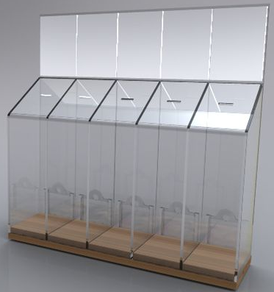 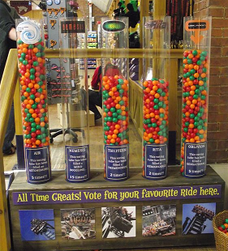

1. *BACK TO OURS* SELFIE STATION (IDEAL: 1 PER VENUE)

* Background board for the selfie, with *Back to Ours* art work (TBC)
* Trunk containing Emoji face and speech bubble props to share post-show feeling
* Easel displaying poster for the show to which the evaluation relates
* Chalkboard advertising selfie station and giving short instructions
* Include hash tag
* Include caption
* Include “call to action” to ensure online posting
* Selfie stick(s) to help people take their shots
* 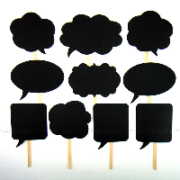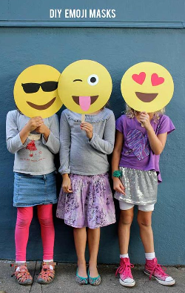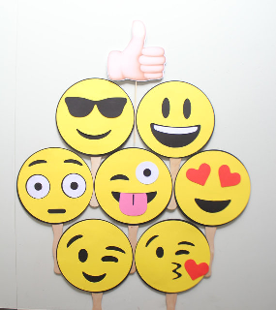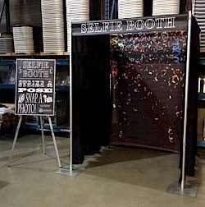Tablet to take selfies for those without a phone

1. TABLET QUICK FIRE SURVEY (IDEAL: 1 PAIR PER VENUE)

* Two wall mounts OR tablet kiosks per booth customised with *Back to Ours* docking/graphic panels
* *Back to Ours* branded short survey

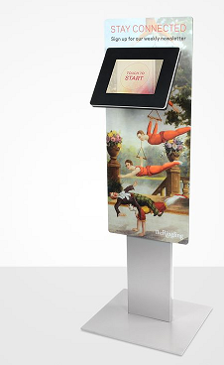 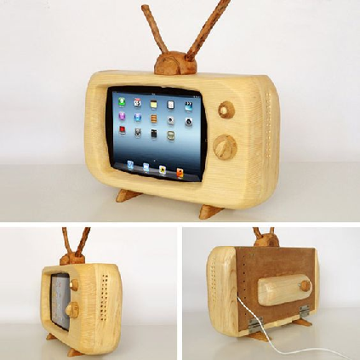 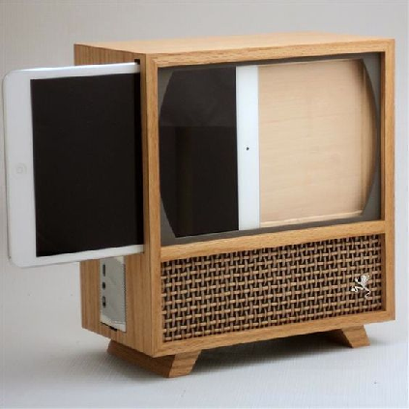

1. CHAT WITH NAN (IDEAL: 1 PER AREA @ SLECTED SHOWS)

* Comfy sectioned off area, decorated to look like Nan’s living room
* Armchairs, old lady lamp, coffee table, tea
* Dictaphone to record discussion
* Build in some still shots of ‘Chat with Nan’

