Fountain 17 Links

Launch Day Video

<https://youtu.be/ntt3p_pLhTg>

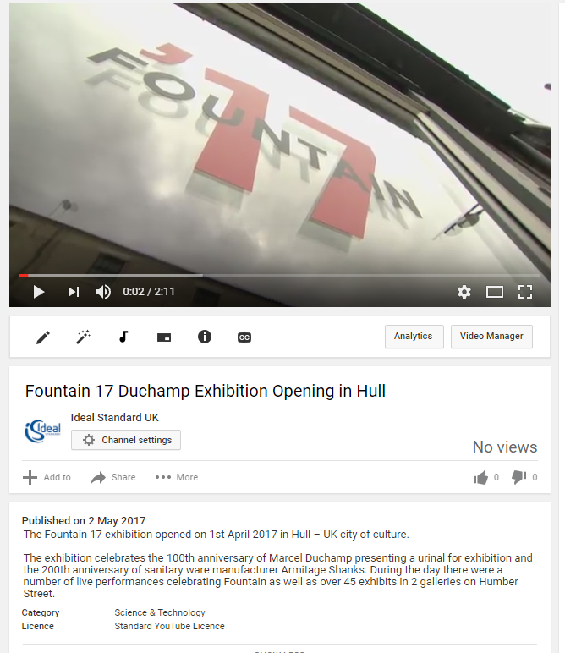

<https://www.facebook.com/theculturezone/videos/1316832618413117/>

Film made by local Film company

<http://www.fountain17.com/>

<https://www.youtube.com/watch?v=hnh0Pfy3elI>

Factory visit