

**LOOK UP**

**A HALL FOR HULL**

**VOLUNTEER**

**BRIEFING NOTES v2**

**Volunteer Briefing Notes**

**OVERVIEW**

Thank you for signing up to volunteer for A Hall for Hull. Conceived by architects Pezo Von Ellrichshausen and working with artist Felice Varini, A Hall for Hull has been created for Look Up, a programme of temporary artworks created for the city’s public spaces and places. It is a joint commission with the Royal Institute of British Architects (RIBA).

**WHAT IS LOOK UP?**

Look Up is a year-long programme of artists’ works made specifically for Hull’s public places and spaces. Designed to challenge people’s perceptions of Hull and offer different ways to experience the city.

Look Up will present a series of new artworks to intrigue and inspire throughout 2017, created in partnership with organisations including The Deep, GF Smith and Hull School of Art & Design. Featured artists include: Nayan Kulkarni, Bob and Roberta Smith, Michael Pinsky, Tania Kovats, Claire Barber and Claire Morgan.

**WHAT IS A HALL FOR HULL?**

*A Hall for Hull* has been created specifically for Trinity Square. The design was chosen from a limited competition between teams of architects and artists. The panel making the choice included representatives from Hull Minster, the city Council, Hull 2017, RIBA and external arts and architecture experts.

The work consists of 16 6m high columns, 2m in diameter, made of perforated galvanized steel. They are arranged in a grid across the square, aligning with architectural features of Hull Minster. They invite people to explore and interact with them. Their presence challenges the way in which we think about architecture and the city, inviting new ways to imagine the use of public space. The design team hopes that ‘A Hall for Hull’ will act as a catalyst, encouraging people to see the familiar in a new light and to explore new activities in the square.

The doorways into the columns are at different positions, to give different views and experiences. You might want to step inside and simply look up at the sky, or look at the surroundings through the perforated sides.

The columns have been fabricated off site, brought to Wedge galvanizing plant in Hull in panels and then assembled on site by the specialist contractor Setworks, who often work on large scale public art installations. Wedge have sponsored the project, as well as providing the galvanizing.They have been installed on wooden bases to protect the square, and levelled off, and are designed with heavily weighted, engineered bases to remain stable.

The artwork on the columns has been created by Swiss artist Felice Varini. It has been designed to distort the view and challenge the perspective of the regular column grid pattern . There are three artworks, down each “avenue” of columns across the square, the two outer ones are viewed from the north side, and the middle one viewed from the south. When perfectly aligned, each of the artworks appears as an unexpected two-dimensional design against the three dimensional architecture.

Varini created this artwork by projecting the design onto the columns at night, stencilling in the outlines and then painting the final artwork during the day. He creates the designs in his studios, using scale models and computer modelling, before applying them at large scales in a variety of settings. It’s really worth looking at his website (see below) and inviting visitors to do the same, to see how he has played with perspective and optical illusion in a huge variety of sites and locations.

Varini brought two assistants from Paris to help make the work, and the team was completed by two young Hull artists who worked on the painting element of the scheme.

The project received planning permission from the city council as a temporary installation.

Pezo von Ellrichshausen (<http://pezo.cl/>) are based in Chile and Chicago. They are a small architectural practice who work internationally and are particularly interested in temporary structures and have also designed many residential projects.

The Paris-based artist Felice Varini ([www.varini.org](http://www.varini.org)) has made artworks internationally for many years. He is very well known for his perspective based artworks, both indoors and outdoors.

WHAT WILL HAPPEN TO HALL FOR HULL AFTER 11 NOVEMBER?

The artist, architect and RIBA are looking for a new home for the artwork after it finishes its installation period in Hull. We think it will probably be exhibited in Europe, although with such an international design team, it could go anywhere in the world.

**YOUR ROLE ON A HALL FOR HULL**

It is important that you read *and* understand the contents of these briefing notes prior to your shift to help you perform your duties.

**KEY TIMES**

10. am to 1.00 pm - Morning Shift

1.0 0pm to 4.00pm – Afternoon Shift

**KEY Hull 2017 STAFF**

Hannah Williams Walton, Assistant Producer

Andrew Knight, Look Up Curator

Hazel Colquhoun, Look Up Curator

**SHIFT MEETING POINT**

You must sign in at the beginning of your shift at Hull Minster

Please ensure you sign out as well.

Volunteers should arrive at the north porch of Hull Minster and sign in at the desk in the north transept.  One of the Hull Minister volunteers will show you where to leave your bags if you would like.

On Mondays the Minister is closed so please sign in at The Parish Centre which is in Trinity Square a few doors up from the pub called A Head of Steam. The address is: Parish Centre, 10a-11 King Street, Kingston upon Hull HU1 2JJ.

**YOUR ROLE**

Your role is a Visitor Information role. Volunteers will be present in Trinity Square to answer any questions that members of the public may have about A Hall for Hull and to be a friendly Hull 2017 presence.

There will be an interpretation board close to A Hall for Hull with information about the installation but please also familiarise yourself with the information in this document. We will also be printing some information leaflets, but are waiting for final photography before these are ready. They will be given to volunteers as soon as they are printed. Please note these may not be available until mid October.

There is no on site briefing for A Hall for Hull so it’s really important that you have read the notes and feel comfortable talking to members of the public to undertake this shift.

Please take some time when you get on site to familarise yourself with the space and have a walk around to try and find the best angles to view the work.

**ON SHIFT**

Please make sure you are in your volunteer uniform. It may be cold outside so make sure you dress up warm.

It is important while in Trinity Square to make sure that you are within sight of another volunteers on shift.

If you need to get in contact with a member of staff please speak to a volunteer or member of staff in Trinity Minister.

The nearest toilets can be found in the Minster and also in the indoor market hall.

If you need to take a break you are free to just please let the other volunteers know you are leaving site.

**WHAT SHOULD I DO IF SOMEONE DAMAGES A HALL FOR HULL WHILE I AM VOLUNTEERING?**

Please make sure you do not put yourself in a dangerous situation. Please report any damage or dangerous behavior to Trinity Minster where you signed in.

**AFTER SHIFT**

You must sign out at the Minster after your shift end time. Please let a member of staff know if you have any feedback from your shift. You can also email the volunteering team to pass on any feedback.

**FAQs**

WHO IS THE WORK BY?

The work was conceived by architects Pezo Von Ellrichshausen. They worked with the artist Felice Varini who applied the white artwork to it.

WHERE IS THE BEST PLACE TO VIEW THE WORK?

As you can see from the photos below if you view the work from a certain point the lines join together to make circles and squares. There is no exact spot for this to happen as it is dependent on height so encourage visitors to move around the square and explore the work. Please encourage people to stick to the Square or the pavement to view the work.

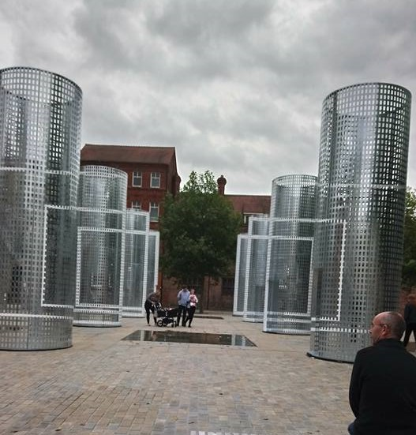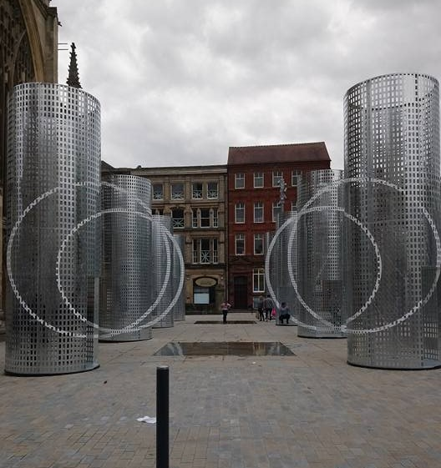

‎Photos taken by Cher Perrin and posted on One Hull of a City.

WHAT IS HAPPENING TO THE WORK AFTER IT HAS BEEN DISPLAYED IN HULL?

There is no confirmed plan at the moment. It may be displayed in another gallery or it may be bought by a private collector. Hull 2017 does not own the work so RIBA and the artist are looking at its future plans.

WHAT OTHER LOOK UP INSTALLTIONS ARE THERE TO SEE?

Claire Morgan “Elephant in the Room” in Princes Quay

Michael Pinsky The City Speaks at the Tidal barrier

Claire Barber The Train Track and the Basket at Hull Paragon station

WHAT IS PEOPLE WANT MORE INFORMATION?

Please direct them to the Look Up page on our website https://www.hull2017.co.uk/lookup

**HEALTH & SAFETY RESPONSIBILITIES**

Please note this important extract from our Health and Safety Policy, bearing in mind that we expect you to act in the manner of a Hull 2017 employee whilst volunteering at the event:

*“All employees have a legal duty to take care of their own health and safety and the safety of others who may be affected by their acts or omissions, and to co-operate with Hull 2017 to enable it to carry out its responsibilities*

*They must not interfere or misuse anything provided to ensure people’s health & safety.*

*They also have a responsibility to report hazards and unsafe practices of which they become aware to their supervisor.*

*The employee should take all reasonable steps to make the situation safe (without putting themselves at risk) until it can be dealt with.*

*It is a responsibility of all Hull 2017 employees to comply with the Health, Safety and Welfare Policy and associated arrangements, and to co-operate with Hull 2017 on its implementation.*

*They must ensure that they are fully aware of their own health & safety responsibilities, these will be detailed in this document.*  *Employees are reminded that failure to comply with health and safety requirements could also lead to disciplinary action.”*

As a Volunteer, it is your responsibility to ensure that you are not undertaking any activity for which you have not been appropriately trained or for which you could be defined in statutory terms as not 'competent'.

If you are in any doubt regarding any activity you are being asked to undertake, it is your duty and responsibility to ask the advice of your supervisor.

**GENERAL DUTIES & RESPONSIBILITIES**

**Assisting individuals who may require FIRST AID:**

If the injury appears to be serious, do not attempt to render aid but call 999 from the nearest phone or payphone. You can also direct people to the closest walk in centre Wilberforce Health Centre, 6-10 Story Street, Hull HU1 3SA

**If you witness a serious incident** please report this to the Welcome Pod. If you feel you are in immediate danger call 999 from your phone or public payphone. Please then report back to or contact the Welcome Pod to let them know of the incident.

**If a member of the public is behaving in a threatening manner** please leave Trinity Square and report this to the Welcome Pod. If you feel you are in immediate danger call 999 from your phone or public payphone. Please then report back to or contact the Welcome Pod to let them know of the incident.

**If you have a SAFEGUARDING concern**, involving a vulnerable adult please inform the member of the staff at the Welcome Pod. In all cases a **Safeguarding Report form** should be completed by the witness.

**YOUR ATTITUDE**

Your attitude will have a major influence on the success of the event. It is important that you always try to be HELPFUL and COURTEOUS and to SMILE and be FRIENDLY when you are dealing with the public. This is particularly relevant if you must deal with complaints.

Be careful not to provoke an incident by your attitude. People must be treated with respect at all times. Do not touch members of the public. Try to avoid confrontations. Remember it is usually right to walk away from a situation if you feel it is becoming confrontational. If in any doubt walk away and report it to a member of staff in the Welcome Pod. This is NOT a sign of failture on your part, but an indication of good judgement.