**What is the role of a capital city?**

Sound Cities: Making Music And Making A Living Outside London

Times are shit, but strange and brilliant music scenes are thriving in fecund pockets of creativity across the UK and especially outside of the capital where costs are lower, gentrification is slower and networks are stronger. On this panel, musicians and industry stalwarts will discuss survival strategies, licensing laws, DIY record labels, building communities, going national, going international, and how to have fun and make music without losing your mind. Chaired by The Quietus

**Katherine Cantwell**

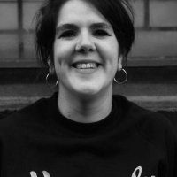

Katherine Cantwell, online content manager at Heavenly Recordings. I have worked at Heavenly full time for the past three years, since graduating from Goldsmiths in 2014 with a BA Honours degree in Media and Communications. Heavenly Recordings is a London based independent label, headed up by Jeff Barrett and existing for 27 years. Since celebrating our 25th birthday two years ago the current label roster is at it’s strongest and most international – yet, with the likes of Temples, Gwenno, Hooton Tennis Club, Amber Arcades, King Gizzard & The Lizard Wizard, Confidence Man, H.Hawkline, Night Beats, The Parrots and Stealing Sheep.I had lived on London for 6 years during my degree and early career in music, growing up in Bournemouth prior to this. In the last three months I have lived in Liverpool - a move that was not a light decision. I'm here to discuss the thoughts, issues, dilemma's and how this decision was supported or perceived as controversial within the music industry.

**Vanessa Reed**

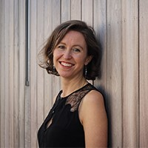

Vanessa leads the overall strategic direction of the PRS Foundation and is responsible for our funding policy, partnership initiatives and resource development. Vanessa joined the Foundation in 2008 having worked previously as an independent arts consultant, on Grants strategy at European Cultural Foundation (Amsterdam) and at British Music Information Centre. In 2010, Vanessa was selected by the Cultural Leadership Programme as one of fifty “[Women to Watch](http://www.culturalleadership.org.uk/w2wlist/)“, and in 2016 she won the music category in the h.Club100 awards for the most influential and innovative people in the UK’s creative industries.

Vanessa specialises in contemporary classical and jazz but enjoys attending a wide range of live gigs, site specific performances and cross art form productions including dance, film and music theatre.

**Cheidu Oraka**

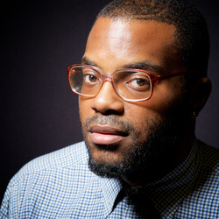

Chiedu Oraka is a UK rapper residing out of the city of Hull (HU6). Chiedu prides him self on being distinctive and different from his peers. Chiedu style isn’t something that can be described easily due to the fact he does not really fit into the stereotype of your current everyday rapper but what he does bring to the table is a fair reflection of a young black man growing up and living in a northern city like hull. His lyrics and flows tell stories and paint pictures with no cut backs or falsification. Chiedu Oraka has number of influences in and out side of music ranging from Nas, Lauryn Hill, TLC and Tupac Shakur to The Specials, Michael Jackson, Stevie Wonder and Chris Eubank Snr. So far it has been a great year for the urban culture in the UK and Chiedu feels that its his time to get a piece of the action there isnt really a northern artist from Yorkshire flying the flag and representing but thats something that is about to change. Do not sleep on this guy because you might not wake up happy.

**Mal Campbel**l

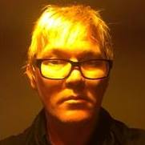

Mal Campbell spent 20 years as a musician in London and New York before moving to Yorkshire in 2007. He has been the promoter of the 200 capacity Trades Club in Hebden Bridge since 2010, has staged shows with the likes of Patti Smith, Thurston Moore, The Unthanks and Richard Hawley and has worked with Heavenly Records, Caught By The River & The Faber Social on events at the venue.