**Stadium Brief**

**KC Lightstream**

Strong family and community emphasis

Season runs from Feb – Sep

Most games 3pm kick off on Sunday but some Thursday and Friday night games (Sky coverage)

No screens in stadium, only for televised Sky Sports games.

Truss at south end for mounting screen

Wi-Fi – no stadium Wi-Fi but do have a few different networks. Feeling they prefer fans to not be on their phones during match as distracts from the action

Stadium PA – ask Joe

North Stand

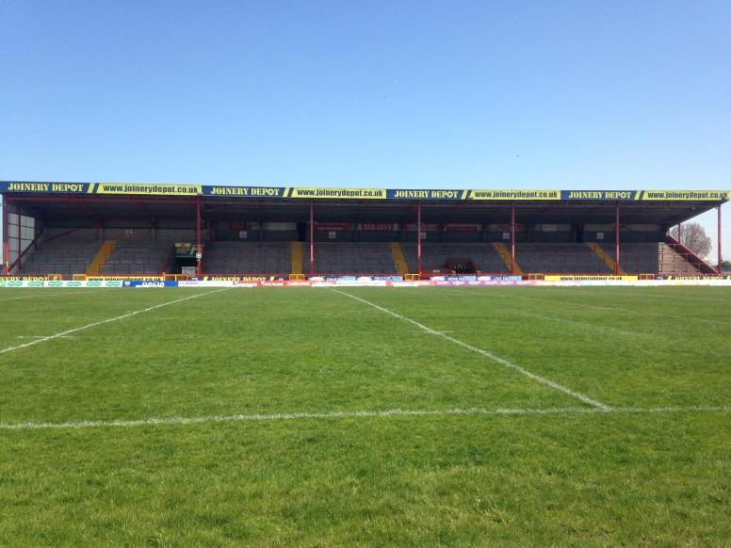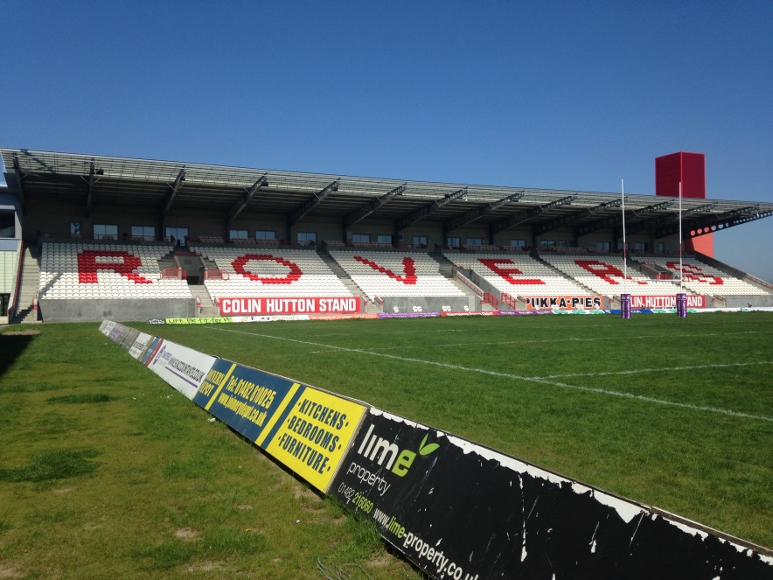Their new £8 million North Stand opened to supporters last season and has already proved a huge success with home (mostly families) and away fans. With nearly 2,600 seats, the Legends Lounge and 10 executive boxes, the North Stand, officially called the Colin Hutton Stand, has transformed the KC Lightstream Stadium's matchday experience. Away supporters will be allocated in blocks 'A' and 'B' of the stand and can enjoy a warm welcome and live entertainment in the concourse underneath the seats from a local artist before each game, which includes: Xboxes, small stage used for local talent, Legends Lounge and a bar area. Concourse also includes closed off area offices and education rooms.

East Stand

Standing terrace

Bit rowdy on match days

Capacity about 3,000

Bar and food concession underneath

People get there early to get their spot

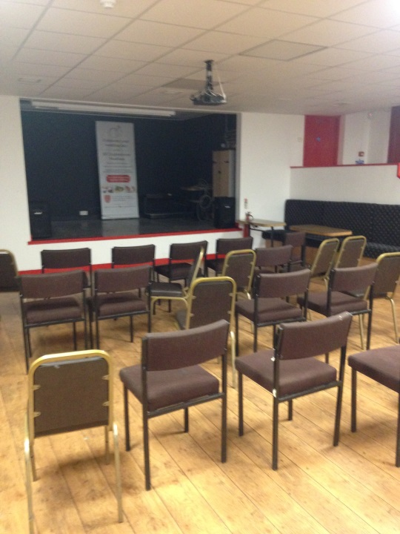West stand

Capacity 5,000

All seated

Chairman and Vice Chairman Suite

Robins Nest and Harry Poole bars (see image) open to fans. One with stage area, which feels a bit like working men’s club

10-5 suite – members only

South Stand

Not currently in use

Outside area

Plenty of parking

Hosting panto there this year

No real pubs close to ground so fans tend to arrive earlier and drink/socialise in the ground

Current half time entertainment

Occasional big names e.g. Tony Christie and Andy Bell

More often fans kicking games, ex players etc

**KC Stadium**

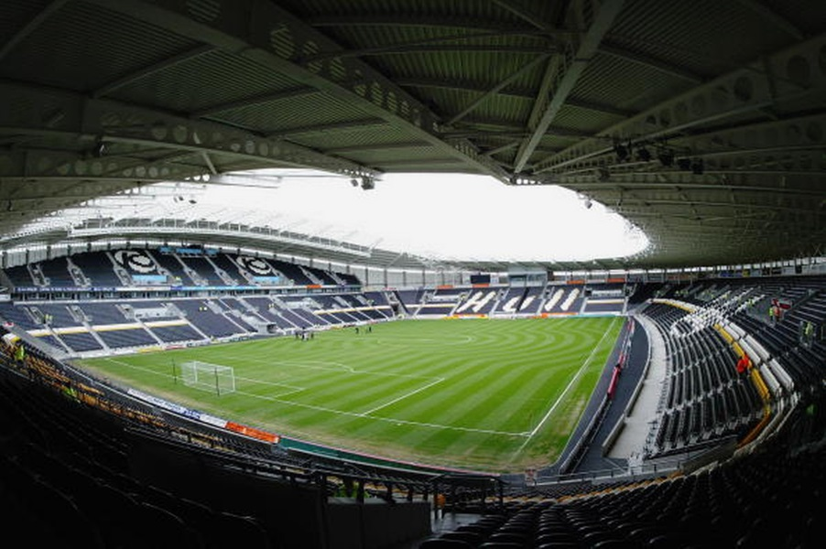The Stadium is owned by the Hull City Council and managed by the Stadium Management Company (SMC), which holds a 50 year lease. It comprises a state-of-the-art all-seater spectator arena with a capacity of 25,586.

It is designed as a single tier, asymmetrical bowl of approximately 20,000 seats with a second upper tier to the West Stand of over 5,000 seats. The seat colours are predominantly black with a white and amber band around the stadium and logos depicted in amber and white.

A generator of 600KVA supplies enough power to evacuate the stadium safely if a power cut occurs.

The floodlights at the Stadium are 1700 lux, compared to 274 lux at Hull City’s old ground, Boothferry Park, and 250 lux at Hull FC’s old ground, the Boulevard. The Stadium has a total of 57 CCTV cameras.

A computerised turnstile monitoring system linked into the control room, keeps check on how many people are entering each stand. There are 2 screens in the Stadium.

West stand lower: where sponsors are seated for its close proximity to private function rooms/boxes with 6,000 capacity. The Stadium caters for over 2,000 corporate guests on match days, with 2,000 square feet of conference and exhibition space, which caters for private or corporate functions.This corporate accommodation includes 28 executive boxes, a restaurant overlooking the pitch, 4 banqueting/hospitality suites and a Sports Bar.

West upper: owner is looking to make this where away fans are seated though it’s looking like this won’t be likely and if it does happen won’t be for a while. It has a 5,000 capacity

East stand: 6,000 capacity

South stand: family-friendly stand with 4,000 capacity

North stand: 4,000 capacity

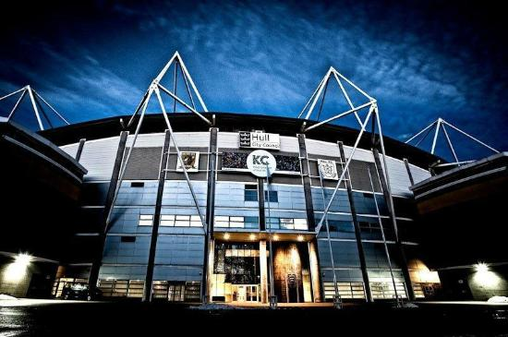

Outside area

The exterior of KC Stadium is quite striking: the four external columns, which can be seen from the exterior of the building, use the corporate colours of the Hull City Council – blue and yellow.

Located within Victorian Park called West Park, the stadium complex is the first in the UK in a parkland setting. The Stadium manages 34.2 acres of land. Also incorporated in the Stadium complex is a Sports Arena, two multi-use all weather pitches, and a learning zone (run by Hull College). The site, including the Walton Street Car Park, accommodates up to 1,100 vehicles. The link foot bridge from Londesborough Street to the Stadium takes away approximately 30% of pedestrian traffic to and from the Stadium.

**The Teams**

Hull City AFC

Founded 1904

Nickname – The Tigers

Ground: KC Stadium Capacity – 25,586

Average Attendance

2015/16 – 17,128 (Championship)

2014/15 – 23,557 (Premier League)

Season runs - August 16 to May 17

Aug 17 to May 18

Fans Groups, blogs etc – Amber Nectar, Hull City OSC, Hull City Supporters Trust, From Boothferry to Wembley, 3 o clock at Kempton

Pubs: Silver Cod, Tigers Lair, Brownies, The George, The Boot Room, Brickmakers

Hull City play in the championship (the second tier of English football)

In 2008/9 they were promoted to the top flight for the first time in the club’s history via the play offs. The winning goal was scored by home-grown hero Dean Windass... A trip to the FA Cup final in 2014 ensued.

Prior to moving to the KC stadium in 2002 City played their home games at Boothferry Park. Much affection for ‘Fer Ark’ remains.

The club is about to take part in the ‘play offs’ which if successful could see the club return to the Premier League.

The club currently put on a pre match light show using the LED lighting in the stadium. It can be switched off instantaneously to create moments of darkness.

Lack of atmosphere in the stadium has long been an issue. The noisiest fans are in the north stand, followed by the east stand. The south stand is currently a family stand and the west stand is mainly full of older less vocal fans.

Hull FC

HULL FC is one of the oldest clubs in the Rugby League and was formed by a group of ex-public schoolboys from York in 1865. Following a succession of grounds and headquarters, the club moved into the Hull Athletic Club’s ground at the Boulevard. Their first game came September 1895, when a record crowd of 8,000 witnessed the ‘Airlie Birds’ defeat Liversedge in the very first season of Northern Union Football.

Ground: KC Stadium Capacity – 25,586

Average Attendance – 11,000

Season runs – Feb 17 to Sep 17

Nickname – The Airlie Birds, the Black & Whites

Supporters Groups – FC Voices, @Hullfcfaithful

Hull KR

Hull Kingston Rovers were formed in 1882 by a group of boilermakers and started life as Kingston Amateurs playing in Albert Street to the west of the city in the autumn of 1883.

Ground: KC Lightstream Stadium (formerly known as Craven Park) Capacity 12,225

Average attendance – 7,500

Season runs – Feb 17 to Sep 17

Nickname – The Robins, red and whites

Fans Groups – Rovers Supporters Trust, Disabled Supporters Group, West Hull Supporters Group, Hull KR Supporters Association

East and south stands are standing terraces

Potential Spaces

KC Stadium, pitch, stands and concourse

West Park – busy route into stadium

Footbridge on north eastern side of ground

Pubs on Anlaby road: Silver Cod, Brownies Bar, Three Crowns, Circle, Albert Hotel, Tigers Lair

Station

Lightstream

Pubs around Marfleet Lane, Preston Road, Holderness Road, Hedon Road