HMAP Dataset 18

Colombian Caribbean Sea

Supporting Documentation



Summary

Dataset Title: Colombian Caribbean Sea

Large Marine Ecosystem: 12: Caribbean Sea

Subject: catch data collected during scientific cruises in northern Colombian Caribbean Sea, 1970-2001

Data Providers: C.B. García & L.O. Duarte
Universidad Nacional de Colombia
UN/INVEMAR A.A. 1016
Santa Marta (Magdelena)
Colombia
email: cgarcia@invemar.org.co

Data Editor: David J Starkey, MHSC, University of Hull
d.j.starkey@hull.ac.uk

Extent: 2231 records

Keywords: historical statistics; HMAP; Caribbean; artisanal fisheries

Citation:
(a) The dataset: please cite as follows: C.B. García & L.O. Duarte, ‘Columbian Caribbean Sea’, in D.J. Starkey & J.H. Nicholls (comp.) HMAP Data Pages (www.hull.ac.uk/hmap)
(b) Supporting documentation: please cite as follows: C.B. García & L.O. Duarte, ‘HMAP Dataset 18: Columbian Caribbean Sea, Supporting Documentation’, in D.J. Starkey & J.H. Nicholls (comp.) HMAP Data Pages (www.hull.ac.uk/hmap)

2. Research Context & Objectives

The study area is the Columbian Caribbean Sea (approximately 13ºN to 8ºN; 71ºW to 77ºW), a diverse marine and coastal region that has a tropical climate. It contains upwelling systems to the north, and estuarine ecosystems to the south, with reef formations close to the coasts of the mainland and offshore islands. Although biodiversity is high in terms of species, stocks are small and sustain only one industrial fishery – shrimp. Artisanal fisheries, nevertheless, are widely practised and intensive in character. Within this area, the research is designed to elucidate the relationship between fishing effort and catches during the 1970-2001 period. More specifically, attention is afforded to the attainment of three principal objectives:

the compilation and online publication of a bibliography of works pertaining to the biology, ecology, oceanography, taxonomy and fisheries of the Colombian Caribbean (see sample page below);

the construction of catch-per-unit-effort indices for the industrial shrimp fishery;

the generation and analysis of the oral testimony of artisanal fishers regarding perceptions of the changing productivity of the fisheries.

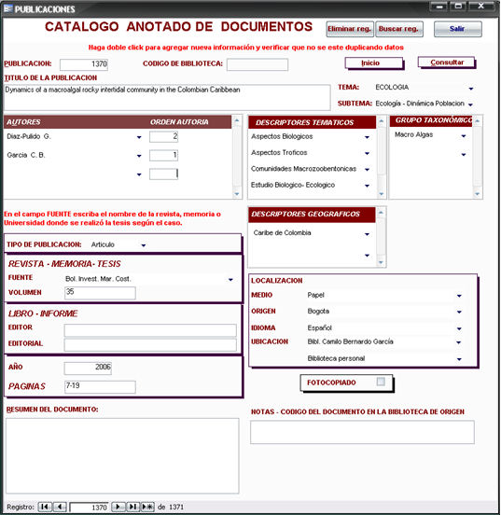

3. Primary Source Materials

As well as the secondary literature catalogued in the online bibliography, the research effort has drawn upon two main forms of primary information. First, the results of 36 scientific cruises (33 bottom trawl, 3 mid-water trawl) undertaken between 1970 and 2001, which in total returned observations on 468 species recorded at 609 stations, have been utilised to inform analysis of the removal of stocks (both target species and by-catch) from the northern waters of the study area by industrial fishers. These data will be augmented with information derived from the results of a further 10 scientific cruises (all bottom trawl, 119 stations, 357 species) conducted in the southern sector between 1968 and 2001.

Second, over 500 interviews have been conducted with artisanal fishers based in the northern, central and southern districts of the Columbian coast (see below).These structured interviews are designed to yield evidence of change in catch rates as perceived by those engaged in fishing activity over the last 30 years. This will generate information concerning artisanal catches that are often unrecorded, and thereby serve to test and correct the official catch statistics published by government agencies, the accuracy of which are generally doubted.

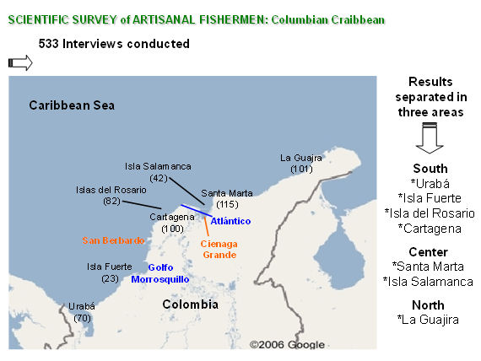

4. Metadata: Explanation of Data Fields

The entries below are outlined as per the field headings of HMAP Dataset 18. An explanation is offered for each field in general terms, and also in dataset specific terms.

ID
ID is the unique, consecutive serial numbers for the complete HMAP database.

InstitutionCode
InstitutionCode is the name given to the overall project of which this Dataset forms a part (HMAP).

CollectionCode
CollectionCode is the specific HMAP project Dataset reference code (used for OBIS referencing purposes).

DateLastModified
This is the date when the data were last modified.

CASE_STUDY
CASE_STUDY is the location identifying description of the Dataset. In this instance: Colombian Caribbean Sea.

DATASET
DATASET is the HMAP project unique Dataset reference.

PERIOD
The Historical Period covered.

ID_NUMBERS
This field contains the range of record numbers shown in the ID field.

REFERENCE
REFERENCE refers to the source of records employed in the research.

GENERAL_DESCRIPTION
This is a brief description of the Dataset: Colombian Caribbean Sea 1970-2001, Observed Weights

Publication_date
This is the date when the Dataset was published.

Citation
Citation is the field where the formal attribution is shown for users of the HMAP Datasets to cite; it credits the researchers and editors of a Dataset together with its database compilers. This citation must be quoted whenever records are referenced or employed for any purpose.

Please quote the relevant citation when using extracts or details from this Dataset:

- C.B. García & L.O. Duarte, ‘Columbian Caribbean Sea’, in D.J. Starkey & J.H. Nicholls (comp.) HMAP Data Pages (www.hull.ac.uk/hmap)

BasisOfRecord
BasisOfRecord is the abbreviation applied that indicates whether the record is based on observations (O), living organisms (L), specimens (S), germplasm/seeds (G), photos (P), or from literature with original basis unknown (D); the HMAP value is generally 'O'.

OCEAN_REGION
This field indicates the specific Ocean Region where the Dataset research has been carried out. If this field shows 'None', then the research reflects activities carried out in non-seaward locations (e.g. in rivers, weir fishing, etc.). In this Dataset, the North Atlantic Ocean region was researched.

LME
This field indicates the name of the Ecosystem where the record event occurred. To find out more about LMEs (which are confined to continental shelf regions) browse the Large Marine Ecosystem site (http://www.edc.uri.edu/lme/) where LME GIS data may be downloaded. In this Dataset, the Caribbean Sea region was researched.

LME_NUMBER
This field indicates the number of the LME that is shown in the previous field. In this Dataset, the LME number is 12.

LATITUDE
The LATITUDE refers to a mean value of the species distribution from surveys and should be cross referenced with the LONGITUDE field for specific location determination.

LAT_PRECISION
This gives the actual precision of the calculated LATITUDE field. The available options are:
- Approx Approximate position
- Estimated Estimated position
- Exact Exact position
- Ground Centre Notional centre of the relevant fishing ground
- Unknown Position not known

LONGITUDE
The LONGITUDE refers to a mean value of the species distribution from surveys and should be cross referenced with the LATITUDE field for specific location determination.

LON_PRECISION
This gives the actual precision of the calculated LONGITUDE field. The available options are:
- Approx Approximate position
- Estimated Estimated position
- Exact Exact position
- Ground Centre Notional centre of the relevant fishing ground
- Unknown Position not known

ST_YEAR
This field refers to the start year of the beginning of the sampling.

EN_YEAR
This field refers to the end year of the end of the sampling. Unless the sampling spanned an extensive period, this value is usually the same as the ST_YEAR field entry.

ScientificName
This field indicates the scientific name of the species under investigation which is linked to the HMAP related FISH BASE database containing detailed information about the species that were sampled.

ObservedWeight
This field indicates the observed mass of the sample in Kilograms. Where this data is not available, a value of "unknown" is entered.

Catch_N
CATCH_N indicates the actual number of specimens sampled for a particular record. Where this data is not available, a value of "unknown" is entered.

GENDER
This field indicates the Gender of the species in the sample. The values available are shown as follows:
- 'M' male
- 'F' female
- 'U' unknown
- 'B' both male and female
- 'H' hermaphrodite

NOTES
The NOTES field gives detailed information specific to a particular record. The details are provided to clarify specific entries and where further explanation is required than is generally provided in this METADATA file. For complete and academically verifiable explanations, refer to the published research materials that are indicated in the REFERENCE field.

CPUE
The CPUE field (Catch Per Unit Effort).

VESSEL_NAME
The Name of the Vessel involved in the fishing operation.

METHOD
The METHOD is an indicator of the primary gear used in the fishery; it indicates the means by which samples were extracted. This is typically the actual method of fishing, such as "Bottom Trawl".

5. Outputs
Camilo B. García, Luis O. Duarte, Jairo Altamar and Luis M. Manjarrés, ‘Demersal fish density in the upwelling ecosystem off Colombia, Caribbean Sea: Historic outlook’, Fisheries Research, 2007, 85(1-2), 68-73.
Caldas JP (2006) Preliminary analysis of the sharks and rays fisheries in the Colombian Caribbean Sea [In Spanish] Proceedings of MarCuba Congress, La Habana.
Luis O. Duarte, ‘Status of Coastal Ecosystems in Colombia: Bottom-up vs. Top-down Pressures’, in Coastal Ecosystems: Hazards, Management and Rehabilitation (NAM S&T Centre, in press).
Garcia CB, Caldas JP, ‘Grenadier Fishes (Gadiforms: Macruridae) from the Colombian Caribbean: What do we know?’ chapter in Grenadiers of the World’s Oceans (American Fisheries Society, in press).

Theses in preparation

Caldas JP (MSc thesis) Reconstruction of catch data
Vivas J (BSc thesis) Historical trends of trophodynamic indicators
Diaz E (BSc thesis) Spatial and temporal analyses of sharks and rays biomass
Ticora A (BSc thesis) Revision of published and unpublished literature on fisheries

Enquiries regarding the information contained in this document and the accompanying dataset should be directed to David J Starkey (d.j.starkey@hull.ac.uk) or John H Nicholls (j.nicholls@hull.ac.uk).

