**Northern Souls**

Northern Fiction Alliance lead a discussion on how independent publishers and new voices are flourishing in the North, and how there has never been a better time to get your voice heard in the North.

**Ra Page – Chair**



**Ra Page** founded Manchester-based independent publisher Comma Press in 2007. Comma Press is the coordinator of the Northern Fiction Alliance.

**Saba Ahmed - Panellist**

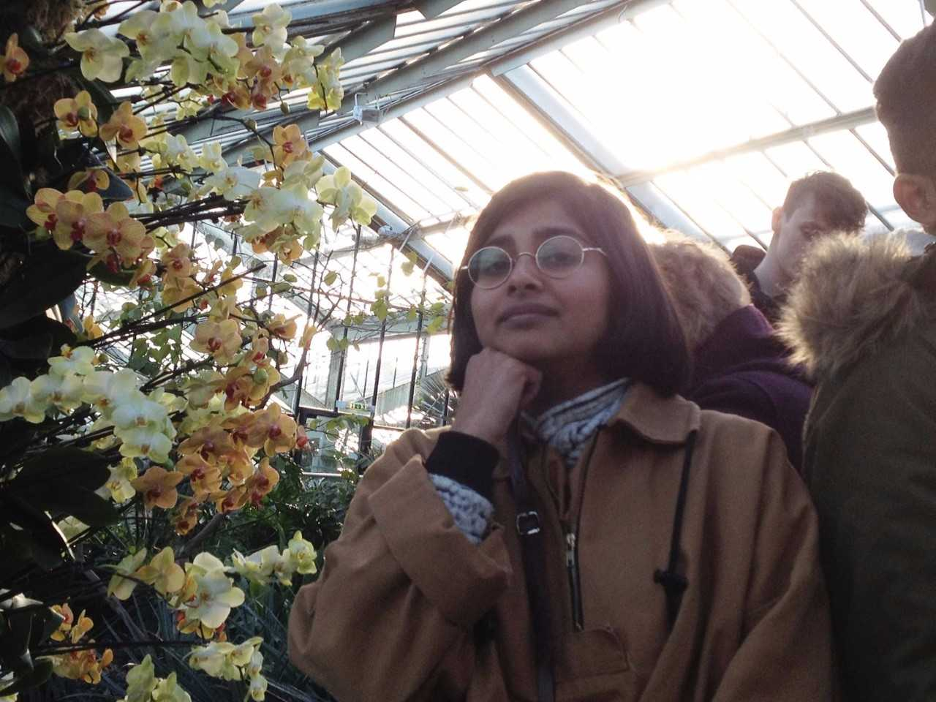

**Saba Ahmed** is the Associate Publisher at Tilted Axis, and Editorial Production Manager at And Other Stories. She has previously worked at a small literary agency in Notting Hill and a large publishing company in King’s Cross.

**Jacob Ross - Panellist**

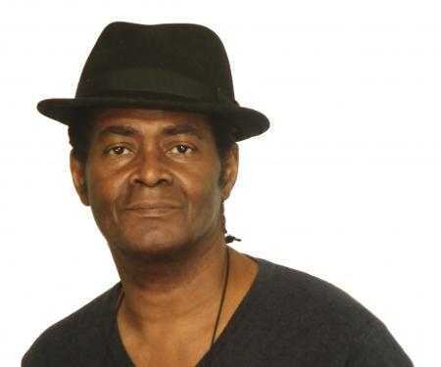

**Jacob Ross** is Associate Fiction Editor at Peepal Tree Press. He is also a novelist, short story writer, editor and creative writing tutor. His novel, [The Bone Readers](http://www.peepaltreepress.com/books/bone-readers), won the inaugural Jhalak Prize in 2017. His latest collection of stories, *Tell No-One About This, was recently published by Peepal Tree.*

**Jamie McGarry - Panellist**

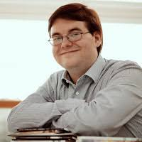

**Jamie McGarry** founded Valley Press in 2008 as an English Literature undergraduate, and has since grown it into 'one of Yorkshire's leading publishing houses' (Yorkshire Post). He lives in Scarborough with his wife, son and cat.