**Epicycle**

12 & 13 Aug 2017

West Park Hull

Capacity 4,500 per night

Pros:

* Free
* Unticketed
* Family event
* Summer holidays
* Weekend
* Circus/acrobatic events always popular
* Hull has earned a great reputation for putting on spectacular outdoor events

Cons:

* May be too late for some families
* West Park doesn’t have a great reputation – especially at night
* Weather can be unpredictable
* Limited opportunities to promote the event in the local community
* Family event on the opposite side of town on Saturday afternoon
* Limited time to publicise the event

General summary:

Previously we discussed not promoting the event on Anlaby Road or through the Hull Daily Mail and avoiding public social media posts to ensure that the event is not oversubscribed. While there are advantages to this approach for the local community with just 460 properties in the immediate vicinity of the park it will be necessary to cast our net wider if we are to attract the 4,500 attendees per night we are hoping for. Furthermore, if our activity achieves the desired results and people start talking about Epicycle ahead of the event it will be difficult to keep it out of the media.

Approach:

In order to ensure that as many of the local community as possible have the opportunity to experience the event, the focus of the marketing campaign will be on hyper-local activity. This in itself presents its own difficulties as there are limited outdoor advertising opportunities in the immediate park area (excluding Anlaby Road) and all bus stop/phone box options are already booked.

We can however, look at more direct marketing tactics, targeting a wider geographical residential area from Anlaby Road down to Spring Bank and across to Calvert Lane. We would also recommend a very targeted social media campaign which is kept off the general Hull 2017 timeline.

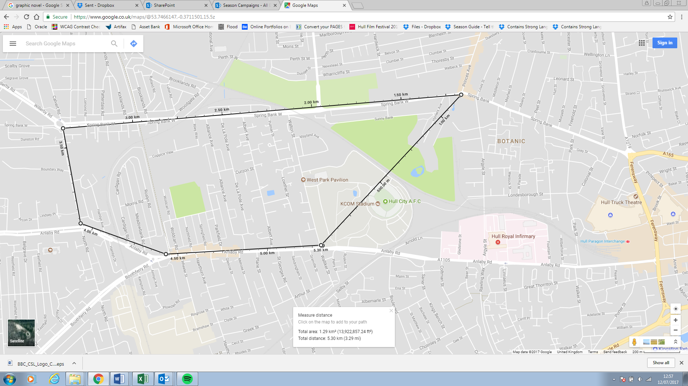

This table details our proposed pre-event marketing spend.

It does not take into account event dressing requirements (for which I will need to take the company down to site to discuss options (I hope to be able to do that w/c 17 July) or event filming/photography (though we have allocated funds to this)

Marketing Budget

Overall pot = £5,000

Event filming/photography = £1,250

Total to spend = £3,750

|  |  |  |  |
| --- | --- | --- | --- |
| **Audience** | **Activity** | **Notes** | **Estimated cost** |
| Resident notification | 460 letters | Print only | £100 |
| Resident door drop | Leaflet/postcard & poster | Design | £150 |
| Resident door drop | 10,000 leaflets & 150 posters | Print | £375 |
| Resident door drop | Distribution of leaflets & posters from the top of Walton St at Anlaby Rd down to Sunny Bank and across to Calvert Lane (awaiting final residential numbers) –  any additional to be distributed to businesses  on Chanterlands Avenue | Distribution – leaflet  & letter x 460 plus  Chanterlands avenue – Volunteers to engage with local businesses  & passers-by | £750  £500 |
| West Hull community & youth groups | Posters & leaflets distributed through Hull 2017 community liaison team |  | Nil |
| Accessibility | Printed site maps with key accessibility details – also available to download too | Design | £200 |
|  | 250 A4 accessible site maps | Print | £350 |
|  |  |  | **£2,425** |

The print will need to be impactful and engaging so as to stand out from the plethora of other leaflets people receive through their doors. It should make them stop in the street and look at posters or pick up a leaflet in their local shop. This should spark conversation and create a buzz in the local community. It’s unrealistic to expect that once it’s in the public domain people won’t take photos of the posters/leaflets and share them online with their friends so we should monitor our social media channels in the days immediately following the door drop to check interest and be ready with a contingency plan should things seem a little quiet.

Contingency

|  |  |  |  |
| --- | --- | --- | --- |
| **Audience** | **Activity** | **Notes** | **Estimated cost** |
| Social Media | Facebook advertising/ promoted post | V. targeted audiences - smallest radius from park poss & not shown on Hull 2017 timeline | £300 |
| Advertising | HDM full page | Consider only if things are very quiet | £750 |
|  | HDM full page | Design | £150 |
|  |  |  | **£1,200** |

We also feel that it might be detrimental to our efforts if we don’t inform HDM on the day we go live. People will naturally talk about the event online and surely it’s better they are on board early (even if they don’t pick it up) than trying to salvage a relationship later.

To that end we’d recommend preparing a press release to go out at the time the event is live. We acknowledge there are risks regarding oversubscription but feel these are offset by the opportunity to accommodate additional numbers behind the allocated seating area, the fact the event is later in the evening (as opposed to 6/7pm) and is not in the heart of the city centre so those not in the immediate vicinity will have to make an effort to get there.

There is a high chance that the HDM will run the story anyway if they uncover it elsewhere at least by issuing a press release as part of the marcomms plan we have some chance of controlling the messaging.

Timeline:

Although Epicycle is not competing with anything else in the programme for onsale dates as such and its ‘live’ date will not be affected by traffic to the site for other events, it’s important it doesn’t get lost in the noise of other events around that time.

Royal Ballet goes on sale on 21/22 July – so there may still be some fallout from this week commencing 24 July.

BBC Contains Strong Language goes on sale on 24 July.

We’d suggest therefore a ‘live’ date of 26 July.

|  |  |
| --- | --- |
| **Date** | **Description** |
| 17 July | Start leaflet design |
| 19-20 July | Draft resident letter |
| 20 July | Leaflet sign off |
| 21 July | Door drop booking deadline |
| 21 July | Resident letter sign off |
| 21 July - AM | Leaflet/letter print deadline |
| 25 July | Courier leaflet/letter to distribution company |
| 26 July | West Park area door drop to land |
| 26 July | Event live on website |
| 26 July | Press release issued |
| 26 – 30 July | Monitor social media traffic |
| 27 July | Book event dressing assets in |
| 28 July | Chanterlands Avenue distribution |
| 31 July | Launch Facebook advert (if needed) |
| 31 July | Book HDM advert (if needed) |
| 31 July | Design HDM advert |
| 1 Aug | Design event dressing assets |
| 2 Aug | HDM advert artwork deadline |
| 4 Aug | HDM advert published |
| 4 Aug | Sign off all event dressing assets |
| 7 Aug | Event dressing assets to print |
| 11 Aug | Dress site |
| 12/13 Aug | Event |
| 14 Aug | Remove event dressing |

­­