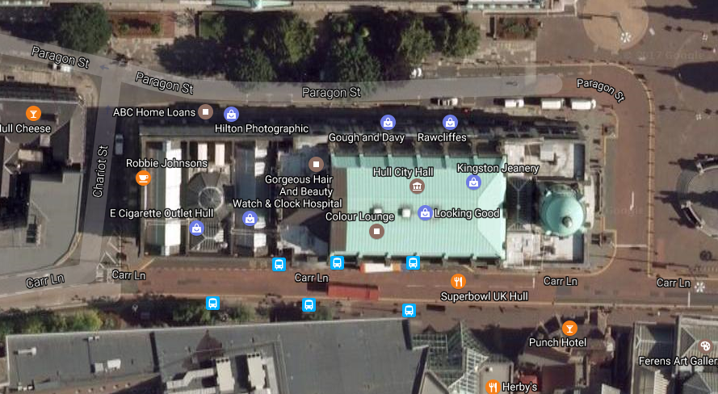

**HPSS truck**

**Production truck**

**Production vehicles**

PRSF Composer Residencies in Hull

Saturday 24 June 2017