

Hull prisoners build replica of Amy Johnson's bi-plane
News Home
- More from Local News
Friday, February 10th, 2017 9:00am
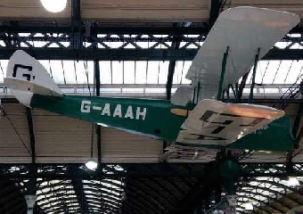
A replica of Amy Johnson's Gipsy Moth bi-plane is to go on display at Hull's Paragon station today.

Inmates at HMP Hull have built a replica of the Gipsy Moth plane flown by Hull aviator Amy Johnson.
It's part of the prison’s reducing re-offending initiative, and will go on display at Hull Paragon Station today.
The project is part of the City of Culture's creative communities.
The project instructors was to:
"Allow inmates to give themselves some self-worth of doing the jobs, working on things, welding, making parts of the plane, suspension work and everything like that and improving their engineering skills. This has been done in the engineering workshop in the prison."
He says the plane has been built from original designs:
"It's a full-size model constructed on an aluminum interior structure. The wings are made in timber and covered in linen, as the original one would've been. People have tried to have one here, now they've got one. I think it should be an interesting thing for the city."

