

**Feedback**

|  |  |
| --- | --- |
|  | **Proportion of people attending with a disability** |
| 21% | considered themselves to have a disability |
| 11% | considered themselves to have a learning disability or difficulty |
| 9% | considered themselves to have a physical disability |
| 3% | considered themselves to have a sensory disability |
|  |  |
|  | **Feedback about the event** |
| 100% | rated the event as good |
| 100% | felt welcomed |
| 74% | tried something new |
| 61% | met new people |
|  |  |
|  | **Previous or future Hull Red customers?** |
| 23% | had attended a Hull Red event previously |
| 99% | would attend a Hull Red event in the future |
|  |  |
|  | **Use of accessibility provisions** |
| 11% | accessed the BSL interpreter |
| 20% | accessed the disabled toilets |
| 14% | accessed the changing place |
| 20% | said they would not have attended if the access provisions had not been available |

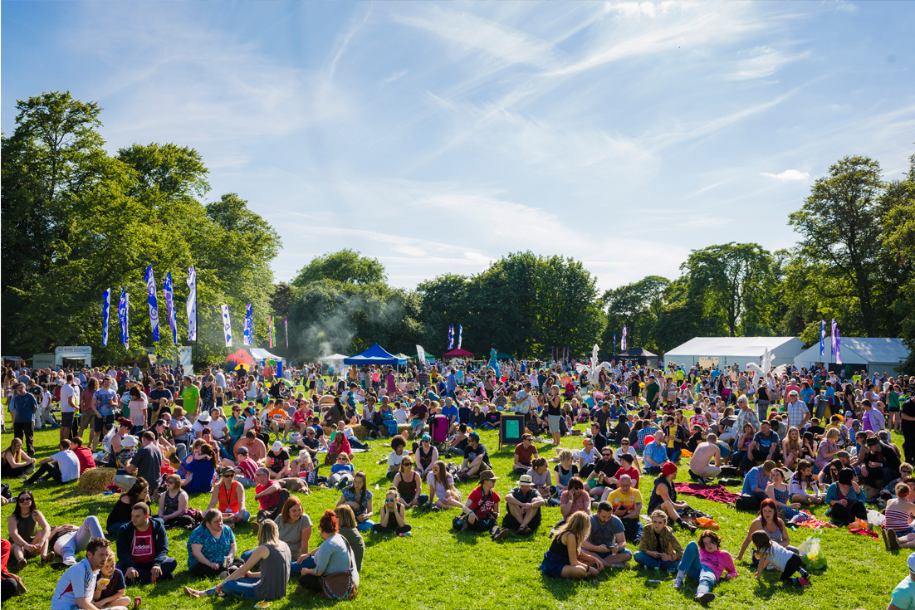

*All statistics based on 109 feedback forms completed on the day.*