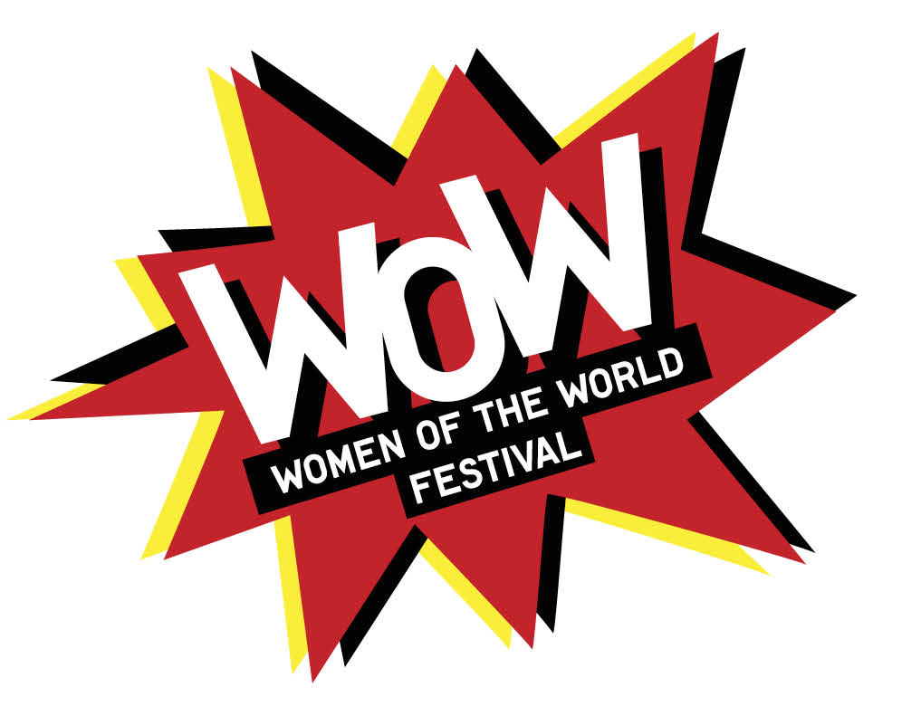HULL

**The Think Ins**

**Aims**

* Determine content for your WOW
* Find new speakers who might appear as part of the festival
* Build relationships with local and international groups
* Tell people you’re doing the festival – see it as a marketing tool, too
* Networking opportunity for the programmers and everyone there

**Structure**

|  |  |  |
| --- | --- | --- |
| Time | What | Lead |
| 10 | Introduction – WOW Story  Ideas – Marketplace – headliners – talks - guests  Dates – Friday 10th to Sunday 12th March  Social Media/Hashtag - | HD and LH |
| 5 | WOW film  Entertainment? | ? Set Up |
| 10 | Everyone introduces themselves – why they’ve come. | Dependent on group size? |
| 15 | **Warm Up**  3/5 questions at each table   * Favourite thing about Hull? * What are some of things that bothers you as a woman? * What’s are some your guilty pleasures? * What advice would you give your 16-year-old self? * Who’s a woman that has inspired you? * What skills would you like to learn that you’ve never been able? What would you like to learn * What | Each table has a facilitator who asks the questions and logs the answer |
| 15 | **3 Level Thinkins for Planning**  (festival programme/headliners/local input/legacy)   * Dreamer (what would be awesome) * Reality (what would be realistic) | Different Tables/Posters for each contribution.  Participants can add to any table. |
| 10 | **Planning ?**   * Talks * Fun Stuff * Local input * Impact | Group with sheets of paper  Write down what talks they would like  What fun stuff they would like. Etc. |
| 10 | Feedback to the room | Tables feedback |
| 5 | Summing up |  |

**Requirements**

Room Set Up

Branding Pop up banners

Posters – Who would they like to invite?

What local concerns would they like to address?

What national concerns would they like to address?

What international concerns would they like to address?

What fun things would they like to see?

What will be Hull specific?

Which local women should speak?

Who should be at a think in?

Disney Thinkin Boards

Dream Board

Realist Board

Critical Board.

Goodie Bags - Information about WOW Festival (Save the Date) card

Information about how to get in contact with us/Social media

Freebies – Beauty Samples, Other Groups info, Chocolate, Recipe Cards, Crafts share.