**LARKIN**

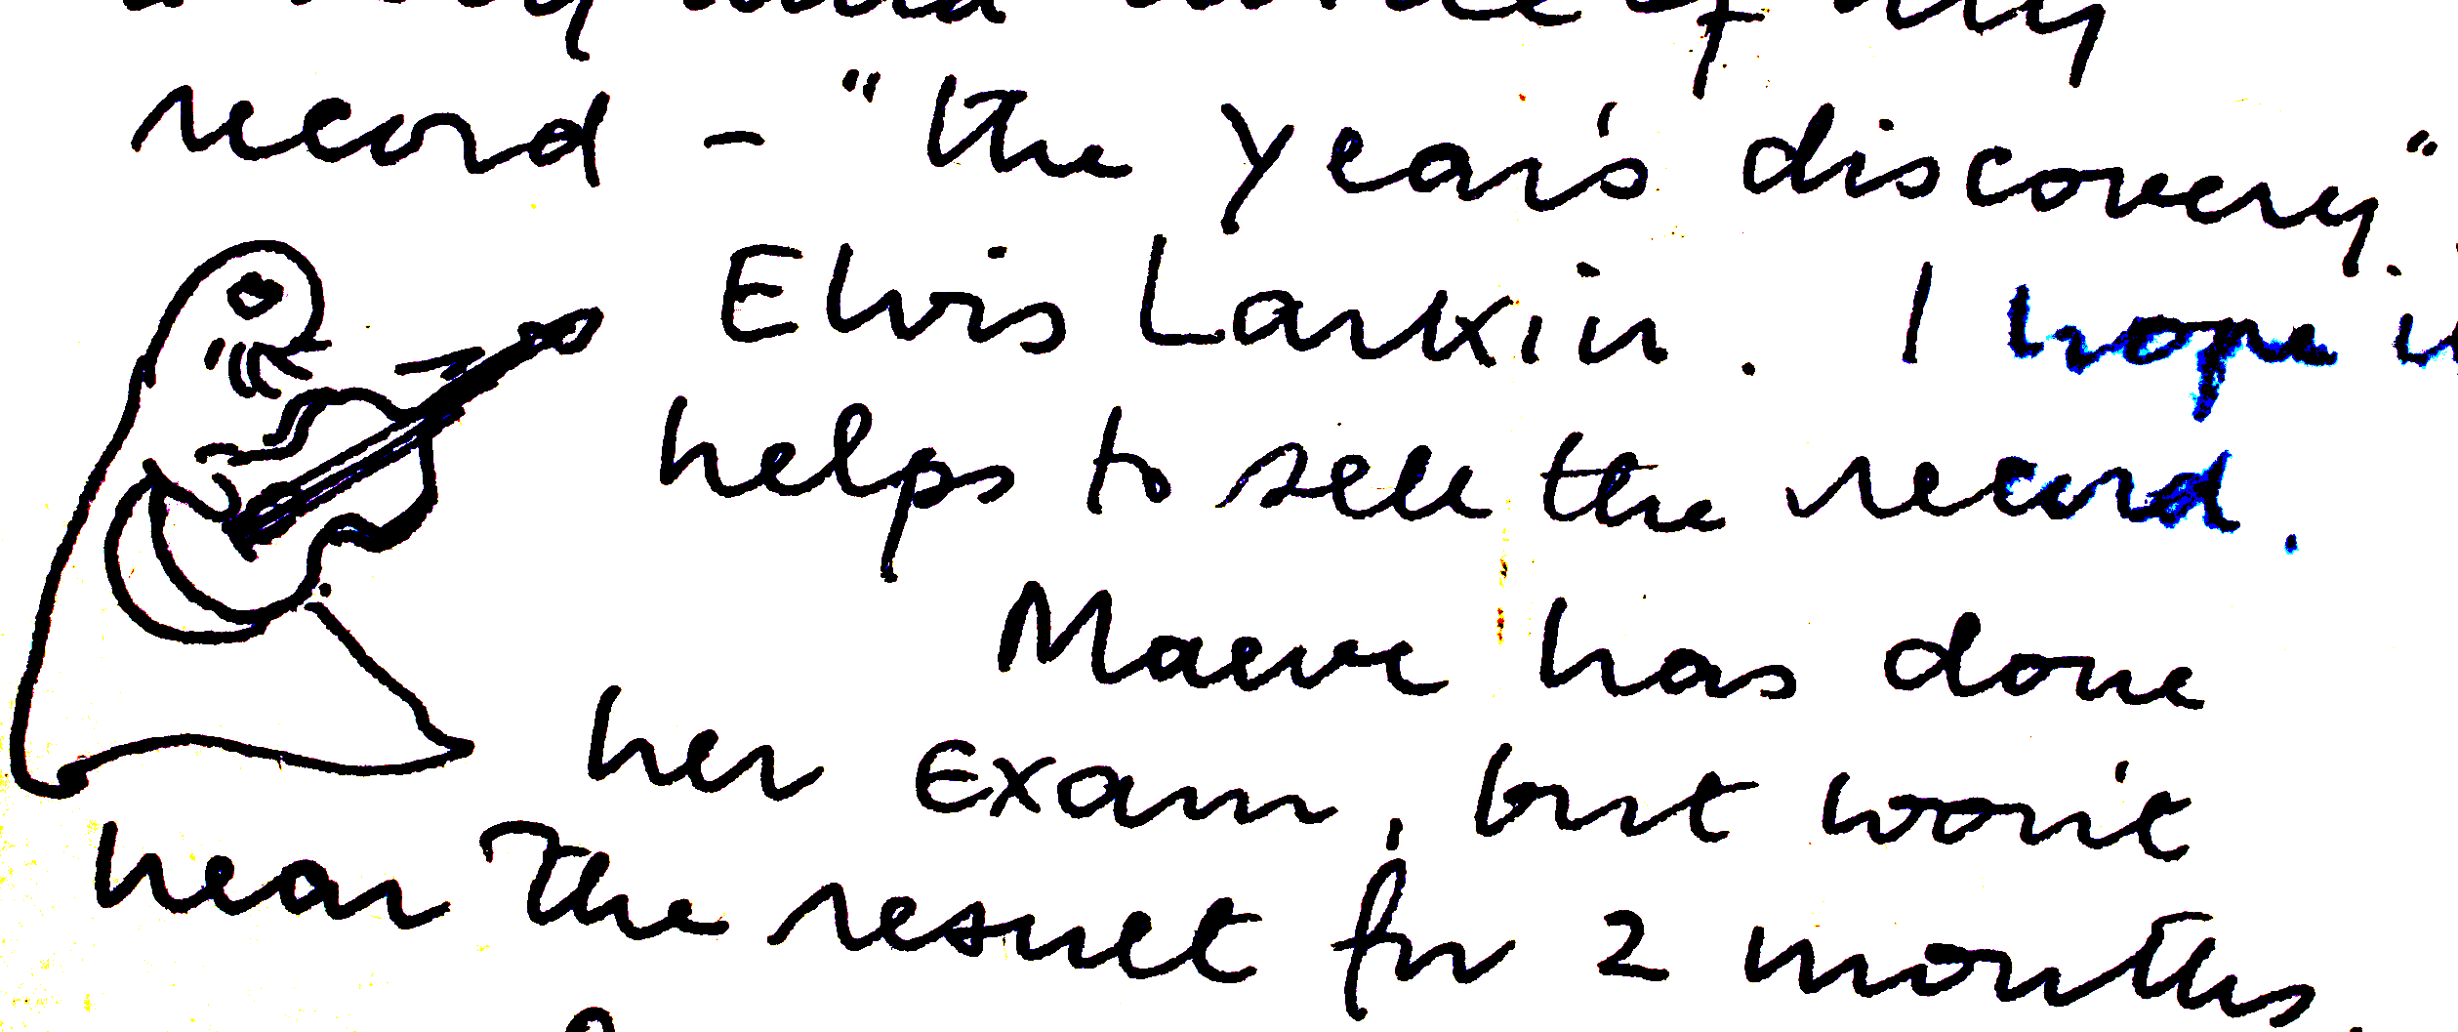

In May 2017 and as part of the Hull UK City of Culture celebrations, it is proposed to present an exhibition on Philip Larkin, poet, librarian, novelist, jazz critic and photographer at the Brynmore Jones Exhibition Centre, University of Hull.

The planned exhibition will look at the life and work of the poet and will draw upon research material and exhibits from the Hull History Centre archive. The exhibition will also include information and contributions from a number of sources including The Philip Larkin Society and the University of Hull.

It is the aim of the exhibition to present a definitive exhibition with an accompanying publication.

**Content**

The exhibition will examine the life and work of Philip Larkin supported by a number of exhibits from the vast range of images, archival materials, and available information. The story will be presented in a series themes interpreting the many facets of a complex and compelling character.

The themes will include a number of interpretation processes including the following:

* Photographic images
* Interpretation graphic panels
* Audio/visual presentations
* Electronic / multimedia interactives
* Tactile interactives
* Showcasing of exhibits and archive materials for display

The exhibition will follow a didactic approach and allow visitors the time to investigate and discover many of the known and not so well known aspects of the poet’s life. The exhibition will occupy the entire display area (approx.150m/sq.) of the Brynmor Jones Exhibition Centre.

**Other considerations:**

* The team will work closely with the 2017 Culture Committee to observe consistency of design and consideration of the established event media identity for 2017.

**Client requirements:**

* Client to provide all text and narrative information (including a copy writer if required) and supply of all image/origination (including copyright fees as necessary).
* Client to be responsible for all applications which require listed status planning or advertisement consent. Ian Goodison Design Consultancy will assist the client with the applications as necessary.

**Optional:**

* Within the scope of the works IGDC will be happy to discuss additional interpretation ideas for development outside the scope of the brief if required.

**LETTERS**

Philip Larkin was one of the last great literary letter writers of the 20th Century, but, beyond that, he was also probably one of the last great letter writers *per se*. Richard Bradford described Larkin as addictive and ‘almost fanatical’ in his approach to letter writing.

When he was not producing literature, working, socialising or sleeping, much of his time was given over to composing letters to friends, literary acquaintances, family or lovers. [Richard Bradford, *The Odd Couple*]

Larkin spanned an era where postal communication was the major form of inter-personal contact, beyond the face-to-face, for people of all walks of life and which offered them a form of expression different and arguably more richly expressive than that of the telephone, email or text. His was a world where the post was delivered two or three times a day, where a first class letter was almost guaranteed to be delivered within 24 hours, and where urgent communication took place by telegram, even if only to send forgotten birthday greetings. Larkin’s personal correspondence captured in great detail every single element of his complex life, from family, to lovers, to various kinds of literary expression. From time to time, it has to be said, they also contain some unsavoury political rhetoric and what would now be regarded as socially unacceptable, albeit entirely private, thoughts. Reading the letters brings the man alive again in every respect and reveals him to be a perceptive, sad, funny, grumpy, passionate, observant individual and, above all, a brilliant writer; *they represent Philip Larkin writ large.*

Some of Larkin’s correspondence, of course, is already very well known. When first published as *The Selected Letters* in 1992 they caused Larkin’s reputation to take a nose dive, partly because they revealed aspects of Larkin’s personality which sometimes shocked and dismayed those who thought they knew him well. This first publication was, however, somewhat selective as well as selected and ignored both Larkin’s correspondence with his long time lover, Monica Jones (subsequently published in 2010) and those to members of his family, particularly his mother Eva, of which some 8000 letters and related documents, are located within the Philip Larkin Archive at Hull History Centre. The published letters also omit altogether the vast correspondence from public figures and ‘fans’ which Larkin received and responded to in his capacity as Librarian at the University of Hull. Taken together, these currently unpublished sources form a rich, and as yet unseen vein of material that could be used to powerful effect within an exhibition and offer fresh perspective on Larkin the man and writer.

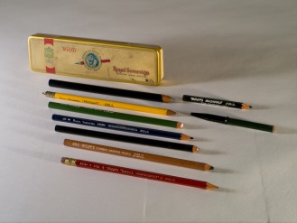

**Why the family letters are important**

* The represent the longest period of continuous correspondence that Larkin entered into and they are the only source of significant correspondence where both sides exist and are available
* They demonstrate an important ‘voice’ in Larkin but indicate something of a ‘joined-upness’ of Larkin’s personality - he shows more than a side of himself to his mother. In a sense, all elements of him are here
* They fill in gaps/unexplained features of the biographical narratives gleaned from other letters and sources. In fact, they provide a kind of ‘seam’ from which the context and the gaps in other letters  can be made sense of
* They indicate the importance of Larkin’s mother, Eva, to his life and work
* They also provide a means of ‘situating’ and providing a commentary on other ‘Larkinalia’, such as the vast number of photographs located within the archive (some of which were sent with letters)

**What the public and fan mail corrrespondence offers**

* Unpublished material and another aspect of Larkin’s letter writing prowess
* Humour
* Another side of Larkin – engagement with ‘fans’
* Reflections of/engagement with the City of Hull in a public capacity

**Some possible thematic uses of the Larkin correspondence within the Exhibition**

* *A day in the life….* Larkin was a very prolific letter-writer and spent a considerable proportion of most days writing a host of letters to various correspondents. It would be quite fascinating, for example, to take particular days on which significant (or perhaps not so significant but personal) events happened and demonstrate the way in which Larkin described and respondent to various people – sometimes the same response but delicately nuanced, sometimes very different (rage against his mother when writing to Monica, loving kindness when writing home, adolescent smut to Kingsley Amis, polite, admiring sincerity and gentle humour to Barbara Pym]
* *A month of Sundays…* Larkin was a creature of habit and ritualistically sat down to write a four page letter to his mother every Sunday morning. They depict life in Hull in the 1950s, 60s and 70s, when recreational options were much more limited.
* *A perspective on Hull and the East Riding*…..*’It’s a bit chilly here and smells of fish’*… Larkin’s letters describe his surroundings in great descriptive and emotional detail, sometimes more positively than might have been expected. They reveal Hull as he saw and lived it, especially in the 1950s, 60s and 70s. Combined with the photographic archive, they capture the changing landscape that Larkin lived through. Using the pre-1955 letters, the same could be done for Belfast.
* *What’s on the back of envelopes…..* It is not just the written content of Larkin’s letters which is fascinating, they are artifacts in their own right. Both he and his mother use different styles and colours of writing paper to amuse each other, and the envelopes document the changing style of postal communication over the years [war time economy envelopes in the 1940s letters, for example, lettercards, postcard depicting Hull in its earlier guises and the holiday destinations visited]. Larkin carried his mother’s letters round with him and frequently used the backs of the envelopes as convenient aide memoires, shopping lists, or reminders of tasks to complete. One contains the cricket scores noted down as he attended a Lords test match with Monica, another contains four lines of a poem not located anywhere else and suggestive of a railway journey.
* *Creature comforts…..* Larkin illustrated his letters (particularly those to his mother) with clever and amusing drawings, usually of seal-like creatures depicting him and her undertaking various activities [or imagined activities] in their day-to-day lives. They would present wonderful opportunities to display the comic, and often self-deprecating humour that Larkin so cleverly deployed.

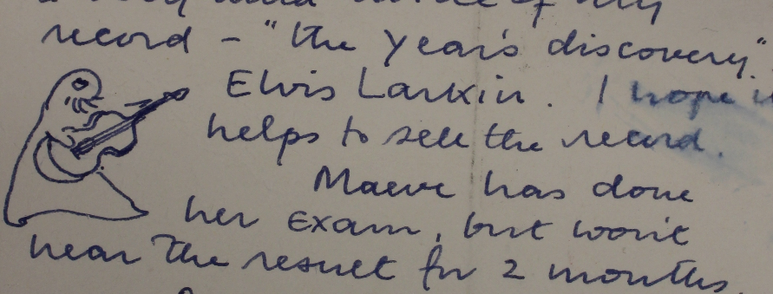

*The Sutton Letters – all that jazz* ….. Larkin’s letters to his close childhood and adolescent friend, Jim Sutton, have been used as a major source of detail on Larkin’s youthful experiences and views in all of the published biographies. The letters span the period from 1939 to 1985, although the bulk of them end in 1951 after Sutton had made a disastrous visit to see Larkin in Belfast. The correspondence was taken up again a few years prior to Larkin’s death. The bulk of the correspondence discusses jazz records and their performances as well as the angst Larkin felt over his fiancé, Ruth Bowman. Sutton’s side of the correspondence has received very little exposure and offers additional insights in to Larkin’s personality and life in Coventry.

* *What puts me off marriage*….. Larkin defended his bachelor status with great energy, considerable guile but not with a lot of angst and this is revealed very powerfully in the correspondence. The awkward triangle between himself, his long term lover, Monica Jones and his library colleague and some time lover, Maeve Brennan is revealed is powerfully acted out in the various correspondences. Add to that, the presence of the other significant woman in his life, his mother Eva and the letters throw considerable light on Larkin’s almost life-long emotional dilemmas.
* *‘Dear Mr Larkin’….dealing with the fans*…. Larkin received a considerable amount of ‘fan mail’ and various requests for comment, personal appearances, book signings etc. His secretary. Betty Makereth, was very adept at keeping people at bay and many letters/requests went unanswered, though they were carefully filed away. However, on occasions Larkin did reply, often with considerable humour. A display based around this correspondence would reveal yet another aspect of Larkin’s character.

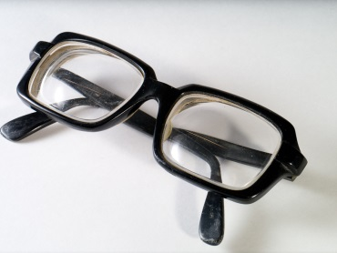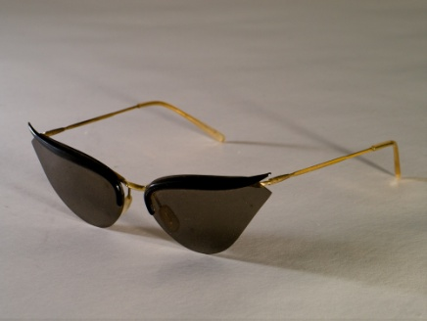

**THE LIBRARIAN**

*Librarianship suits me –I love the feel of libraries – and it has just the right blend of academic interest and administration that seems to match my particular talents, such as they are.* Philip Larkin.

Philip Larkin’s career as a very successful librarian has been a somewhat understated aspect of the retrospective reviews and exhibitions of his life. During his lifetime, Larkin oversaw two major re-developments of the Library at the University of Hull, the legacy of which is firmly embedded and retained in the present Library; indeed the Librarian’s Office is still much the same as it was in Larkin’s day.

In addition to his posts in three British university libraries [Leicester, Belfast and Hull) Larkin also had an experience of and appreciation for public libraries, taking up his very first post as librarian at Wellington Public Library in 1943 and also writing positively about his memories of visiting the public library in Coventry as a boy [ ‘the addictive excitement a large open-access public library generates’….‘the silence of wet artesian-winter nights’ …..‘the holiday-fattened shelves of summer afternoons.’ Philip Larkin, ‘Books for the people’ *New Statesman*, May 1977]

The Philip Larkin Society journal *About Larkin* dedicated its October 1997 issue to various aspects of Larkin’s life as a librarian. An article by Richard Goodman, in particular, documents his librarianship career in very helpful reflective detail and carefully illustrates his successes. In addition to highlighting his successful and innovative work in all five libraries in which he worked, Goodman also acknowledges the wider influence of Larkin in the world of librarianship. Larkin was an active member of the Standing Committee of National and University Libraries (SCONOL) for example, and fought passionately for the retention in English libraries of manuscripts of contemporary British writers which were so often the prey of foreign bidders. In addition, the development of ‘special collections’ at the Univeristy of Hull, the most significant being the Labour Archive (centred on the acquisition of the Fabian Society Library) + the National Council for Civil Liberties (now the Liberty Collection) + an archive of poets reading their work are all down to Larkin.

The significance of Larkin’s librarianship is also reflected in this extract from the Hull History Centre catalogue:

*Larkin was a superb administrator in the traditional style, and his activities were copiously documented in the form of letters, memoranda and minutes. The surviving numerous boxes of archives cover every aspect of his Librarianship, and much more besides, ranging from day-to-day library matters, such as cataloguing backlogs, to University matters, such as staff appointments and the University bookshop, to national activities, such as his work for the Arts Council, and other bodies. There are literally thousands of carbon copies of letters and memoranda, covering topics as far-ranging as the banning of stiletto-heeled shoes in the Library in the early 1960s, to Library sit-ins in the early 1970s, to computerisation in the 1980s. In addition, there are hundreds of photographs.*

The Philip Larkin archive therefore provides a very wide range of fascinating items relating to Larkin the librarian which could be used to good effect in the Exhibition. They include: the letter of appointment to his first post at Wellington; a hand-written request for references from the Librarian at University College Leicester, Rhoda Bennett [the Library did not possess a typewriter until Larkin bought a secondhand one from Leicester market for £30]; an over-due reminder card for a book Larkin took out of Loughborough Public Library; and a letter to his sister Kitty, criticizing the Bodleian Library for not allowing him to borrow the unexpurgated version of *Lady Chatterley’s Lover* -

*Oxford 6-3-41*

*Talking of DHL, I applied for the original "Lady C" and "Paintings" at the Bodleian yesterday. After about 3/4 of an hour I was disturbed at my desk by a girl - an unpleasant girl with spectacles - with a face as red as a peony who demanded "what is your reason for applying for these books? I laid down my pen gave her a look & said "I want to read them." This rather puzzled her - nobody in the Bodleian "just reads." She didn't consider this to be a serious answer & pressed me for a reason. I repeated that I wanted to read them with motions of the hands slightly suggesting one who explains to a child, I pointed out that those works were not available to the general public and, as I had a considerable admiration for Lawrence, I wanted to read them. She said I couldn't have them without being a student of Lawrence or writing a thesis on him or something. I frowned and said: "Isn't that rather childish?" She became even redder and whimpered that it wasn't anything to do with her and would I come to see Mr Wright? I said: "Certainly." So I came and saw Mr Wright, an objectionable little man like a constipated bank clerk. I repeated the foregoing inessentials and so did he. Then I remarked with artificial scorn: "You see, I don't consider these works obscene." This touched him in his sensitive spot - his "tolerance" - and he snivellingly began explaining that neither did he nor the Library. I said that their action implied as much, and brushing aside his mumbling about copyright, responsibility, defacement etc I shambled back to my seat, snarling. Actually, I suppose I could have got them by pretending I was writing a thesis on Lawrence - anything as long as I wasn't going to "read" him, and admire him.*

Larkin’s letters contain much amusing description of library life across the four institutions in which he worked. Eg this on a visit by the Queen and Duke of Edinburgh to Queens Belfast Library in 1952 –

*The Duke arrived & put in his 12 hours - I stood on the back steps of the Library & watched him stride by, left hand tucked in the jacket pocket of his dark grey suit with the thumb protruding, right occasionally “acknowledging applause” as if he were flicking flies away from his right eye. He left a large & not too illiterate “Philip” in the Common Room visiting book. He was very lean & brown. We did not get much sense out of the Library girls that morning.*

Many of the letters document Larkin’s involvement in the library rebuild and his anxieties leading up to the opening of Stage One of the new University of Hull Library and beyond. For example, in 1960 he informs his mother that when the two official photographs taken the Queen Mother is asking in the first one whether she should put down the date and, whilst the second was taken, asked, "What is the date?"

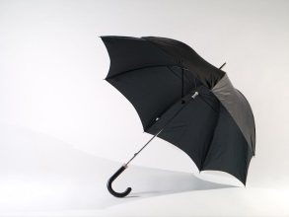

**How the library theme might feature in the exhibition**

**‘The Toad Work’: the minute as an art form**

*And when I bind up the Library Committee minutes at the end of five years it makes a great fat volume; but they’re not the same as a volume of poetry. They’re very good minutes, but the minute as an art form has its limitations.’ [Philip Larkin to John Betjeman, BBC Monitor programme 1964]*

Larkin’s scrupulously recorded minutes of the various [do we have a number?] Library Committee meetings at the University of Hull are all contained within the archive. Larkin dreaded his attendance at these meetings, a point documented in his letters, particularly those to his mother but he clearly did the job diligently.

There is one particular committee meeting that stands out in Larkin history, that of Monday 6th March 1961. At this meeting, Larkin collapsed, displaying some of the conditions of epilepsy, although the exact cause was never clearly diagnosed. There is an x ray of Larkin’s brain within the archive [although this item relates to a later consulation made by Larkin in the 1980s]

The event is well documented and commented on in Larkin’s personal correspondence, particularly the family letters and might tell an interesting story.

**Personal recollections of Larkin the Librarian**

This could include video/audio of people who are still alive and who worked with Larkin together with those already recorded on film or in print.

**Love in the Library [or ‘love amongst the stacks’]**

The libraries that Larkin worked in formed the background to several of his love affairs. For example, he met his first girlfriend and only fiancé in the Wellington Public Library. As a sixth former studying English, Ruth Siverns was a frequent library user and soon fell for the charms of the new young Librarian, with an endearing stammer, an Oxford First and already a published author. Larkin first met Monica Jones, his lifetime companion and lover, in the Library at University College Leicester. At Belfast he became infatuated with one of the young library assistants, Winifred Arnott; although his passions were not reciprocated he wrote several significant poems about her including *Libes From A Young Lady’s Phtograph Album*. At Hull, Larkin was to develop a long-standing affair with his senior librarian, Maeve Brennan and, towards the end of his life, with his secretary, Betty Mackereth.

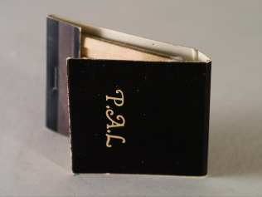

**Approach**

**It is the intention to progress the project in consultation with the exhibition interpretation team, building a team of consultants as the project develops.**

The following points show the intended design development of the project underpinned with a project cost plan:

1) Start-up meeting

An initial start-up meeting and subsequent meetings with the project team to exchange ideas views on the project development.

2) Programme

To initially build the project around a detailed work programme developed in consultation with the interpretation team and other commissioning bodies as necessary.

IGDC believe that a detailed programme with time indicators allocated to deliver tasks will give structure to the project and highlight issues that may arise in the course of development.

3) Initial design proposals

To take key elements from the brief and develop initial design proposals which would also form the basis of a consultation document. Work will also begin on developing the text and images for the information exhibition interpretation and catalogue.

4) Consultation

The process of consultation is a key factor in assisting and steering the ideas developed in the initial design proposal in a positive forward direction. It is the intention to provide an adequate timescale within the project to seek the views/ comments from user groups and other bodies through a proposed framework of planned sessions.

5) Final design proposals

To review the comments and feedback generated from the initial design discussions and from consensus of opinions to produce an amended document as final design proposals for the display interpretation. This will be issued for approval to move to the next stage. Work will be reviewed on the development of the text and images for the information/interpretation.

6) Design development

This is the stage where the final proposals are developed for final presentation.

7) Client approval

To finalise sign off from client and associated approvals

8) Commissioning

To commission manufacturers to plan process and build exhibition displays and associated items.

9) Delivery and Installation

To manage, report and monitor the delivery and installation of the exhibition displays.

12) Cost Plan

Throughout the life of the project and at key stages I will assist in developing a cost plan that will adhere to the budget needs and engineered as necessary to keep the project within the agreed project finance.

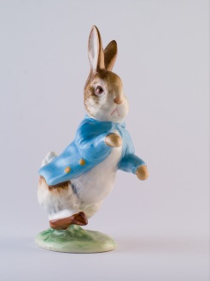

**Finance**

*The following cost are based on an assumption of the provision services initially discussed with the client team that will be further explored in the development of*

*the design brief:*

Graphic images to perimeter walls £4,280.00

Graphic Interpretation Panels £1,680.00

Housing structures for Interpretation Panels & Graphics £6,600.00

5no interactive units

* 2 monitor displays £2,880.00
* 1 Multimedia interactive £4,200.00
* 2 small mechanical interactives £3,600.00

1no Costume case and mannequin (Hire 2 months) £2,455.00

7no plinth showcases for archive material (Hire 2 months) £6,525.00

Installation of above items £3,600.00

Breakdown and removal of exhibition £1,500.00

Sub Total £37,320.00

**Project Value £37,320.00**

Exhibition /Graphic Design Fees (includes all expenses)

• Project management for the delivery for design services.

• Attendance of a number of project meetings at site for

interpretation and project development.

• Design and development of initial design proposals

• Design and development of final design proposals

• Artwork and ‘mock-ups’ for exhibition graphics

• Artwork and detailed drawings for exhibition structures and

graphics

• Provision of material samples

• Attendance for on-site installation £ 8,584.00

**Project Total £45,904.00**

Additional Item:

**Replacement of existing roller blinds with blackout (Provisional Sum) £ 2,000.00**

*(Design Day rates for work falling outside the scope of work £250.00)*

**Programme**

* IGDC would recommend a total project timescale of 43 weeks and estimate a 24 week provision for research, interpretation, audio and visual briefs to include the development of the interpretation script for the exhibition and catalogue and inclusion of objects and archive materials.
* Curatorial/design team meetings to review and progress and development could be arranged at the end of each month over the 24 week period.
* Design development of 19 weeks to include design development, production and install for **1May 2017**
* January/February 2016 is allocated for finalisation of funding decisions therefore project planning could begin as early as **1 March 2016.**
* The following table is indicative of anticipated milestones and deadlines for the latest start date **1June 2016**

|  |  |  |  |  |  |  |  |  |
| --- | --- | --- | --- | --- | --- | --- | --- | --- |
|  | **Research/ Interpretation**  **brief** | **Object selection/**  **preparation** | **Archive**  **selection/**  **preparation** | **Audio**  **brief** | **Visual**  **brief** | **Design**  **process** | **Production/**  **installation** | **Opening** |
| **Jun16** | **Begin process**  **1 June 2016** |  | **Begin process**  **1 June 2016** |  |  |  |  |  |
| **Jul16** |  |  |  |  |  | **Begin 1st update**  **Meeting**  **30 Jul** |  |  |
| **Aug16** |  | **Begin process**  **1 Aug 2016** |  | **Begin process**  **1 Aug 2016** | **Begin process**  **1 Aug 2016** | **2nd update**  **Meeting**  **28 Aug** |  |  |
| **Sep16** |  |  |  |  |  | **3rd update**  **Meeting**  **30 Sep** |  |  |
| **Oct16** |  |  |  |  |  | **4th update**  **Meeting**  **30 Oct** |  |  |
| **Nov16** | **Complete by**  **28 Nov 2016** | **Complete by**  **28 Nov 2016** | **Complete by**  **28 Nov 2016** | **Complete by**  **28 Nov 2016** | **Complete by**  **28 Nov 2016** | **5th update**  **Meeting**  **30 Nov** |  |  |
| **Dec16** |  |  |  |  |  | **Initial**  **Designs** |  |  |
| **Jan17** |  |  |  |  |  | **Final**  **Designs** |  |  |
| **Feb17** |  |  |  |  |  | **Prod/Dwgs**  **Artwork** |  |  |
| **Mar17** |  |  |  |  |  |  | **Production** |  |
| **Apr17** |  |  |  |  |  |  | **Production**  **On site 3 days 28-30** |  |
| **May17** |  |  |  |  |  |  |  | **Opening**  **1 May 2017** |

**IGDC** (Ian Goodison Design Consultancy) - Draft 1 - 22/12/15

1 -- Reading lamp

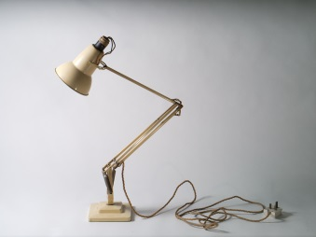

The anglepoise lamp, invented by British designer George Carwardine in 1932, concentrates a directed funnel of illumination on to a small area. Together with the windowscape outside and the hiss of a gas fire, the lamp symbolises for the young Larkin the joy of self-possession. His imagination seeks release in a 'padlocked cube of light'. In 'Livings II' he redirects the lamp, now huge and ambiguous, outwards at the reader, as the speaker tends his mythic lighthouse, 'Guarded by brilliance'. But as Larkin's inspiration faded lamplit solitude turned to simple loneliness. In ‘Vers de Société’ (1971), he deserts its private space for the 'forks and faces' of public social intercourse:

The time is shorter now for company,

And sitting by a lamp more often brings

Not peace, but other things.

Beyond the light stand failure and remorse

Whispering *Dear Warlock-Williams: Why, of course—*

The lamps inside the Old Fools' heads have slipped into the hands of others as they falter into dementia. Nameless familiar figures appear to them, 'Setting down a lamp, smiling from a stair, extracting / A known book from the shelves.' The lights may be on, but there's nobody at home.

2 -- Trunk

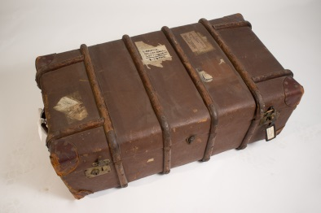

One end of this substantial ribbed and riveted trunk bears a glued label reading: 'BELFAST Passenger's luggage in advance'. But, judging by the remnants of other glued labels, it had seen service during Larkin's student days before it was put to service transferring his effects across the Irish Sea in October 1950 – and then back again five years later. The bold label glued on the top reads:

LARKIN

HOLTBY HALL.

COTTINGHAM

E. YORKS.

This University-owned house was Larkin's first perching point in Hull in 1955. Later, when he was living in his high-windowed flat he graduated to a smart leather-framed address tag attached by a strap to the left front clasp. It reads: 'Larkin 32 Pearson Park Hull'. Perhaps this stylish piece of luggage-furniture dates from his sojourn in Oxford during his work on the *Oxford Book of Twentieth-Century English Verse* in 1970-1.

3 -- Larkin’s spectacles



It was a significant moment in the history of poetry when on New Year's Day 1942 Larkin received official notification that his medical condition had been graded at IV. He would be exempt from military service. Consultant Ophthalmologist, Colin Vize, has recently analyzed spectacles from various phases of the poet's life and concludes that 'less than 1% of the population exhibit short-sightedness of the magnitude experienced by Larkin'. It seems, even, that Larkin may have been right after all to attribute his mysterious collapse at a University’s Library Committee meeting in March 1961 to a mis-prescription for his new spectacles.

Do the 'out of reach' light-filled vistas in such poems as 'High Windows' and 'Here' owe something perhaps to Larkin's acute, lifelong myopia?

Larkin appears to be wearing these thickly-framed rectangular bifocals in the iconic photographs taken by Fay Godwin in 1974. One of them was used for the cover of *Required Writing* in 1983, at which time the poet wrote to the photographer that he had made Faber promise never to use the photographs in the series which made him look like the Boston Strangler. Faber nevertheless chose one of these very images for the cover of Martin Amis's selection of Larkin's poetry in 2011, compounding the insult by showing just one sinister, bespectacled eye at the bottom left corner of the back dustwrapper.

4 – Monica’s spectacles



By all accounts, Monica Jones had a keen, sometimes even unnerving dress sense. One student taught by her in the 1950s recalls that she wore 'pretty pastel shades when her topic was the Romantics; severe flowing black when she spoke about tragedy'; she wore tartan for her Macbeth lecture. Later when she came to live with Larkin in Hull she cut a striking figure in her flamboyant cape. A member of the library staff recalls: 'You couldn't miss her bright colours.' These sunglasses, worn on holidays in Scotland and Sark are redolent of the 'sophisticated' film-star culture of the 1960s.

5 -- Typewriter

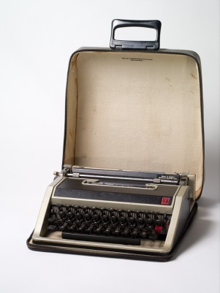

Those of us of a certain age will remember fondly this De Luxe version of the celebrated Olivetti Lettera 32, on which we typed our student essays in the 1960s, and embarked on the formalities of adulthood, laboriously adjusting our application forms round the barrel, so that the responses would be positioned horizontally between the lines (which they never were). It was manufactured in Spain to an Italian design, and like the BMC mini it has an iconic status, with its futuristic silver-grey, black-banded case and moulded plastic finger-friendly keys. Best of all, it was 'portable'.

The young Larkin typed his first truly Larkinesque poems, the 'Sugar and Spice' sequence in 1943, on a heavy archaic machine with circular metal keys. He used a two-banded ribbon so that he could shift between red and black, and inserted three sheets of carbon paper to produce a limited edition of four copies. No doubt he welcomed the advent of the more convenient, lightweight technology of the Lettera. On the other hand, with a charming archaic sense of etiquette, he would apologise to his more intimate correspondents when he sent them typed letters rather than more 'sincere' holographs.

6 -- Newland Park letter-writing paper

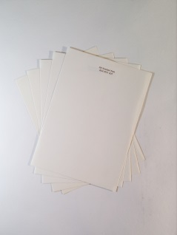

Writing on his familiar 32 Pearson Park notepaper in February 1974, Larkin told Judy Egerton about the property he had just bought: 'an utterly undistinguished little modern house in *Newland Park* (Plus ça change, plus c'est la même parc). I can't say it's the kind of dwelling that is eloquent of the nobility of the human spirit. It has a huge garden – not a lovely wilderness (though it soon will be) – a long strip between wire fences – oh god oh god […] So Larkin's Pearson Park Period ends, & his Newland Park Period commences.'

Shortly afterwards, in April, the cruellest month, he began his 'final' poem, 'Aubade'.

7 -- Blank workbook



Larkin outlived his inspiration, and during his career seems, almost uniquely among poets, to have explored every poetic opportunity to the limits of his sensibility and genius. Consequently this blank manuscript book does not have quite the evocative power it would possess had it belonged to John Keats or Wilfred Owen. But it has its own eloquence. The blankness of these pages seems a deliberate choice. We may recall 'Forget What Did':

Stopping the diary

Was a stun to memory,

Was a blank starting […]

And the empty pages?  
Should they ever be filled  
Let it be with observed  
  
Celestial recurrences,  
The day the flowers come.  
And when the birds go.

8 -- Frog

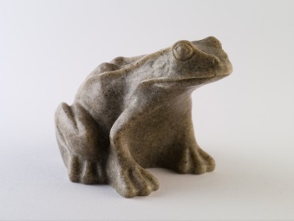

Larkin was no naturalist and did not distinguish between toads and frogs when, in the years following the publication of 'Toads' and 'Toads Revisited', he surrounded himself on desk-top and mantelshelf with symbols of the toad work, in stone, plastic or glass. He even had a large wickerwork wastepaper basket in the shape of a toad with a gaping mouth. This particular lugubrious but elegant frog, with its air of longsuffering stolidity, expresses something of Larkin's ambiguous attitude towards the animal, and towards the work which it symbolises:

No, give me my in-tray,

My loaf-haired secretary,

My shall-I-keep-the-call-in-Sir:

What else can I answer,

When the lights come on at four

At the end of another year?

Give me your arm, old toad;

Help me down Cemetery Road.

He would have been delighted by the plague of variegated toads that occupied Hull during the Larkin25 celebrations in 2010.

9 -- Lenses

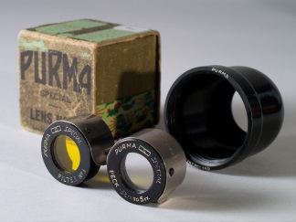

Larkin took photography seriously. Among his effects in Newland Park were three cameras, a light meter, a tripod and several lenses. In his early years in Hull he took responsibility for the annual Library staff photograph, using a delayed shutter release, so that he himself could be in the shot. Some of the most familiar photographs of the poet, gazing into a puddle on the library building site, standing beside a monument in Spring Bank cemetery, looking out of a train window at the rain, were taken under his direction, though other people clicked the shutter. Some of his photographs could be called experimental: Maeve Brennan half-hidden behind reeds, the library staff seen in bird's eye view from his office window.

He valued the 'faithful and disappointing' immediacy of photography in recording everyday life. In 'Lines on a Young Lady's Photograph Album' he celebrates the way the album preserves 'a real girl in a real place / In every sense empirically true.' He described his poetry in similar terms: 'there's not much to *say* about my work. When you've read a poem, that's it. It's all quite clear what it means.' However, as this technological paraphernalia suggests, there is more conscious artistry than he cares to admit in his interventions between subject and audience, in both his photography and his poems.

10 -- Puncture outfit

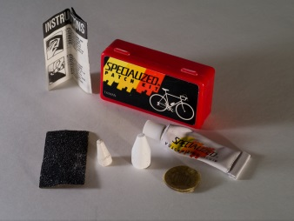

Who of us now recalls the exasperating ritual? – levering the inner tube out of its rigid casing, pumping it up, immersing it in a bowl of water, and watching to see where bubbles betrayed a puncture; then roughening the rubber with emery paper to ensure the glue would take properly before carefully positioning the patch. And it never, ever worked! But perhaps Larkin had the knack, since his puncture kit has clearly seen much use.

Larkin developed a taste for cycling in the days before the motor car took over all roads. In August 1939, at the age of 17 he spent a week cycling with his father between Radstock, Glastonbury and Ilminster in Somerset. Sydney's diary proudly records: 'Philip's cyclometer indicated that we had ridden 162 miles.' Shortly after his arrival in Hull, in April 1956, the poet set off on a typically aimless exploration. Arriving too late at Victoria Pier to catch the ferry to New Holland, he enjoyed a lunch of beer and biscuits in the Minerva Hotel, then cycled round the dock area 'a good bit'. Eventually he 'got out on the west side of Hull', and tried to find Tranby Croft. 'But I got lost, & tried to photograph lambs instead: but as soon as I approached two a sheep lifted its head and said something, & they ran away to her.'

11 -- Beatrix Potter: Peter Rabbit



Philip and Monica shared an intimate Beatrix Potter language. He addresses her as 'Forepaws', 'Ears' or 'Bun' and adorns his letters in the 1950s and 60s with charming sketches of a rabbit in a skirt: watching cricket under a parasol, playing croquet, or sleeping under a huge mushroom in the rain surrounded by slugs and dangling spiders. In his late poem, 'The little lives of earth and form', he reflects with some profundity on this sentimentalism:

And this identity we feel  
– Perhaps not right, perhaps not real –  
Will link us constantly;  
I see the rock, the clay, the chalk,  
The flattened grass, the swaying stalk,  
And it is you I see.

Nevertheless when he realised in 1951 that he was sharing his flat with a mouse he commented: 'not very nice! This depresses me rather – Beatrix Potter's all very well in print but ...' The dying animal of his poem 'Myxomatosis', in its invisible trap in the middle of a soundless field, occupies a harder world than that of Peter Rabbit:

You may have thought things would come right again

If you could only keep quite still and wait.

12 -- Concave shaving-mirror ('Send No Money')

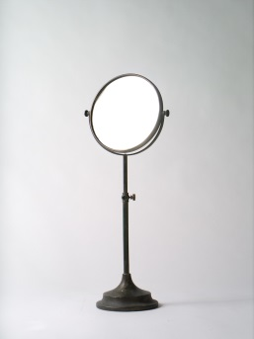

If one looks into the concave side of this adjustable mirror, every pore and blemish is magnified to an alarming extent. Did Larkin perhaps recall the image presented to him by this mirror as he shaved when he wrote his fortieth birthday poem 'Send No Money' in 1962?

Half life is over now,  
And I meet full face on dark mornings  
The bestial visor, bent in  
By the blows of what happened to happen.

What does it prove? Sod all.

13 -- Plaque from the toilet: PREPARE TO MEET THY GOD

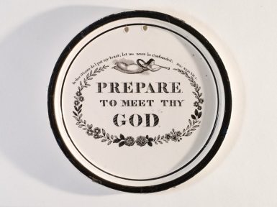

In May 1975 Ted Hughes gave a reading at Hull University. Larkin commented: 'He filled our hall and got a great reception. I was in the chair, providing a sophisticated, insincere, effete, and gold-watch-chained alternative to his primitive forthright leather-jacketed *persona*.' Sometime afterwards Larkin positioned a framed photograph of this event above the cistern of his downstairs toilet. Radiating shamanic sexual magnetism, Hughes stands mid-stage, while the poet-librarian sits inscrutably at a table to the side.

High on the wall opposite this image Larkin hung this antique ceramic plate, a reminder perhaps that we not infrequently go to meet our maker with our trousers about our ankles. Even his toilet was a Larkinesque creation.

14 -- Umbrella



Larkin was jealous of his private space, an aspect of his personality dramatized by former Politics student and later screenwriter, Neville Smith, in a story told to Roger McGough. Waiting for a bus in the rain on Cottingham Green, Smith attempted to gain shelter under Larkin's capacious umbrella with the words: 'I did enjoy *The North Ship*'. Larkin looked down at him and said: 'If you think you can begin a conversation in order to share my umbrella you've got another think coming', and pressed the catch so that the umbrella folded close around his head. It would be nice to believe that this piece of comic stage-business really happened.

15 -- Cigarette cards: Cricketers

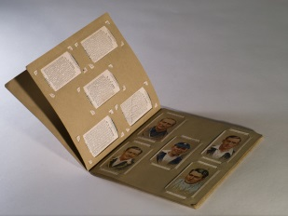

Larkin attributed 'the slight scholarly stoop in my bearing today' to his boyhood habit of searching for cigarette cards of 'Famous Cricketers' in Coventry gutters. He was an enthusiast for cricket throughout his life, as a spectator rather than participant. His friend Ansell Egerton, City Editor at the *Times*, would send him tickets and he and Monica would take the Egertons out to dinner annually during the Lord's Test Match. In 1974, together with Harold Pinter, Egerton proposed Larkin for membership of the MCC.

In his poetry, cricket makes a memorable appearance in the glimpse of 'someone running up to bowl' in 'The Whitsun Weddings'. Apart from that however, it appears only in 'Sugar and Spice', written when he was 20 in 1943. In the exquisite final poem of the sequence the motifs of the girl's school story become a metaphor for life itself. An eloquent fourth-former, alone in the lengthening shadows of the outfield after the end of the Old Girls' match, juxtaposes childhood present with adult future:

Wenda, Brenda, Kathleen and Elaine

Have flattened down the long grass where they've lain,

And brownlegged Jill has left her hat,

For they have gone to laugh and talk with those

Who've played the Old Girls' match out to its close.

She delicately elides the generations: girls and old girls; the game of cricket; the game of life.

16 -- Paisley handkerchief with four knots: a hat for holidays and cricket.

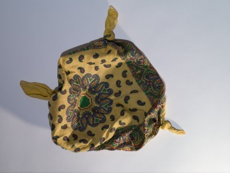

What more potent image of the informal English holiday spirit could one find than this Paisley handkerchief, made into a makeshift sunhat by knots tied in its four corners? Did Larkin wear it perhaps while mowing the lawn in the D. H. Lawrence T-shirt he bought in Nottingham when he opened an exhibition of books and manuscripts by the great novelist in 1980?

17 -- Pencils



For Larkin writing itself was an enjoyable, sensuous experience. Following his father's discriminating taste he favoured a soft 2B Royal Sovereign pencil, and it is this that he used to write the poems in his workbooks. But he could be adventurous. He frequently refers to the new pen or pencil he is using in writing a letter, or the colour of the paper, and in his 1940s fiction he experiments with the recently-patented biro. When the Larkin Society cleared his effects from 105 Newland Park in 2003 his old school case came to light, in which, among Cash's name tags and bottles of ink, was this collection of nine different Royal Sovereign and Wolff's pencils of different thicknesses and hardness, most of them well used.

18 -- Combined corkscrew and bottle-opener

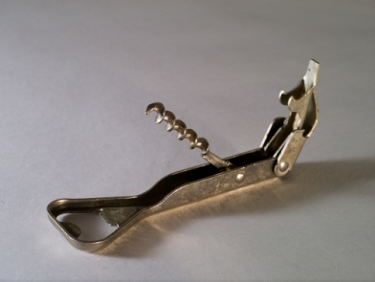

In his youth Larkin socialised in pubs over a pint (or many pints) of beer. But as he grew older he turned to harder drinking, with Monica Jones or on his own. In a letter to Monica in 1968 he complained that it was such 'an *angry* time. When left to oneself irritation begins to ferment like some neglected juice! Only drink releases me from this bondage.'

Towards the end 'dead' drinks became a metaphor of his lost youth. In 'Love Again' the poet contemplates: 'The drink gone dead, without showing how / To meet tomorrow'. In 'We met at the end of the Party', all of the glasses are dirty and all of the drinks are dead. It is appropriate enough, perhaps, that his last completed poem, 'Party Politics', first appeared in a special issue of *Poetry Review* in 1984 devoted to 'Poetry and Drink'.

19 -- Ashtray

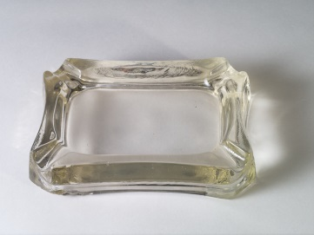

Larkin died of cancer of the oesophagus exacerbated by lifelong addictions to cigarettes and alcohol. In 'Essential Beauty' (1962) the 'Platonic essences' of cigarette advertisements are celebrated and at the same time bitterly satirised:

… and dying smokers sense

Walking towards them through some dappled park   
As if on water that unfocused she   
No match lit up, nor drag ever brought near,   
Who now stands newly clear,   
Smiling, and recognising, and going dark.

It would be fascinating to know whether Damien Hirst's masterpiece, 'The Acquired Inability to Escape', which includes just such an ashtray as this, would have broken through Larkin's dislike of *avant* *garde* experiment.

Towards the end, as public awareness of the dangers of smoking increased, Larkin made unsuccessful efforts to break himself of the habit. In 1984, he wrote to Amis that he would decline the laureateship: 'the thought of being the cause of Ted's being buried in Westminster Abbey is hard to live with. "There is regret. Always, there is regret." Smoking can damage your bum.'

20 -- Matches



In his review of Motion's biography in 1993 Alan Bennett expressed disillusion that the poet whose initials had seemed to suggest that he was our intimate 'pal' had been revealed to have so many unpleasant qualities. Larkin always treated his name as a valuable possession. In the mid or late 1950s he pasted thirty-five carefully numbered versions ('Philip Larkin', 'Philip Larkin Esq') into his diary, cut from envelopes, each written by a different correspondent: from his mother to John Betjeman and Pamela Hansford Johnson. In the 1960s he stopped signing fine notices in the library when he realised that students were offending simply in order to obtain his signature. At some point, no doubt with a certain self-irony, he commissioned these smartly-designed book-matches with their ornate lettering on a glossy black background. No doubt James Bond would have used similar personalised matches with the initials JB.

21 -- Bow tie

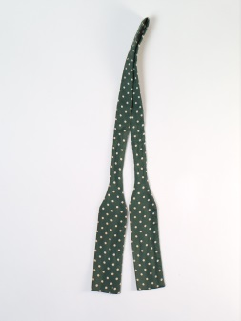

Larkin dressed with a certain independent flair. Maeve Brennan comments in her memoir that he seemed an exotic when he arrived in Hull in 1955, in his 'sports jacket, corduroy trousers, socks in vivid plain colours, and often a pink shirt, which we considered very daring'. Like his father he affected silk bow ties. In contrast the two other men on the Library staff both wore 'the customary dark, pin-striped suits'.

22 -- British Rail Catering tie (Centenary of Railway Catering.)

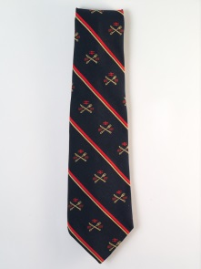

The inventory of effects recovered from 105 Newland Park in 2003 following Monica Jones's death includes 123 ties, some declaring allegiances, some merely stylish or flamboyant. Some are worn and stained, others are brand new and still in cellophane wrappers. It seems that Larkin never threw a tie away. This particular tie came to him under unusual circumstances. He wrote in a letter to Winifred Bradshaw in 1979: 'My latest tie commemorates the centenary of railway catering (1879-1979). I admired it in a bar & the chap took it off and gave it to me. Can't think when I shall wear it – visiting Betjeman, perhaps. It's really quite a smart tie. It's only when you get close you see it's crossed knife & fork, BR arrows, sausage rolls rampant & so on.'

23 -- National Trust tie

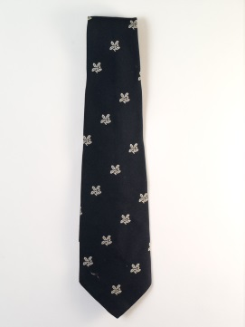

Many of Larkin's ties declare ideological allegiances. A green tie showing a Celtic harp, for instance, hung in his wardrobe alongside a Red Hand Defenders tie. He had a Library Association tie, an MCC tie, and a tie showing the bear and ragged staff emblem of Warwickshire. His beloved Beatrix Potter had left most of her estate to the National Trust, and this was a cause dear to his heart. 'Going, Going (1972), commissioned by a Government Working Party on 'The Human Habitat', could be seen as his 'National Trust poem': 'And that will be England gone, / The shadows, the meadows, the lanes, / The guildhalls, the carved choirs'.

24 -- Assorted labelled champagne corks

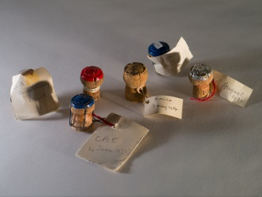

When Larkin and Monica Jones travelled to Hamburg in 1978 to collect his 'Shakespeare Prize', they gleefully raided the hotel mini-bar for half-bottles of champagne, since the Toepfer Foundation was bearing their expenses. Here we see the relics of other intimate celebrations *à deux.* One cork is labelled 'CBE 14 June 1975'. The cork labelled '28th Anniversary lunch' may possibly commemorate their first meeting; in which case it dates to 1976. A third cork bears the date of his sixtieth birthday: '9 August 1982', a fourth that of her 62nd birthday: 'Monica 7 May 1984'. Betty Mackereth, Larkin’s secretary at the Library, recollects calling at 105 Newland Park on the poet's birthday in the early 1980s, bearing a bottle of champagne. Monica possessively cut the interloper out of the celebration by proposing a toast 'To Oxford Firsts!'

25 -- Mortar board



Larkin had an ambiguous attitude towards academe. He resented Monica Jones's long 'holidays', and in 'Toads' he lists lecturers among those who dodge the toad work by living on their wits. Jake Balokovsky is not a good advertisement for the academic profession. Moreover Larkin deplored the idea of 'studying' poetry. Nevertheless he worked in an academic environment all his life, and after he was awarded a professorship in 1982 he was consistently addressed as 'Professor Larkin' within Hull University. He greatly relished the honorary degrees which, by the time of his death, he had collected in large numbers. Even when Monica Jones was convalescing from shingles in 1983, he took time to make a quick trip across the Irish Sea for the award of an Honorary DLitt from the New University of Ulster.