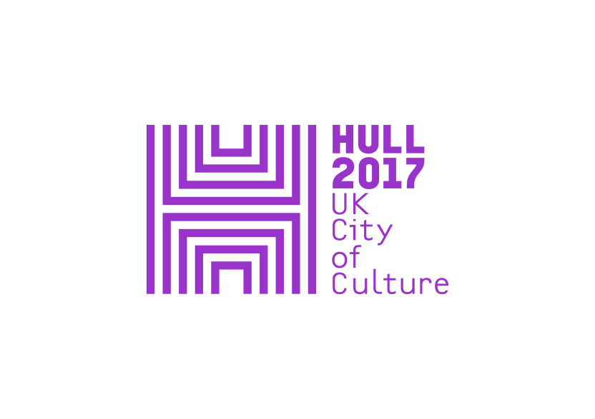

**News Release – 15 November 2017**

***Floe* at The Deep – spectacular large scale projection event by artists Heinrich and Palmer**

**Final commission in the *Look Up* programme for**

**Hull UK City of Culture 2017**

**8-10 December at The Deep, Hull**

**[CONCEPT AND DESIGN IMAGES AVAILABLE HERE](https://www.dropbox.com/sh/dzfuzt9qejowtib/AABkbL12PosCgq7SpbBlCZSca?dl=0)**

***Floe*** , a major new projection, sound and light event created by acclaimed UK artists Heinrich and Palmer, will show for three nights from Friday 8 December at Hull’s iconic aquarium, The Deep. ***Floe*** will “virtually” remodel the architecture and façade of The Deep, a major partner in Hull 2017, and will be the final commission in Hull 2017’s ***Look Up*** programme of artworks in the public realm.

***Floe*** investigates the nature and inspiration behind The Deep, from its unique design and structure, to its position today as major visitor attraction and international conservation and research charity. Using film, modelling, mapping and projection, Heinrich and Palmer explore the material, form and surface qualities of The Deep, conjuring with the geological and biological processes which inspired the building and the rich aquatic life and environments it houses.

Anna Heinrich and Leon Palmer are two UK based artists who have worked in collaboration since 1991. Their artworks range from photographic and light installations to large scale projection events and public art interventions. This latest commission transforms The Deep, creating new identities and hinting at ancient associations, linking to Hull’s historical and modern relationship with the sea. Inspiration and content has been taken from geological and tectonic processes, ice and rock, marine life and landscapes.

Since The Deep opened in 2002 it has become synonymous with Hull. Sir Terry Farrell and Partners created a dramatic architectural statement sited at the confluence of the Hull and the Humber, and ***Floe*** responds to the architect’s vision for an expressive building. The Deep is one of the world’s leading aquariums and an internationally recognised attraction. It has played a transformative role in Hull’s development as an important city in the North.

**Anna Heinrich and Leon Palmer said:** “With Floe we have set out to ‘virtually’ reshape and remodel the architectural façade of The Deep. We want to create a sense of drama and depth using projection, light and sound reflecting the environment within and the geological associations underpinning The Deep’s design. When we delved into Sir Terry Farrell’s vision and conceptual approach to designing the building, we uncovered various images and ideas that sparked our imagination. Geology holds clues to the history of the oceans; during the last ice age the ice sheet terminated in this area and we want to suggest a sense of geological change and deep time linked to the rich aquatic life found in the world’s oceans.”

People will be able to see *Floe* from the opposite side of the River Hull, by the C4DI building, from Friday 8 to Sunday 10 December. It will be presented between 6pm – 10pm each evening and is free to view. There is no need to book and visitors can come back to view the work as many times as they like.

***Floe*** is the fourth joint commission between Hull 2017 and The Deep, including three *Look Up* installations and the curious directive production *Frogman*.

*Look Up* is a year-long programme of major public art commissioned by Hull UK City of Culture 2017 and made for Hull’s public spaces and places, co-curated by Andrew Knight and Hazel Colquhoun. Each installation reflects Hull’s history, its present or future, and is designed to catch passers-by by surprise interrupting the public realm with ideas that amuse, confront or challenge residents and visitors alike from Nayan Kukarni’s *Blade* in January to Michael Pinsky’s *The City Speaks*, which can still be seen on Hull’s Tidal Surge Barrier.

**Sam Hunt, Executive Producer at Hull 2017, said**: "The Deep is a massively successful attraction for Hull, which also undertakes important conservation work. As part of the year-long Hull 2017 *Look Up* programme of temporary public art we have been delighted to collaborate on three commissions, inspired by their work studying interconnected ecosystems around the world. This third co-commission, Heinrich and Palmer's *Floe*, is a stunning exploration of this architectural landmark and what goes on inside it, with breathtaking images that will be projected onto its iconic facade.

"*Floe* is also the final of our 12 Look Up commissions, which started back in January with Nayan Kulkarni’s Blade, and should not be missed."

**The Deep** is a key creative partner for Hull 2017 and together they have jointly funded and developed a series of new, site specific commissions for the *Look Up* programme. The other works were ‘Washed up Car-go’ by Chris Dobrowolski and BLEACHED by Tania Kovats.

**Katy Duke, CEO at The Deep said:** “We are delighted to be partnering with such talented artists in our final collaboration of 2017. Being the inspiration behind *Floe* is a huge privilege,which we hope will engage and inspire audiences, not only with our iconic building but the natural world.”

*Floe* takes place during ***Substance***, 10 days of music, art installations, performance and provocations, celebrating this City of Culture year and exploring the culture, creativity and the future of the North. This includes two other installations around the city, Jason Bruges Studio's *Where Do We Go From Here?* and Marshmallow Feast's *A Colossal Wave!*

[**www.heinrichpalmer.co.uk**](http://www.heinrichpalmer.co.uk)

ENDS

**LISTINGS**

***Floe***

**The Deep, Tower St, Hull HU1 4DP**

**(view from opposite side of the River Hull)**

**8 – 10 December, 6pm – 10pm**

[**www.hull2017.co.uk/floe**](http://www.hull2017.co.uk/floe)

**FREE**

For press information, please contact:

Susie Gray or Clair Chamberlain at The Corner Shop PR

[susie@thecornershoppr.com](mailto:susie@thecornershoppr.com) /07834 073 795

[clair@thecornershoppr.com](mailto:clair@thecornershoppr.com) / 020 7831 7657

[IMAGES AVAILABLE](https://www.dropbox.com/sh/dzfuzt9qejowtib/AABkbL12PosCgq7SpbBlCZSca?dl=0) **[HERE](https://www.dropbox.com/sh/dzfuzt9qejowtib/AABkbL12PosCgq7SpbBlCZSca?dl=0)**

For general information about Hull UK City of Culture 2017, please contact;

Ben McKnight – [ben.mcknight@hull2017.co.uk](mailto:ben.mcknight@hull2017.co.uk) / 07718 100 793.

**Heinrich and Palmer**

Anna Heinrich and Leon Palmer are two UK based artists who have worked in collaboration since 1991. Their artworks range from photographic and light installations to large scale projection events and public art interventions.

Their approach is often site specific, allowing the development of artworks to evolve in response to the context of a place and its unique qualities. Observing the movement and flow of people within the space can also inform the nature and configuration of the artwork, so it connects strongly with the unfolding perception of the viewer. Light, photography, optics and projection are frequently used in their artworks as means to open up, transform and blur the boundaries of built space.

Heinrich and Palmer have been frequently commissioned to create site specific artworks for galleries, museums, hospitals, schools and public spaces. They have worked as Lead Artists on a number of major art projects and have experience of working collaboratively with architects and contractors to integrate artworks from an early stage and advise on design issues. Individual and collaborative studio-based work and research underpins the partnership's practice.

**Substance**

Hull 2017 marks the start of December with more than 10 days of music, art installations, performance and provocations with the title ***Substance***, celebrating this City of Culture year and exploring the culture, creativity and the future of the North.

*Substance* includes new art commissions and immersive experiences popping up in city streets from internationally renowned **Jason Bruges Studio** and **Marshmallow Laser Feast** alongside **Heinrich and Palmer**; a major music event, ***Substance Live: Future of the North****,* featuring some of the UK's most exciting and pioneering musicians, including **Jane Weaver**, **Nadine Shah**, **Hannah Peel** and **Lone Taxidermist**; a brand new play from artist and cultural agitator **Bill Drummond**; a specially curated film festival in association with ***Aesthetica*** ***Magazine***; and evening featuring writer, actor and comedian **Reece Shearsmith**. A key event in the Substance season is ***Substance Future Forum***, taking place on Thursday 7 December it is a lively, creative inquiry into how arts and culture are redefining the image of the North and their critical importance in the success of the region. [www.hull2017.co.uk/substance](http://www.hull2017.co.uk/substance)

**Hull UK City of Culture 2017**

Hull UK City of Culture 2017 is a 365 day programme of cultural events and creativity inspired by the city and told to the world. Hull secured the title of UK City of Culture 2017 in November 2013. It is only the second city to hold the title and the first in England. Divided into four seasons, this nationally significant event draws on the distinctive spirit of the city and the artists, writers, directors, musicians, revolutionaries and thinkers that have contributed to the development of art and ideas.

The Culture Company was set up to deliver the Hull 2017 programme and is an independent organisation with charitable status. It has raised £32 million, with over 70 partners supporting the project, including public bodies, trusts and foundations and local and national businesses. Key contributions are coming from: Host City – Hull City Council; Principal Partners - Arts Council England, BBC, Big Lottery Fund, East Riding of Yorkshire Council, Heritage Lottery Fund, KCOM, KWL, Spirit of 2012, Yorkshire Water and the University of Hull; Major Partners –Associated British Ports, Arco, BP, the British Council, British Film Institute, Green Port Hull, Hull Clinical Commissioning Group, MKM Building Supplies, P&O Ferries, Paul Hamlyn Foundation, Sewell Group, Siemens, Smith & Nephew and Wykeland Group. The National Lottery has contributed more than £10m of this funding, making it the largest single funding body for Hull 2017.

For information go to www.hull2017.co.uk Follow us on Twitter @2017Hull Instagram @2017hull Facebook HullCityofCulture