**PRS New Music Biennial 2017 – Composer Residency**

The PRS New Music Biennial Composer Residency project is an embedded community participation project in Hull, running from January 2017-March 2018, part of the UK City of Culture programme.

Multiple award winning musician SAM LEE, is one of five composers undertaking residencies, working in Hull, so that local communities can spend time and create music with some of the New Music Biennial’s brilliant music creators.

Each residency will lead to the creation of music involving community participants, which will be showcased in a sharing event at Hull City Hall on 24 June, and extracts from the resulting work will be presented as part of the PRS New Music Biennial Festival weekend (2 July) woven together into a large-scale culmination piece, bringing together community participants and musicians from all five residencies for a ‘supergroup’ moment.

Sam Lee’s residency will involve collecting people’s stories and he’s particularly interested in Hull’s links to sea faring heritage, Trinity House, and he’s also interested in working with the local Traveller community. Sam, would like to meet and talk with local people, particularly associated with Hull’s sea faring traditions, and with connections to Trinity House, and the Trinity House Brethren.

As a starting point, Sam would record some interviews either in sound or video, which will then form the basis for creative exploration, and music creation, with school children in Buckingham Primary School and Trinity Academy.

Sam will then collate everything that he has collected, and into a format that will form the basis of follow on music creation work. It will inspire the creation of the lyrics and music for the residency. The outcomes of these interviews and people’s sharing of their stories will also influence the overall feel and style of the commissioned music.

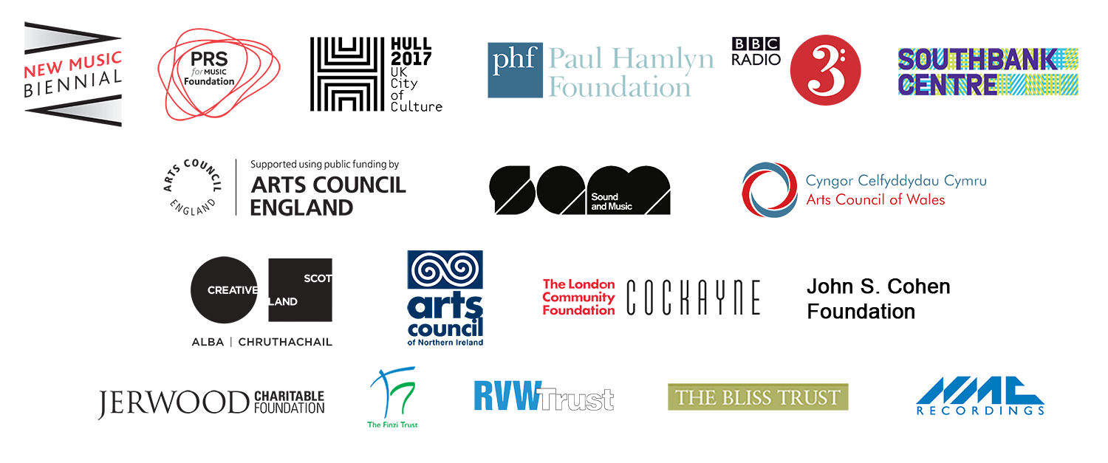

**SAM LEE – Biography**

Mercury Prize nominated Folk singer, song collector, promoter (of BBC award winning Nest Collective) radio host, TV personality, teacher and animateur,

Sam's two critically acclaimed albums place songs he has collected first hand from the Gypsy Traveller Community at their heart with inventive arrangements bringing these ancient songs to life for the 21st Century.

The Live band 'Sam Lee & Friends' perform unconventional and contemporary interpretations challenging all preconceptions of what ‘traditional folk’ should sound like.

**MUSIC**

How many traditional English folk singers do you know who come from North London, studied at Chelsea School of Art, worked as a forager and wilderness expert while moonlighting as a burlesque dancer   – until a chance encounter led to the door of the great Scottish Traveller singer Stanley Robertson, and an extraordinary four-year apprenticeship into the arcane, living world of traditional song?

Since bursting on to the folk scene at the end of the Noughties, Mercury Prize nominee **Sam Lee** has blazed a trail as an outstanding singer and song collector. He’s also been the driving force behind the eclectic, award-winning folk club The Nest Collective, which has brought traditional music to all kinds of new stages and venues, as well as the founder of a burgeoning song collectors’ movement that inspires a new generation of performers to draw on living source singers rather than books and records.

Lee is a 21st-century artist, collecting new versions of old songs on his iPhone and laptop, but his repertoire is steeped in the reek and smoke of folk history and lore, its tales of love, parting, exile and murder bound by a sympathetic magic still resonant today, parting the veil on vivid scenes from our islands’ deep history.

Awarded the 2011 Arts Foundation prize and nominated for the 2012 Mercury Award for his debut album, ‘**Ground Of Its Own’**, he has taken his music worldwide to more than 20 countries, appeared in ‘Peaky Blinders’ on TV, and joined The Unthanks to commemorate the Great War at the Barbican in London. Lee reached an even larger audience with his performance of ‘The Tan Yard Side’ to the accompaniment of a nightingale on Radio 4 on 19 May 2014. This remarkable recording marked the 90th anniversary of the first-ever outside broadcast of ‘Singing with the Nightingales’ by cellist Beatrice Harrison on 19 May 1924.

Sam is also an award-winning promoter and live events producer through his 2010 BBC Folk club of the year ʻThe Magpieʼs Nestʼ, now “The Nest Collective”. The Nest has played a key role in the resurgence of the live folk music scene and is behind many innovative concerts across London, festival stages around the UK and radio and television appearances.

Impassioned and hugely ambitious in scope, Sam’s album, **The Fade In Time** is a major statement from an artist and group extending the borders of their music beyond its national boundaries to encompass Bollywood beats, Polynesian textures and contemporary classical music. From the blaring brass and martial drums of opening track, *Johnnie O the Brine* through to the softly closing account of *The Moss House*, with just Sam’s voice and Arthur Jeffes’ beautifully minimalist, elegant piano, the instrumental textures and vocals –augmented by the Roundhouse Choir on *Lovely Molly* – make **The Fade In Time** a distinctive and radical reinterpretation of the British folk tradition.