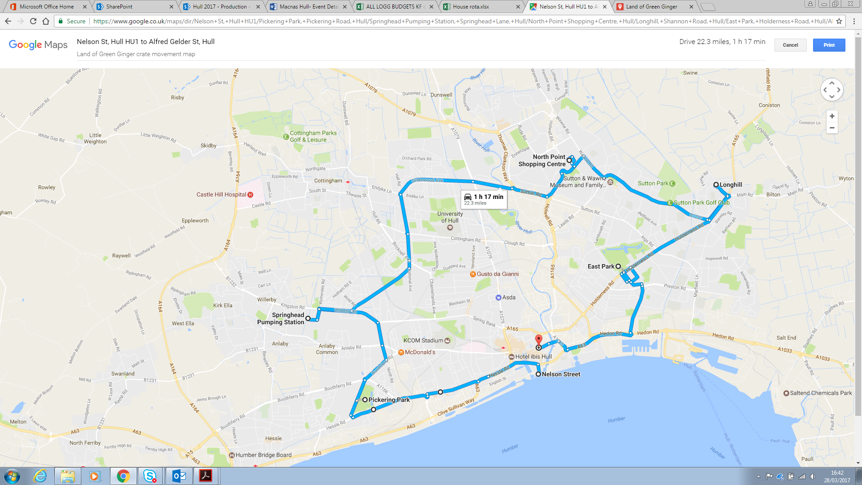

**Land of Green Ginger Crate Movement Map**

|  |  |
| --- | --- |
| PRESS CALL AND TOURING |  |
| 10th April |  |
| Schedule |  |
| PRE PRODUCTION | FAQ sheet to Pete from Maddie |
| Sunday 9th April |  |
| 11am - 4pm | Load one crate large and a few smaller crates onto flatbed |
|  | Rig sound and smoke in the large crate |
|  | Put branding on flatbed |
| Monday 10th April |  |
| 06:30 | Meet at Staples - Maddie and Pete |
|  | All to be in green overalls, green hardhats, gloves - you are now the Green Ginger Fellowship |
| 07:00 - 08:00 | Flatbed to Land of Green Ginger (the Street) |
|  | Photo of loading (or looking like loading crates) - |
|  | Green smoke release |
|  |  |
| 08:00 - 09:00 | To Nelson Street for potential Press Call |
|  | Green smoke release |
|  |  |
| 09:00 - 12:30 | Tour of neighbourhoods - Chrissie with Pete with directions |
| 10:00 - 10:30 | Nelson Street Car Park (HU1 1XE). Press op in front of the Deep |
| 10:30 | Depart from Nelson Street, head for Pickering Park **(HU4 7AB).** 15-minute journey |
| 10:45 | Chrissie photo op at Pickering Road. Trailer can loop round park via: Pickering Rd -> A1166 -> Council Ave -> Hessle Road -> Pickering Road, OR pull over on Pickering Road. |
| 11:00 | Depart from Pickering Road to Springhead Pumping Station **(HU5 5YJ).** 10-minute journey |
| 11:10 | Chrissie photo op on Springhead Lane facing station, either on street or in car park |
| 11:20 | Depart from Springhead to North Point Shopping Centre **(HU7 4EE).** 22-minute journey |
| 11:40 | Chrissie photo op on Holwell Road. Trailer can loop round NPSC car park, or simply park in car park for still shot. |
| 12:00 | depart from NP and head to Longhill Estate **(HU8 9PD).** 11-minute journey |
| 12:10 | Chrissie photo op facing parade of shops at St Margaret’s OR facing Eastmount Recreation Centre (HU8 9NB) |
| 12:20 | depart Longhill and head down Holderness Road to East Park **(HU8 8JU).** 10-minute journey |
| 12:30 | Chrissie photo op in the car park off Holderness Road right at entrance, maybe facing gate? |
| 12:40 | depart East Park and head back to town, hitting Alfred Gelder Street **(HU1 2AN).** 12-minute journey |
| 13:00 | Chrissie photo op facing Guildhall |
|  | Back to Staples - unload crates |
|  |  |
| 13:00 - 13:30 | BREAK |
|  |  |
| 13:30 - 16:30 | Elizabeth to meet Pete with keys at storage |
|  | Flatbed to Storage to load ALL materials |
|  | Flatbed to Low Gate to load printer from MCL |
|  | Flatbed back to Staples unload and leave |