How to avoid an identity crisis
Hullness revisited.
Hullness was referred to by the UK City of Culture selection panel and the spirit of local identity has underpinned much of the 2017 cultural programme. At the end of a phenomenal year, the way that Hull is perceived by external observers has undoubtedly changed. But what does this mean to those who live here? In this discussion, we revisit Hullness to ask if a year in the spotlight has changed what people think about what their city is, and what it could be in the future? And we explore how an international city can retain its identity and sense of pride on a local scale.
Professor David Atkinson – Chair
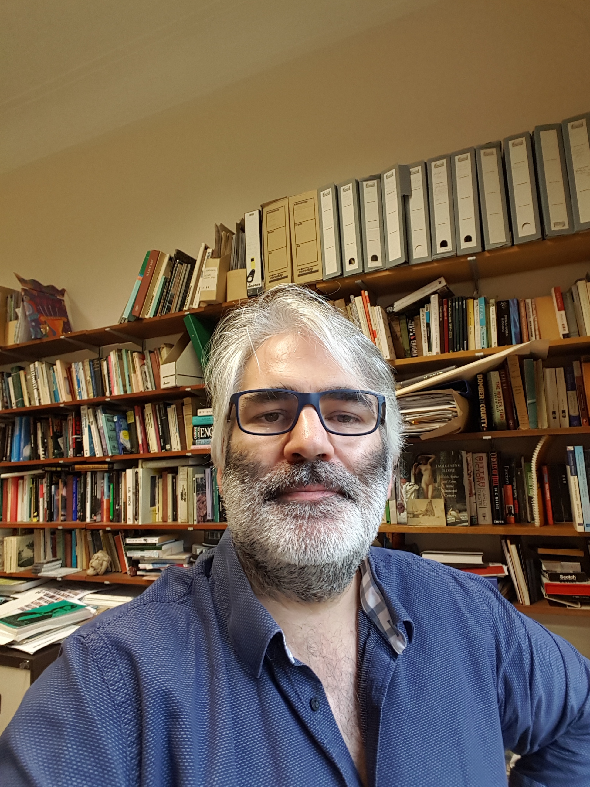
Professor of Cultural and Historical Geography, University of Hull
Associate Dean for Research, Faculty of Science and Engineering and Professor of Cultural and Historical Geography, School of Environmental Sciences.
David Atkinson is a cultural and historical geographer who has taught and researched at the University of Hull since 1998. His interests include the geographies of the dark 20th century and the roles of geographical sciences in the production of modern Italy and Italian colonial space. David also works on the histories of geographical knowledge and its applications and imaginaries. A final interest revolves around the intersections of place, memory, identity and landscape, and the insistent eruptions of the past in the spaces of the present.
Before moving to Hull, David was a lecturer at the University of Wales, Lampeter.
Lottie Gross - Panellist
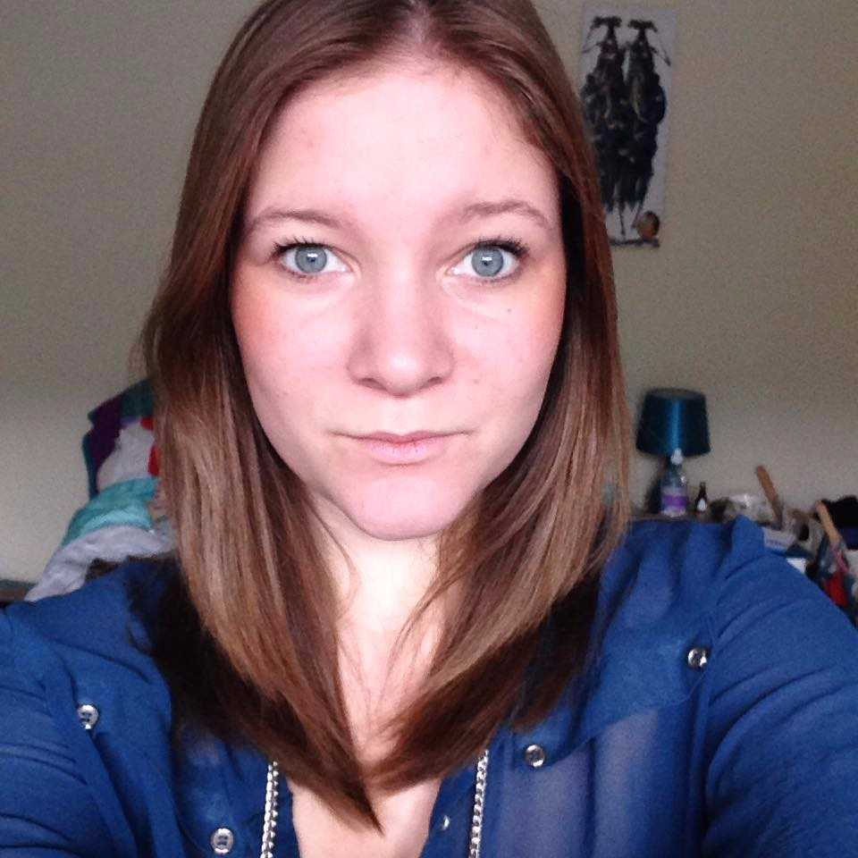
Lottie Gross is a travel editor, writer and photographer, currently editor of loveEXPLORING.com – an inspiration and advice site for independent-minded travellers as part of digital publisher Love Inc's lifestyle portfolio. During the past five years, she has worked for Rough Guides as a web editor and guidebook contributor, and has had her words and pictures published with National Geographic Traveller, Mashable, Elle magazine and more.

Dr Jo Byrne – Panellist
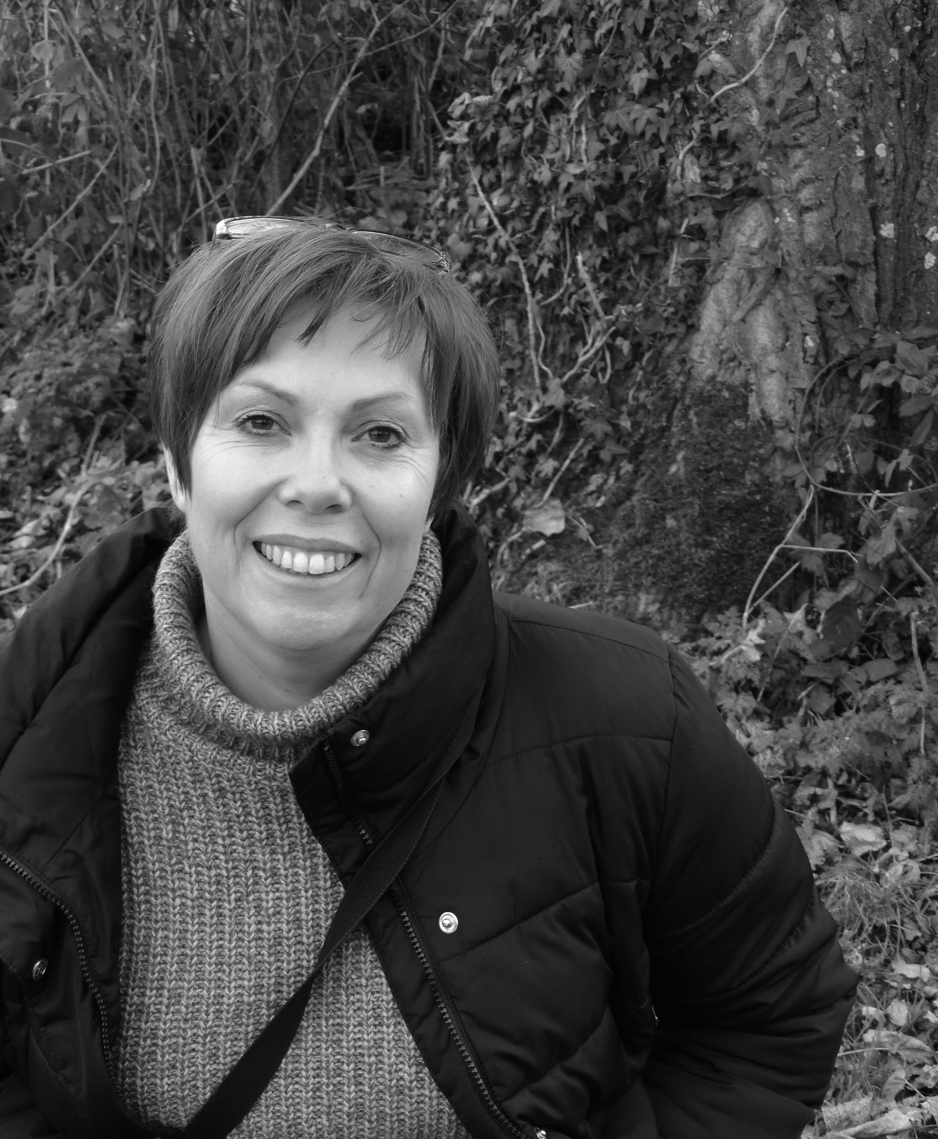
Research Manager, Culture, Place and Policy Institute (CPPI), University of Hull
Dr Jo Byrne is the Research Manager at the Culture, Place and Policy Institute at the University of Hull. Prior to this role she worked for over 20 years as a practitioner in the cultural sector, primarily in the fields of the historic and built environment. She has worked in project and grant management, policy development and service delivery, located within the public, third and higher education sectors. Her own research has a focus on Hull, combining oral history, cultural geography and heritage curatorship, to explore lived experience of place, identity and community heritage.
Emma Davidson - Panellist

Emma Davidson is a London-based writer offering a unique perspective on fashion, art and culture for publications including Dazed & Confused, i-D, Another Man and Highsnobiety.
Julie Corbett - Panellist

Hullness volunteer and Hull 2017 volunteer

Anthony Yates - Panellist
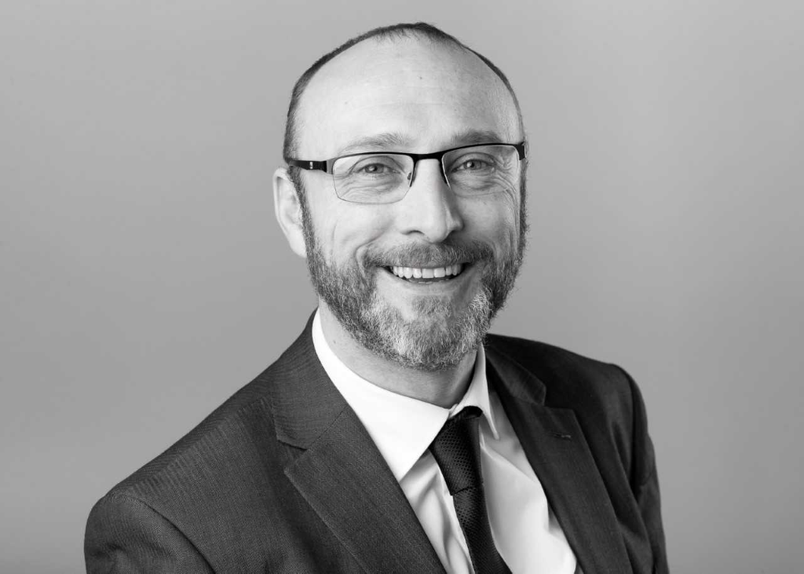
Anthony Yates joined Visit Hull and East Yorkshire (VHEY) in 2007 as the Visitor Economy Manger.
Prior to this he spent seven years at Marketing Birmingham developing and marketing the city’s leisure tourism offer and five years at the North West Tourist Board leading several region-wide marketing and development programmes.
Leading Hull’s Conference Bureau and Leisure Tourism teams, Anthony has overseen the continued growth of the city’s tourism economy in both the leisure and business tourism sectors.
Anthony was part of the Bid Team securing the UK City of Culture for Hull and now sits on the Hull 2017 Senior Leadership Team, City Council’s Place Management Group and National Tourism Funding Project Boards.

