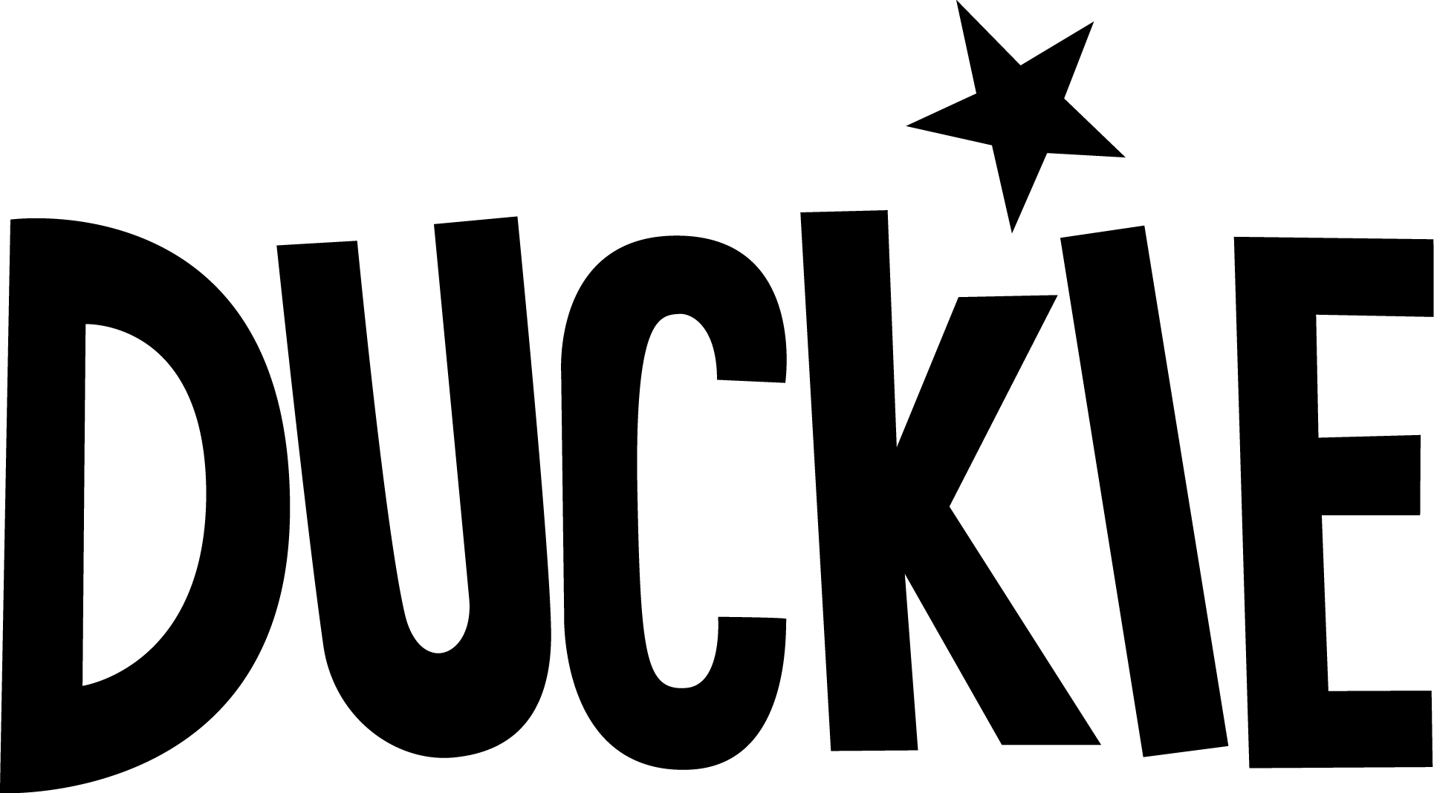

Method Statement /Safe System of Work

Duckie will provide a plastic dustbin per area (if not already present) for staff to dispose of litter, which will be emptied when required during the day.  
  
**Cleaning and Equipment Preparation**  
All work areas including all surfaces will be maintained in a good clean condition  
  
It is Duckie’s policy and practice to “clean as you go” in addition to any regular cleaning tasks. This includes cleaning spillages and soiling as they occur during work activities and also includes cleaning surfaces and equipment that have been in contact with food after every use or frequent use.  
  
Where necessary, safety equipment such as gloves, goggles and rubber aprons will be provided to staff and volunteers.  
  
Duckie will ensure that all possible health and safety precautions have been taken to minimise the risk to staff and the public.  
  
**Food Preparation, Storage and Handling**  
Regular temperature checks will be taken on refrigerators throughout the day.   
These will be recorded in the Daily Recording Diary.

No raw food is being used, but we will ensure that the kitchen and preparation areas are checked regularly to avoid cross contamination and bacteria growth.  
  
A cleaning schedule will be implemented, maintained and recorded in the Daily Recording Diary.  
  
**Serving Food**  
Duckie staff are trained in food hygiene matters and have a high level of customer service skills  
All Duckie food handlers will be wearing a special uniform.

**Departing from Site**When departing from site, the installations will be cleaned and waste deposited at the designated waste points.  
The site supervisor will report and record the time of departure, signing any relevant documentation required.