On the Bench, 2017 by Harry Meadley

On the Bench is a new commission by artist Harry Meadley being presented on The Floating Cinema during the 2017 Hull City of Culture celebrations.

As conveyed by its title, the work plays on the ambiguity that comes with not being directly involved, but instead waiting for the chance to be part of something. Created in collaboration with residents dispersed across the industrial landscape of South and East Yorkshire, On the Bench features conversations with individuals articulating how new opportunities for creative expression are identified. Through frank and personal discussions, a range of topics are covered including the relationship between central and peripheral geographical locations; the influence of education on imagination; and the complexity of positioning alternative stories in order to challenge dominant narratives. Collectively the eight episodes that form the series underline the dynamics between culture, creativity and identity.

Building on Meadley’s interest in humour as a device to explore complex issues and spurred on by his circumstances as an artist contemplating his own trajectory, On the Bench is a part biographical, part autobiographical work, where personal concerns and modes of navigation are highlighted and imagined futures are articulated.

Following the format of web-based interviews by comedians, On the Bench will exist as an online series while simultaneously being presented on The Floating Cinema.

The Floating Cinema tours to eight different locations from 1st July – 13th August 2017 and will feature a programme of archive footage and independent films that expand on the themes of On the Bench.

Stills from filming sessions (I will ask Harry if we can include stills)

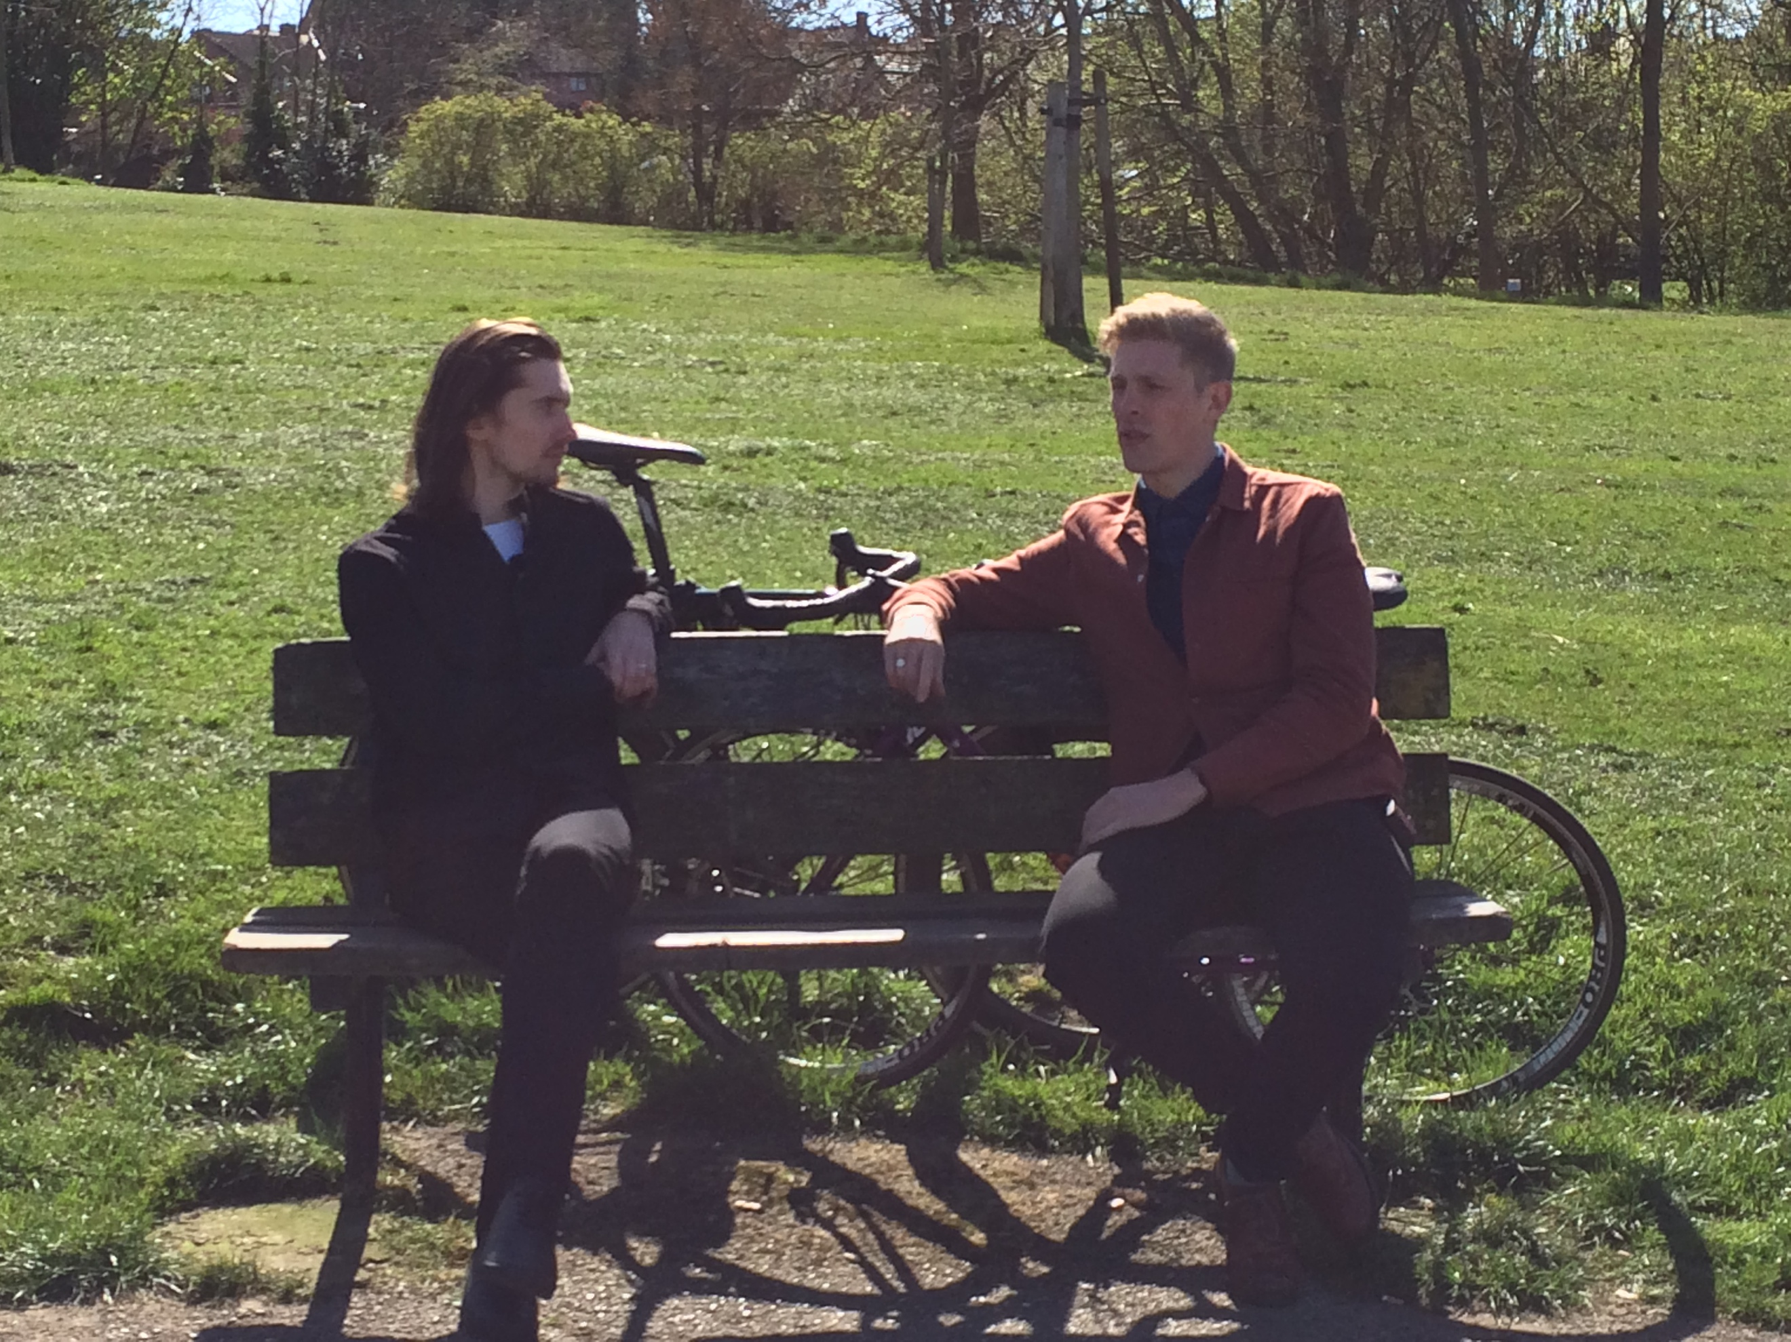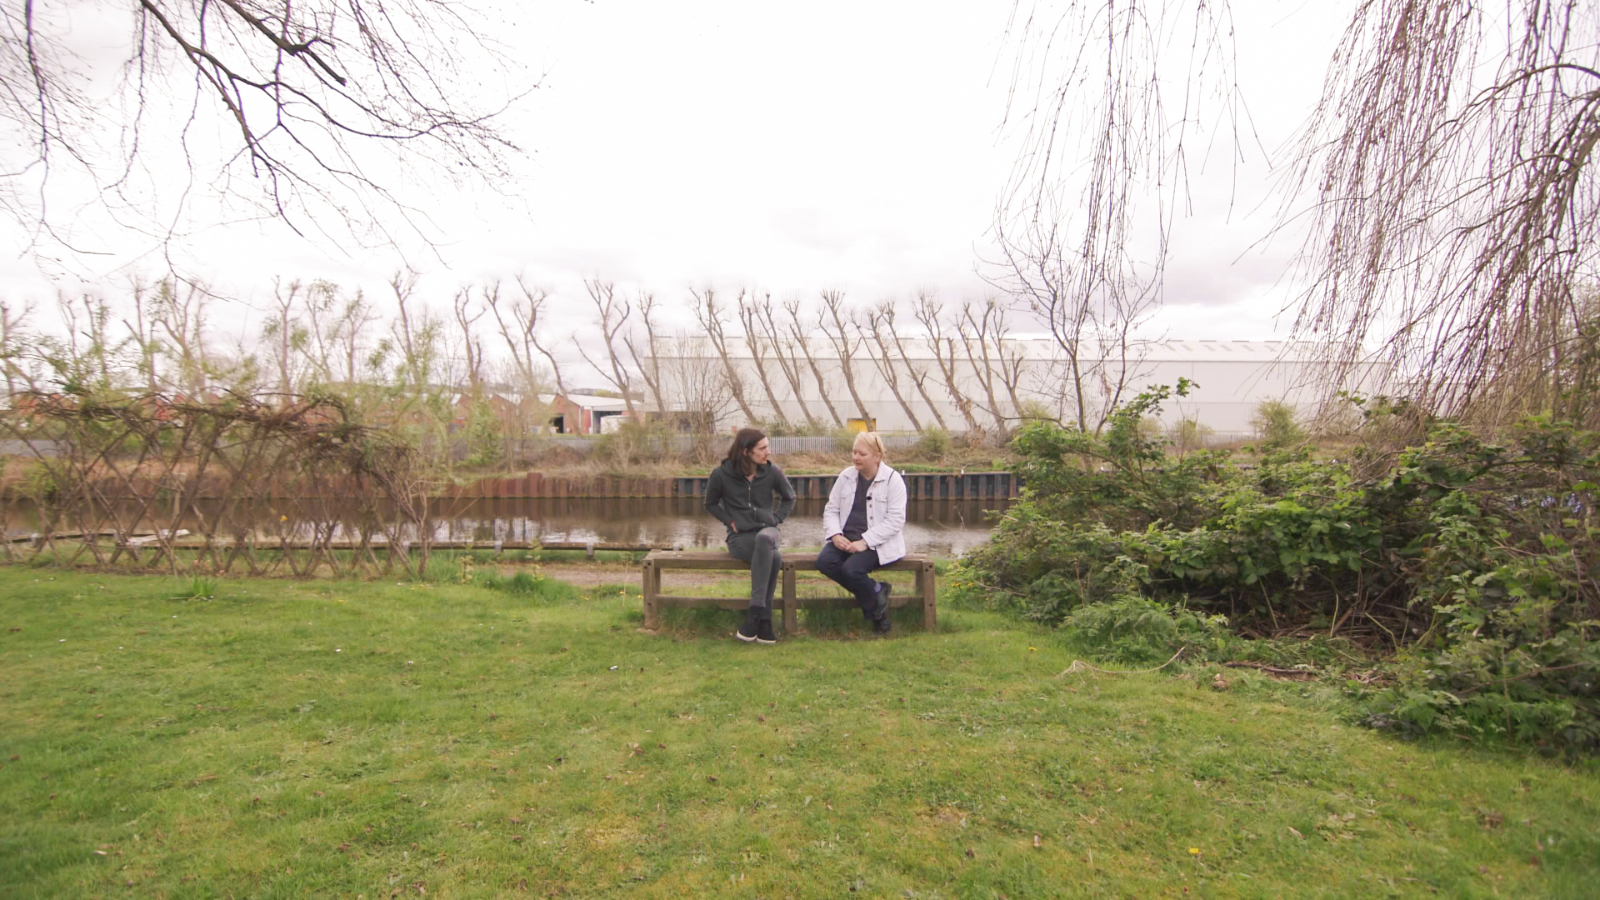
Left: Tair in Rotherham.
Middle: David in Sheffield
Right: Debbie at Swinton Lock

Tour details

27 – 30 June 2017: Hull to Sheffield: Promo Tour (No screenings)
1 – 3 July 2017: Sheffield
5 – 6 July 2017: Rotherham
8 – 9 July 2017: Swinton
14 - 16 July 2017: Doncaster
18 - 19 July 2017: Thorne
22 – 23 July 2017: Goole
25 - 26th July 2017: South Ferriby
7 – 13 August 2017: Hull

About Floating Cinema
The Floating Cinema is an award-winning structure conceived and commissioned by UP Projects and designed by Duggan Morris Architects. The structure is mechanism through which artists’ films, independent cinema and archive footage can be brought outside of the gallery or cinema space and presented in public locations. Alongside a programme of screenings, the structure has been used to host talks, performances, workshops and events for audiences across the country. On the Bench is a new commission for the 6th and final iteration of The Floating Cinema. Previous seasons have included Extra-Ordinary, Extra-International and Extra-Terrestrial.

