**How Can Arts Save the NHS?**

An all-party enquiry this summer showed how a thriving arts and culture scene has a huge impact on the health and well being of any town or city, leading to a fall in hospital admissions. Can arts relieve the pressure on the NHS?

**Nikki Bedi – Chair**

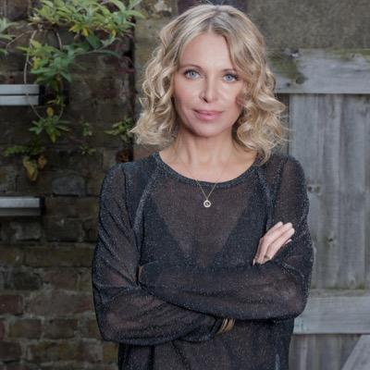

Nikki is a televison and radio broadcaster with a passion for making arts and culture accessible. She currently wakes up the capital presenting the Early Breakfast Show Monday to Friday on BBC Radio London. Nikki curates, writes and presents The Arts Hour on the BBC World Service, is a regular interviewer and presenter on BBC Radio 4’s Loose Ends, can often be seen on BBC1's Sunday Morning Live interviewing famous names and celebrities about their faith and also on BBC1's current affairs show Inside Out reporting on everything from eye transplants to cinema restorations. Nikki also presents The Heart Of... TV series on BBC World News, an arts and culture programme looking at fresh new talent from across the world's great cities and has presented BBC Radio 4's Womans Hour.

**Nicky Taylor – Panellist**

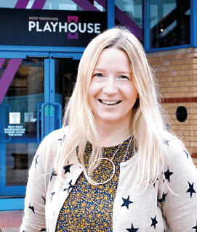

**Theatre & Dementia Research Associate**

PhD student at Leeds Beckett University, Theatre & Dementia Research Associate at West Yorkshire Playhouse, Churchill fellow – Nicky Taylor has pioneered the way in dementia friendly performance at West Yorkshire Playhouse, the largest regional repertory theatre in the UK outside London and Stratford. Nicky’s research has taken her all over the world and as well as receiving many awards and accolades for her work in making theatre and performance more accessible in new and innovative ways Nicky has more recently secured funding to develop the first Festival of theatre and dementia.

**Vicki Amedume - Panellist**

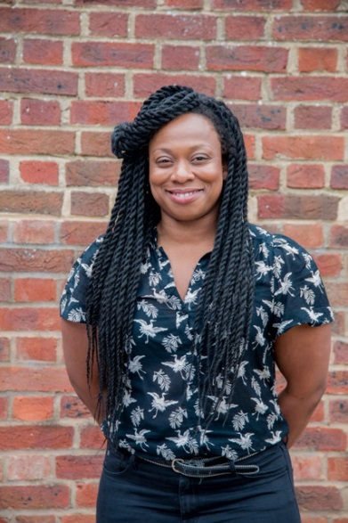

**Artistic Director Upswing**

Vicki has over 18 years of experience of working in circus arts following her initial training as a research scientist. She founded Upswing, a contemporary circus company, in 2006 after years performing and devising with circus companies in the UK, France and the US. Upswing is now a charity and an Arts Council England NPO developing a variety of performances, programmes and participatory experiences that use the playfulness and wonder of circus to bring people together and enable them to discover new potential in themselves and in others. Their work is presented in range of contexts from theatres and festivals to libraries, care homes and other public spaces, taking shows beyond theatres to meet people in the places they live, work and play. As a freelance practitioner she has previously been an associate director of Greenwich + Docklands International Festival producing large-scale spectacular outdoor work in Greenwich and East London, a circus and aerial consultant on a range companies including The RSC, The National Theatre of Scotland, New Vic Theatre and The Royal Exchange.

**Dr Dan Roper - Panellist**

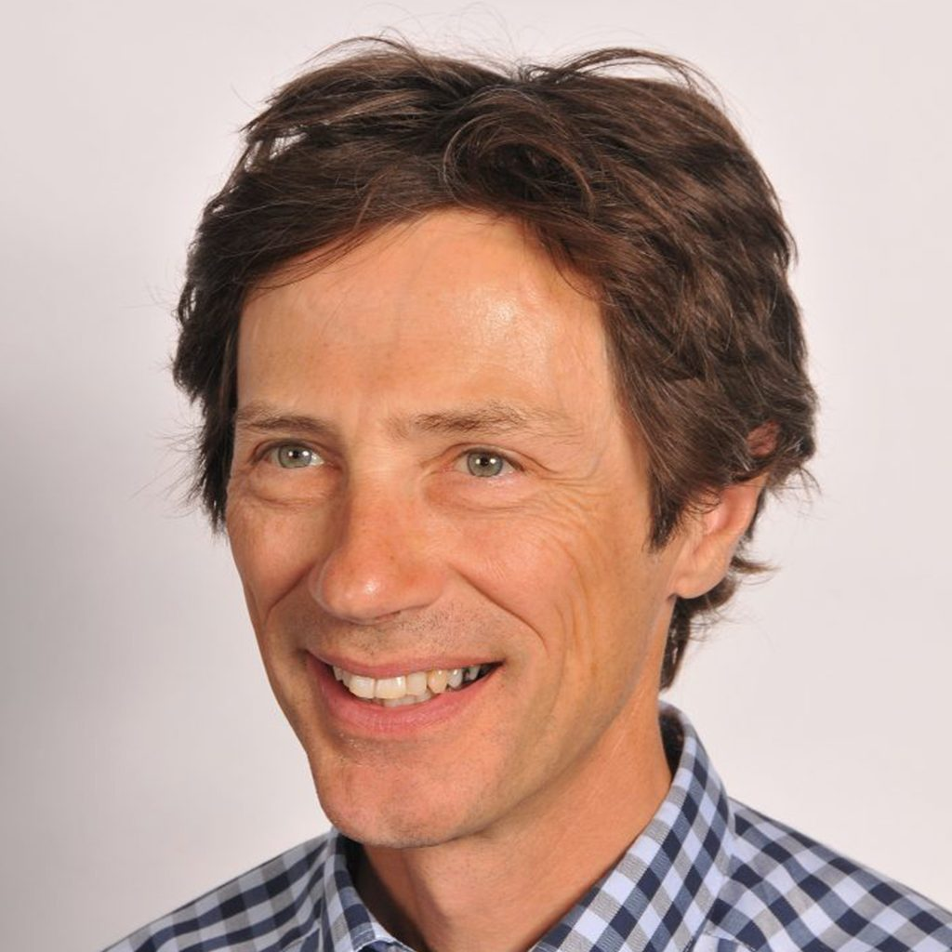

**Chair of Hull Clinical Commissioning Group**

Dr Dan Roper is the Chair of Hull CCG, one of the major sponsors of the City of Culture, an association that recognises the strong links between art, culture and health.

He was a GP in Hull for 30 years and was born and grew up in Hull. He was involved in the training of health care professionals for 25 years with an emphasis on cultural influences and what the impact of those influences might be on behaviour affecting peoples health and how they seek and access health and social care.

**Alex Mitchell - Panellist**

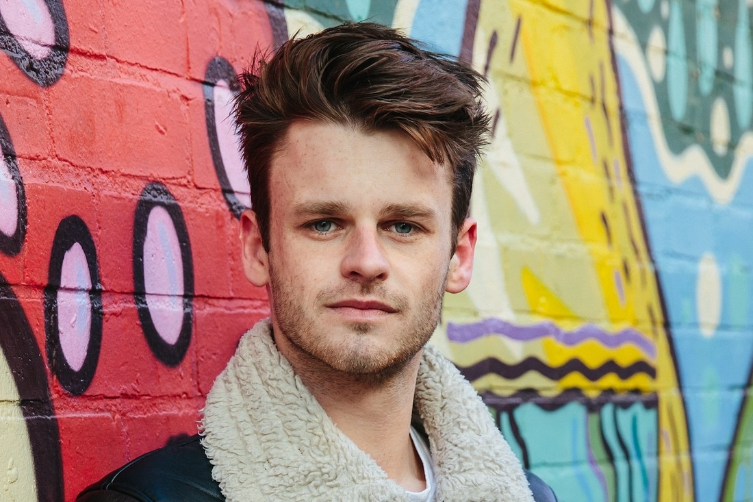

**Artistic Director Silent Uproar**

Alex founded Silent Uproar in late 2012. As well as being Artistic Director of the company, he is also the company's theatre director. Alex has worked and been trained by practioners and companies throughout the UK. Originally from down south Alex went to Hull University and thought to root himself in the north.

Alex directed the smash hit, critically acclaimed A Super Happy Story (About Feeling Super Sad), an energetic, touching musical about depression. Written by Olivier award winning Jon Britten, winning a fringe first and Best Musical award at the Edinburgh Festival, the performance was described by the Guardian as **"A mix of wit and low-key emotion that suddenly grips your heart"**

**Sarah Emmott - Panellist**

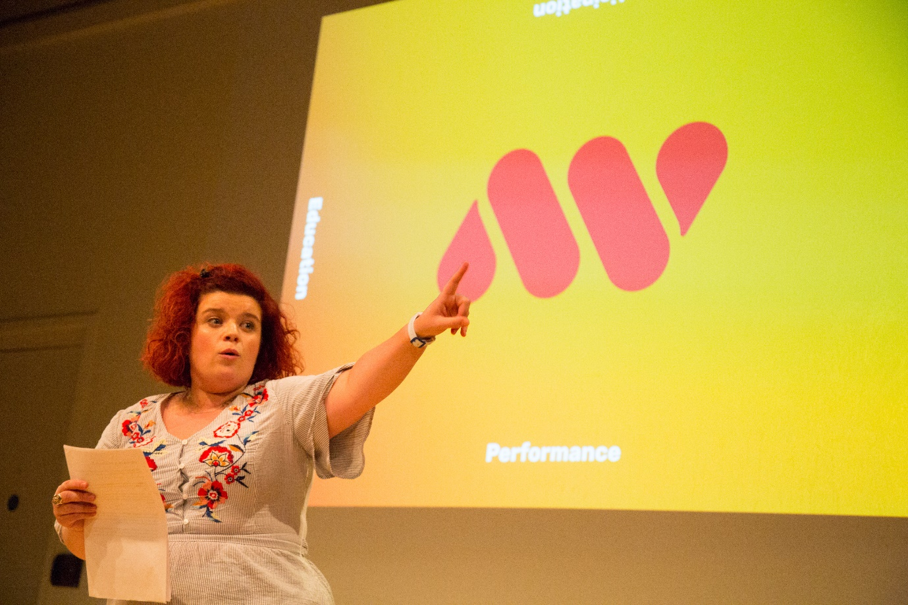

**Creative Director: Art with Heart**

Sarah is a theatre-maker, writer, performer, producer, facilitator and Co-Creative Director of Art with Heart. Salford based award winning Art with Heart are Associate Artists at The Lowry Theatre who deliver Performance, Participation and Education projects both locally and nationally.

Our latest theatre production is Declaration; an autobiographical, riotous celebration of Sarah’s experience with ADHD, mental health and diagnosis which toured in Summer 2017 with 5* reviews. Alongside Declaration tours our curated wellbeing room ‘SPACE’ which was visited by 78% of our audiences. On tour 47% of our audience were age 14-35 and 20% identified as neurodiverse, deaf or disabled. For 44% it was their first visit to the venue and for 13% was their first theatre experience. We are looking to re-tour Declaration in Autumn 2018.

We make work for the here and now which responds to the world we live in and questions what it means to be part of society and provide platforms for under-represented voices; working to open conversations, provoke debate and challenge perceptions. “The work of Art with Heart is a must see. The positive change they are making is incredible” - The Reviews Hub