Appendix 21: ‘Audience Mapping’

  - Introduction
As ‘Back to Ours’ was a ticketed event, there is postcode data linked to all those who booked a ticket. This is the most comprehensive post code data set linked to the event, so has been used to map the audiences that came to ‘Back to Ours’.
Postcode Area | Postcode Name | Count | Percentage
HU | Hull | 553 | 91.0%
YO | York | 14 | 2.0%
DN | Doncaster | 14 | 2.0%
LS | Leeds | 2 | 0.0%
S | Sheffield | 2 | 0.0%
Hull City Council’s Business Intelligence Team have undertaken a post code analysis of this data set on behalf of Hull 2017. The following maps and tables show breakdowns of postcodes; Local Authorities; wards and LSOA split by festival, area and overall.
Table 1: Back to Ours - Post Code Area Festival 1
Postcode Area | Postcode Name | Count | Percentage
HU | Hull | 607 | 90.0%
YO | York | 14 | 2.0%
DN | Doncaster | 13 | 2.0%
LS | Leeds | 7 | 1.0%
S | Sheffield | 4 | 1.0%

Table 2: Back to Ours - Post Code Area Festival 2

Table 3: Back to Ours - Post Code Area Festival 3
Postcode Area | Postcode Name | Count | Percentage
HU | Hull | 530 | 91.0%
YO | York | 12 | 2.0%
DN | Doncaster | 14 | 2.0%
LS | Leeds | 4 | 1.0%
S | Sheffield | 3 | 1.0%

Table 4: Back to Ours - Post Code Area Festival 4

Postcode Area | Postcode Name | Count | Percentage
HU | Hull | 1189 | 94.0%
YO | York | 27 | 2.0%
DN | Doncaster | 20 | 2.0%
LS | Leeds | 5 | 0.0%
S | Sheffield | 4 | 0.0%
Table 5: Back to Ours - Post Code Area Festivals average
Postcode Area | Postcode Name | Count | Percentage
HU | Hull | 719.8 | 91.0%
YO | York | 16.8 | 2.0%
DN | Doncaster | 15.3 | 2.0%
LS | Leeds | 4.5 | 1.0%
S | Sheffield | 3.3 | 0.0%

Table 6: Back to Ours - Post Code District Festival 1
Postcode District | Count | Percentage | Postcode District | Count | Percentage
HU5 | 116 | 17.0% | HU16 | 20 | 3.0%
HU7 | 88 | 13.0% | HU13 | 25 | 4.0%
HU8 | 51 | 8.0% | HU6 | 24 | 4.0%
HU9 | 58 | 9.0% | HU3 | 33 | 5.0%
HU4 | 51 | 8.0% | HU10 | 29 | 4.0%
HU17 | 40 | 6.0%

Table 7: Back to Ours - Post Code District Festival 2
Postcode District | Count | Percentage | Postcode District | Count | Percentage
HU5 | 126 | 21.0% | HU16 | 33 | 5.0%
HU7 | 53 | 9.0% | HU13 | 29 | 5.0%
HU8 | 49 | 8.0% | HU6 | 27 | 4.0%
HU9 | 37 | 6.0% | HU3 | 22 | 4.0%
HU4 | 52 | 9.0% | HU10 | 23 | 4.0%
HU17 | 32 | 5.0%

Table 8: Back to Ours - Post Code District Festival 3
Postcode District | Count | Percentage | Postcode District | Count | Percentage
HU5 | 147 | 25.0% | HU16 | 27 | 5.0%
HU7 | 52 | 9.0% | HU13 | 21 | 4.0%
HU8 | 55 | 9.0% | HU6 | 20 | 3.0%
HU9 | 44 | 8.0% | HU3 | 22 | 4.0%
HU4 | 23 | 4.0% | HU10 | 17 | 3.0%
HU17 | 33 | 6.0%

Table 9: Back to Ours - Post Code District Festival 4
Postcode District | Count | Percentage | Postcode District | Count | Percentage
HU5 | 222 | 18.0% | HU16 | 82 | 6.0%
HU7 | 130 | 10.0% | HU13 | 62 | 5.0%
HU8 | 156 | 12.0% | HU6 | 51 | 4.0%
HU9 | 112 | 9.0% | HU3 | 45 | 4.0%
HU4 | 67 | 5.0% | HU10 | 41 | 3.0%
HU17 | 60 | 5.0%

Table 10: Back to Ours - Post Code District Festivals Average
Postcode District | Count | Percentage | Postcode District | Count | Percentage
HU5 | 153 | 20.0% | HU16 | 41 | 5.0%
HU7 | 81 | 10.0% | HU13 | 34 | 4.0%
HU8 | 78 | 9.0% | HU6 | 31 | 4.0%
HU9 | 63 | 8.0% | HU3 | 31 | 4.0%
HU4 | 48 | 6.0% | HU10 | 28 | 4.0%
HU17 | 41 | 5.0%

Table 11: Back to Ours – Hull & East Riding Post Code Sector Festival 1
Postcode Sector | Count | Percentage | Postcode Sector | Count | Percentage
HU5 3 | 53 | 8.0% | HU8 0 | 13 | 20%
HU7 4 | 41 | 6.0% | HU8 8 | 16 | 2.0%
HU5 4 | 18 | 3.0% | HU9 3 | 18 | 3.0%
HU8 9 | 20 | 3.0% | HU5 5 | 17 | 3.0%
HU7 3 | 35 | 5.0% | HU16 5 | 11 | 2.0%
HU4 6 | 31 | 5.0% | HU4 7 | 20 | 3.0%

Table 12: Back to Ours – Hull & East Riding Post Code Sector Festival 2
Postcode Sector | Count | Percentage | Postcode Sector | Count | Percentage
HU5 3 | 63 | 10.0% | HU8 0 | 15 | 2.0%
HU7 4 | 22 | 4.0% | HU8 8 | 15 | 2.0%
HU5 4 | 28 | 5.0% | HU9 3 | 12 | 2.0%
HU8 9 | 18 | 3.0% | HU5 5 | 18 | 3.0%
HU7 3 | 18 | 3.0% | HU16 5 | 14 | 2.0%
HU4 6 | 24 | 4.0% | HU4 7 | 28 | 5.0%

Table 13: Back to Ours – Hull & East Riding Post Code Sector Festival 3
Postcode Sector | Count | Percentage | Postcode Sector | Count | Percentage
HU5 3 | 72 | 12.0% | HU8 0 | 12 | 2.0%
HU7 4 | 27 | 5.0% | HU8 8 | 21 | 4.0%
HU5 4 | 31 | 5.0% | HU9 3 | 14 | 2.0%
HU8 9 | 20 | 3.0% | HU5 5 | 21 | 4.0%
HU7 3 | 14 | 2.0% | HU16 5 | 15 | 3.0%
HU4 6 | 12 | 2.0% | HU4 7 | 11 | 2.0%

Table 14: Back to Ours – Hull & East Riding Post Code Sector Festival 4
Postcode Sector | Count | Percentage | Postcode Sector | Count | Percentage
HU5 3 | 106 | 8.0% | HU8 0 | 55 | 4.0%
HU7 4 | 69 | 5.0% | HU8 8 | 42 | 3.0%
HU5 4 | 53 | 4.0% | HU9 3 | 50 | 4.0%
HU8 9 | 57 | 5.0% | HU5 5 | 37 | 3.0%
HU7 3 | 43 | 3.0% | HU16 5 | 47 | 4.0%
HU4 6 | 40 | 3.0% | HU4 7 | 27 | 2.0%

Table 15: Back to Ours – Hull & East Riding Post Code Sector Festivals Average
Postcode Sector | Count | Percentage | Postcode Sector | Count | Percentage
HU5 3 | 74 | 10.0% | HU8 0 | 24 | 3.0%
HU7 4 | 40 | 5.0% | HU8 8 | 24 | 3.0%
HU5 4 | 33 | 4.0% | HU9 3 | 24 | 3.0%
HU8 9 | 29 | 3.0% | HU5 5 | 23 | 3.0%
HU7 3 | 28 | 3.0% | HU16 5 | 22 | 3.0%
HU4 6 | 27 | 3.0% | HU4 7 | 22 | 3.0%

Table 16: Back to Ours - Local Authority Festival 1
Local Authority Area | Count | Percentage
Hull | 417 | 62.0%
East Riding | 204 | 30.0%
Hull and ER Sub Total | 621 | 92.0%
Other Local Authorities | 51 | 8.0%

Table 17: Back to Ours - Local Authority Festival 2
Local Authority Area | Count | Percentage
Hull | 360 | 59.0%
East Riding | 203 | 33.0%
Hull and ER Sub Total | 563 | 93.0%
Other Local Authorities | 45 | 7.0%

Table 18: Back to Ours - Local Authority Festival 3
Local Authority Area | Count | Percentage
Hull | 358 | 61.0%
East Riding | 183 | 31.0%
Hull and ER Sub Total | 541 | 93.0%
Other Local Authorities | 41 | 7.0%

Table 19: Back to Ours - Local Authority Festival 4
Local Authority Area | Count | Percentage
Hull | 779 | 62.0%
East Riding | 432 | 34.0%
Hull and ER Sub Total | 1211 | 96.0%
Other Local Authorities | 52 | 4.0%

Table 20: Back to Ours - Local Authority Festivals Average
Local Authority Area | Count | Percentage
Hull | 479 | 61.0%
East Riding | 256 | 32.0%
Hull and ER Sub Total | 734 | 93.0%
Other Local Authorities | 47 | 7.0%

Table 21: Back to Ours - Hull & East Riding Wards Festival 1
Ward | Local Authority | Count | Percentage
Avenue | Hull | 56 | 9.0%
Holderness | Hull | 20 | 3.0%
Hessle | East Riding | 24 | 4.0%
Kings Park | Hull | 40 | 6.0%
Bricknell | Hull | 16 | 3.0%

Table 22: Back to Ours - Hull & East Riding Wards Festival 2
Ward | Local Authority | Count | Percentage
Avenue | Hull | 70 | 12.0%
Holderness | Hull | 25 | 4.0%
Hessle | East Riding | 29 | 5.0%
Kings Park | Hull | 25 | 5.0%
Bricknell | Hull | 27 | 4.0%

Table 23: Back to Ours - Hull & East Riding Wards Festival 3
Ward | Local Authority | Count | Percentage
Avenue | Hull | 84 | 16.0%
Holderness | Hull | 24 | 4.0%
Hessle | East Riding | 21 | 4.0%
Kings Park | Hull | 17 | 3.0%
Bricknell | Hull | 28 | 5.0%

Table 24: Back to Ours - Hull & East Riding Wards Festival 4
Ward | Local Authority | Count | Percentage
Avenue | Hull | 122 | 10.0%
Holderness | Hull | 77 | 6.0%
Hessle | East Riding | 62 | 5.0%
Kings Park | Hull | 49 | 4.0%
Bricknell | Hull | 48 | 4.0%

Table 25: Back to Ours - Hull & East Riding Wards Festivals Average
Ward | Local Authority | Count | Percentage
Avenue | Hull | 83 | 12.0%
Holderness | Hull | 37 | 5.0%
Hessle | East Riding | 34 | 5.0%
Kings Park | Hull | 33 | 5.0%
Bricknell | Hull | 30 | 4.0%

Map 1: Post Code Mapping – Back to Ours from Hull Festival 1
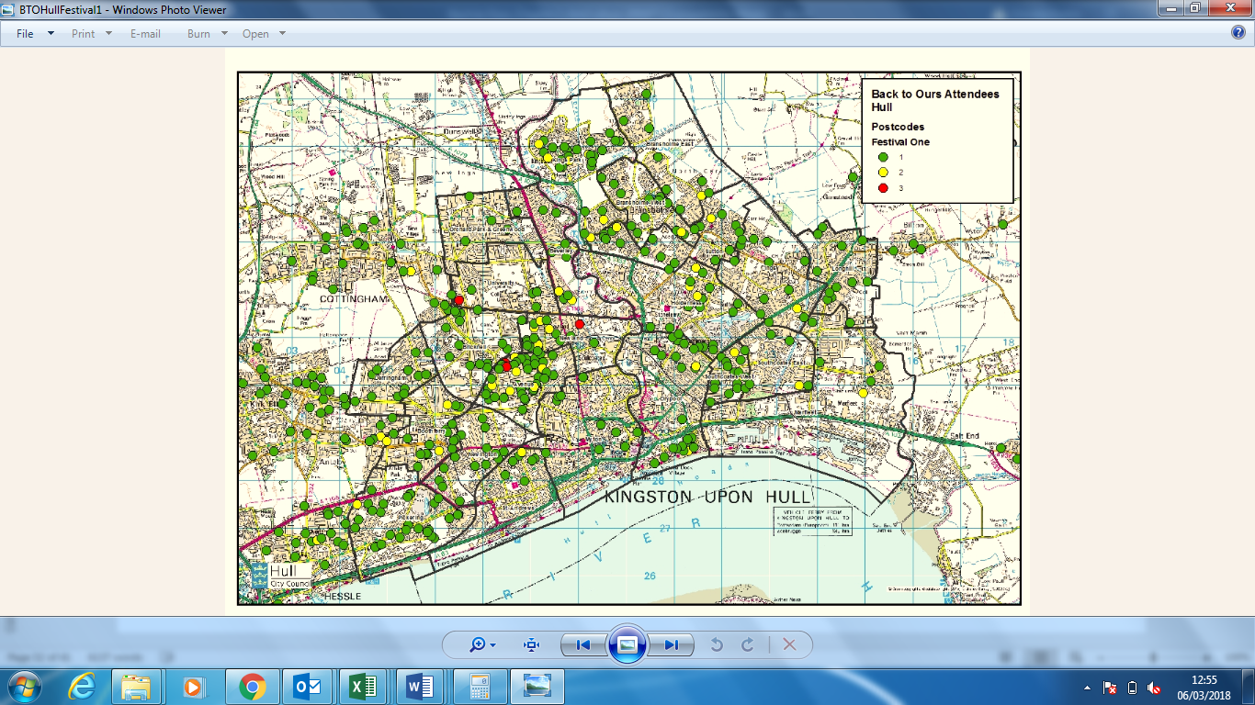

Map 2: Post Code Mapping – Back to Ours from Hull Festival 2
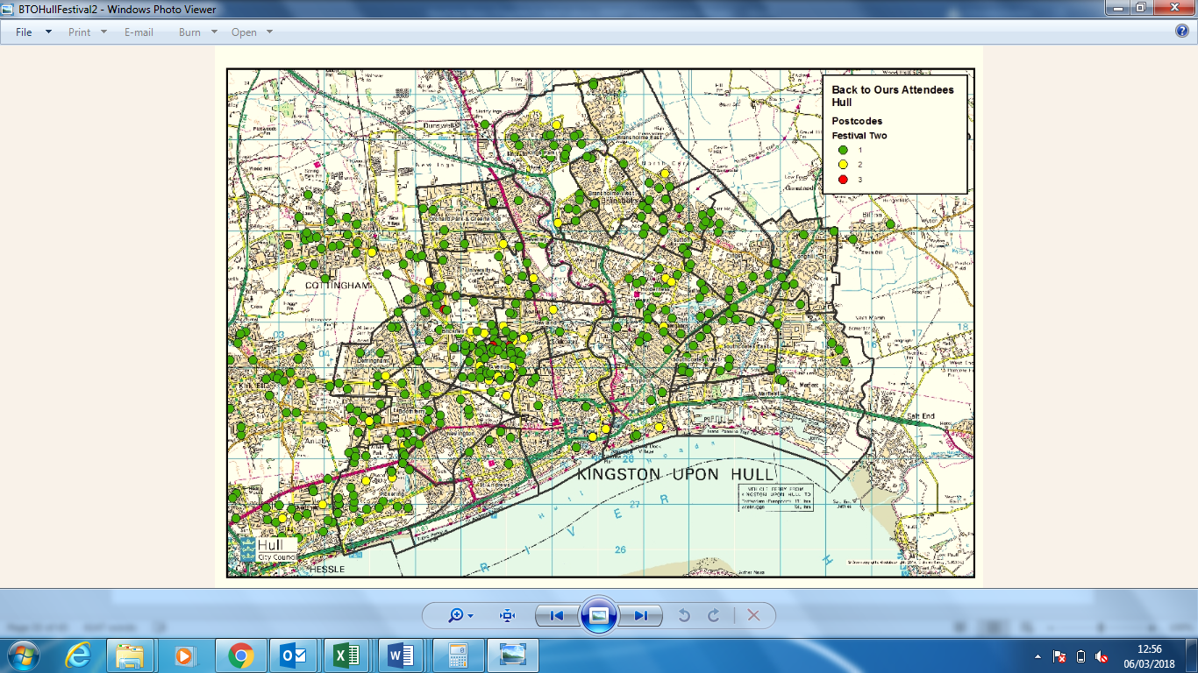
Map 3: Post Code Mapping – Back to Ours from Hull Festival 3
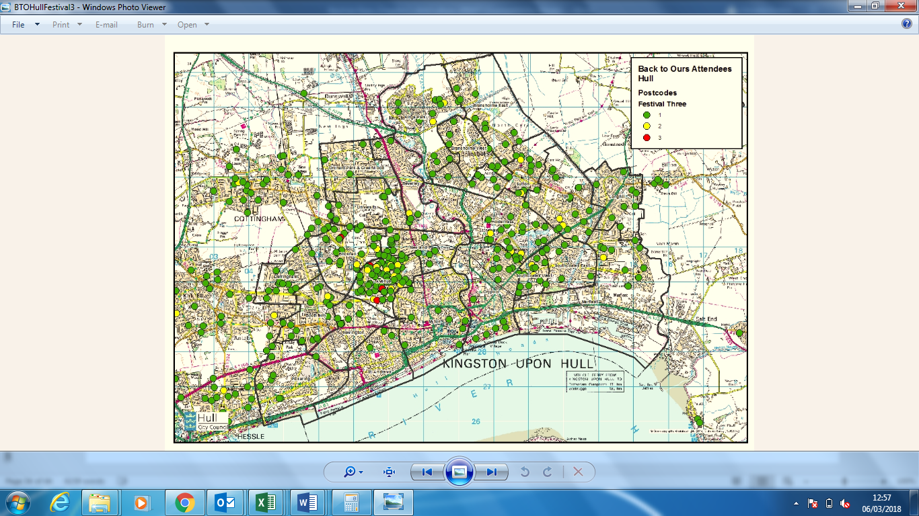

Map 4: Post Code Mapping – Back to Ours from Hull Festival 4
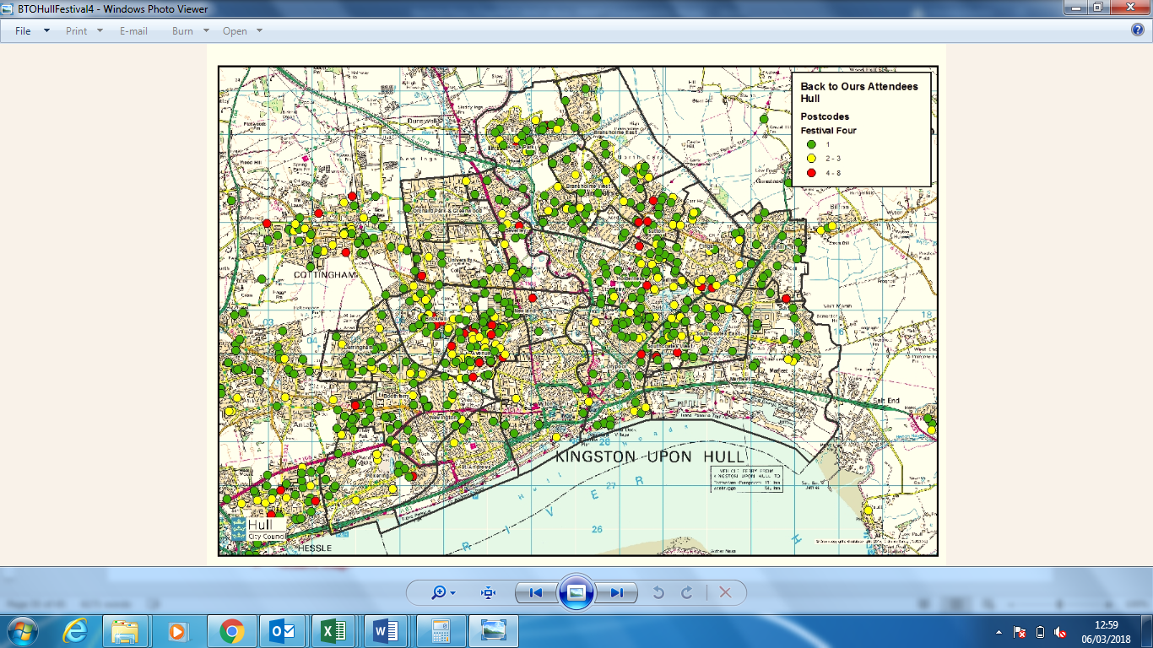
Map 5: Post Code Mapping – Back to Ours from Hull Festivals total
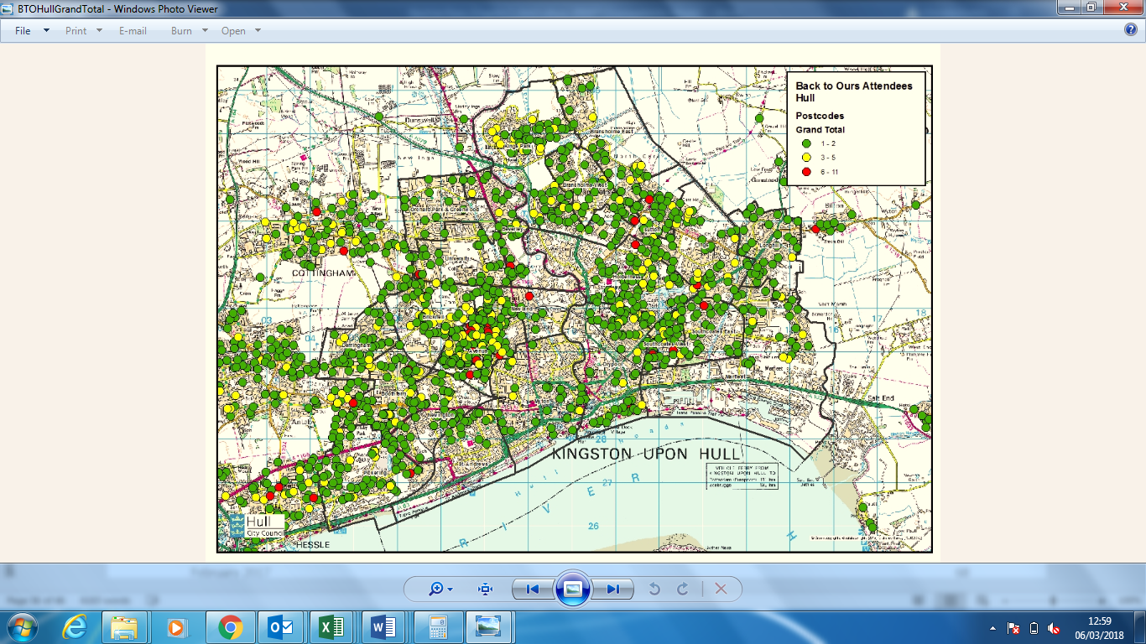

Map 6: Post Code Mapping – Back to Ours from Hull & East Riding Festival 1
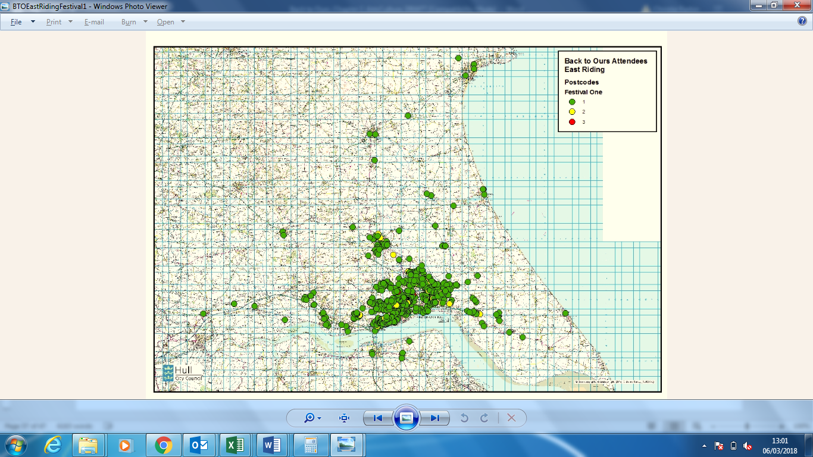
Map 7: Post Code Mapping – Back to Ours from Hull & East Riding Festival 2
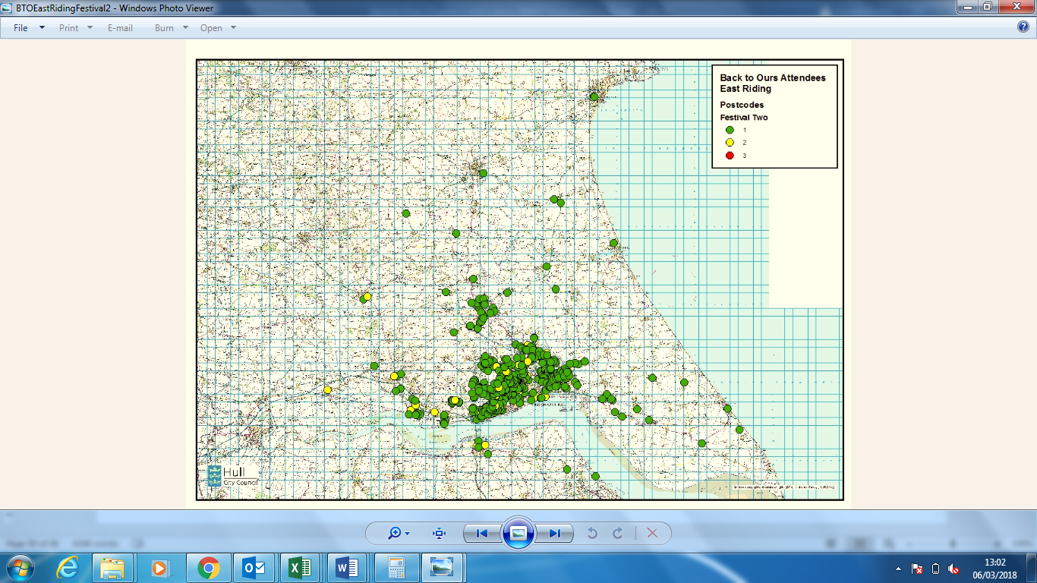

Map 8: Post Code Mapping – Back to Ours from Hull & East Riding Festival 3
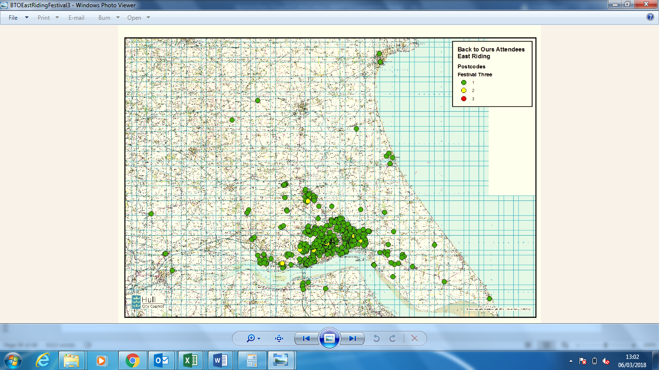
Map 9: Post Code Mapping – Back to Ours from Hull & East Riding Festival 4
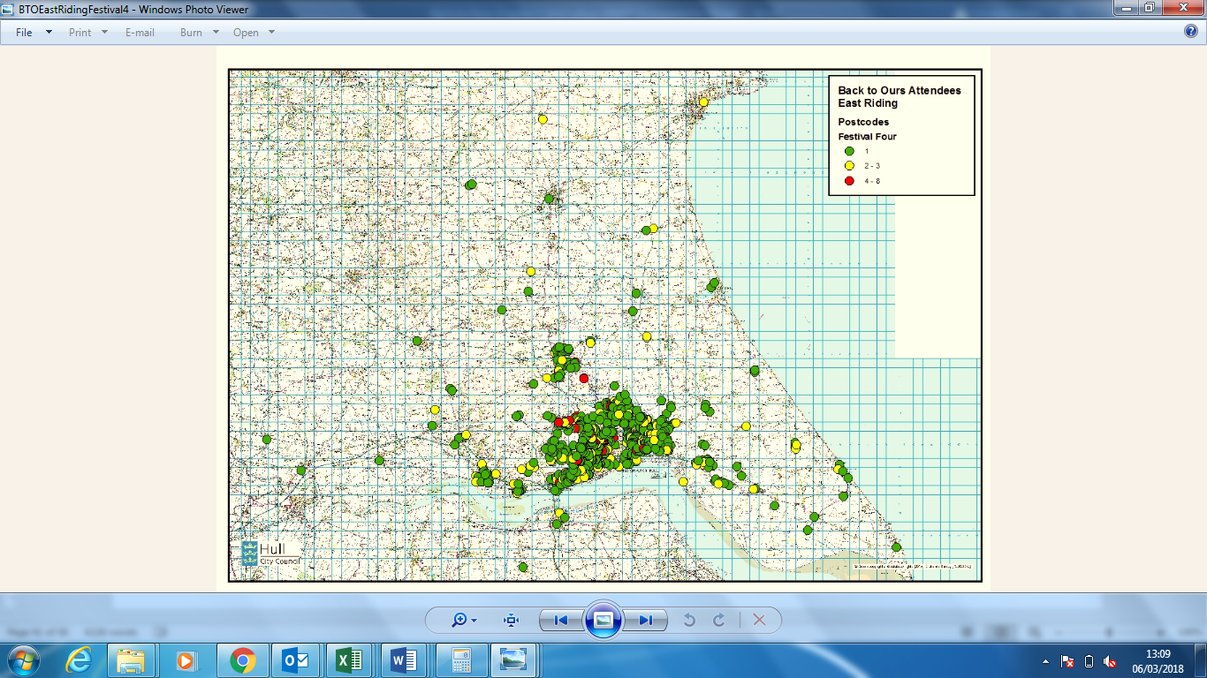

Map 10: Post Code Mapping – Back to Ours from Hull & East Riding Festivals total
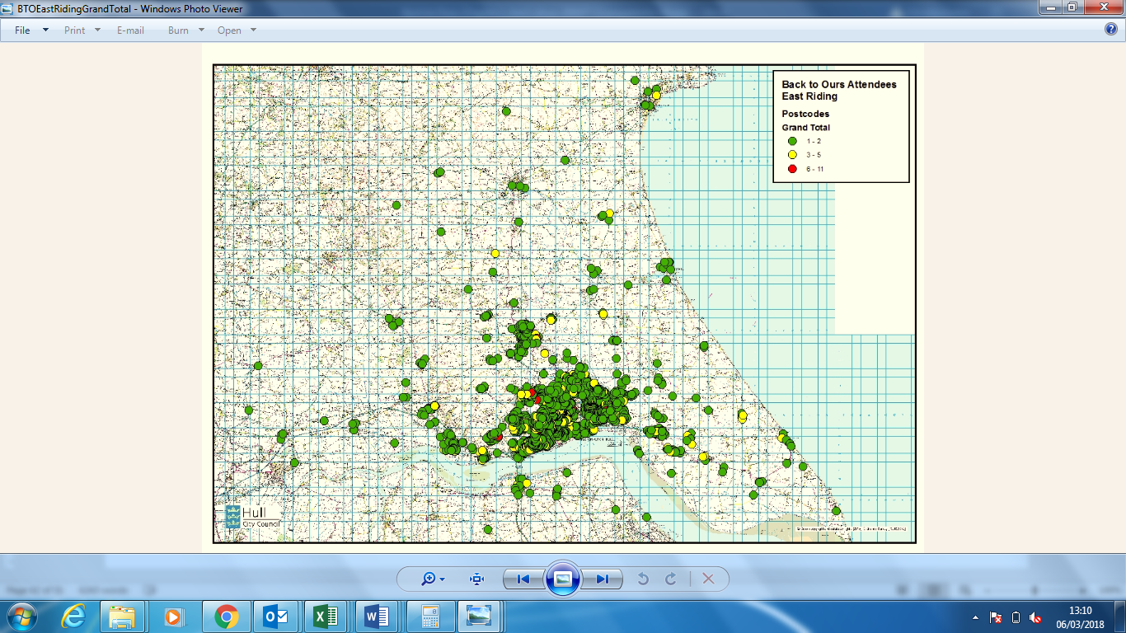
Map 11: Post Code Mapping – Back to Ours from Hull LSOA Festival 1
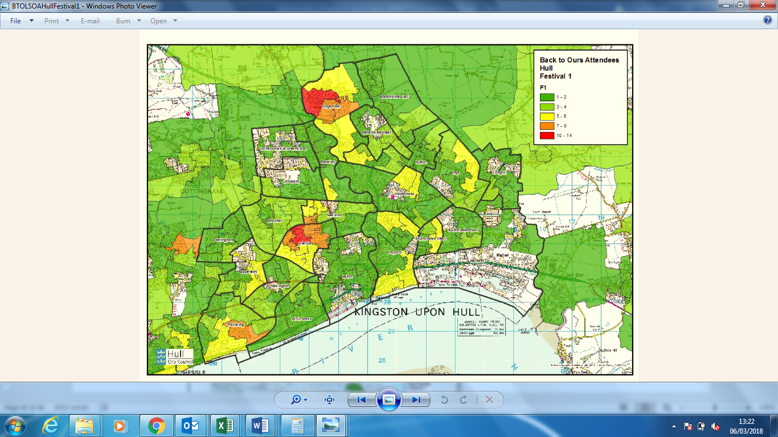

Map 12: Post Code Mapping – Back to Ours from Hull LSOA Festival 2
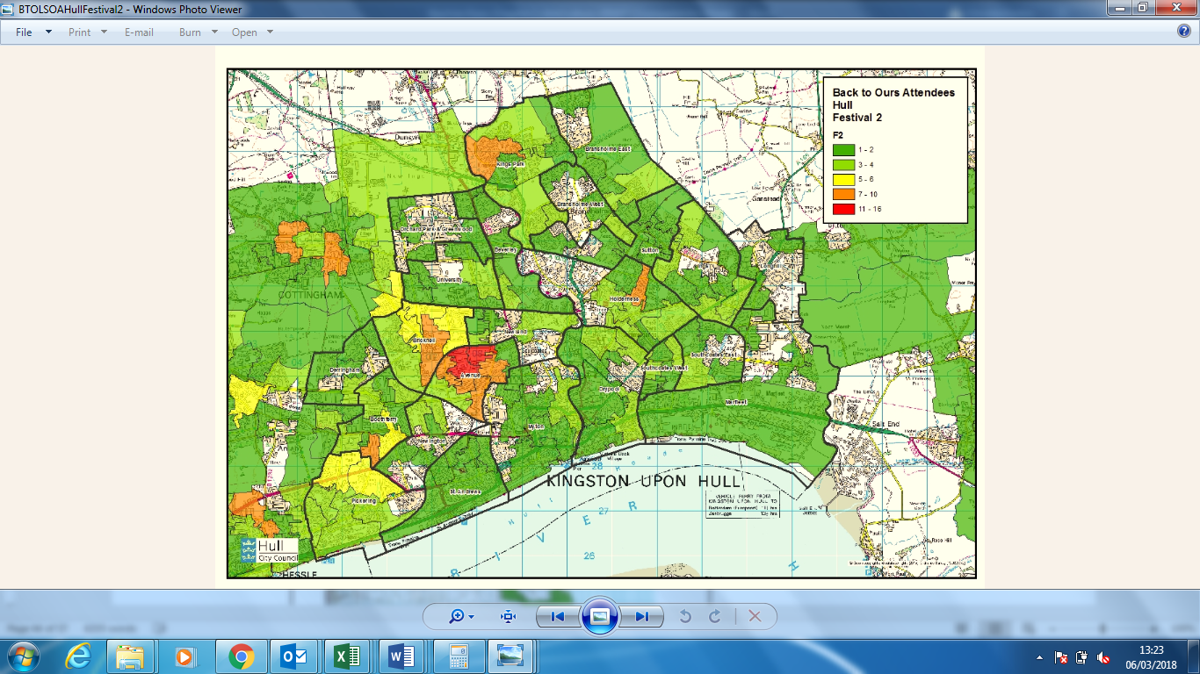
Map 13: Post Code Mapping – Back to Ours from Hull LSOA Festival 3
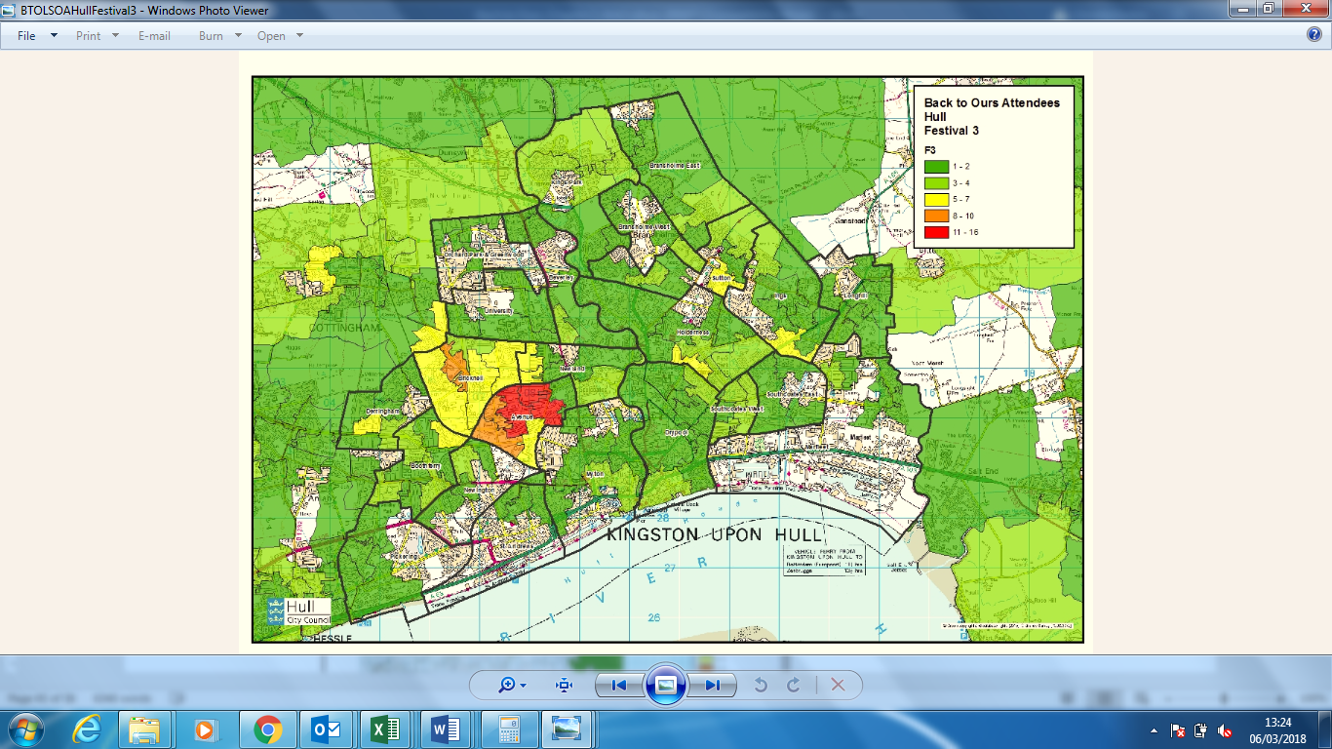
Map 14: Post Code Mapping – Back to Ours from Hull LSOA Festival 4
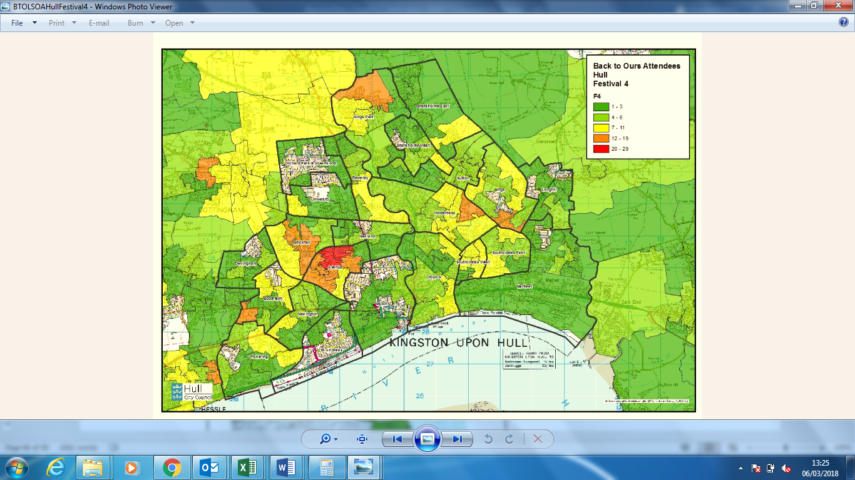

Map 15: Post Code Mapping – Back to Ours from Hull LSOA Festivals total
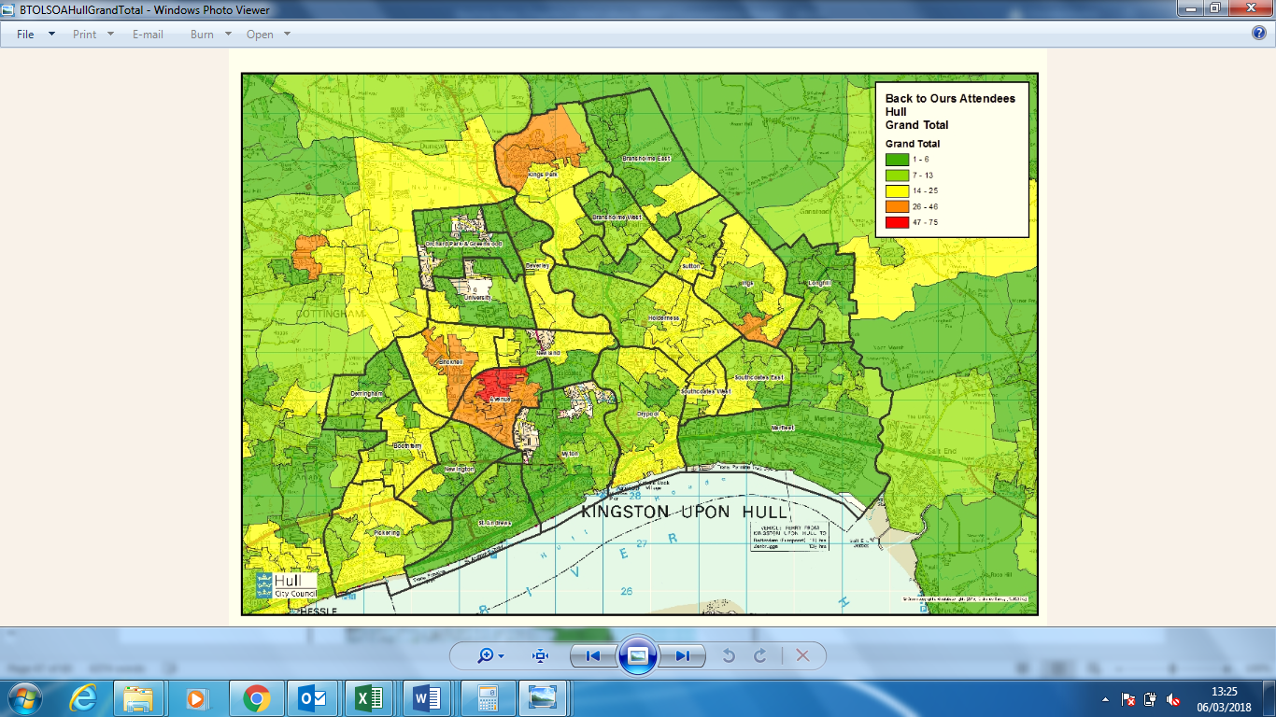
Map 16: Post Code Mapping – Back to Ours from Hull & East Riding LSOA Festival 1
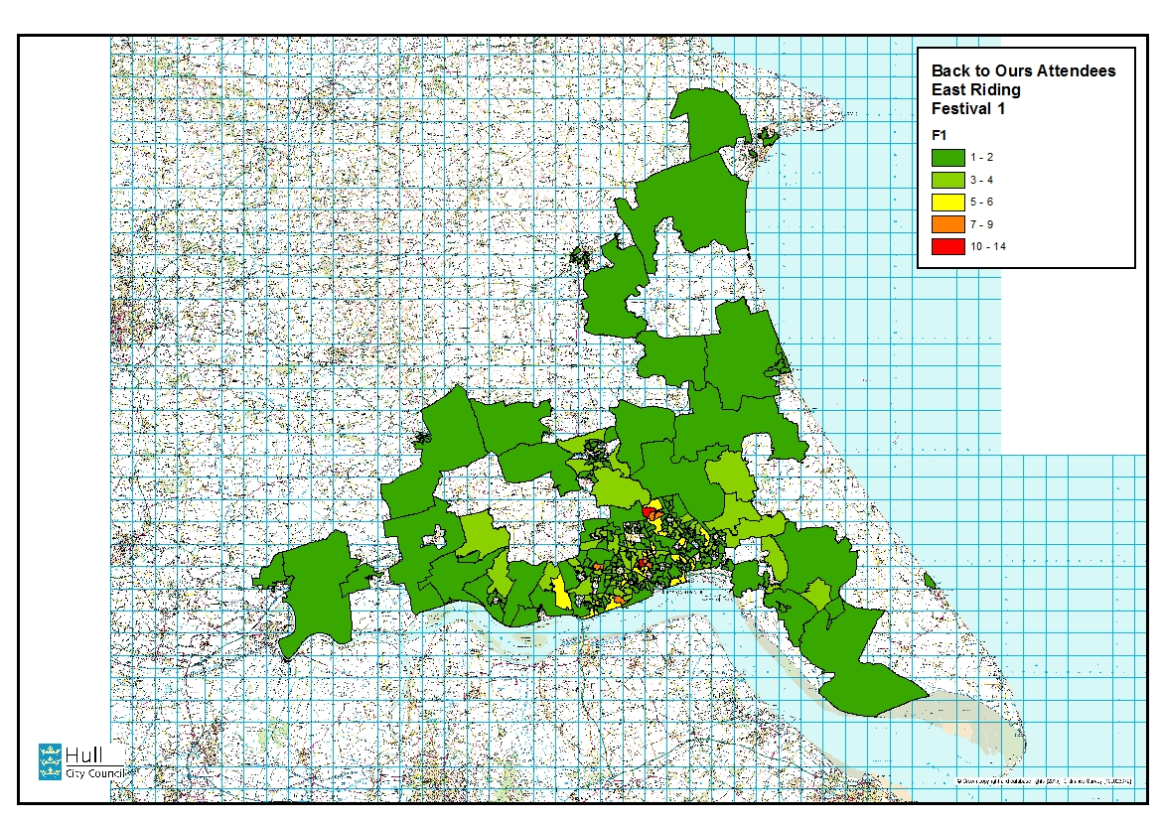

Map 17: Post Code Mapping – Back to Ours from Hull & East Riding LSOA Festival 2
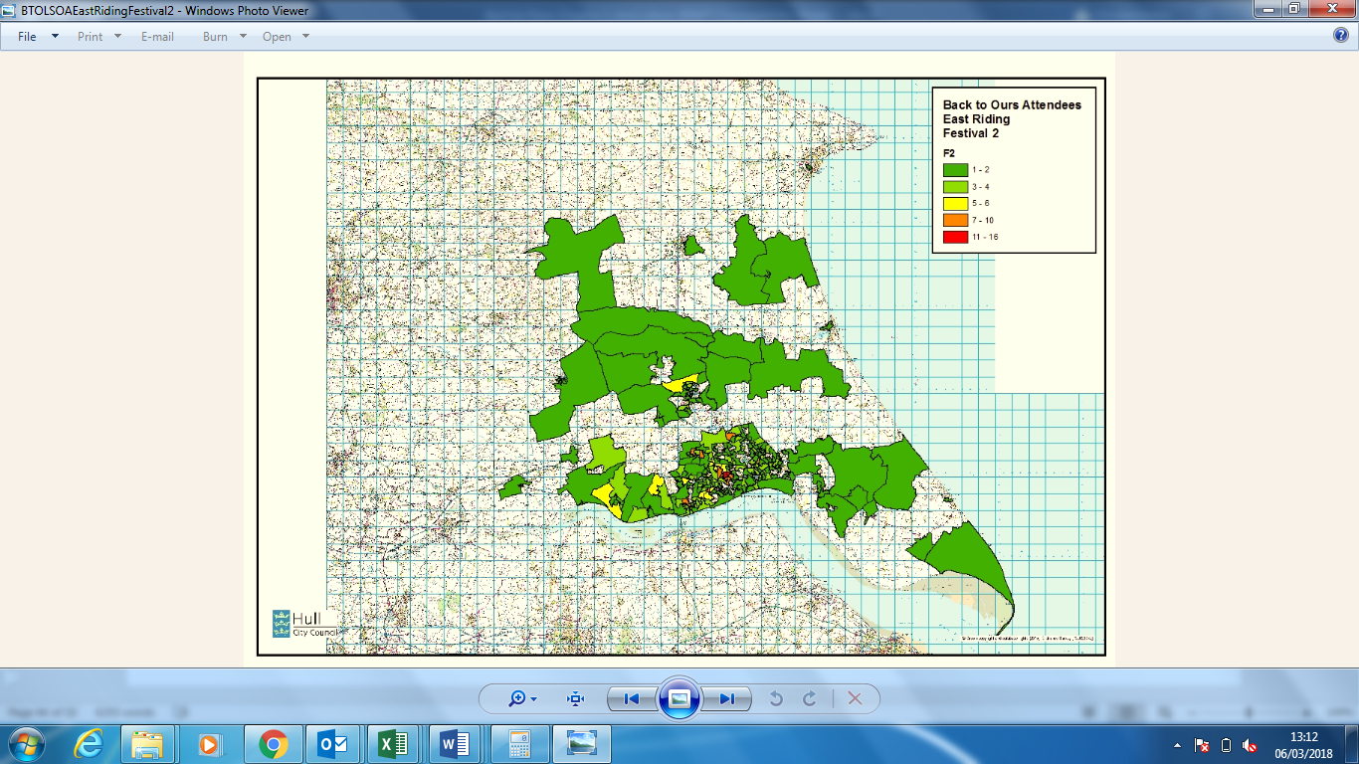

Map 18: Post Code Mapping – Back to Ours from Hull & East Riding LSOA Festival 3
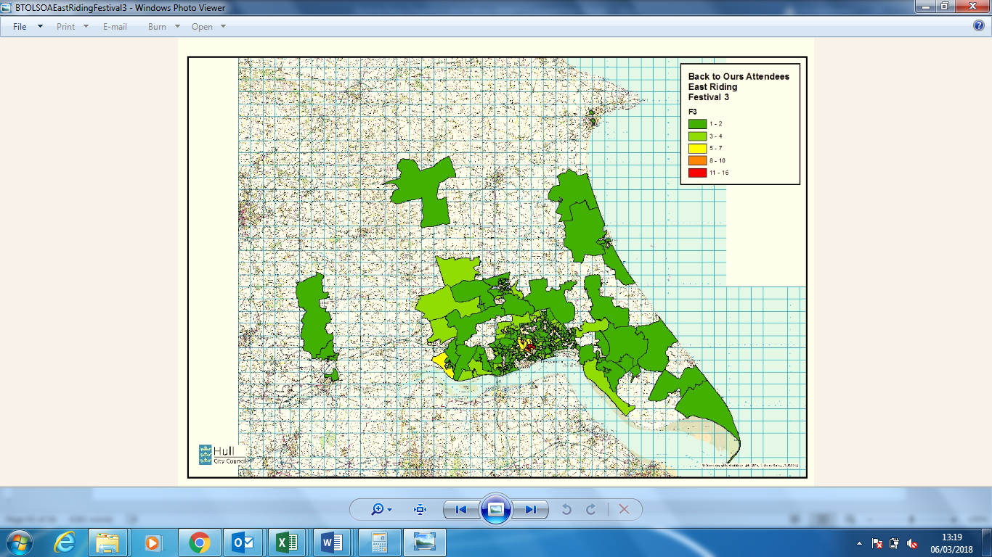
Map 19: Post Code Mapping – Back to Ours from Hull & East Riding LSOA Festival 4
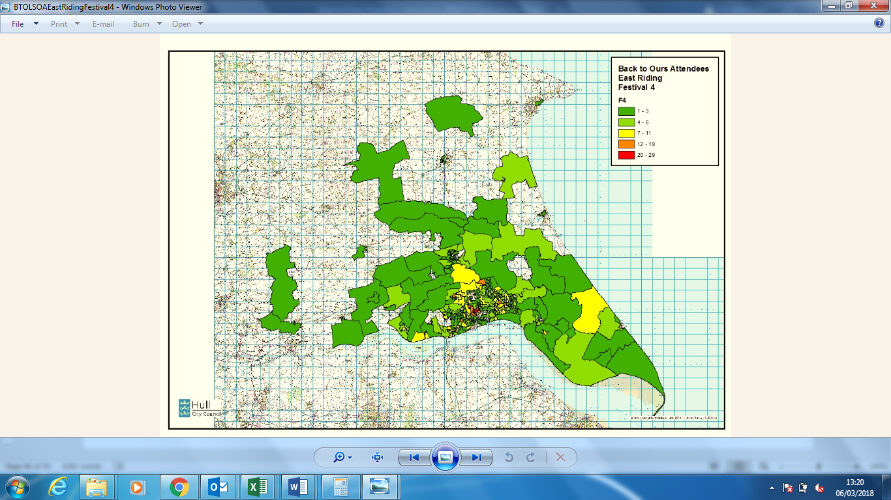

Map 20: Post Code Mapping – Back to Ours from Hull & East Riding LSOA Festivals total
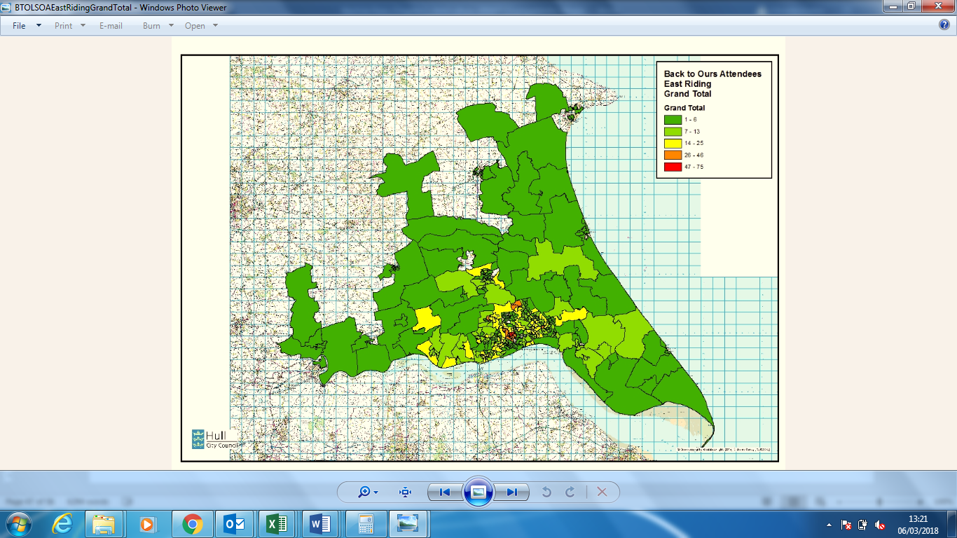
Map 21: Post Code Mapping – Back to Ours East from Hull LSOA
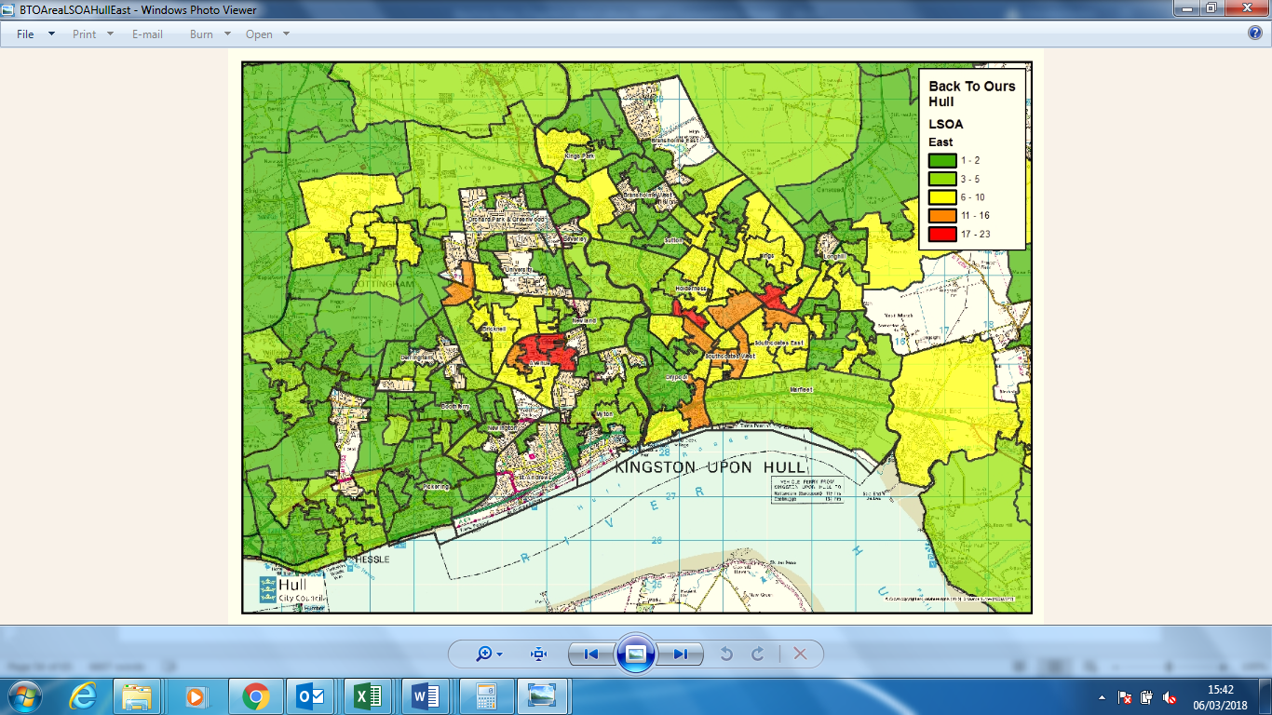
Map 22: Post Code Mapping – Back to Ours North from Hull LSOA
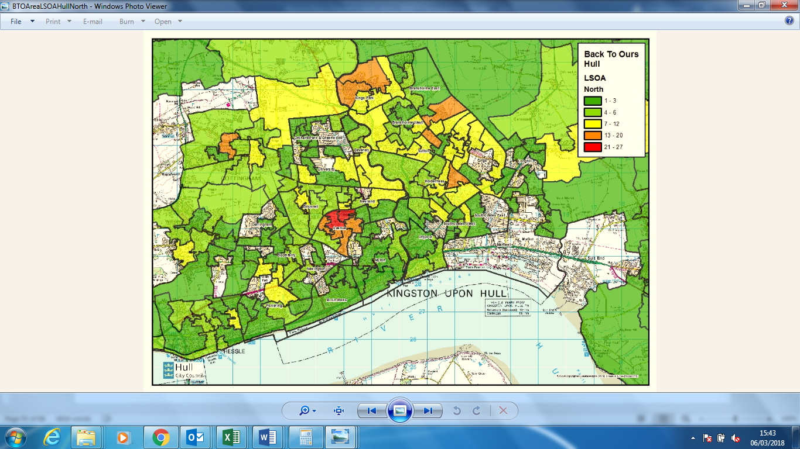

Map 23: Post Code Mapping – Back to Ours West from Hull LSOA
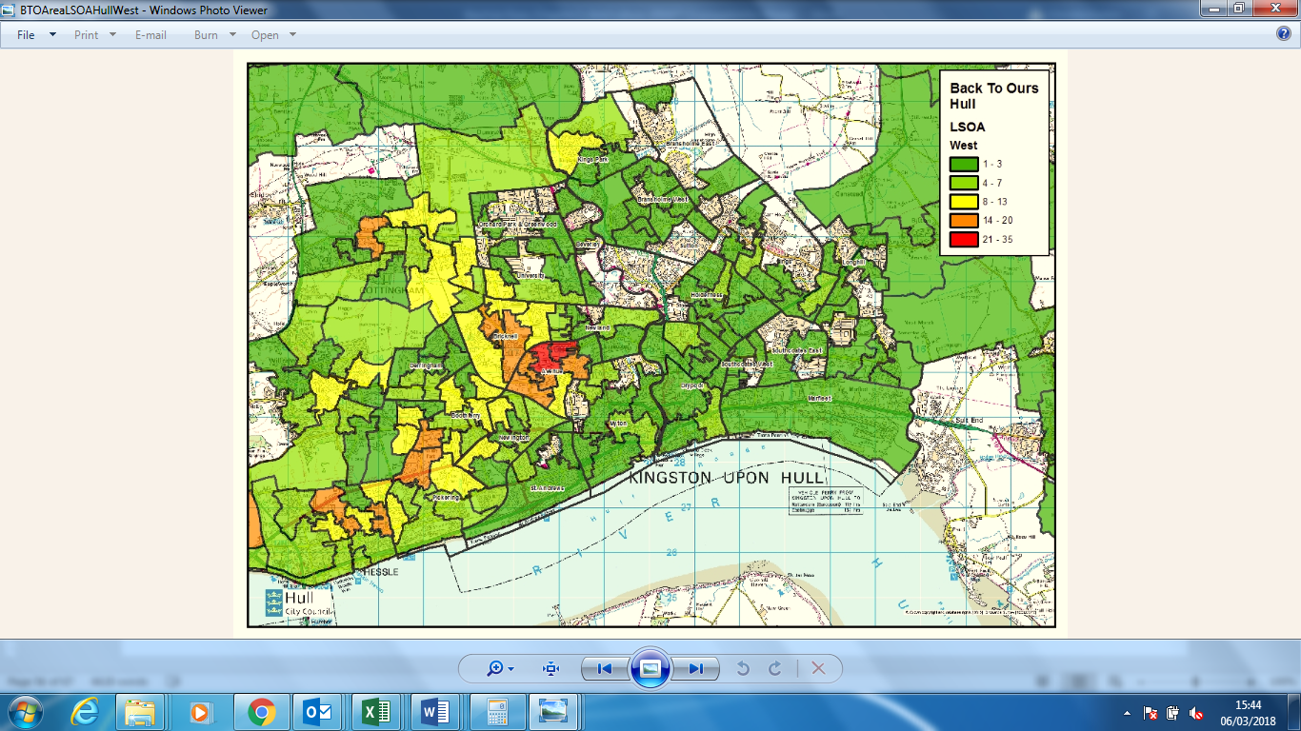

Map 24: Post Code Mapping – Back to Ours East from Hull & East Riding LSOA
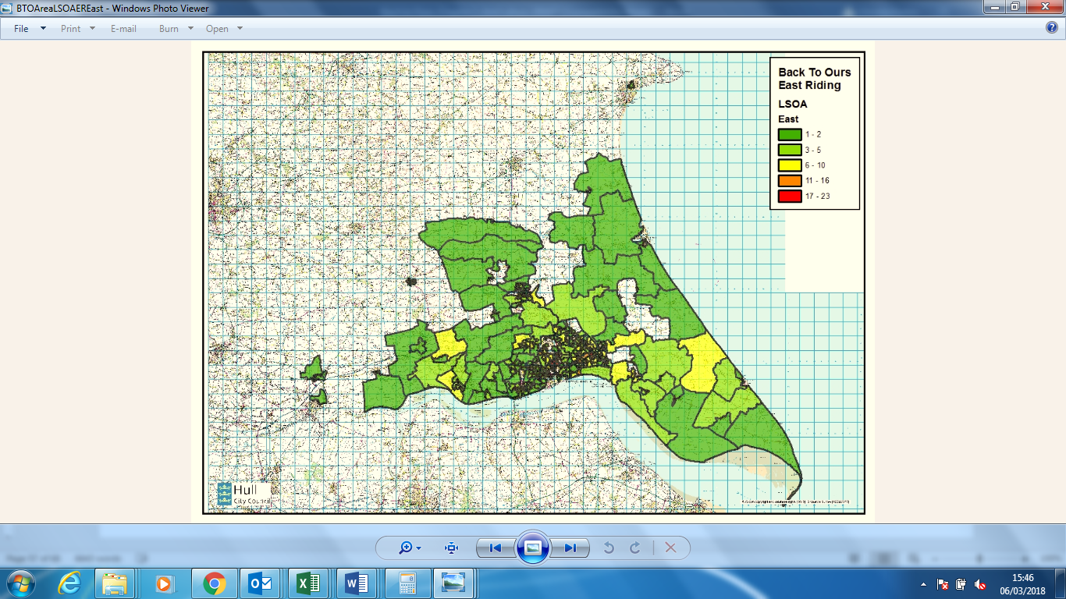
Map 25: Post Code Mapping – Back to Ours North from Hull & East Riding LSOA
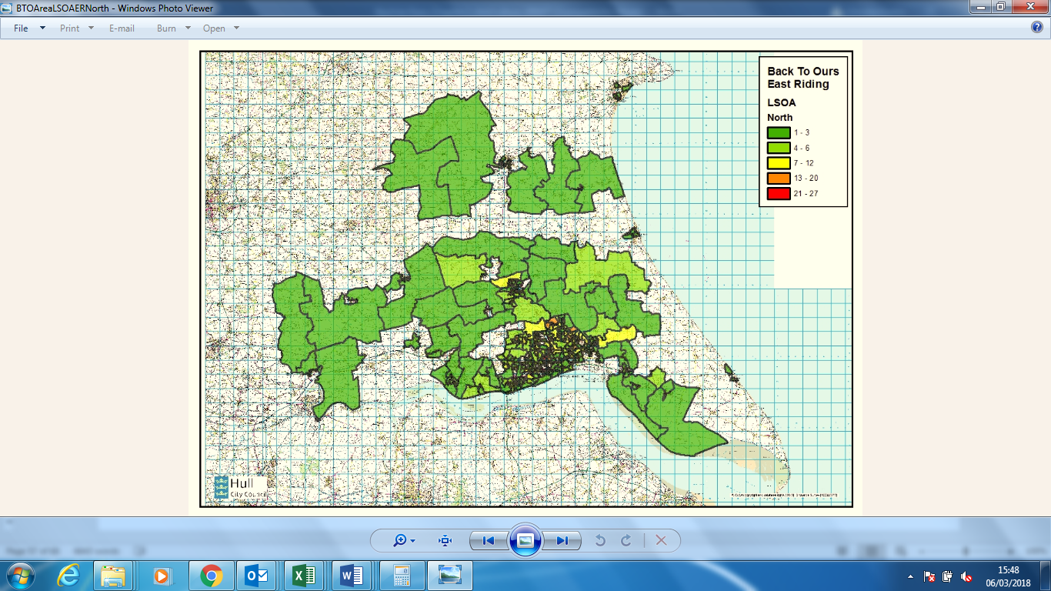

Map 26: Post Code Mapping – Back to Ours West from Hull & East Riding LSOA
