

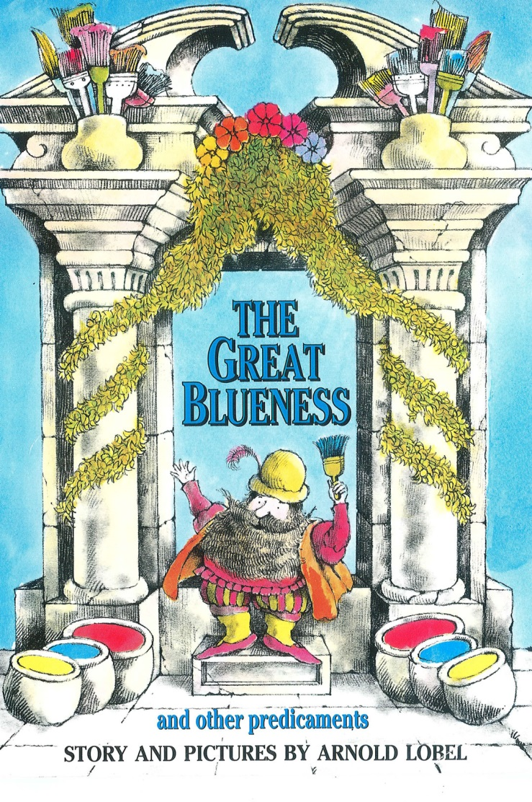



**RESEARCH AND DEVELOPMENT FOR HULL2017**

**TUESDAY 28TH – THURSDAY 29TH 2016**

HULL2017 – PRODUCTION BASE

PACIFIC EXCHANGE

40 HIGH STREET

HULL

HU1 1PS

HULL COLLEGE

QUEENS GARDENS

WILBERFORCE DRIVE

HULL

HU1 3DG

ENDIKE SCHOOL

ENDIKE LANE  
HULL

HU6 8DX

NORTHERN ACADEMY OF PERFORMING ARTS

ANLABY ROAD

HULL

HU1 2PD

**STAFF ON SITE**

*CBEEBIES PRODUCTION*

ANGELA YOUNG Producer 07976 353 608 / [angela.young@bbc.co.uk](mailto:angela.young@bbc.co.uk)

DEE KALAKOTI Asst Producer 07703887787 / [Dee.Kalakoti@bbc.co.uk](mailto:Dee.Kalakoti@bbc.co.uk)

BRUCE TURNER Runner 07595 204408 / bruce.turner@bbc.co.uk

*NORTHERN BALLET*

MARK SKIPPER Chief Executive [mark.skipper@northernballet.com](mailto:mark.skipper@northernballet.com)

DANIEL DE ANDRADE Choreographer 07411 683163 / [dan.deandrade@hotmail.co.uk](mailto:dan.deandrade@hotmail.co.uk)

LEANNE KIRKHAM Workshop Leader 07825 545072 / [Leanne.kirkham@northernballet.com](mailto:Leanne.kirkham@northernballet.com)

SOPHIE ALDER Early Years Specialist [Sophie.alder@northernballet.com](mailto:Sophie.alder@northernballet.com)

MARK WILKINSON Pianist 07930 664451 / [markwmusician@gmail.com](mailto:markwmusician@gmail.com)

GARY YERSHON Composer [gsyershon@gmail.com](mailto:gsyershon@gmail.com)

MARK BAILEY Designer [mark@mawb.co.uk](mailto:mark@mawb.co.uk)

**SCHOOL CONTACTS**

Andrew Shimmin, Head Teacher Helen Dent Julie Lovewell

McMillan Nursery School Endike Primary Head of Dance, NAPA

07854769318 / (01482) 331370 01482 616461 07725213005

[head@mcmillan.hull.sch.uk](mailto:head@mcmillan.hull.sch.uk) [hdent@endike.hull.sch.uk](mailto:hdent@endike.hull.sch.uk) [julieLovewell@northernacademy.org.uk](mailto:julieLovewell@northernacademy.org.uk)

HULL COLLEGE

Mark Pearce

079552251122

|  |  |  |
| --- | --- | --- |
| **BBC CONTACTS** | | |
| Head of CBeebies In-House Production | Alison Stewart  [Alison.Stewart1@bbc.co.uk](mailto:Alison.Stewart1@bbc.co.uk)  Assistant: angela.burton@bbc.co.uk | 0161 836 0616  07712 876073 |
| Production Executive Childrens | David Noble  [David.Noble@bbc.co.uk](mailto:David.Noble@bbc.co.uk)  Sally Carroll  [Sally.carroll@bbc.co.uk](mailto:Sally.carroll@bbc.co.uk) | 079735 05360  07912 583838 |
| Legal & Business Affairs Manager | Mark Bennett  mark.bennett1@bbc.co.uk | 07714 957258 |
| Business Affairs Executive | Hesham Sabry  hesham.sabry@bbc.co.uk | 07712 301171 |
| Business Affairs Executive – Talent Rights | Amanda Barker | 07702 512 188 |
| Bridge House Mail Room |  | 0161 836 0056 |
| BBC 24 hour Ed Policy Advice |  | 020 8008 1819 |
| BBC Safety Advisor | Katherine Fry | 07703 885814 |
| Children’s IT Assistant | Jo Flitcroft | 07702444529 |
| BBC Hotel bookings | Access Bookings | 0870 855 5777 / 0208 752 7555 |
| BBC Trains | Train line | 020 8752 7676 |
| BBC One Transport Taxis |  | 020 8225 8555 / 0345 155 0801 |
| BBC Transport Hire Cars |  | 0844 579 8832 |
| BBC Couriers |  | 07536 015200/ 020 8752 7555 |
| Enterprise Car Hire |  | 0844 335 3825 |

**TUESDAY 28TH JUNE**

10:15 RV AT HULL2017, PACIFIC EXCHANGE

THE BOARD ROOM

COFFEE

10:30 OPENING DISCUSSION OF CREATIVE AND R&D PLAN

including Gary’s musical creative thoughts

13:00 LUNCH

*MARK BAILEY ARRIVES OVER LUNCH*

14:00 TRAVEL TO HULL COLLEGE

14:30 – 16:30 *SESSION 1*: HULL COLLEGE DANCE STUDENTS AND GRADUATES

16:45 TRAVEL BACK TO PACIFIC EXCHANGE

17:00 EVALUATION ON HOW SESSION WENT

FURTHER CREATIVE DISCUSSION TO END OF DAY

Including Mark’s design creative thoughts

**WEDNESDAY 29TH JUNE**

08:15 RV AT EXPRESS BY HOLIDAY INN

TRAVEL TO ENDIKE PRIMARY SCHOOL

09:15 – 10:15 SESSION 2: MACMILLAN NURSERY UNDER 4s

10:15 BREAK

10:45 – 11:45 SESSION 3: ENDIKE PRIMARY YEAR 1s

12:00 LUNCH

13:30 – 15:00 SESSION 4: ENDIKE PRIMARY YEAR 4s

15:30 TRAVEL TO NAPA

16:30 SET UP READY FOR DANCE SESSIONS

17:00 – 18:00 SESSION 5: BALLET STUDENTS AGED 7 to 10

18:00 – 19:00 SESSION 6: BALLET STUDENTS AGED 7 to 10

**THURSDAY 30TH JUNE**

09:30 RV AT HULL2017, PACIFIC EXCHANGE

EVALUATION SESSION

12:00 LUNCH

12:30 RECCES OF HULL VENUES – ADDRESSES TBC

*Mark Skipper and Northern Ballet Technical Manager to join*

*15:13 GARY YERSHON AND MARK BAILEY BOOKED TRAIN*

*SESSION INFORMATION*

SESSION 1 1 Group of Graduates and Students from Hull College

Session led by Daniel exploring movement motifs and characters

SESSION 2 1 Group of Under 4s – approx. 15 children

Session led by Sophie focussing on creative child led movement, focus on story through sensory movement play, play and painting with colours

SESSION 3 1 Group of Year 1s – approx. 30 children

Session led by Sophie with support from Leanne – movement and music focussed with children creating movements based on responses to primary colours; mixing colours and mixing movements

SESSION 4 1 Group of Year 4s - approx. 30 children

Session led by Leanne with support from Sophie – travelling movements inspired by the 3 primary colours; Dan will teach 3 actions and movements from the fairy / goblin repertoire; children create their own short dances

SESSIONS 5 & 6 2 Groups of Ballet Students aged 7 to 10 – 20 per group

Sessions led by Dan – experimenting with character / repertoire

*ACCOMMODATION – BREAKFAST COST INCLUDED*

EXPRESS BY HOLIDAY INN, HULL CITY CENTRE

80 FERENSWAY, HULL HU2 8LN

28th and 29th Angela Young / Bruce Turner / Daniel de Andrade / Gary Yershon /

Mark Bailey

28th only Dee Kalakoti / Mark Wilkinson