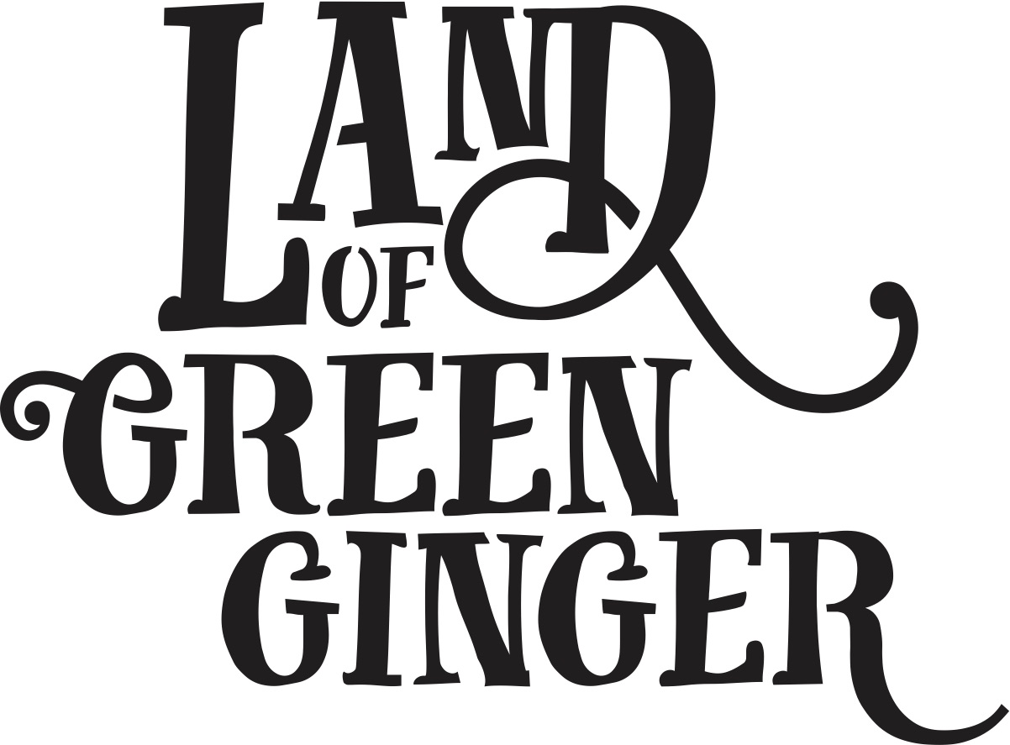

**The Longhill Burn**

**Participation Opportunities**

We are looking for Longhill residents to take part in The Longhill Burn as **Longhill Hosts** or as **performers**.

**The Longhill Hosts** will be Longhill ambassadors; meeting and greeting the public and welcoming them to join in with the gathering events and The Longhill Burn itself. These gathering events are working towards the beautiful animated bonfire – The Longhill Burn - which will be lit on Saturday 15 July.

At the gathering events the Longhill Hosts can take part in:

* Fun and entertaining games and activities
* Collective activities around song and movement
* Collecting and gathering wooden things to burn
* Collecting answers to the question, “what gives you hope?”, which will be burnt on the fire sending them out into the world
* Collecting words and phrases which will later be part of a song for Longhill
* Collecting water from various rivers (the roads with river names)
* Recruiting other helpers
* Working alongside Fire Smiths leading up to and during the bonfire

**Performers** are invited to be part of the event. If you are interested, please come and speak to us at any of the gathering events, which will be taking place:

**Monday 10 July, 3-7pm, Cam Grove**

**Wednesday 12 July, 3-7pm, Weaver Grove**

**Thursday 13 July, 3-7pm, Limerick Close**

Feel free to drop in at any time, or if you’d like to find out more please contact **Lis Poulsom** on **07462 693457**.

We would also like Longhill Hosts to be part of The Longhill Burn itself, where they will be collecting more messages and hopes, helping to gather audiences and encouraging movement during the event, and enjoying the bonfire themselves.

Performers, and Longhill Hosts are invited to the following rehearsals and event times:

Friday 14 July 6-9pm, rehearsal, Eastmount Playing Fields

Saturday 15 July 2-5pm, rehearsal, Eastmount Playing Fields

Saturday 16 July 8-11pm, bonfire, Eastmount Playing Fields