INNER COVER(front)

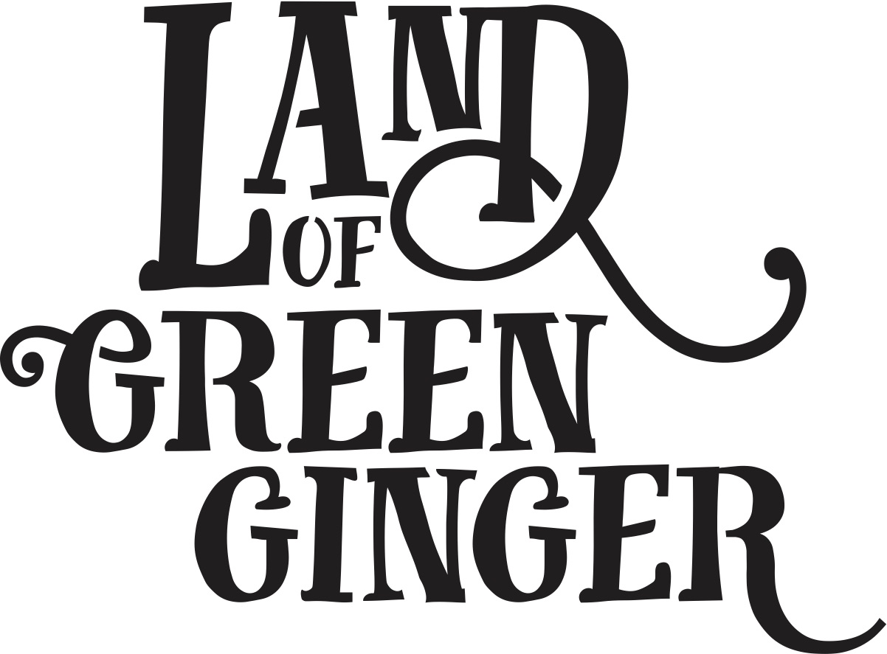

Written by XXXXX

Illustrated by Katy Riddell

© 2018 Hull UK City of Culture 2017 / Absolutely Cultured

All rights reserved. This book or any portion thereof may not be reproduced or used in any manner whatsoever without the express written permission of the publisher except for the use of brief quotations in a book review.

*All characters and events in this publication, other than those clearly in the public domain, are fictitious and any resemblance to real persons, living or dead, is purely coincidental.*

Limited Edition

First printing, 2018

Printed in the United Kingdom

ISBN No. XXX-X-XXXX-XXXX-X

Published by Absolutely Cultured

Pacific Exchange

40 High Street

Hull

HU1 1PS

[www.hull2017.co.uk](http://www.hull2017.co.uk)

Illustration by Katy Riddell

[www.katyriddell.tumblr.com](http://www.katyriddell.tumblr.com)

Design by Process Black

<http://processblack.co.uk>

Printed and bound by Bluestorm Design & Marketing

<https://bluestormdesign.co.uk>

Dedicated to

XXXXXXXXXXXX

**LAST PAGE**

**Background**

Throughout 2017, Hull 2017’s ground-breaking community engagement project, *Land of Green Ginger*, invited Hull’s residents to immerse themselves in a magical citywide story, inspired by and celebrating the spirit of Hull.

The *Land of Green Ginger* project was presented as a series of events or *Acts of Wanton Wonder* united under an overarching narrative. The individual Acts were developed and delivered with artists who worked both independently and in collaboration to bring new kinds of art and culture into the neighbourhoods outside the city centre.

Six *Acts of Wanton Wonder* transformed communities across the city into places of wonder, delight, magic and possibility.

This book is the seventh and final *Act* of the *Land of Green Ginger* project.

It has been delivered to residents and schools across the city as a record of the project that took place and as a keepsake for the people whose lives were touched by the magic of *Land of Green Ginger*.

*Land of Green Ginger* was delivered and produced by Hull UK City of Culture 2017.

The live Acts were created and delivered by the following artist companies:

Act I: **7 Alleys** by **Periplum**

Act II: **The Gold Nose of Green Ginger** by **Joshua Sofaer**

Act III: **The Longhill Burn** by **And Now:**

Act IV: **Re-Rediffusion’s Voice Park** by **Aswarm**

Act V: **Micropolis** by **The McGuires**

Act VI: **Land of Green Ginger Unleashed** by **Macnas**

Find out more about the live project by visiting [www.hull2017.co.uk/landofgreenginger](http://www.hull2017.co.uk/landofgreenginger)

INNER COVER (back)