Appendix 15:
Audience Survey Analysis – All Artworks

  - Executive Summary
This report contains the findings from surveys conducted with the audience for the ‘Look Up’ artworks. The research was commissioned by Hull UK City of Culture 2017 and conducted by Information by Design (IbyD) with fieldwork undertaken between September 2017 and January 2018.
Key findings from the research include:
- 82% had seen ‘Blade’ and over half of respondents had seen ‘The Train Track and the Basket’, ‘The City Speaks’, ‘A Hall for Hull’ and ‘Elephant in the Room’.
- 18% have seen the artwork because they were in the area anyway, 17% because ‘it’s part of Hull 2017’ and 13% because they thought it was a unique experience not to be missed.
- 90% of respondents agreed that they felt welcomed by Hull 2017 volunteers and 80% agreed that they had felt welcomed by security or stewards. Only 1% disagreed that they had felt welcomed by Hull 2017 volunteers and 1% disagreed that they had felt welcomed by security or stewards.
- 43% of respondents had seen the information boards about the ‘Look Up’ artworks that they saw and 33% had read the information boards. Of the respondents who had read the information boards about the ‘Look Up’ artworks that they saw, 89% strongly agreed or agreed that the information boards contained information they found interesting, 83% strongly agreed or agreed that the information boards helped them to understand the artwork better and 69% strongly agreed or agreed that the information boards made them think differently about the artwork.
- 23% of respondents had found out about the ‘Look Up’ artwork they saw from TV. 19% had found out from being told in person by a friend, family member or colleague, 15% had found out from Hull 2017 social media and 13% had found out from the Hull 2017 website.
- 85% of respondents had been to, or planned to attend or take part in other events and activities programmed for Hull 2017.
- 89% had purposely visited an artwork in a public building or place in the last 12 months.
- 55% of respondents visiting the ‘Look Up’ installations were from Hull. 93% of visitors had been to Hull prior to the visit when they saw the ‘Look Up’ artwork. 7% were visiting Hull for the first time when they saw the ‘Look Up’ artwork.
- Of respondents who were visitors to Hull, 43% were in Hull on the day they saw the ‘Look Up’ artwork ‘mainly’ due to the artwork and 83% had taken part in other arts and cultural events or activities during their visit.
- 29% of respondents who were visitors to Hull were in Hull just to see the ‘Look Up’ artwork. 20% were in Hull for general leisure purposes and 16% were in Hull when they saw the ‘Look Up’ artwork because it was UK City of Culture 2017.
- Hull was rated highly on overall visitor welcome and value for money with 85% of respondents satisfied with the general visitor welcome and 83% satisfied with overall value for money (a score of 4 or 5 out of 5).
- 82% of visitors to Hull were just in Hull for the day and 18% were staying overnight. Overnight visitors had stayed in Hull for a mean of 2.09 nights and 2.77 days and spent a mean of £100 on accommodation. 47% of overnight visitors to Hull had stayed in a hotel and 41% had stayed with friends or family.
- Respondents estimated that they spent a mean of £57.71 on themselves and others with them in Hull during their visit to Hull when they saw the ‘Look Up’ artwork. 41% of this spend was on food and drink, 39% on shopping and 9% on travel and transport.
Blade
- 70% of respondents said that they were very likely to recommend something like ‘Blade’ to friends or relatives (a score of 9 or 10 on a 0-10 scale).
- Over 80% of respondents strongly agreed (a score of 9 or 10) with the statements ‘it is important it’s happening here in Hull’ and ‘it was an interesting idea’.
- Over 90% of respondents strongly agreed or agreed with the statements ‘Blade was an enjoyable experience’, ‘Blade showed the aspirations of the City now and in the future’ and ‘Blade provided me with a different experience of the city’.
The City Speaks
- 90% of respondents to ‘The City Speaks’ audience survey had seen other peoples’ speech displayed on the tidal surge barrier, 51% had spoken into the lectern and 45% had seen their own speech displayed on the tidal surge barrier.
- 59% of respondents said that they were very likely to recommend something like ‘The City Speaks’ to friends or relatives (a score of 9 or 10 on a 0-10 scale).
- Over 70% of respondents strongly agreed (a score of 9 or 10) with the statements ‘it is important it’s happening here in Hull’, ‘it was different from things I’ve experienced before’ and ‘it was an interesting idea’.
- Over 90% of respondents strongly agreed or agreed with the statements ‘The City Speaks was an enjoyable experience’ and ‘The City Speaks has introduced me to the work of Michael Pinsky for the first time’.
Washed Up Car-go
- 51% of respondent said that they were very likely to recommend something like ‘Washed Up Car-go’ to friends or relatives (a score of 9 or 10 on a 0-10 scale).
- 70% of respondents strongly agreed (a score of 9 or 10) with the statements ‘it is important it’s happening here in Hull’ and 60% strongly agreed with the statement ‘it was different from things I’ve experienced before’.
- 93%) of respondents strongly agreed or agreed with the statement ‘Washed Up Car-go has introduced me to the work of Chris Dobrowolski for the first time’ and 81% strongly agreed or agreed with the statement ‘Washed up Car-go was an enjoyable experience’.
The Train Track and the Basket
- 36% of respondents said that they were very likely to recommend something like ‘The Train Track and the Basket’ to friends or relatives (a score of 9 or 10 on a 0-10 scale).
- 69% of respondents strongly agreed (a score of 9 or 10) with the statement ‘it is important it’s happening here in Hull’ and 57% strongly agreed with the statement ‘It was well produced and presented’.
- 94% of respondents strongly agreed or agreed with the statement ‘The Train Track and the Basket has introduced me to the work of Claire Barber for the first time’ and 88% strongly agreed or agreed with the statement ‘The Train Track and the Basket was an enjoyable experience’.
- 29% of respondents felt that they had learnt ‘a lot’ about transmigration through Hull between 1848 and 1914 and 20% of respondents felt that they had learnt ‘a lot’ about the history of Hull Paragon Interchange (a score of 9 or 10).
- 94% strongly agreed or agreed with the statement ‘using art works to present the history and heritage of Hull makes the history and heritage more interesting’ and 93% strongly agreed or agreed with the statement ‘Using art works to present the history and heritage of Hull makes the history and heritage easier to understand’.
- 40% of respondents had attended, or planned to attend, exhibitions about transmigration through Hull and 37% had attended, or planned to attend, events about transmigration through Hull. 22% of respondents had undertaken, or planned to undertake, their own research into Hull Paragon Interchange and 22% had undertaken, or planned to undertake, their own research into transmigration through Hull.
Paper City
- 68% of respondents said that they were very likely to recommend something like ‘Paper City’ to friends or relatives (a score of 9 or 10 on a 0-10 scale).
- 78% of respondents strongly agreed (a score of 9 or 10) with the statements ‘it is important it’s happening here in Hull’ and 69% strongly agreed with the statement ‘I would come to something like this again’.
- Over 90% of respondents strongly agreed or agreed with the statements ‘Paper City was an enjoyable experience’ and ‘Paper City provided me with a different experience of the city’. 81% of respondents strongly agreed or agreed with the statement ‘Paper City made me look at Hull's buildings and public spaces in a different way.
Bleached
- 52% of respondents said that they were very likely to recommend something like ‘Bleached’ to friends or relatives (a score of 9 or 10 on a 0-10 scale).
- 75% of respondents strongly agreed (a score of 9 or 10) with the statement ‘it is important it’s happening here in Hull’ and 69% strongly agreed with the statements ‘it has something to say about the world in which we live’.
- Over 90% of respondents strongly agreed or agreed with the statements ‘Bleached has introduced me to the work of Tania Kovats for the first time’ and ‘Bleached was an enjoyable experience’.
This is a Freedom of Expression Centre
- 63% of respondents said that they were very likely to recommend something like ‘This is a Freedom of Expression Centre’ to friends or relatives (a score of 9 or 10 on a 0-10 scale).
- 85% of respondents strongly agreed (a score of 9 or 10) with the statements ‘it is important it’s happening here in Hull’. 70% or more strongly agreed with the statements ‘I would come to something like this again’ and ‘it was an interesting idea’.
- 93% of respondents strongly agreed or agreed with the statement ‘This is a Freedom of Expression Centre was an enjoyable experience’. Over 80% of respondents strongly agreed or agreed with the statements ‘This is a Freedom of Expression Centre provided me with a different experience of the city’ and ‘This is a Freedom of Expression Centre showed me that there is more to Hull than I expected’.

Elephant in the Room
- 40% of respondents said that they were very likely to recommend something like ‘Elephant in the Room’ to friends or relatives (a score of 9 or 10 on a 0-10 scale).
- 70% of respondents strongly agreed (a score of 9 or 10) with the statement ‘it is important it’s happening here in Hull’.
- 92% of respondents strongly agreed or agreed with the statement ‘Elephant in the Room has introduced me to the work of Claire Morgan for the first time’ and 86% of respondents strongly agreed or agreed with the statement ‘Elephant in the Room was an enjoyable experience’.
- 10% of respondents said that they had learnt a lot about Hull’s maritime history as a result of attending ‘Elephant in the Room’ (a score of 9 or 10 on a 0-10 scale) and 18% said that they had learnt ‘nothing at all’ (a score of 0 or 1).
- 91% strongly agreed or agreed with the statement ‘using art based approaches to present the history and heritage of Hull makes the history and heritage more interesting’. 85% strongly agreed or agreed with the statement ‘using art based approaches to present the history and heritage of Hull makes the history and heritage easier to understand’.
- 62% of respondents had visited, or planned to visit, the Hull Maritime Museum as a result of seeing ‘Elephant in the Room’. 46% had visited, or planned to visit, Hull History Centre. 42% had sought out, or planned to seek out, exhibitions or events about Hull’s maritime history. 19% had undertaken, or planned to undertake, their own research into Hull’s maritime history and 17% had undertaken, or planned to undertake, their own research into Hull’s whaling industry.
A Hall for Hull
- 57% of respondents said that they were very likely to recommend something like ‘A Hall for Hull’ to friends or relatives (a score of 9 or 10 on a 0-10 scale).
- 75% of respondents strongly agreed (a score of 9 or 10) with the statement ‘it is important it’s happening here in Hull’ and 62% strongly agreed with the statement ‘I would come to something like this again’.
- 90% of respondents strongly agreed or agreed with the statements ‘A Hall for Hull’ was an enjoyable experience’ and ‘A Hall for Hull has introduced me to the work of architects Pezo von Ellrichshausen for the first time’. Over 80% of respondents strongly agreed or agreed with the statements ‘A Hall for Hull has introduced me to the work of artist Felice Varini for the first time’ and ‘A Hall for Hull provided me with a different experience of the city’.
Floe
- 34% of respondents had visited ‘Floe’ on Friday 8th December, 38% had visited on 9th December and 32% had visited on Sunday 10th December. 3% had visited ‘Floe’ on two nights and less than 1% had visited on three nights.
- 69% of respondents said that they were very likely to recommend something like ‘Floe’ to friends or relatives (a score of 9 or 10 on a 0-10 scale).
- Over 80% of respondents strongly agreed (a score of 9 or 10) with the statements ‘it is important it’s happening here in Hull’ and ‘I would come to something like this again’. 74% strongly agreed (a score of 9 or 10) with the statement ‘it was well produced and presented’.
- Over 90% of respondents strongly agreed or agreed with the statements ‘Floe was an enjoyable experience’ and ‘Floe has introduced me to the work of artists Anna Heinrich and Leon Palmer for the first time’. Over 80% of respondents strongly agreed or agreed with the statements ‘Floe provided me with a different experience of the city’ and ‘Floe gave everyone the chance to share and celebrate together’.
  - Background and Methodology
This report contains the findings from audience reaction surveys conducted to evaluate a number of the ‘Look Up’ Installations. The ‘Blade’ (Blade) was the first of these installations in Queen Victoria Square in the early part of the year and the results from this were produced an initial report. This final report contains the findings from the combined results (where common questioning was used) from all Look Up installations:
- Blade
- The City Speaks
- Washed up Car-go
- The Train Track and the Basket
- Paper City
- Bleached
- This is Freedom of Expression Centre
- Elephant in the Room
- A Hall for Hull
- Floe.
The research was commissioned by the Hull UK City of Culture 2017 and conducted by Information by Design (IbyD) with fieldwork undertaken using online and CATI surveys. Fieldwork was undertaken between 8 January and 12 March 2017 for ‘Blade’ and between 21 September 2017 and 10 January 2018 for the other artworks. The overall aim of the research was to provide information to support the evaluation of the process and impact of the installations, with the key objectives being to:
- Provide an accurate and robust count of some of the audiences for the installations.
- Measure audience awareness, motivation and reaction to the installation
- Understand the economic, social and cultural impact
- Inform future planning of events.
    - Methodology and Sampling
There were three strands to the research:
- Audience counts from the installations.
- Gathering details of members of the audience at the event (name, telephone number, email address, party composition and age).
- Post-event questionnaires completed by telephone (CATI) interviews and online with the audience, using names collected at the event/s.
- It should be noted that some of the audience counts were undertaken by volunteers, and some by IbyD. Both volunteers and IbyD also undertook names collection at the different installations, to provide audience details for participation in further research.
- For some of the installations, there were insufficient names to contact to provide a robust sample, and so screening interviews were undertaken online and by CATI to increase the names available for full interviews.
    - Sample Size
In total, the contact details available for each installation are as shown in the table below.
 | Collected by Hull 2017 Volunteers | Collected by IbyD | From screening | Total
Blade | 0 | 1,449 | 0 | 1,499
The City Speaks | 0 | 4 | 277 | 281
Washed Up Car-Go | 0 | 0 | 270 | 270
The Train Track and the Basket | 5 | 97 | 26 | 128
Paper City | 127 | 0 | 240 | 367
Bleached | 222 | 0 | 0 | 222
This is a Freedom of Expression Centre | 144 | 0 | 91 | 235
Elephant in the Room | 350 | 218 | 54 | 622
A Hall for Hull | 0 | 403 | 7 | 410
Floe | 0 | 784 | 0 | 784
Total | 848 | 2,955 | 965 | 4,768

A target sample size was set for each installation. For some installations, the target sample was possible and for others there were insufficient names collected. As such, samples were set to be as high as possible within the constraints of the data. For some, the targets were achieved either at or over target – for others the sample was smaller than that set. The total number of interviews completed for ‘Look Up’ was 2,220. It should be noted that respondents could choose not to answer questions, and so the base size for some of the questions is smaller than the total achieved sample size.
Survey | Sample Size
Blade | 600
The City Speaks | 122
Washed Up Car-Go | 134
The Train Track and the Basket | 89
Paper City | 139
Bleached | 84
This is a Freedom of Expression Centre | 59
Elephant in the Room | 269
A Hall for Hull | 316
Floe | 408
Total | 2,220
As a point of reference, the overall confidence interval for this survey of 2,220 respondents is ±2.08%. Strictly speaking each question will differ as the confidence interval is also dependent on the individual responses to the question. Generally, confidence intervals are quoted in this report at the 95% level.
    - Weighting
The data from the interviews was weighted by the estimated audience size for each installation. Appendix A provides a profile of respondents to the survey. The estimated audience figures used for weighting are shown in the table below.
 | Count | %
Blade | 420,888 | 60%
The City Speaks | 49,547 | 7%
Washed Up Car-Go | 21,044 | 3%
The Train Track and the Basket | 73,320 | 11%
Paper City | 21,299 | 3%
Bleached | 6,603 | 1%
This is a Freedom of Expression Centre | 1,177 | 0%
Elephant in the Room | 32,616 | 5%
A Hall for Hull | 48,329 | 7%
Floe | 10,151 | 2%
Total | 684,974 | 100%
  - ‘Look Up’ - Survey Findings
This section presents the results from analysis of the questions asked of the ‘Look Up’ audience in the post-event survey.
    - Key Audience Demographics
Forty-five (45%) of respondents from the audience survey were from Hull. 35% were from the East Riding and 20% were from the UK but outside of Hull and the East Riding. Less than 1% were from outside of the UK.
Thirty-six percent (36%) of respondents were male, 64% were female and less than 1% defined their gender as ‘other’.
Just over half of respondents (54%) were employed either full or part-time and 7% were self-employed, with 28% retired.
Twenty-one percent (21%) of respondents were aged between 16 and 34, 58% were aged between 35 and 64 and 21% were aged 65 and over.
Ninety-seven percent (97%) of respondents were White British, 2% from other white ethnic groups and 1% were from other ethnic groups.
Three percent (3%) of respondents were ‘limited a lot’ and 5% ‘limited a little’ in their day-to-day activities because of a health problem or disability.
    - Group Composition
Respondents were asked the composition of the group they were with when they saw the ‘Look Up’ artwork. The mean number in the group was 2.96, made up of 0.55 children and 2.39 adults. Please note that some respondents did not answer the number of adults and children in their group, so the total number in the group is slightly higher than sum of the number of adults and children in the group.
    - Artworks Experienced
Respondents were asked which of the ‘Look Up’ art works they had seen. 82% had seen ‘Blade’ and over half of respondents had seen ‘The Train Track and the Basket’, ‘The City Speaks’, ‘A Hall for Hull’ and ‘Elephant in the Room’. 37% had seen between one and three artworks, 43% had seen between four and six, and 20% had seen 7 or more.
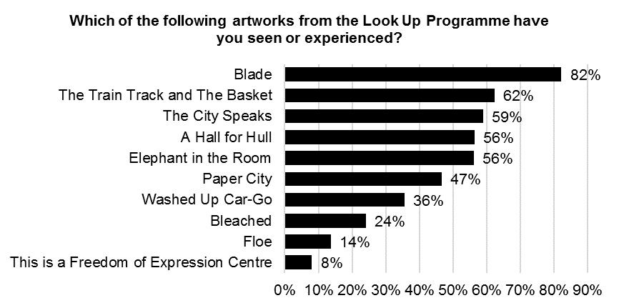
Base size: 1,620
Question not asked on ‘Blade’ audience survey

There were significant differences in the ‘Look Up’ art works seen by gender. Women were more likely to have seen ‘Elephant in the Room’, ‘Paper City’ and ‘Washed up Car-go’. Men were more likely to have seen ‘Floe’ and ‘This is a Freedom of Expression Centre’.
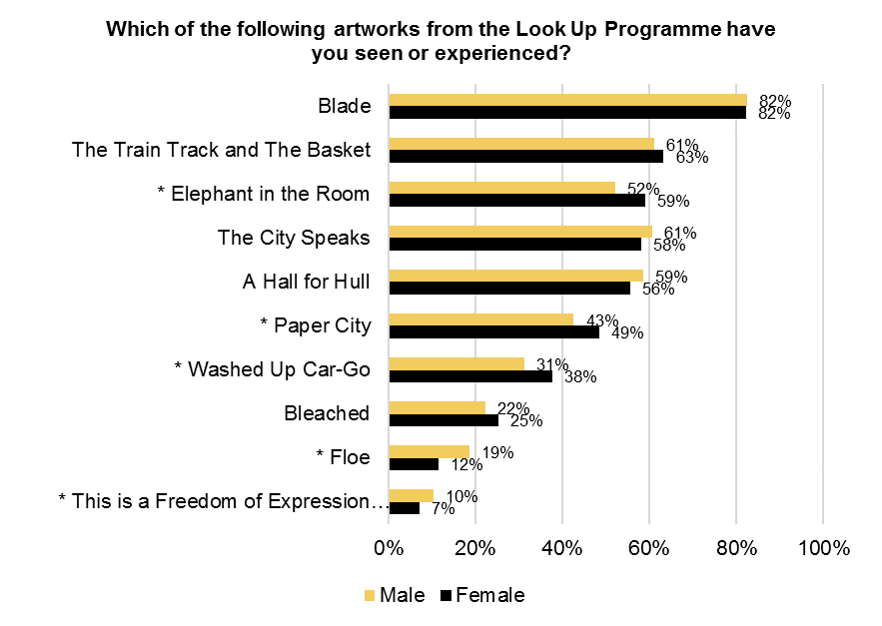
See Appendix B for Base Size
* = Significant differences by gender
Question not asked on ‘Blade’ audience survey

There were significant differences in the ‘Look Up’ art works seen by age. Respondents aged 55 and over were more likely to have seen ‘A Hall for Hull’, ‘Paper City’ and ‘Bleached’. Respondents aged 35-54 were less likely to have seen ‘The Train Track and the Basket’ and more likely to have seen ‘The City Speaks'.
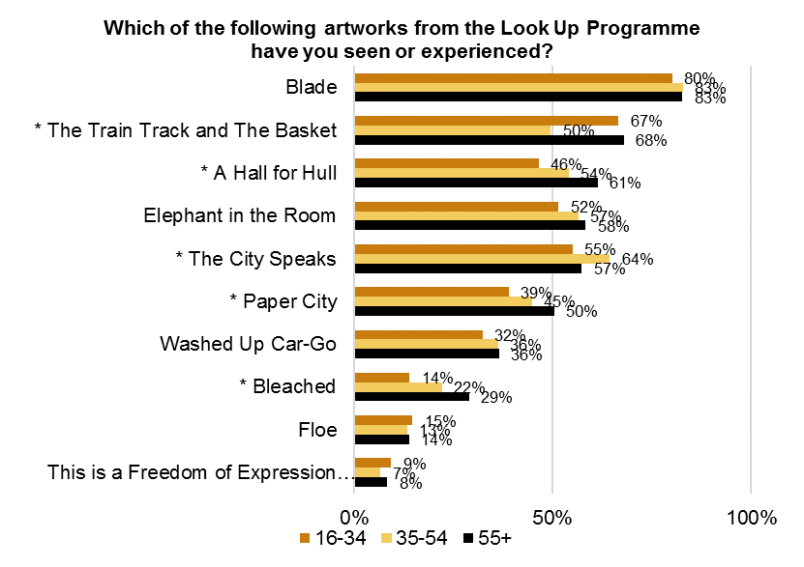
See Appendix B for Base Size
* = Significant differences by age
Question not asked on ‘Blade’ audience survey

There were significant differences in the ‘Look Up’ art works seen by area. Respondents from outside of Hull and the East Riding were less likely to have seen all of the art works.
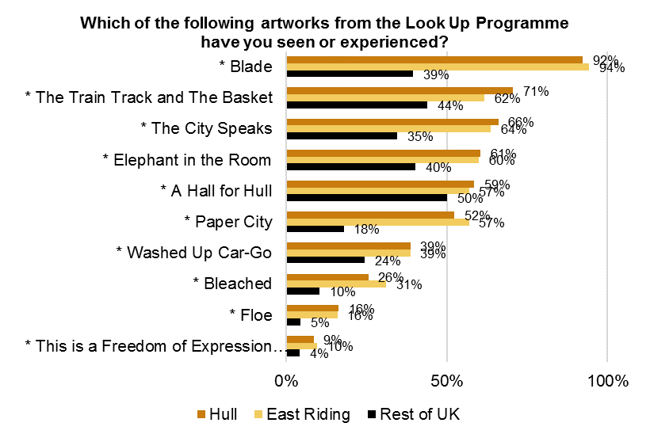
See Appendix B for Base Size
* = Significant differences by area
Question not asked on ‘Blade’ audience survey
There were significant differences in the ‘Look Up’ art works seen by IMD. Respondents from the most deprived areas of Hull were less likely to have seen six of the artworks (‘Blade’, ‘The City Speaks’, ‘A Hall for Hull’, ‘Washed up Car-go’, ‘Bleached’ and ‘Floe’). Respondents from the least deprived areas of Hull were more likely to have seen ‘Elephant in the Room’ and ‘Paper City’.
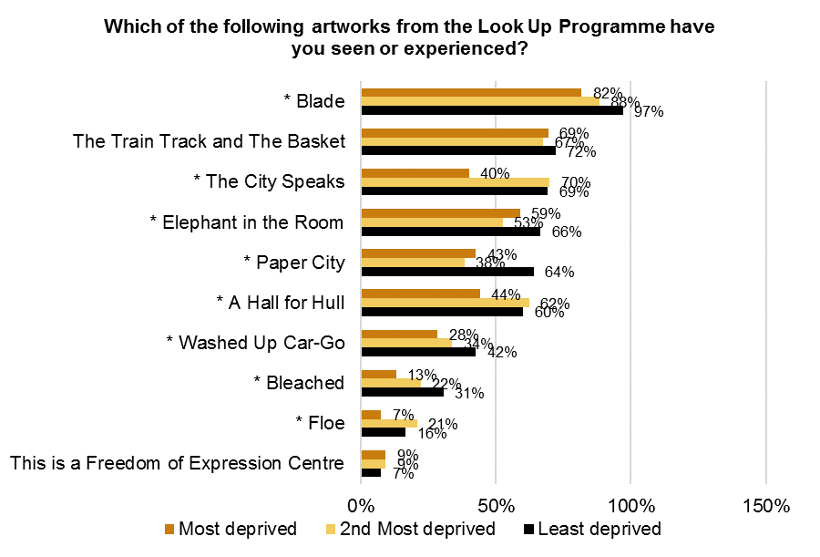
See Appendix B for Base Size
* = Significant differences by Hull IMD
Question not asked on ‘Blade’ audience survey
    - Motivation to attend ‘Look Up’
When asked what was the main reason for seeing the ‘Look Up’ artwork, 18% have seen the artwork because they were in the area anyway and 17% had seen the artwork because ‘it’s part of Hull 2017’. 13% had seen the artwork because they thought it was a unique experience not to be missed, 11% wanted to see or do something creative and 10% had a general interested in the type of work. 15% of respondents gave another reason as their main reason for seeing the ‘Look Up’ artwork. Many respondents who gave another reason were respondents to the ‘Blade’ audience survey and said they had come to the artwork to see ‘Blade’ or come to see how big it was.
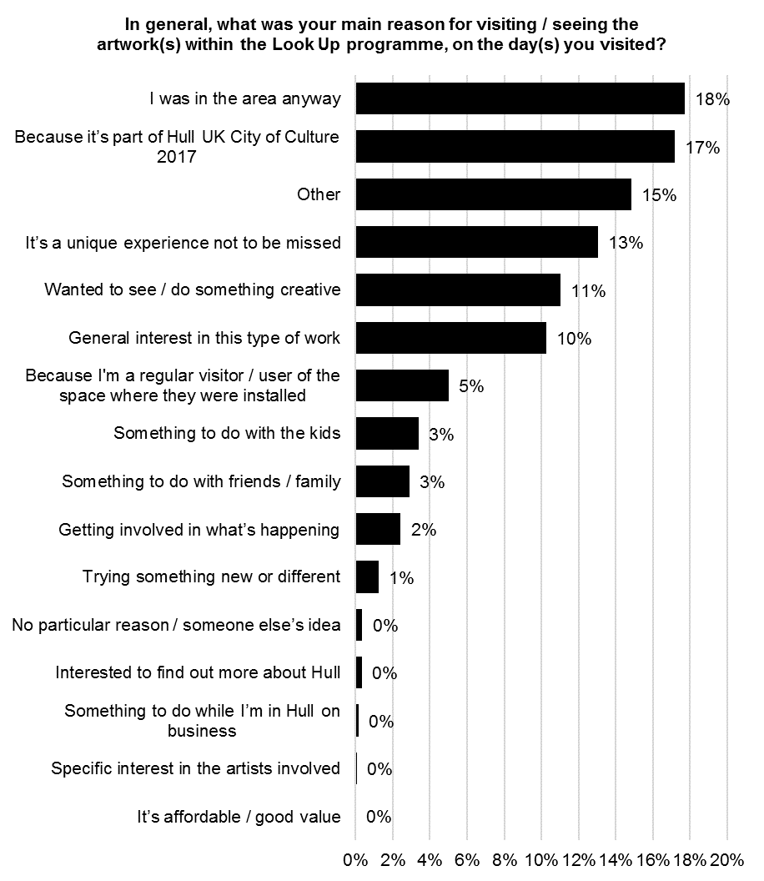
Base size: 2,220
‘Because I'm a regular visitor / user of the space where they were installed’ not an option on the ‘Blade’ audience survey

There were significant differences in the proportion of respondents who had seen the ‘Look Up’ artwork because it is part of Hull 2017 by gender, age and area. Women, respondents aged 55 and over and respondents from outside of Hull and the East Riding were more likely to have seen the artwork because it is part of Hull 2017.
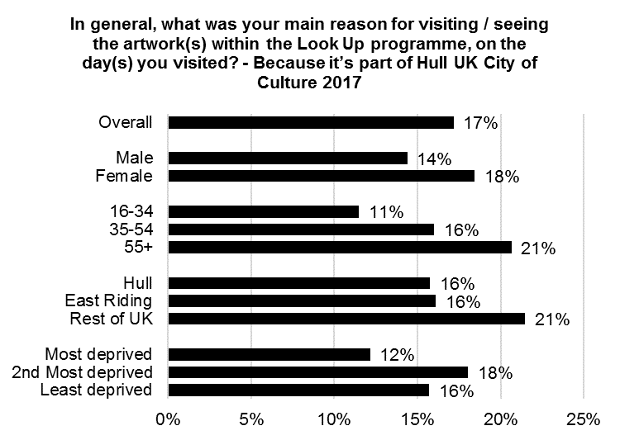
See Appendix B for Base Size
Significant differences by gender, age and area
There were significant differences in the proportion of respondents who had seen the ‘Look Up’ artwork because they were in the area anyway by gender, age and area. Men, younger respondents and respondents from the rest of the UK were more likely to have seen the artwork because they were in the area anyway.
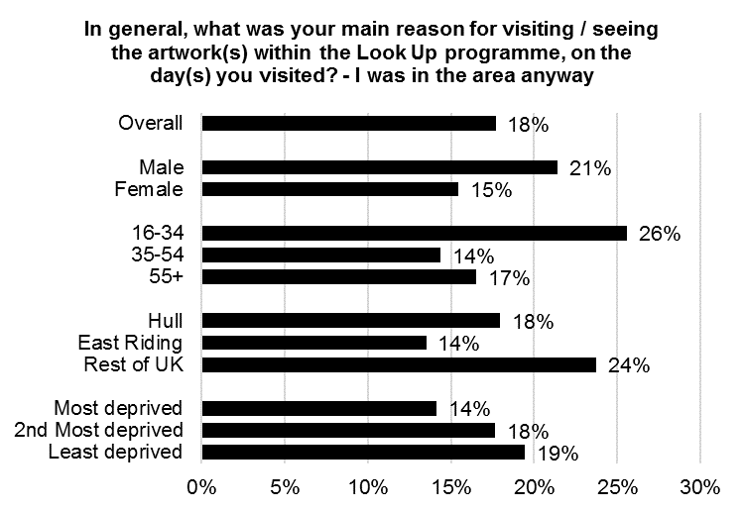
See Appendix B for Base Size
Significant differences by gender, age and area
The table below shows the main reasons for attending the ‘Look Up’ artworks by the survey completed. There were significant differences by survey completed.

In general, what was your main reason for visiting / seeing the artwork(s) within the Look Up programme, on the day(s) you visited?
 | Blade | The City Speaks | Washed Up Car-Go | The Train Track and the Basket | Paper City | Bleached | This is a Freedom of Expression Centre | Elephant in the Room | A Hall for Hull | Floe
Because it’s part of Hull UK City of Culture 2017 | 7% | 43% | 48% | 18% | 40% | 33% | 49% | 29% | 31% | 44%
Because I'm a regular visitor / user of the space where they were installed | 0% | 9% | 4% | 28% | 1% | 1% | 2% | 18% | 3% | 0%
It’s a unique experience not to be missed | 17% | 9% | 31% | 1% | 12% | 7% | 14% | 5% | 3% | 13%
General interest in this type of work | 14% | 3% | 1% | 4% | 9% | 10% | 8% | 4% | 6% | 11%
Wanted to see / do something creative | 17% | 2% | 3% | 0% | 4% | 2% | 3% | 2% | 6% | 3%
Specific interest in the artists involved | 0% | 0% | 0% | 0% | 0% | 2% | 5% | 0% | 0% | 0%
Getting involved in what’s happening | 2% | 6% | 7% | 0% | 1% | 8% | 5% | 0% | 4% | 2%
Trying something new or different | 1% | 1% | 2% | 0% | 3% | 1% | 0% | 0% | 2% | 1%
Something to do while I’m in Hull on business | 0% | 0% | 0% | 0% | 0% | 0% | 0% | 0% | 1% | 0%
It’s affordable / good value | 0% | 0% | 1% | 0% | 0% | 0% | 0% | 0% | 0% | 0%
Something to do with friends / family | 3% | 3% | 0% | 0% | 6% | 4% | 3% | 1% | 9% | 6%
Something to do with the kids | 5% | 1% | 1% | 1% | 2% | 1% | 0% | 1% | 2% | 2%
Interested to find out more about Hull | 0% | 0% | 1% | 0% | 1% | 1% | 0% | 0% | 1% | 2%
No particular reason / someone else’s idea | 0% | 0% | 0% | 1% | 1% | 4% | 0% | 0% | 2% | 1%
I was in the area anyway | 12% | 20% | 1% | 43% | 12% | 25% | 8% | 33% | 25% | 6%
Other | 22% | 2% | 1% | 3% | 6% | 0% | 2% | 4% | 5% | 9%
    - Hull 2017 Volunteers working on ‘Look Up’
The majority of respondents (90%) agreed that they felt welcomed by Hull 2017 volunteers and 80% agreed that they had felt welcomed by security or stewards. Only 1% disagreed that they had felt welcomed by Hull 2017 volunteers and 1% disagreed that they had felt welcomed by security or stewards.
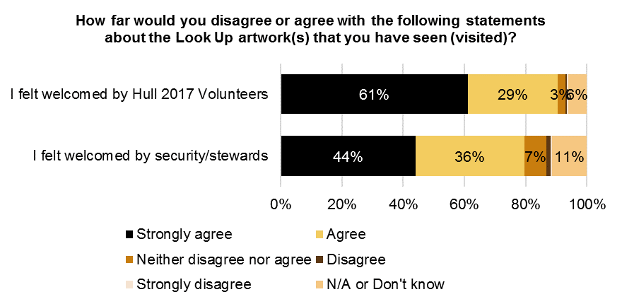
Base size: 2,220

There were significant differences in agreement that respondents felt welcomed by security and stewards by IMD. Respondents from the least deprived areas of Hull were less likely to agree that they felt welcomed by security and stewards.
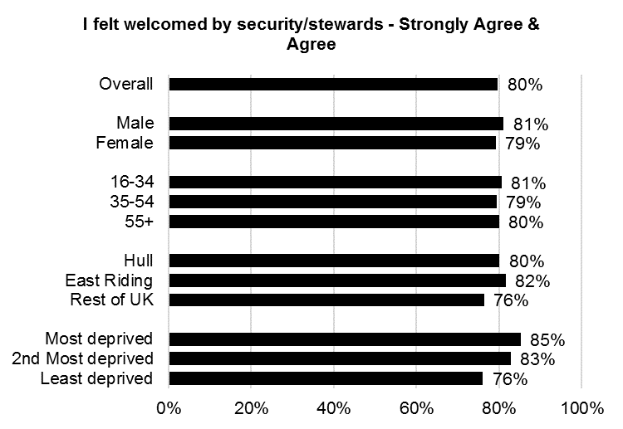
See Appendix B for Base Size
Significant differences by Hull IMD

The table below shows agreement with the statements by the survey completed. There were significant differences by survey completed.

How far would you disagree or agree with the following statements about the Look Up artwork(s) that you have seen (visited)? – Strongly agree & agree
 | Blade | The City Speaks | Washed Up Car-Go | The Train Track and the Basket | Paper City | Bleached | This is a Freedom of Expression Centre | Elephant in the Room | A Hall for Hull | Floe
I felt welcomed by security/stewards | 86% | 55% | 70% | 71% | 81% | 85% | 81% | 68% | 75% | 87%
I felt welcomed by Hull 2017 Volunteers | 92% | 75% | 96% | 89% | 97% | 95% | 95% | 88% | 90% | 92%

    - Experience of ‘Blade’
Seventy percent (70%) of respondents said that they were very likely to recommend a similar type of event to Blade to friends or relatives (a score of 9 or 10 on a 0-10 scale). Only 2% were very unlikely to recommend a similar type of event (a score of 0 or 1), and 29% gave a score of between 3 and 8. The mean score for recommendation was 8.96.
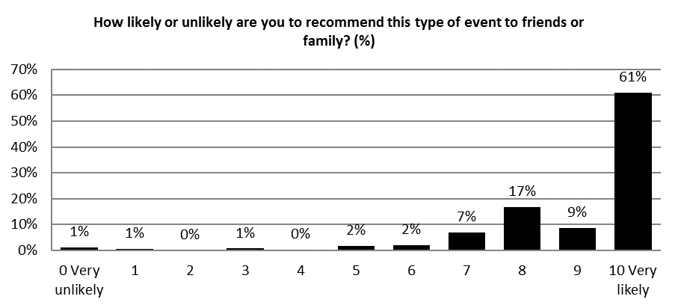
Base: 600

Over 80% of respondents strongly agreed (a score of 9 or 10) with the statements ‘it is important it’s happening here in Hull’ and ‘it was an interesting idea’. 70% or more strongly agreed (a score of 9 or 10) with the statements ‘I would come to something like this again’, ‘it was different from things I’ve experienced before’ and ‘It is well produced and presented’.
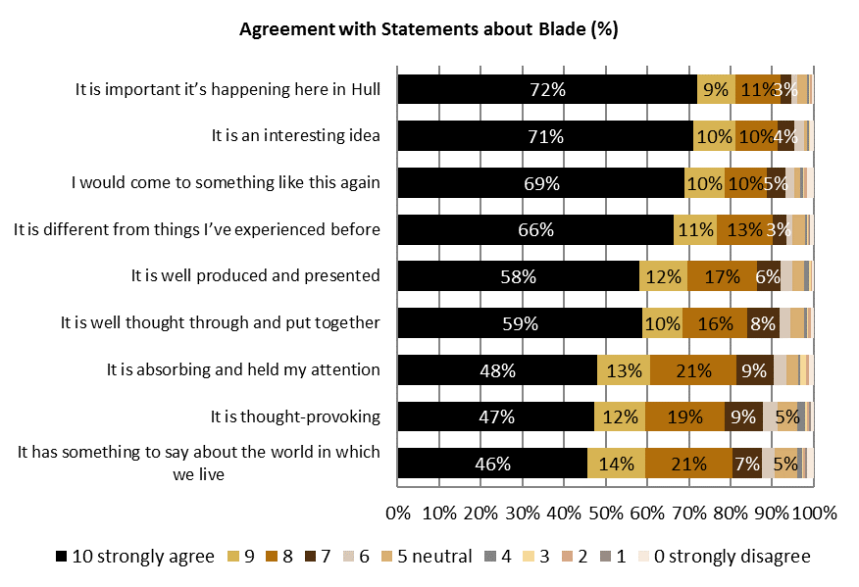
Base: 600

Agreement with the statements about Blade can also be presented as a mean score. The statements with the highest mean score were ‘it was an interesting idea’ and ‘it is important it’s happening here in Hull’ which both had a mean score of 9.31. The table below shows the mean score for each statement.
Agreement with statements about ‘Blade’ (Mean)
 | Mean
It was an interesting idea | 9.31
It was well produced and presented | 8.95
It was different from things I’ve experienced before | 9.14
It was thought-provoking | 8.55
It was absorbing and held my attention | 8.63
I would come to something like this again | 9.14
It is important it’s happening here in Hull | 9.31
It has something to say about the world in which we live | 8.51
It was well thought through and put together | 8.91

Over 90% of respondents strongly agreed or agreed with the statements ‘the Blade was an enjoyable experience’, ‘Blade showed the aspirations of the City now and in the future’ and ‘Blade provided me with a different experience of the city’. Over 80% of respondents strongly agreed or agreed with the statements ‘Blade gave everyone the chance to share and celebrate together’ and ‘Blade made me think about Hull’s contribution to the world’.
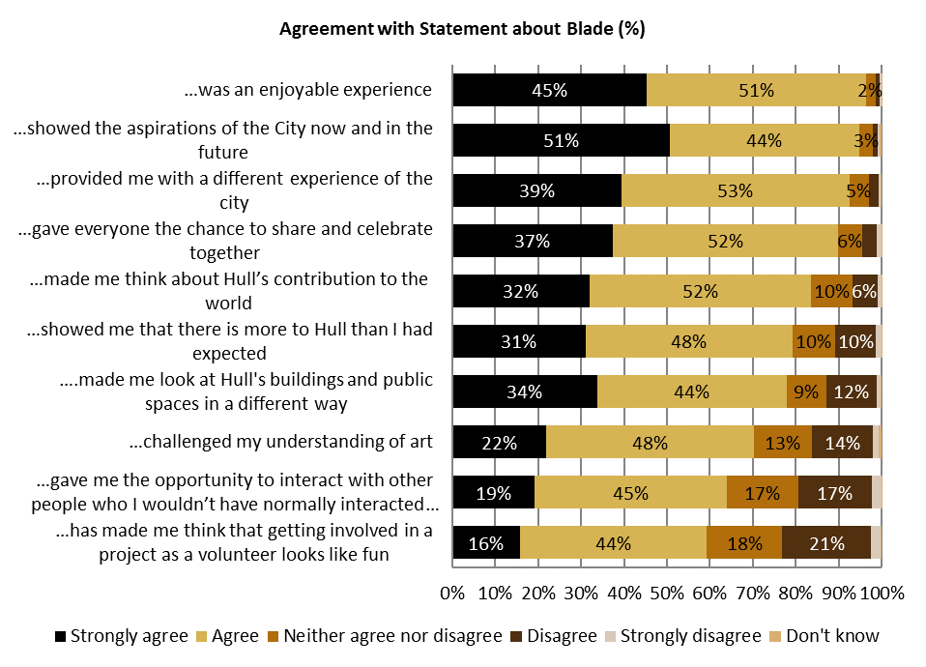
Base: 600

    - Experience of ‘The City Speaks’
Ninety percent (90%) of respondents to ‘The City Speaks’ audience survey had seen other peoples’ speech displayed on the tidal surge barrier, 51% had spoken into the lectern and 45% had seen their own speech displayed on the tidal surge barrier.
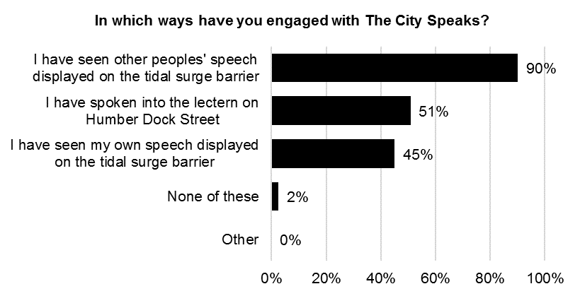
Base size: 122

Fifty-nine percent (59%) of respondents said that they were very likely to recommend something like ‘The City Speaks’ to friends or relatives (a score of 9 or 10 on a 0-10 scale). No respondents were very unlikely to recommend a similar type of event (a score of 0 or 1), and 41% gave a score of between 2 and 8. The mean score for recommendation was 8.66.
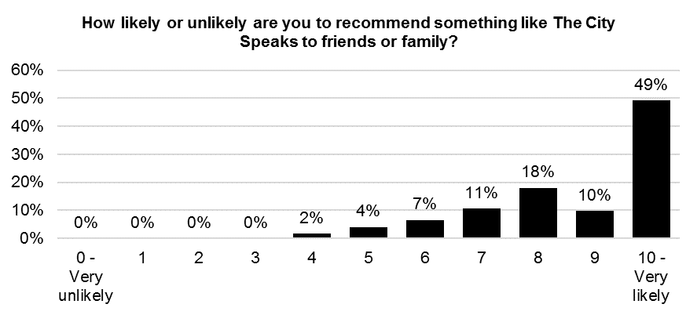
Base size: 122

Over 70% of respondents strongly agreed (a score of 9 or 10) with the statements ‘it is important it’s happening here in Hull’, ‘it was different from things I’ve experienced before’ and ‘it was an interesting idea’. At least half of respondents strongly agreed (a score of 9 or 10) with the statements ‘I would come to something like this again’, ‘it was well thought through and put together’ and ‘it is well produced and presented’.
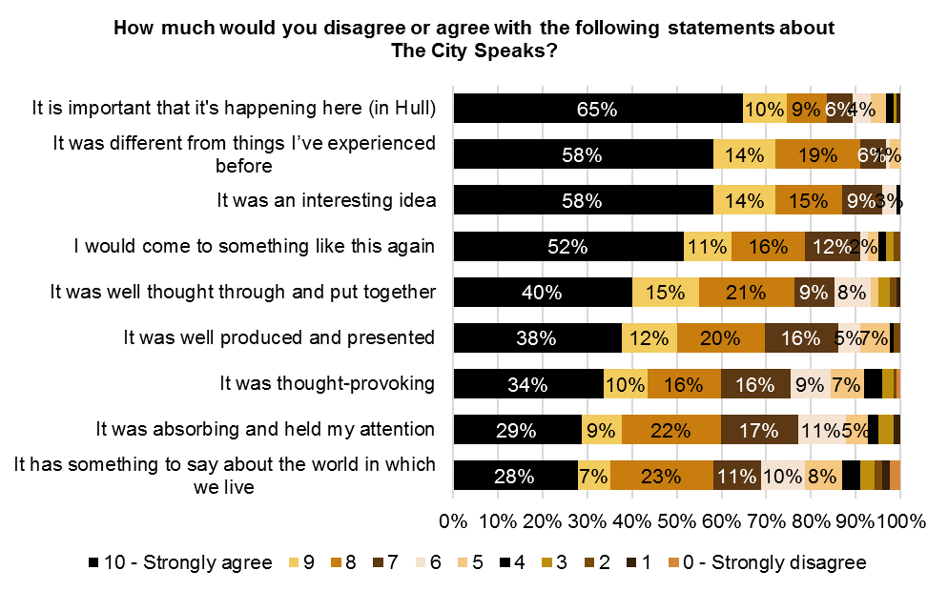
Base size: 122

Agreement with the statements about ‘The City Speaks’ can also be presented as a mean score. The table below shows the mean score for each statement.
How much would you disagree or agree with the following statements about The City Speaks? - Mean
 | Mean
It was an interesting idea | 9.11
It was well produced and presented | 8.29
It was different from things I’ve experienced before | 9.16
It was thought-provoking | 7.81
It was absorbing and held my attention | 7.75
I would come to something like this again | 8.66
It is important that it's happening here (in Hull) | 8.99
It has something to say about the world in which we live | 7.34
It was well thought through and put together | 8.37
Over 90% of respondents strongly agreed or agreed with the statements ‘The City Speaks was an enjoyable experience’ and ‘The City Speaks has introduced me to the work of Michael Pinsky for the first time’. Over 80% of respondents strongly agreed or agreed with the statements ‘The City Speaks provided me with a different experience of the city’ and ‘The City Speaks gave everyone the chance to share and celebrate together’.
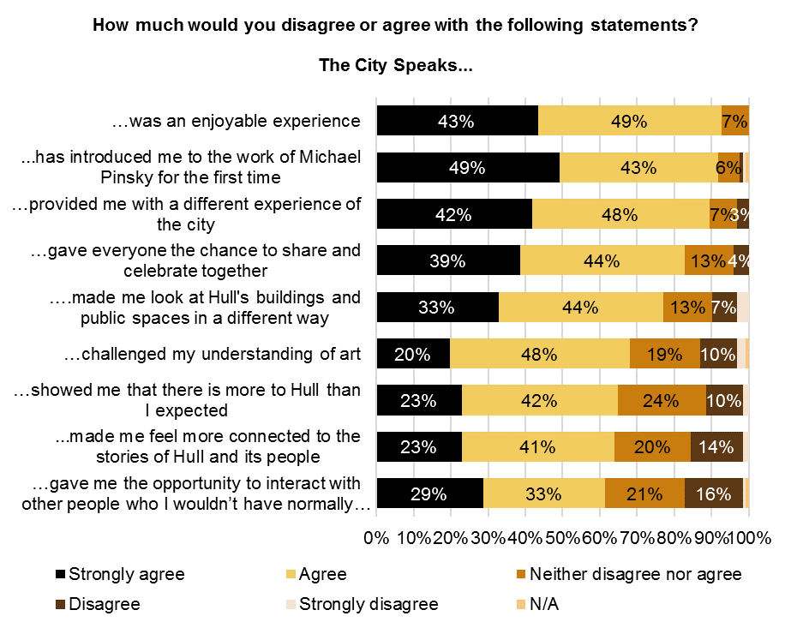
Base size: 122
    - Experience of ‘Washed up Car-go’
Just over half (51%) of respondent said that they were very likely to recommend something like ‘Washed up Car-go’ to friends or relatives (a score of 9 or 10 on a 0-10 scale). No respondents were very unlikely to recommend a similar type of event (a score of 0 or 1) and 49% gave a score of between 2 and 8. The mean score for recommendation was 7.99.

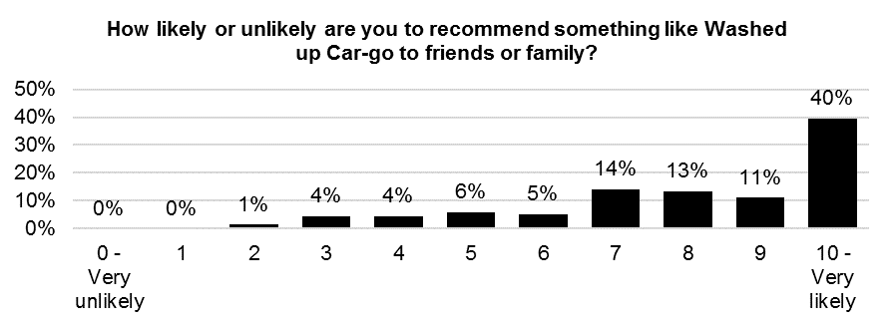
Base size: 134
Seventy percent (70%) of respondents strongly agreed (a score of 9 or 10) with the statements ‘it is important it’s happening here in Hull’ and 60% strongly agreed with the statement ‘it was different from things I’ve experienced before’.
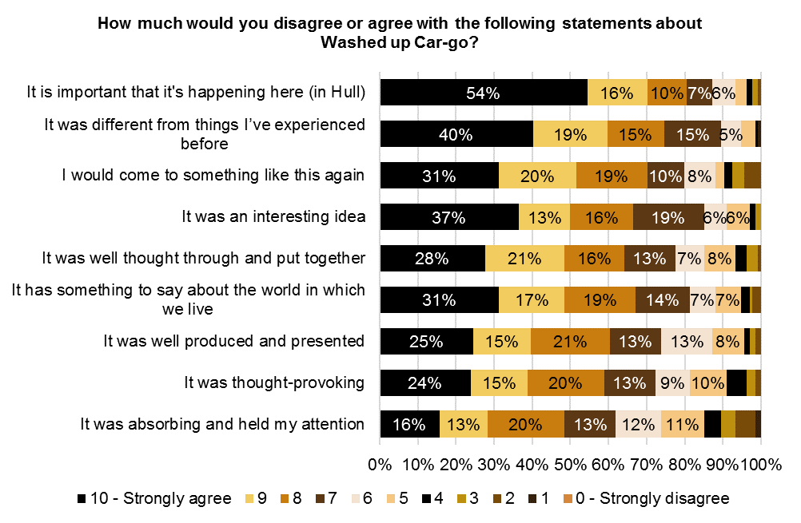
Base size: 134

Agreement with the statements about ‘Washed up Car-go’ can also be presented as a mean score. The table below shows the mean score for each statement.

How much would you disagree or agree with the following statements about Washed Up Car-go? - Mean
 | Mean
It was an interesting idea | 8.25
It was well produced and presented | 7.77
It was different from things I’ve experienced before | 8.55
It was thought-provoking | 7.61
It was absorbing and held my attention | 6.95
I would come to something like this again | 7.99
It is important that it's happening here (in Hull) | 8.79
It has something to say about the world in which we live | 8.06
It was well thought through and put together | 7.92

Ninety-three percent (93%) of respondents strongly agreed or agreed with the statement ‘Washed up Car-go has introduced me to the work of Chris Dobrowolski for the first time’ and 81% strongly agreed or agreed with the statement ‘Washed up Car-go was an enjoyable experience’.
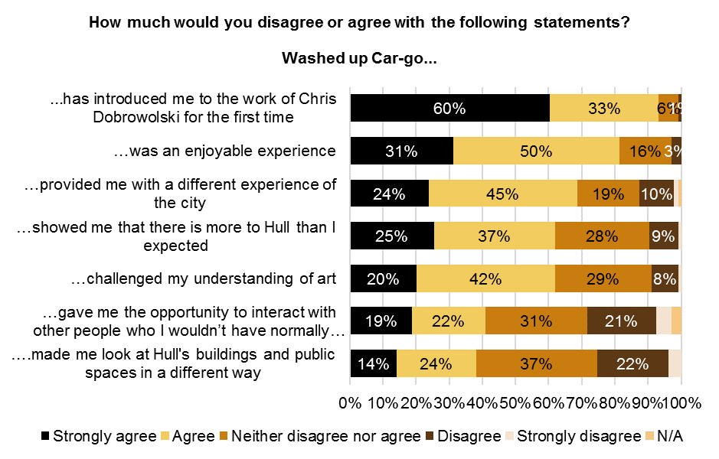
Base size: 134
    - Experience of ‘The Train Track and the Basket’
Thirty-six percent (36%) of respondent said that they were very likely to recommend something like ‘The Train Track and the Basket’ to friends or relatives (a score of 9 or 10 on a 0-10 scale). Only 2% of respondents were very unlikely to recommend a similar type of event (a score of 0 or 1), and 62% gave a score of between 2 and 8. The mean score for recommendation was 7.48.
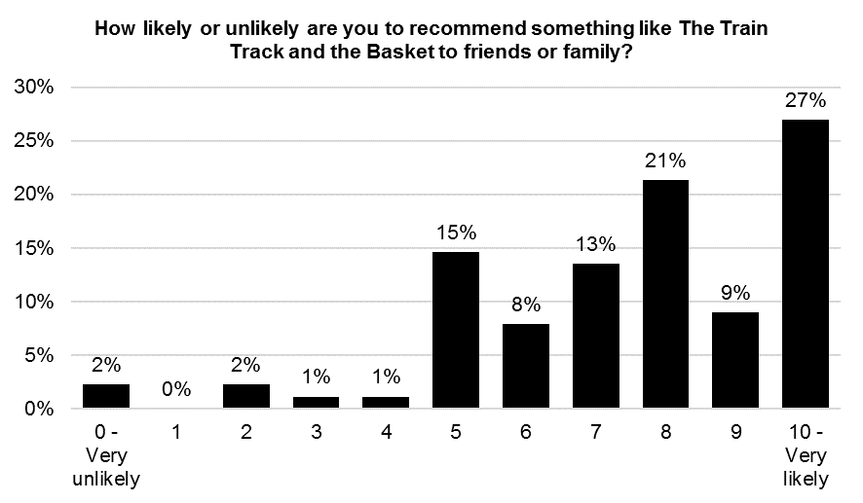
Base size: 89

Sixty-nine percent (69%) of respondents strongly agreed (a score of 9 or 10) with the statement ‘it is important it’s happening here in Hull’ and 57% strongly agreed with the statement ‘It was well produced and presented’.
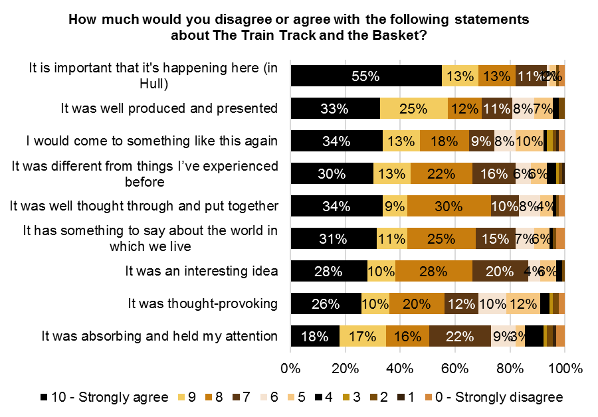
Base size: 89

Agreement with the statements about ‘The Train Track and the Basket’ can also be presented as a mean score. The table below shows the mean score for each statement.
How much would you disagree or agree with the following statements about The Train Track and The Basket? - Mean
 | Mean
It was an interesting idea | 8.04
It was well produced and presented | 8.20
It was different from things I’ve experienced before | 7.97
It was thought-provoking | 7.42
It was absorbing and held my attention | 7.21
I would come to something like this again | 7.78
It is important that it's happening here (in Hull) | 8.79
It has something to say about the world in which we live | 7.91
It was well thought through and put together | 8.08

Ninety-four percent (94%) of respondents strongly agreed or agreed with the statement ‘The Train Track and the Basket has introduced me to the work of Claire Barber for the first time’ and 88% strongly agreed or agreed with the statement ‘The Train Track and the Basket was an enjoyable experience’.
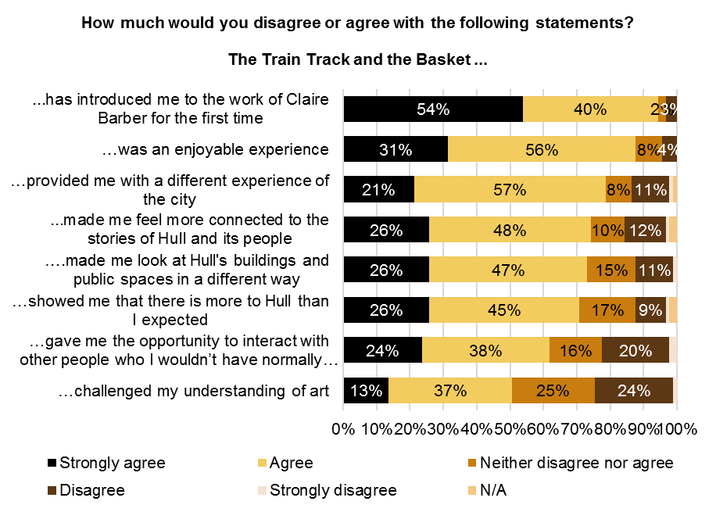
Base size: 89

Twenty-nine percent (29%) of respondents felt that they had learnt ‘a lot’ about transmigration through Hull between 1848 and 1914 (a score of 9 or 10). 9% of respondents felt that they had learnt ‘nothing at all’ about transmigration through Hull between 1848 and 1914 (a score of 0 or 1) and 62% gave a score of between 2 and 8. 20% of respondents felt that they had learnt ‘a lot’ about the history of Hull Paragon Interchange (a score of 9 or 10). 11% of respondents felt that they had learnt ‘nothing at all’ about the history of Hull Paragon Interchange (a score of 0 or 1) and 69% gave a score of between 2 and 8.
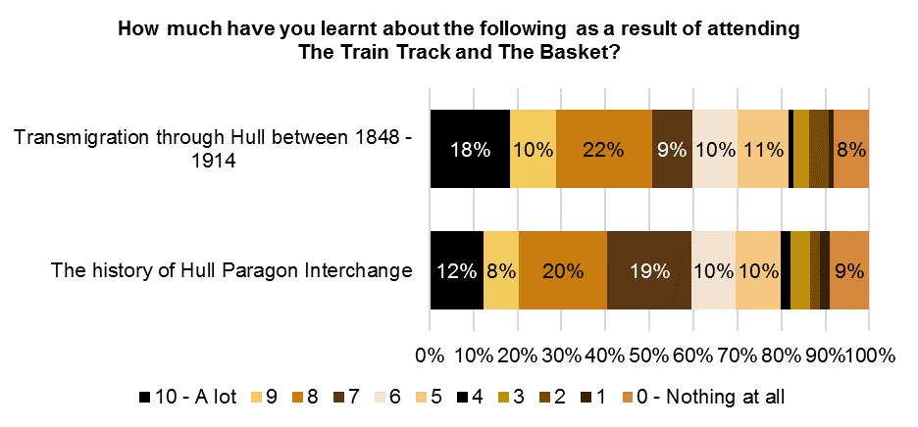
Base size: 89

How much respondents felt they had learnt about transmigration through Hull between 1848 and 1914 and the history of Hull Paragon Interchange can also be presented as a mean score. The table below shows the mean score for each topic.
How much have you learnt about the following as a result of attending The Train Track and The Basket? - Mean
 | Mean
The history of Hull Paragon Interchange | 6.30
Transmigration through Hull between 1848 - 1914 | 6.61

The vast majority of respondents (94%) strongly agreed or agreed with the statement ‘using art works to present the history and heritage of Hull makes the history and heritage more interesting’. 93% strongly agreed or agreed with the statement ‘using art works to present the history and heritage of Hull makes the history and heritage easier to understand’.
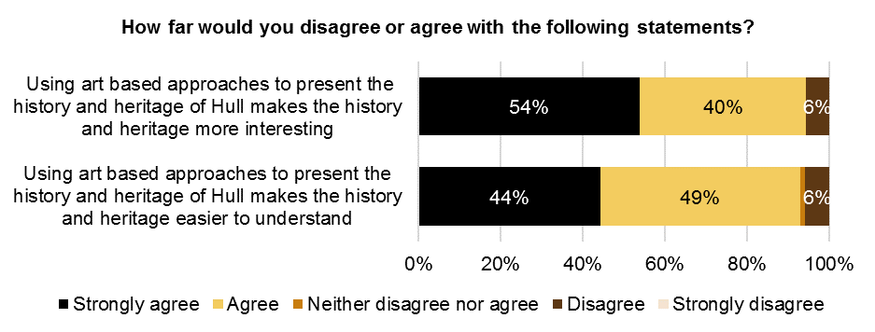
Base size: 89

Two-fifths (40%) of respondents had attended, or planned to attend, exhibitions about transmigration through Hull and 37% had attended, or planned to attend, events about transmigration through Hull. 22% of respondents had undertaken, or planned to undertake, their own research into Hull Paragon Interchange and 22% had undertaken, or planned to undertake, their own research into transmigration through Hull.
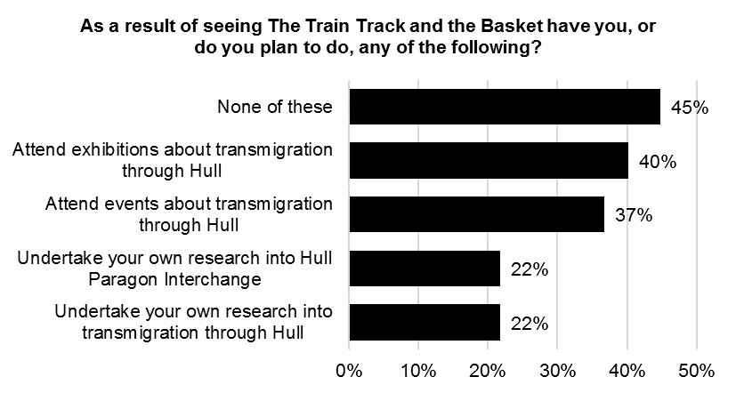
Base size: 89
    - Experience of ‘Paper City’
Sixty-eight percent (68%) of respondents said that they were very likely to recommend something like ‘Paper City’ to friends or relatives (a score of 9 or 10 on a 0-10 scale). Only 1% of respondents were very unlikely to recommend a similar type of event (a score of 0 or 1), and 32% gave a score of between 2 and 8. The mean score for recommendation was 8.90.
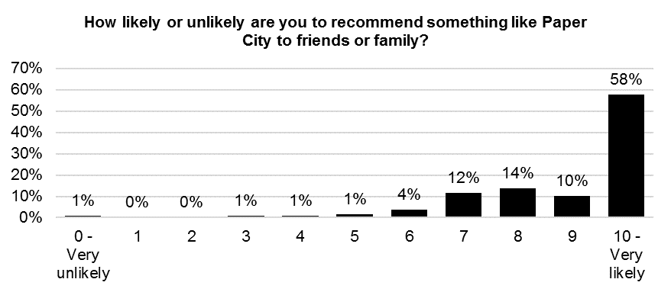
Base size: 139

Seventy-eight (78%) of respondents strongly agreed (a score of 9 or 10) with the statements ‘it is important it’s happening here in Hull’ and 69% strongly agreed (a score of 9 or 10) with the statement ‘I would come to something like this again’.
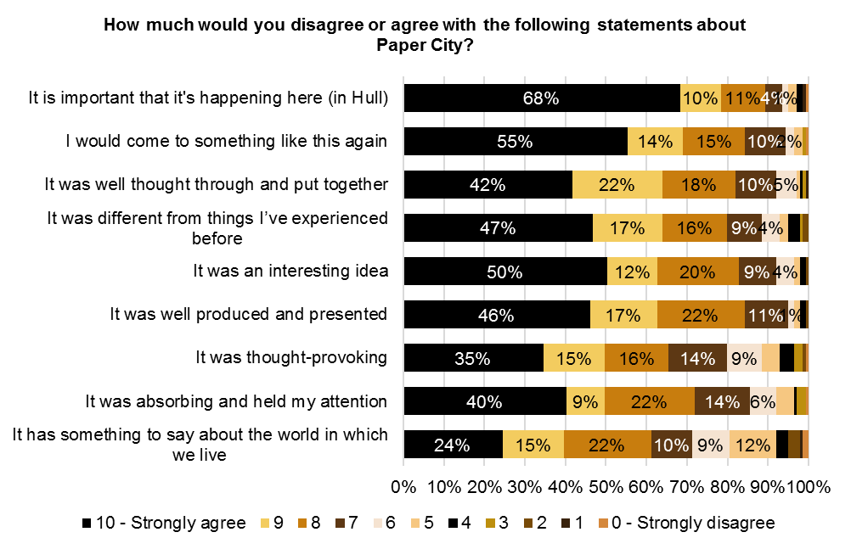
Base size: 139

Agreement with the statements about ‘Paper City’ can also be presented as a mean score. The table below shows the mean score for each statement.
How much would you disagree or agree with the following statements about Paper City? - Mean
 | Mean
It was an interesting idea | 8.81
It was well produced and presented | 8.81
It was different from things I’ve experienced before | 8.63
It was thought-provoking | 8.04
It was absorbing and held my attention | 8.31
I would come to something like this again | 8.94
It is important that it's happening here (in Hull) | 9.17
It has something to say about the world in which we live | 7.55
It was well thought through and put together | 8.72
Over 90% of respondents strongly agreed or agreed with the statements ‘Paper City was an enjoyable experience’ and ‘Paper City provided me with a different experience of the city’. 81% of respondents strongly agreed or agreed with the statement ‘Paper City made me look at Hull's buildings and public spaces in a different way.
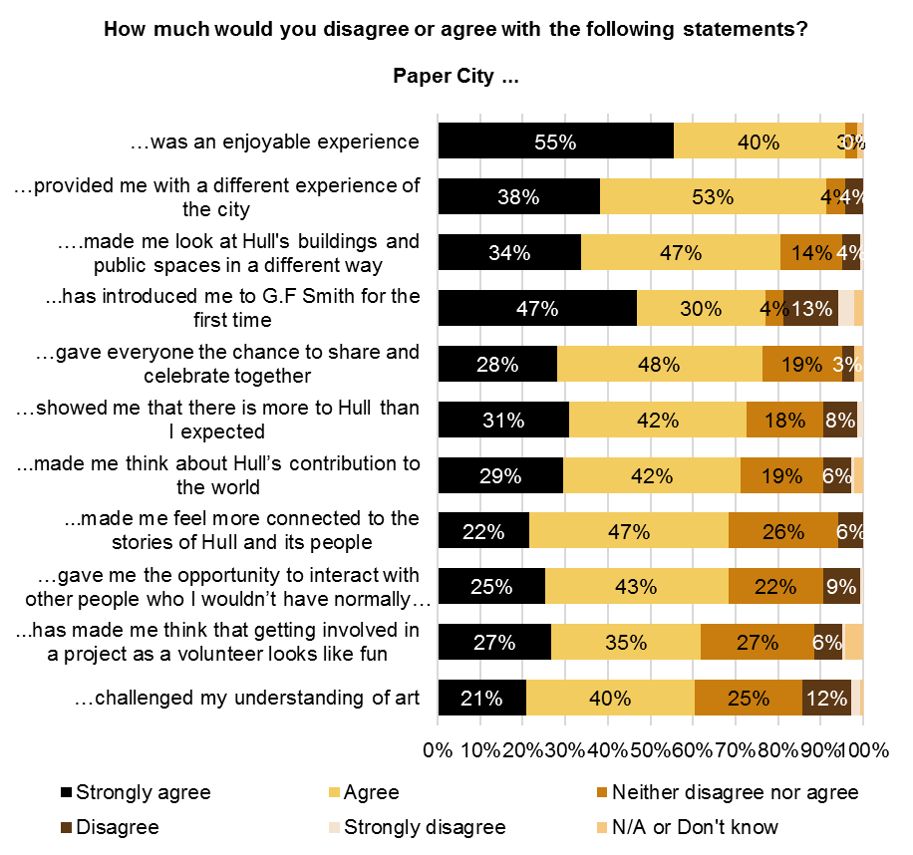
Base size: 139

    - Experience of ‘Bleached’
Fifty-two percent (52%) of respondents said that they were very likely to recommend something like ‘Bleached’ to friends or relatives (a score of 9 or 10 on a 0-10 scale). Only 1% of respondents were very unlikely to recommend a similar type of event (a score of 0 or 1), and 46% gave a score of between 2 and 8. The mean score for recommendation was 8.39.
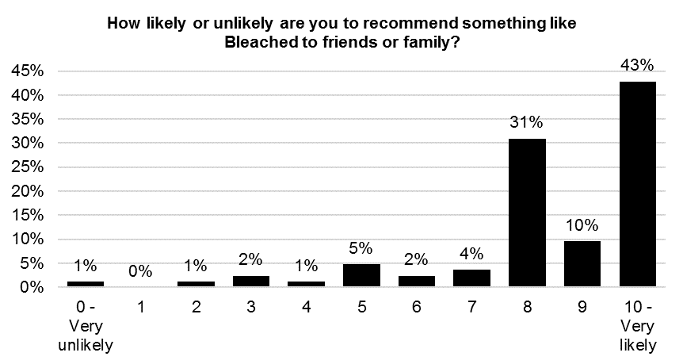
Base size: 84

Seventy-five (75%) of respondents strongly agreed (a score of 9 or 10) with the statement ‘it is important it’s happening here in Hull’ and 69% strongly agreed (a score of 9 or 10) with the statements ‘it has something to say about the world in which we live’.

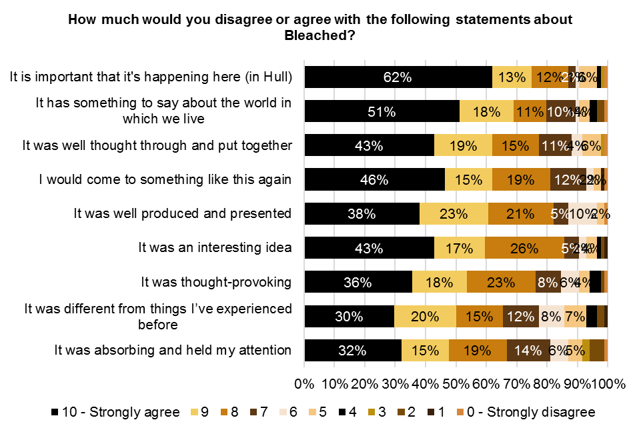
Base size: 84

Agreement with the statements about ‘Bleached’ can also be presented as a mean score. The table below shows the mean score for each statement.
How much would you disagree or agree with the following statements about Bleached? - Mean
 | Mean
It was an interesting idea | 8.62
It was well produced and presented | 8.58
It was different from things I’ve experienced before | 7.93
It was thought-provoking | 8.27
It was absorbing and held my attention | 7.89
I would come to something like this again | 8.67
It is important that it's happening here (in Hull) | 8.94
It has something to say about the world in which we live | 8.64
It was well thought through and put together | 8.54

Over 90% of respondents strongly agreed or agreed with the statements ‘Bleached has introduced me to the work of Tania Kovats for the first time’ and ‘Bleached was an enjoyable experience’.
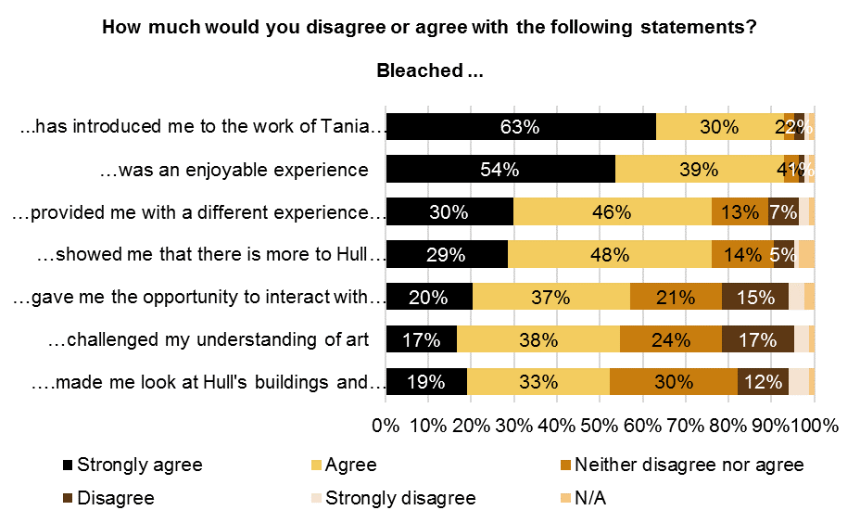

Base size: 84
    - Experience of ‘This is a Freedom of Expression Centre’
Sixty-three percent (63%) of respondents said that they were very likely to recommend something like ‘This is a Freedom of Expression Centre’ to friends or relatives (a score of 9 or 10 on a 0-10 scale). Only 2% of respondents were very unlikely to recommend a similar type of event (a score of 0 or 1) and 36% gave a score of between 2 and 8. The mean score for recommendation was 8.63.
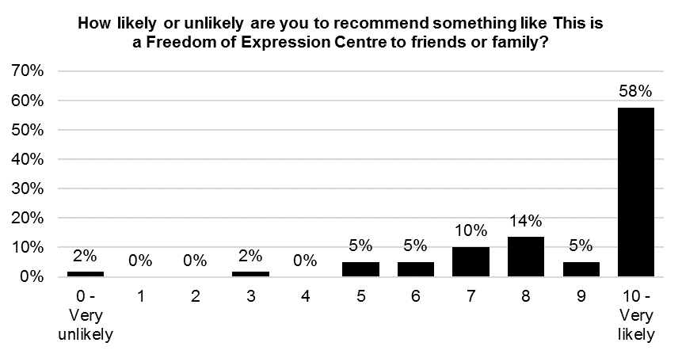
Base size: 59

Eighty-five percent (85%) of respondents strongly agreed (a score of 9 or 10) with the statements ‘it is important it’s happening here in Hull’. 70% or more strongly agreed (a score of 9 or 10) with the statements ‘I would come to something like this again’ and ‘it was an interesting idea’.
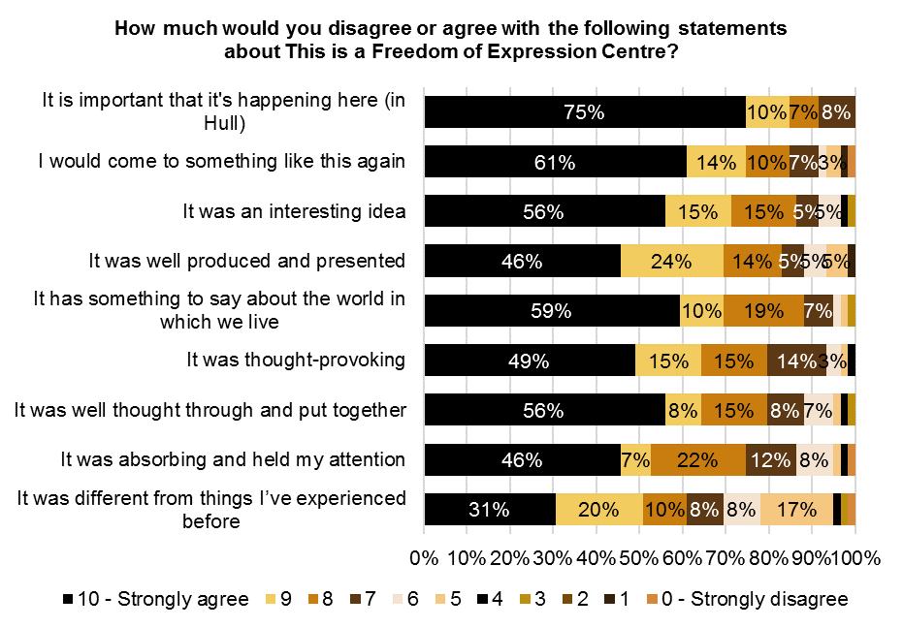
Base size: 59

Agreement with the statements about ‘This is a Freedom of Expression Centre’ can also be presented as a mean score. The table below shows the mean score for each statement.
How much would you disagree or agree with the following statements about This is a Freedom of Expression Centre? - Mean
 | Mean
It was an interesting idea | 8.97
It was well produced and presented | 8.73
It was different from things I’ve experienced before | 7.76
It was thought-provoking | 8.81
It was absorbing and held my attention | 8.44
I would come to something like this again | 8.90
It is important that it's happening here (in Hull) | 9.51
It has something to say about the world in which we live | 9.05
It was well thought through and put together | 8.78
Ninety-three percent (93%) of respondents strongly agreed or agreed with the statement ‘This is a Freedom of Expression Centre was an enjoyable experience’. Over 80% of respondents strongly agreed or agreed with the statements ‘This is a Freedom of Expression Centre provided me with a different experience of the city’ and ‘This is a Freedom of Expression Centre showed me that there is more to Hull than I expected’.
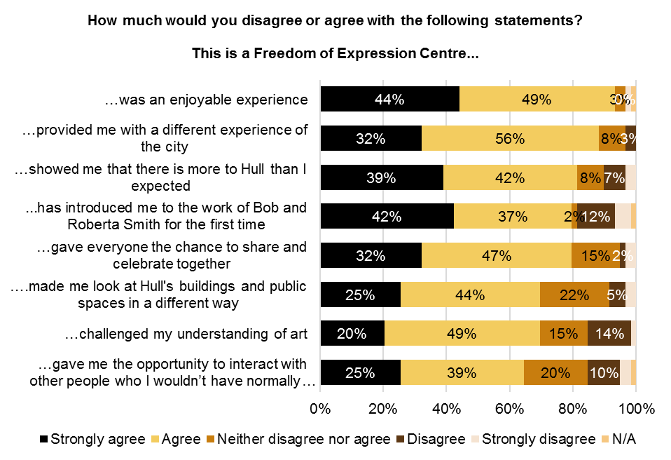
Base size: 59

    - Experience of ‘Elephant in the Room’
Forty percent (40%) of respondents said that they were very likely to recommend something like ‘Elephant in the Room’ to friends or relatives (a score of 9 or 10 on a 0-10 scale). 3% of respondents were very unlikely to recommend a similar type of event (a score of 0 or 1), and 58% gave a score of between 2 and 8. The mean score for recommendation was 7.66.
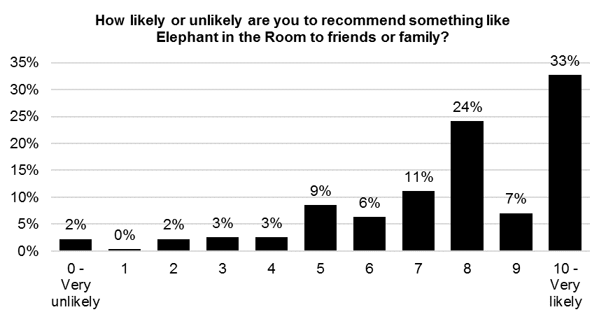
Base size: 296
Seventy percent (70%) of respondents strongly agreed (a score of 9 or 10) with the statement ‘it is important it’s happening here in Hull’.
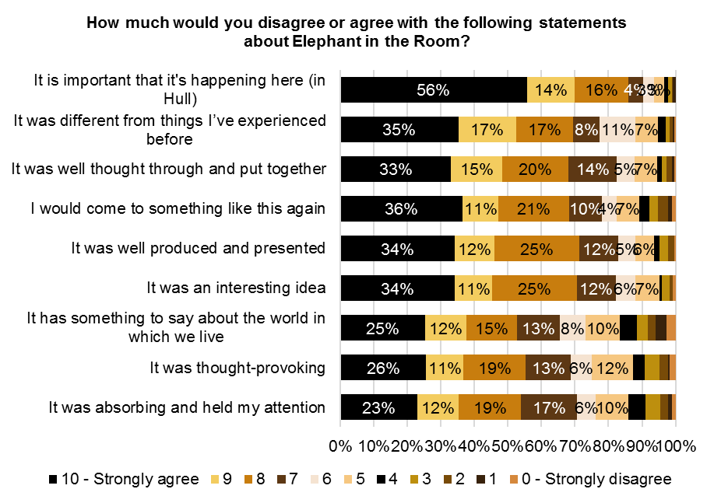
Base size: 296

Agreement with the statements about ‘Elephant in the Room’ can also be presented as a mean score. The table below shows the mean score for each statement.
How much would you disagree or agree with the following statements about Elephant in the Room? - Mean
 | Mean
It was an interesting idea | 8.08
It was well produced and presented | 8.09
It was different from things I’ve experienced before | 8.12
It was thought-provoking | 7.31
It was absorbing and held my attention | 7.28
I would come to something like this again | 7.86
It is important that it's happening here (in Hull) | 8.88
It has something to say about the world in which we live | 7.09
It was well thought through and put together | 8.06

Ninety-two percent (92%) of respondents strongly agreed or agreed with the statement ‘Elephant in the Room has introduced me to the work of Claire Morgan for the first time’ and 86% of respondents strongly agreed or agreed with the statement ‘Elephant in the Room was an enjoyable experience’.
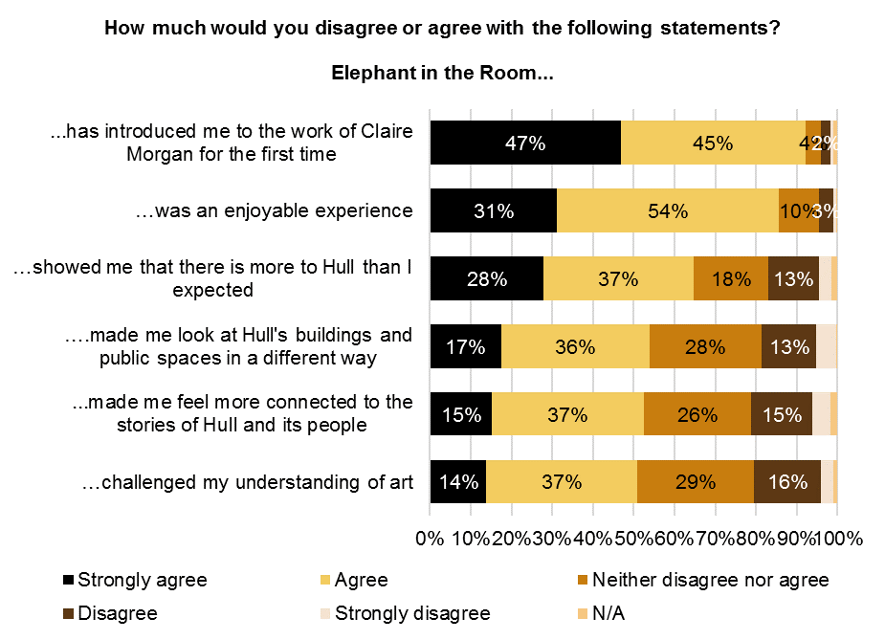
Base size: 296

Ten percent (10%) of respondents said that they had learnt a lot about Hull’s maritime history as a result of attending ‘Elephant in the Room’ (a score of 9 or 10 on a 0-10 scale). 18% of respondents said that they had learnt ‘nothing at all’ about Hull’s maritime history (a score of 0 or 1), and 71% gave a score of between 2 and 8. The mean score was 4.88.
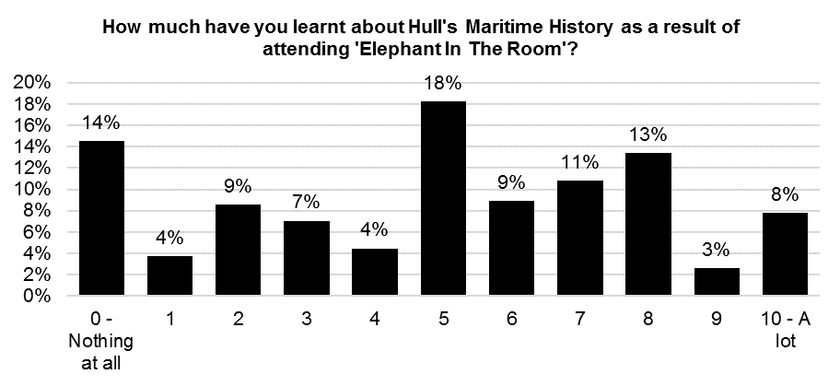
Base size: 296

The majority of respondents (91%) strongly agreed or agreed with the statement ‘using art based approaches to present the history and heritage of Hull makes the history and heritage more interesting’. 85% strongly agreed or agreed with the statement ‘using art based approaches to present the history and heritage of Hull makes the history and heritage easier to understand’.
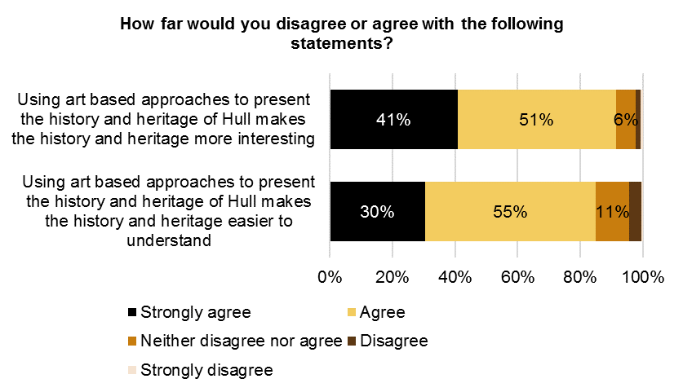
Base size: 296

Over three-fifths (62%) of respondents had visited, or planned to visit, the Hull Maritime Museum as a result of seeing ‘Elephant in the Room’. 46% had visited, or planned to visit, Hull History Centre. 42% had sought out, or planned to seek out, exhibitions or events about Hull’s maritime history. 19% had undertaken, or planned to undertake, their own research into Hull’s maritime history and 17% had undertaken, or planned to undertake, their own research into Hull’s whaling industry.
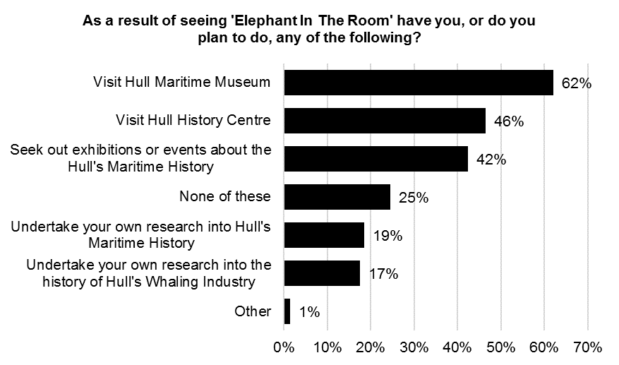
Base size: 296
    - Experience of ‘A Hall for Hull’
Fifty-seven percent (57%) of respondents said that they were very likely to recommend something like ‘A Hall for Hull’ to friends or relatives (a score of 9 or 10 on a 0-10 scale). 3% of respondents were very unlikely to recommend a similar type of event (a score of 0 or 1), and 41% gave a score of between 2 and 8. The mean score for recommendation was 8.40.
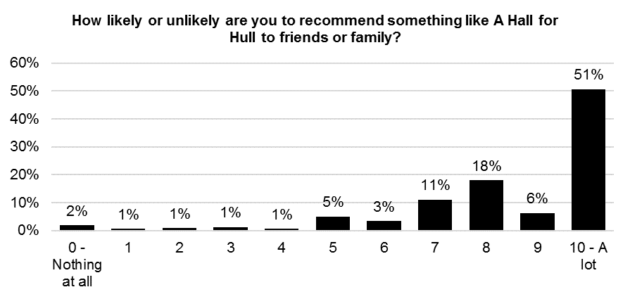
Base size: 316
Seventy-five percent (75%) of respondents strongly agreed (a score of 9 or 10) with the statement ‘it is important it’s happening here in Hull’ and 62% strongly agreed with the statement ‘I would come to something like this again’.
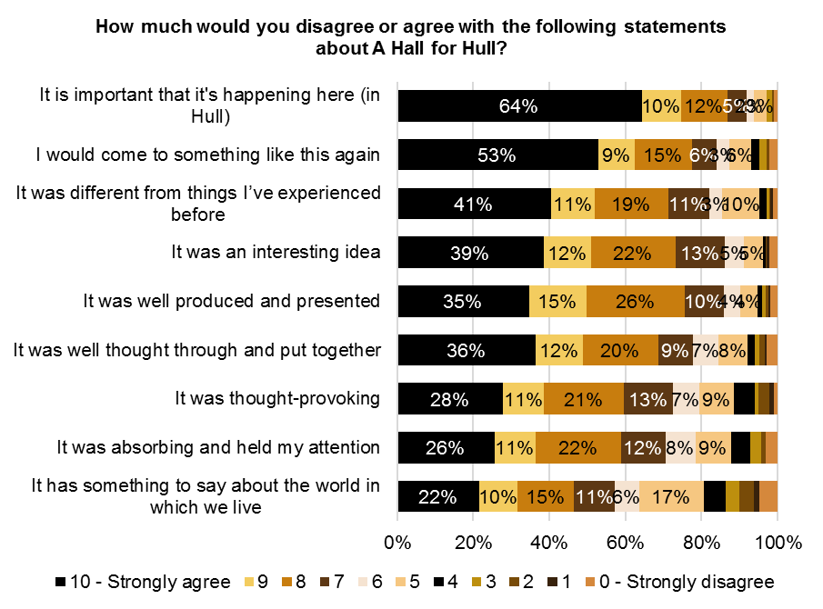
Base size: 316

Agreement with the statements about ‘A Hall for Hull’ can also be presented as a mean score. The table below shows the mean score for each statement.
How much would you disagree or agree with the following statements about A Hall for Hull? - Mean
 | Mean
It was an interesting idea | 8.25
It was well produced and presented | 8.19
It was different from things I’ve experienced before | 8.18
It was thought-provoking | 7.52
It was absorbing and held my attention | 7.40
I would come to something like this again | 8.45
It is important that it's happening here (in Hull) | 9.02
It has something to say about the world in which we live | 6.66
It was well thought through and put together | 7.91

Ninety percent (90%) of respondents strongly agreed or agreed with the statements ‘A Hall for Hull’ was an enjoyable experience’ and ‘A Hall for Hull has introduced me to the work of architects Pezo von Ellrichshausen for the first time’. Over 80% of respondents strongly agreed or agreed with the statements ‘A Hall for Hull has introduced me to the work of artist Felice Varini for the first time’ and ‘A Hall for Hull provided me with a different experience of the city’.

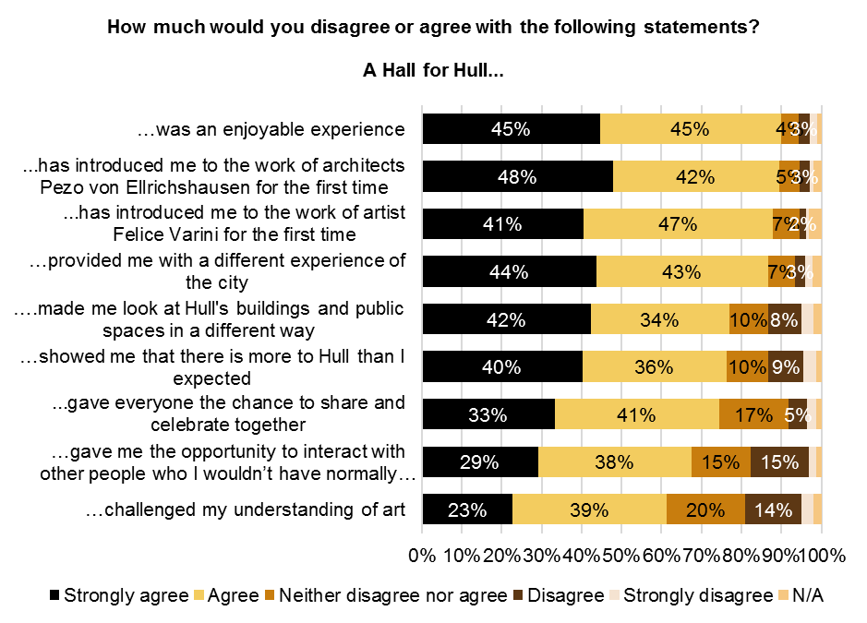
Base size: 316
    - Experience of ‘Floe’
Thirty-four percent (34%) of respondents had visited ‘Floe’ on Friday 8th December, 38% had visited on 9th December and 32% had visited on Sunday 10th December. 3% had visited ‘Floe’ on two nights and less than 1% had visited on three nights.
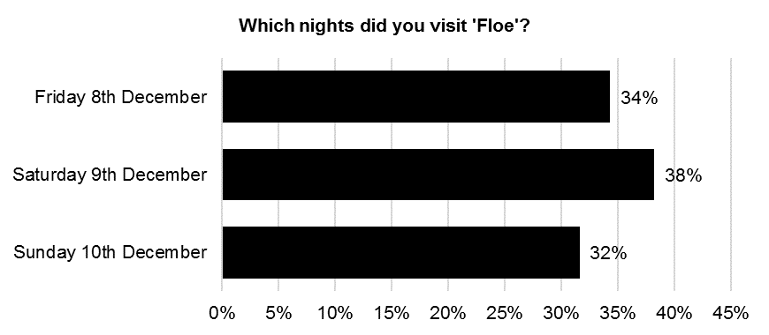
Base size: 408

Sixty-nine percent (69%) of respondents said that they were very likely to recommend something like ‘Floe’ to friends or relatives (a score of 9 or 10 on a 0-10 scale). Less than 1% of respondents were very unlikely to recommend a similar type of event (a score of 0 or 1), and 30% gave a score of between 2 and 8. The mean score for recommendation was 9.02.
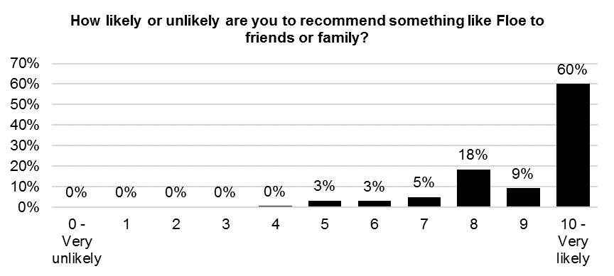
Base size: 408

Over 80% of respondents strongly agreed (a score of 9 or 10) with the statements ‘it is important it’s happening here in Hull’ and ‘I would come to something like this again’. 74% strongly agreed (a score of 9 or 10) with the statement ‘it was well produced and presented’.
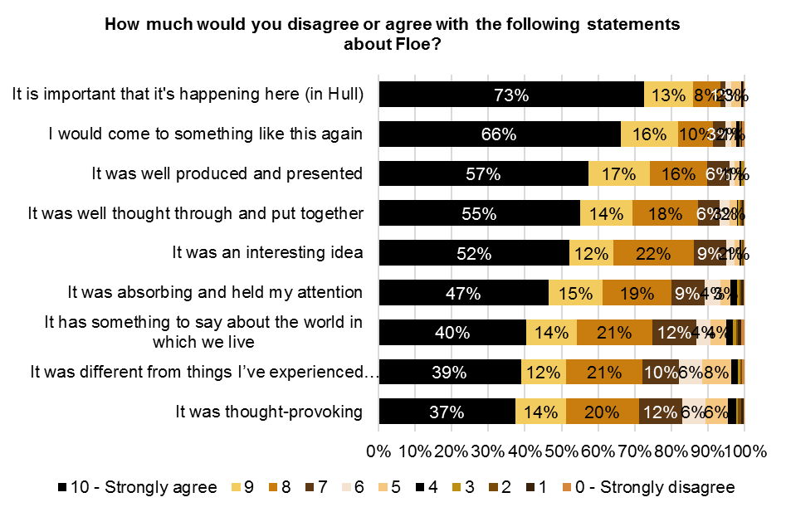
Base size: 408

Agreement with the statements about ‘Floe’ can also be presented as a mean score. The table below shows the mean score for each statement.
How much would you disagree or agree with the following statements about Floe? - Mean
 | Mean
It was an interesting idea | 8.91
It was well produced and presented | 9.11
It was different from things I’ve experienced before | 8.25
It was thought-provoking | 8.22
It was absorbing and held my attention | 8.61
I would come to something like this again | 9.24
It is important that it's happening here (in Hull) | 9.40
It has something to say about the world in which we live | 8.33
Over 90% of respondents strongly agreed or agreed with the statements ‘Floe was an enjoyable experience’ and ‘Floe has introduced me to the work of artists Anna Heinrich and Leon Palmer for the first time’. Over 80% of respondents strongly agreed or agreed with the statements ‘Floe provided me with a different experience of the city’ and ‘Floe gave everyone the chance to share and celebrate together’.
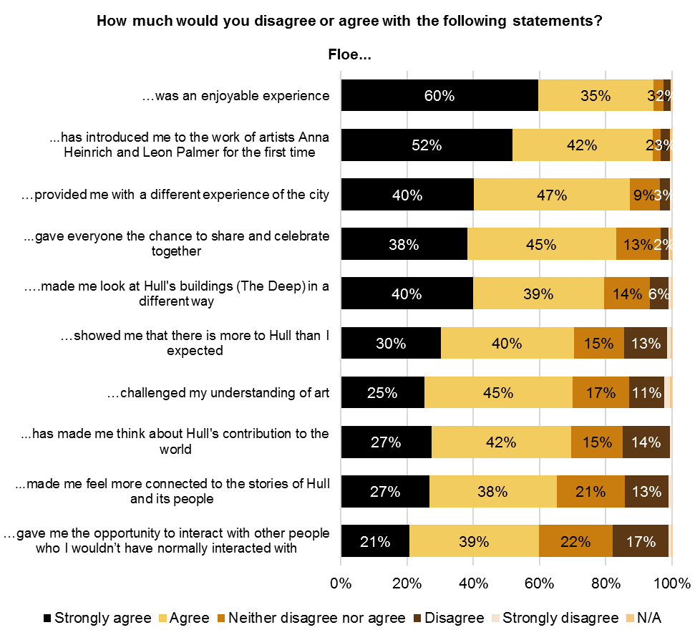
Base size: 408
    - Interpretation
Forty-three percent (43%) of respondents had seen the information boards (information boards, information in a nearby shop window or information leaflets for ‘Blade’) about the ‘Look Up’ artworks that they saw and a third (33%) had read the information boards (information boards, information in a nearby shop window or information leaflets for ‘Blade’).
There was a significant difference in the proportion of respondents who had seen the information boards about the ‘Look Up’ artworks that they saw by age and IMD. Older respondents and those from the least deprived areas were more likely to have seen the information boards.
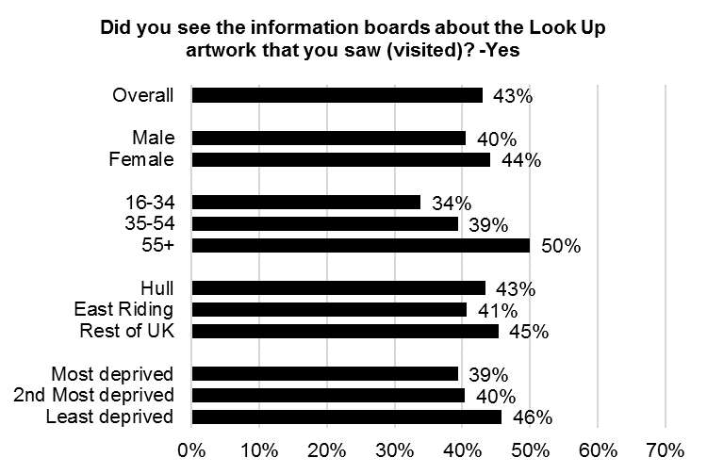
See Appendix B for Base Size
Significant differences by age

There was a significant difference in the proportion of respondents who had read the information boards about the ‘Look Up’ artworks that they saw by age and IMD. Younger respondents and respondents from the most deprived areas of Hull were less likely to have read the information boards.
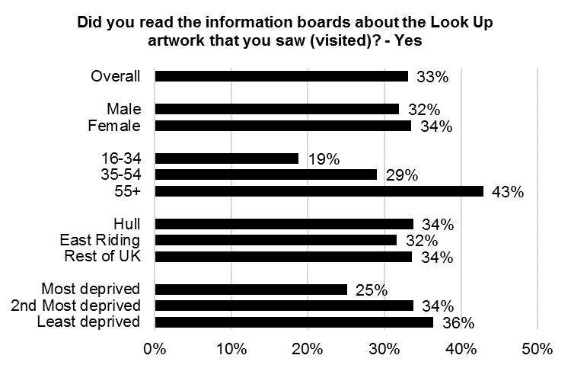
See Appendix B for Base Size
Significant differences by age and IMD

The table below shows the proportion of respondents who had seen and read the information boards about the ‘Look Up’ artwork that they saw the by the survey completed. There are significant differences in the proportion of respondents who saw the information board and read the by survey completed.
Did you see / did you read the information boards about the Look Up artwork that you saw (visited)?
 | Blade | The City Speaks | Washed Up Car-Go | The Train Track and the Basket | Paper City | Bleached | This is a Freedom of Expression Centre | Elephant in the Room | A Hall for Hull | Floe
Seen information boards | 31% | 46% | 63% | 67% | 76% | 88% | 73% | 64% | 60% | 31%
Read information boards | 21% | 39% | 61% | 54% | 63% | 87% | 75% | 54% | 47% | 21%

Of the respondents who had read the information boards about the ‘Look Up’ artworks that they saw, 89% strongly agreed or agreed that the information boards contained information they found interesting, 83% strongly agreed or agreed that the information boards helped them to understand the artwork better and 69% strongly agreed or agreed that the information boards made them think differently about the artwork.
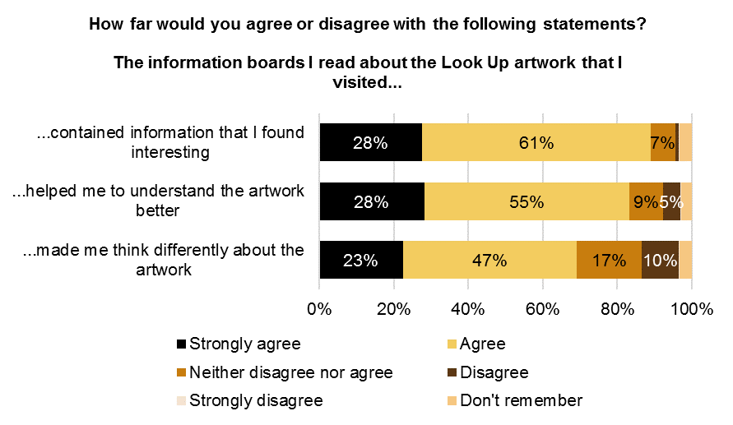
Base size: 761
‘Don’t remember’ was not an option on the ‘Blade’ audience survey

There was a significant difference in agreement with the statement ‘the information boards I read about the ‘Look Up’ artwork that I visited made me think differently about the artwork’ by age and IMD. Respondents aged 16-34 and respondents from the most deprived areas of Hull were more likely to agree with this statement.
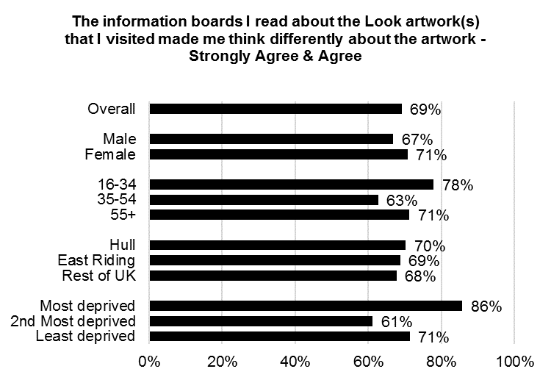
See Appendix B for Base Size
Significant differences by age and IMD

The table below shows agreement with the statements about the information boards by the survey completed. There are significant differences in agreement with all three statements by survey completed.
How far would you agree or disagree with the following statements? – Strongly agree & agree
 | Blade | The City Speaks | Washed Up Car-Go | The Train Track and the Basket | Paper City | Bleached | This is a Freedom of Expression Centre | Elephant in the Room | A Hall for Hull | Floe
The information boards I read about the Look artwork(s) that I visited contained information that I found interesting | 96% | 83% | 56% | 96% | 83% | 92% | 93% | 90% | 86% | 86%
The information boards I read about the Look artwork(s) that I visited helped me to understand the artwork better | 82% | 79% | 60% | 96% | 84% | 88% | 84% | 93% | 83% | 85%
The information boards I read about the Look artwork(s) that I visited made me think differently about the artwork | 67% | 74% | 49% | 77% | 72% | 75% | 73% | 75% | 71% | 67%
    - Marketing
Nearly a quarter (23%) of respondents had found out about the ‘Look Up’ artwork they saw from TV. This figure is largely influenced by the results for Blade where a high proportion had found out about the installation from the TV (see paragraph 2.82). 19% had found out from being told in person by a friend, family member or colleague, 15% had found out from Hull 2017 social media and 13% had found out from the Hull 2017 website. 17% had found out from ‘other’ sources. In the ‘other’ category, many respondents said they had found out about the ‘Look Up’ artwork they saw by coming across it while in the area or passing by.
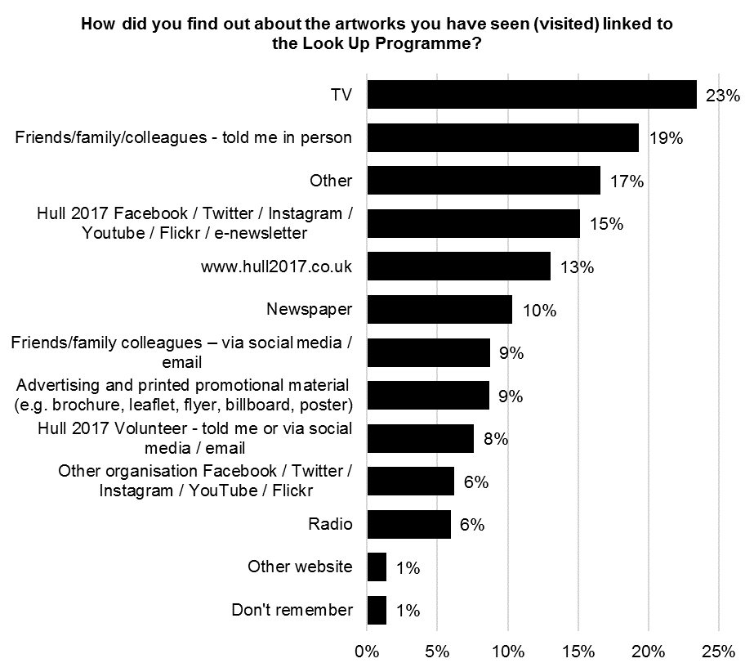
Base size: 2,220

There were significant differences by gender in how respondents had found out about the ‘Look Up’ artwork they saw. Women were more likely to have found out about the ‘Look Up’ artwork from Hull 2017 social media, from a Hull 2017 volunteer and from another organisation on social media. Men were more likely to have found out from ‘other’ sources.
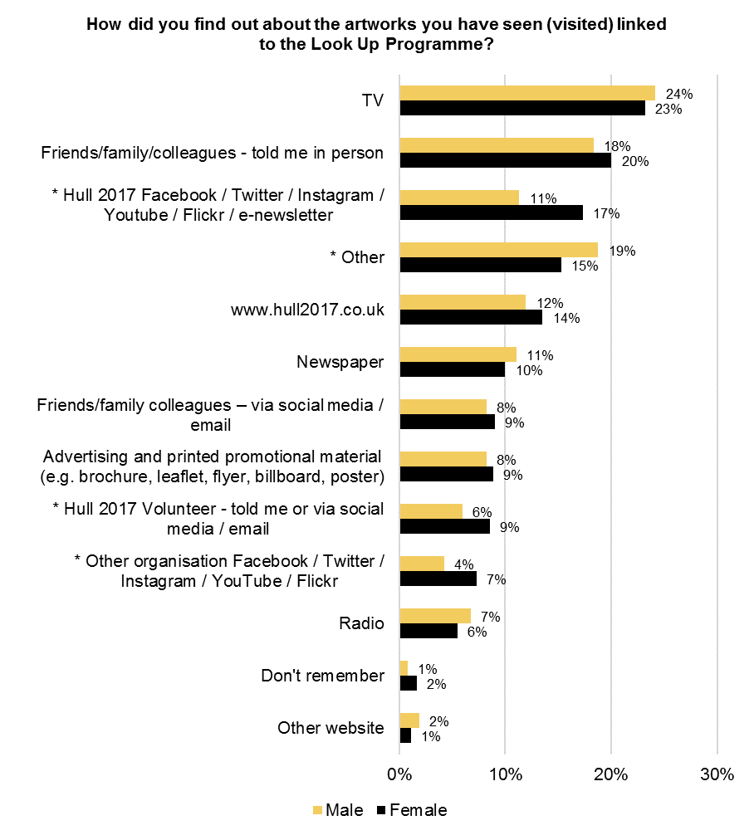
See Appendix B for Base Size
* = Significant differences by gender

There were significant differences by age in how respondents had found out about the ‘Look Up’ artwork they saw. Respondents aged 16-34 were more likely to have found out about the ‘Look Up’ artwork from being told in person by a friend, family member or colleague and from ‘other’ sources. Respondents aged 55 and over were more likely to have found out about the ‘Look Up’ artwork from TV, advertising and printed promotional material, being told by a Hull 2017 volunteer and radio. Respondents aged 35 and over were more likely to have found out about the ‘Look Up’ artwork from the Hull 2017 website. Respondents aged under 55 were more likely to have found out about the ‘Look Up’ artwork from social media from friends, family or colleagues. Respondents aged 35-54 and over were more likely to have found out about the ‘Look Up’ artwork from Hull 2017 social media and social media from other organisations.
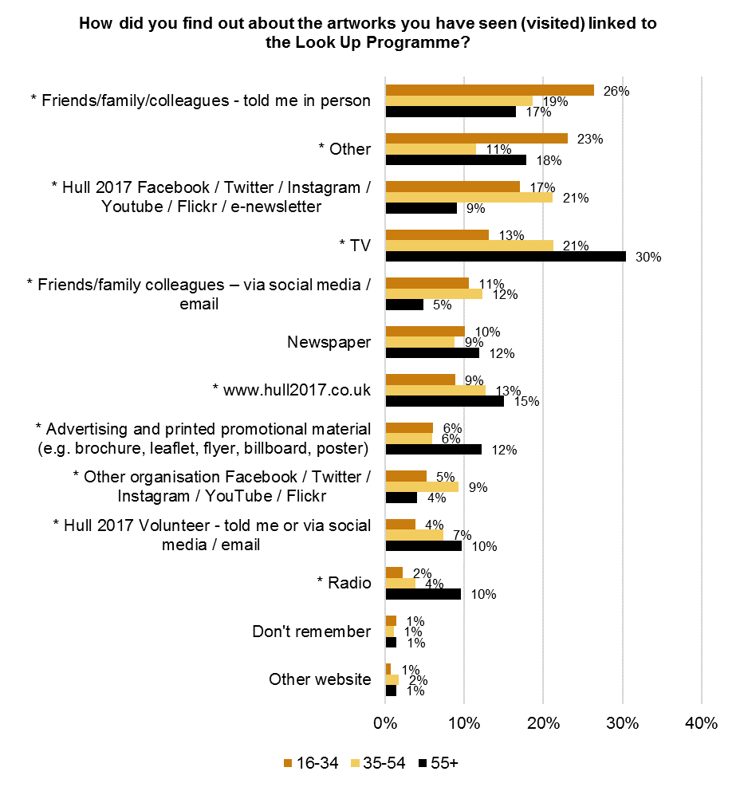
See Appendix B for Base Size
* = Significant differences by age
There were significant differences by area in how respondents had found out about the ‘Look Up’ artwork they saw. Respondents from East Riding were more likely to have found out about the ‘Look Up’ artwork from TV. Respondents from Hull and East Riding were more likely to have found out about the ‘Look Up’ artwork from Hull 2017 social media, newspapers, advertising and printed promotional materials, from other organisations social media and from radio. Respondents from outside of Hull and the East Riding were more likely to have found out about the ‘Look Up’ artwork from being told in person by friends, family or colleges or from ‘other’ sources.
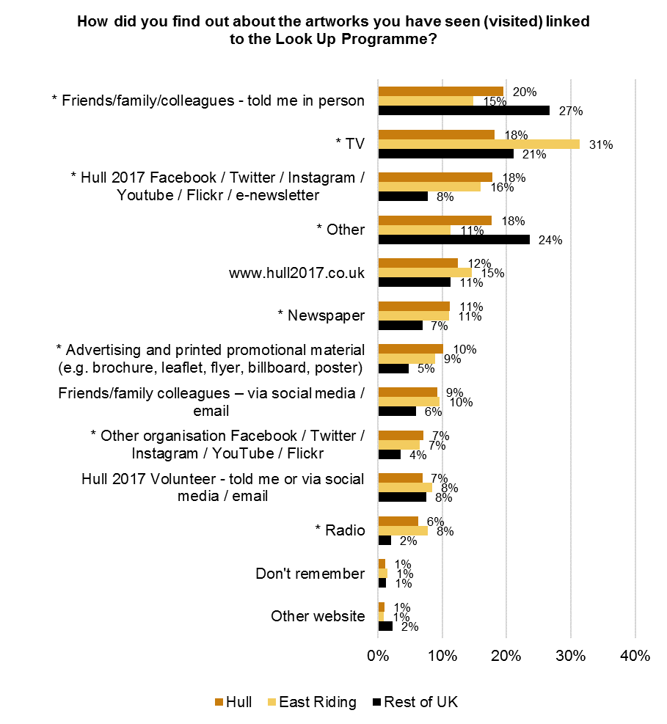
See Appendix B for Base Size
* = Significant differences by area

There were significant differences by Hull IMD in how respondents had found out about the ‘Look Up’ artwork they saw. Respondents from the least deprived areas of Hull were more likely to have found out about the ‘Look Up’ artwork from advertising and printed promotional material. Respondents from the second least deprived areas of Hull were more likely to have found out about the ‘Look Up’ artwork from other organisations social media. Respondents from the least and the second least deprived areas of Hull were more likely to have found out about the ‘Look Up’ artwork from the Hull 2017 website.
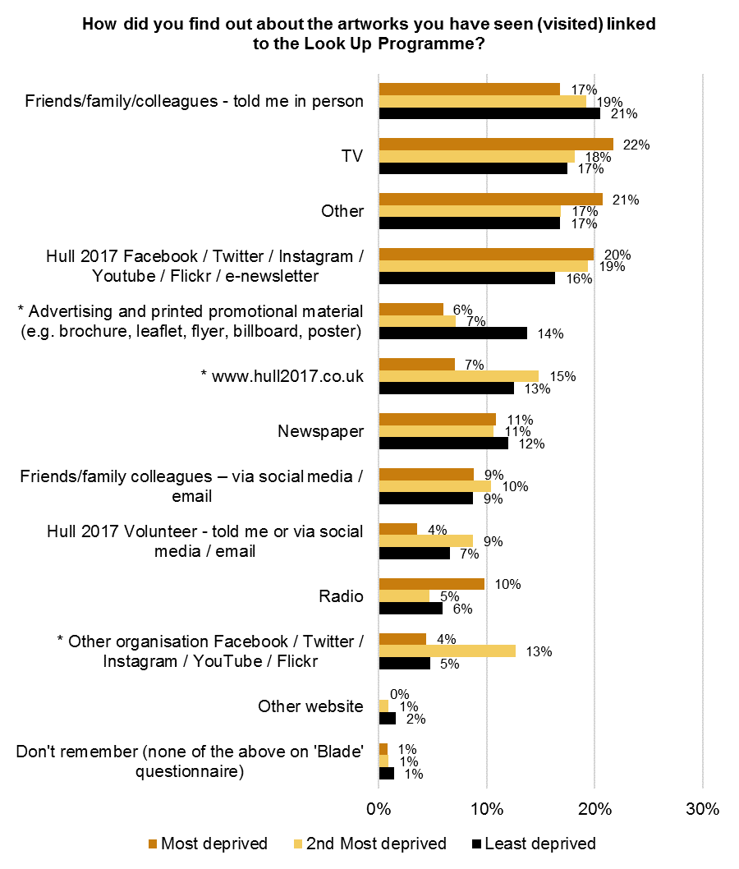c
See Appendix B for Base Size
* = Significant differences by Hull IMD
The table below shows how respondents found out about the ‘Look Up’ artworks they had seen by the survey completed. There were significant differences by survey completed.

How did you find out about the artworks you have seen (visited) linked to the Look Up Programme?
 | Blade | The City Speaks | Washed Up Car-Go | The Train Track and the Basket | Paper City | Bleached | This is a Freedom of Expression Centre | Elephant in the Room | A Hall for Hull | Floe
Friends/family/colleagues - told me in person | 20% | 28% | 17% | 10% | 27% | 15% | 17% | 11% | 26% | 25%
Friends/family colleagues – via social media / email | 11% | 10% | 5% | 3% | 6% | 1% | 8% | 2% | 3% | 6%
Hull 2017 Volunteer - told me or via social media / email | 0% | 25% | 33% | 19% | 20% | 25% | 20% | 16% | 7% | 11%
www.hull2017.co.uk | 5% | 40% | 59% | 9% | 37% | 27% | 39% | 14% | 19% | 29%
Other website | 2% | 1% | 1% | 0% | 0% | 1% | 0% | 0% | 1% | 1%
Hull 2017 Facebook / Twitter / Instagram / Youtube / Flickr / e-newsletter | 17% | 16% | 19% | 6% | 26% | 8% | 19% | 3% | 13% | 18%
Other organisation Facebook / Twitter / Instagram / YouTube / Flickr | 9% | 3% | 2% | 0% | 4% | 2% | 0% | 2% | 4% | 5%
Advertising and printed promotional material (e.g. brochure, leaflet, flyer, billboard, poster) | 3% | 23% | 22% | 13% | 26% | 30% | 25% | 17% | 8% | 9%
Newspaper | 13% | 7% | 4% | 2% | 5% | 0% | 3% | 5% | 9% | 11%
TV | 36% | 7% | 1% | 3% | 2% | 1% | 2% | 2% | 7% | 10%
Radio | 8% | 2% | 4% | 2% | 2% | 0% | 0% | 2% | 5% | 6%
Don't remember | 1% | 1% | 7% | 1% | 1% | 2% | 2% | 5% | 4% | 1%
Other | 9% | 11% | 4% | 51% | 11% | 24% | 20% | 44% | 29% | 4%

Eighty-five (85%) of respondents had been to, or planned to attend or take part in other events and activities programmed for Hull 2017. 7% had not been to, or did not plan to attend or take part in other events and activities programmed for Hull 2017 and 8% were unsure.
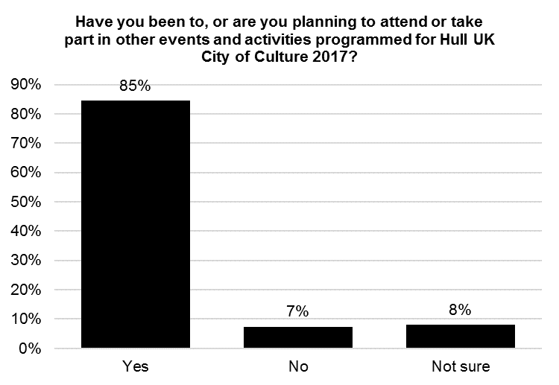
Base size: 2,220

There were significant differences in the proportion of respondents who had been to, or planned to attend or take part in other events and activities programmed for Hull 2017 by age and area. Respondents aged 35 to 54 were more likely to have been to, or have planned to attend or take part in other events and activities programmed for Hull 2017 and respondents from outside of Hull and East Riding were less likely to have been to, or have planned to attend or take part in other events and activities programmed for Hull 2017.
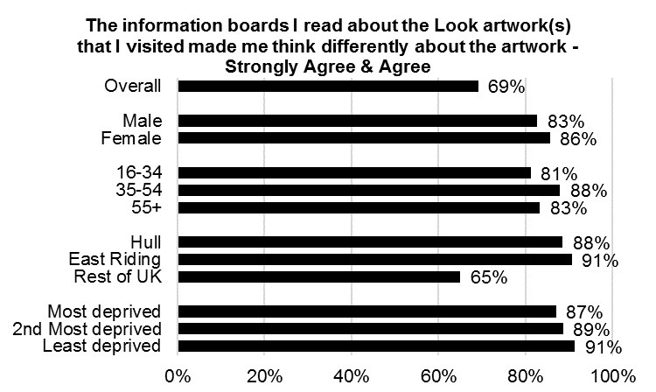
See Appendix B for Base Size
Significant differences by age and area

The table below shows whether respondents had been to, or were planning to attend or take part in other events and activities programmed for Hull UK City of Culture 2017 by the survey completed. There were significant differences by survey completed.

Have you been to, or are you planning to attend or take part in other events and activities programmed for Hull UK City of Culture 2017?
 | Blade | The City Speaks | Washed Up Car-Go | The Train Track and the Basket | Paper City | Bleached | This is a Freedom of Expression Centre | Elephant in the Room | A Hall for Hull | Floe
Yes | 87% | 89% | 99% | 72% | 93% | 83% | 90% | 77% | 72% | 80%
No | 5% | 5% | 1% | 17% | 4% | 10% | 5% | 13% | 19% | 11%
Not sure | 8% | 6% | 0% | 11% | 4% | 7% | 5% | 10% | 8% | 9%

The majority of respondents (89%) had purposely visited an artwork in a public building or place in the last 12 months.
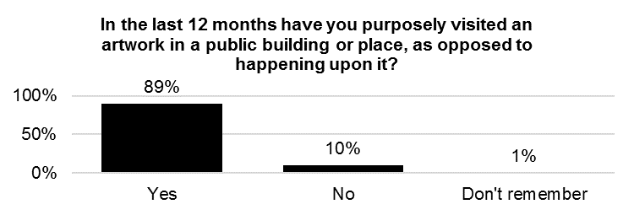

Base size: 1,620
Question not asked on ‘Blade’ audience survey

There were significant differences in the proportion of respondents who had purposely visited an artwork in a public building or place in the last 12 months by age, gender and IMD. Younger respondents, respondents from outside of Hull and the East Riding and respondents from the most deprived areas of Hull were less likely to have had purposely visited an artwork in a public building or place in the last 12 months.
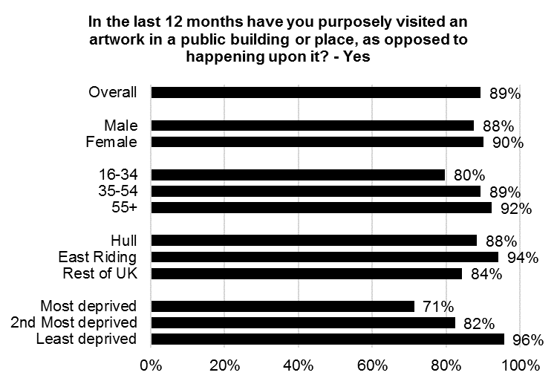
See Appendix B for Base Size
Significant differences by age, area and IMD

The table below shows whether respondents had purposely visited an artwork in a public building or place, as opposed to happening upon it, in the last 12 months by the survey completed. There were significant differences by survey completed.

In the last 12 months have you purposely visited an artwork in a public building or place, as opposed to happening upon it?
 | The City Speaks | Washed Up Car-Go | The Train Track and the Basket | Paper City | Bleached | This is a Freedom of Expression Centre | Elephant in the Room | A Hall for Hull | Floe
Yes | 96% | 99% | 84% | 94% | 90% | 100% | 85% | 86% | 92%
No | 4% | 1% | 15% | 6% | 10% | 0% | 15% | 14% | 7%
Don't remember | 0% | 0% | 1% | 1% | 0% | 0% | 0% | 1% | 0%

    - Visitors to Hull
Forty-five percent (45%) or respondents were from Hull and 55% were visitors to the city.
Of respondents who were visitors to Hull, 43% were in Hull on the day they saw the ‘Look Up’ artwork ‘mainly’ due to the artwork, 34% were in Hull ‘partly’ for the artwork and 22% were in Hull ‘not at all’ for the artwork.
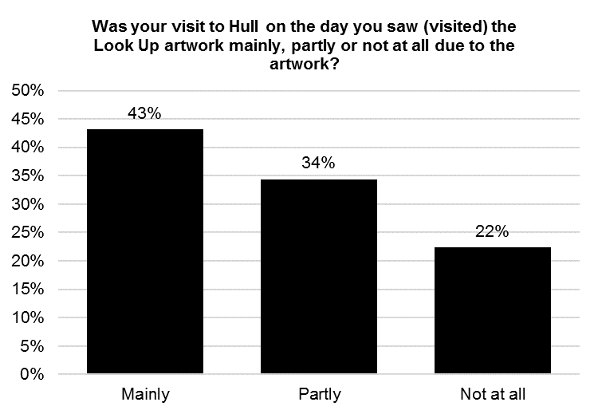
Base size: 1,127

There were significant differences in the proportion of visitors to Hull who were in Hull due to the ‘Look Up’ artworks by gender, age and area. Women, respondents aged 55 and over and those from East Riding were more likely to be in Hull ‘mainly’ due to the artwork.
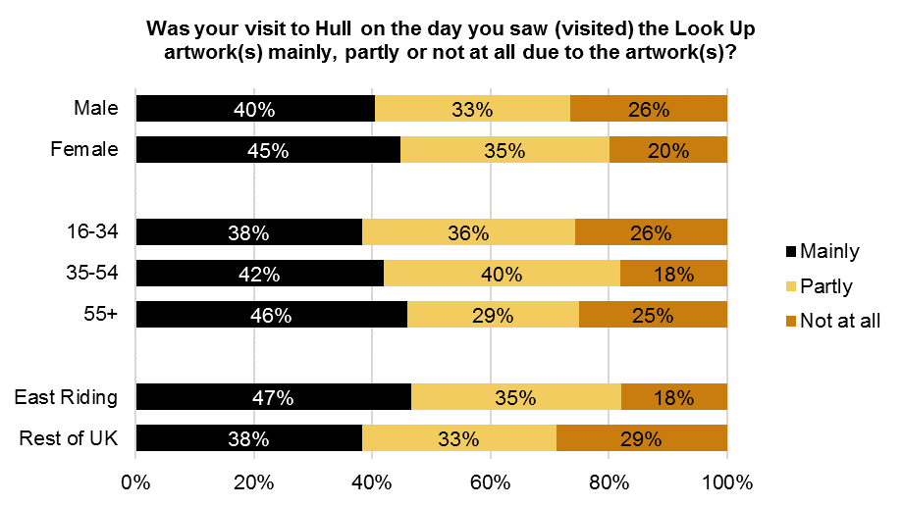
See Appendix B for Base Size
Significant differences by gender, age and area

The table below shows whether respondents’ visit to Hull on the day they saw the ‘Look Up’ artwork was due to the artwork by the survey completed. There were significant differences by survey completed.

Was your visit to Hull on the day you saw (visited) the Look Up artwork mainly, partly or not at all due to the artwork?
 | Blade | The City Speaks | Washed Up Car-Go | The Train Track and the Basket | Paper City | Bleached | This is a Freedom of Expression Centre | Elephant in the Room | A Hall for Hull | Floe
Mainly | 51% | 22% | 28% | 26% | 45% | 21% | 39% | 10% | 26% | 68%
Partly | 33% | 51% | 63% | 26% | 34% | 42% | 57% | 28% | 40% | 26%
Not at all | 16% | 27% | 9% | 47% | 21% | 37% | 4% | 63% | 33% | 6%

Of respondents who were visitors to Hull, 83% had taken part in other arts and cultural events or activities during their visit. 20% had taken part in one other arts and cultural event or activity, 36% had taken part in two or three arts and cultural events or activities and 27% had taken part in four or more arts and cultural events or activities.
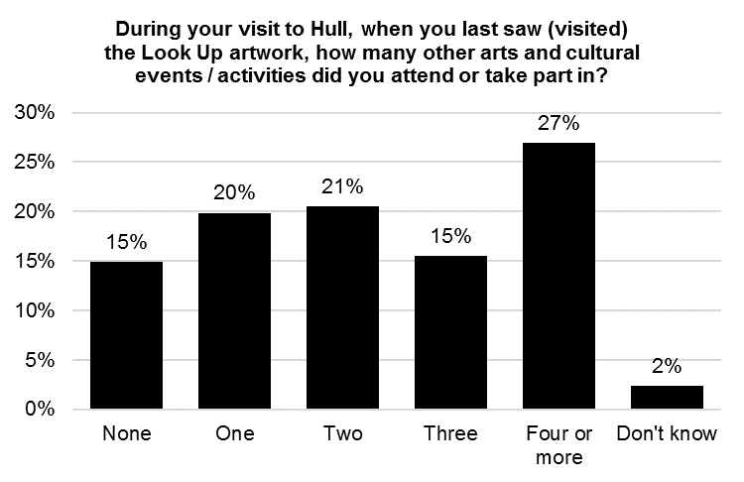
Base size: 622
Question not asked on ‘Blade’ audience survey

Twenty-nine percent (29%) of respondents were in Hull because just to see the artwork when they saw the ‘Look Up’ artwork. 20% were in Hull for general leisure purposes and 16% were in Hull because it was UK City of Culture 2017 when they saw the ‘Look Up’ artwork.
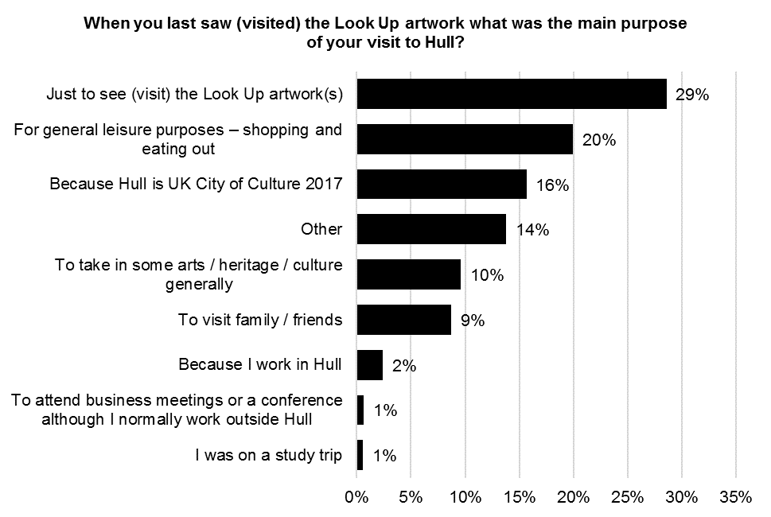
Base size: 1,127

There were significant differences in the main purpose of respondents’ visit to Hull when they saw the ‘Look up’ art work by age. Respondents aged 16 to 34 were more likely to be in Hull to take in some arts, heritage and culture generally, to visit family or friends or because they were on a study trip. Respondents aged 35 and over were more likely to be in Hull just to see the ‘Look Up’ artwork. Respondents aged 55 and over were more likely to be in Hull because Hull is UK City of Culture 2017. Respondents aged 16 to 54 were more likely to be in Hull because they work in Hull.
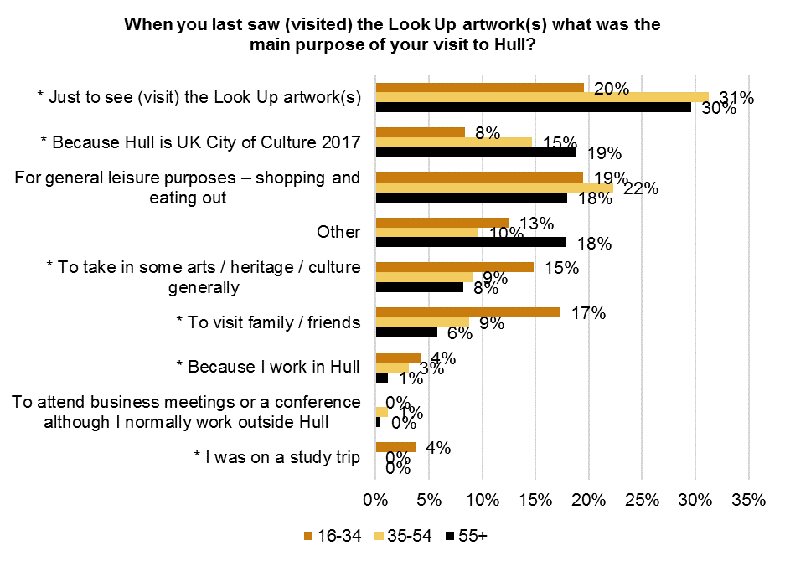
See Appendix B for Base Size
* = Significant differences by age
There were significant differences in the main purpose of respondents’ visit to Hull when they saw the ‘Look up’ art work by area. Respondents from the East Riding were more likely to be in Hull just to see the ‘Look Up’ artwork and for general leisure purposes. Respondents from outside of Hull and the East Riding were more likely to be in Hull to visit family and friends or to attend a business meeting or a conference.
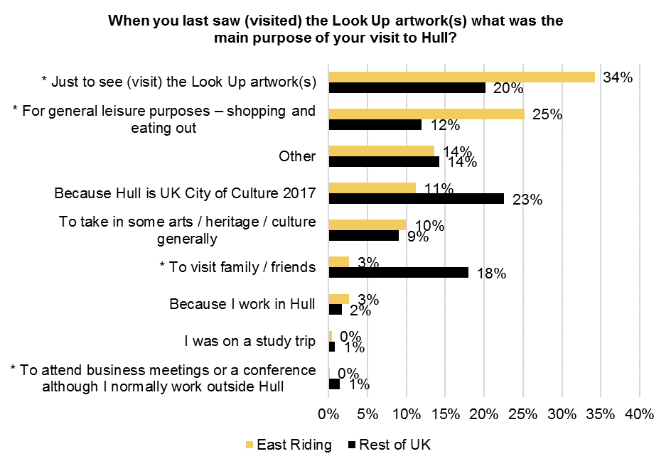
See Appendix B for Base Size
* = Significant differences by area

There were also significant differences in the main purpose of respondents’ visit to Hull when they saw the ‘Look up’ art work by gender. Men were more likely to be in Hull to attend a business meeting or a conference although they normally work outside of Hull and because they were on a study trip. 1.4% of men and less than 1% of women were in Hull to attend a business meeting or a conference although they normally work outside of Hull when they saw the ‘Look Up’ artwork. 1.5% of men and less than 1% of women were in Hull because they were on a study trip when they saw the ‘Look Up’ artwork.

The table below shows the main purpose of respondents’ visit to Hull on the day they saw the ‘Look Up’ artwork by the survey completed. There were significant differences by survey completed.

When you last saw (visited) the Look Up artwork(s) what was the main purpose of your visit to Hull?
 | Blade | The City Speaks | Washed Up Car-Go | The Train Track and the Basket | Paper City | Bleached | This is a Freedom of Expression Centre | Elephant in the Room | A Hall for Hull | Floe
Because Hull is UK City of Culture 2017 | 8% | 32% | 38% | 32% | 34% | 40% | 39% | 37% | 33% | 23%
To take in some arts / heritage / culture generally | 7% | 22% | 31% | 18% | 17% | 19% | 17% | 9% | 10% | 9%
To visit family / friends | 8% | 5% | 3% | 9% | 14% | 9% | 4% | 8% | 21% | 11%
To attend business meetings or a conference although I normally work outside Hull | 1% | 0% | 3% | 0% | 0% | 0% | 0% | 1% | 2% | 0%
I was on a study trip | 0% | 0% | 0% | 3% | 0% | 0% | 0% | 0% | 0% | 0%
For general leisure purposes – shopping and eating out | 21% | 19% | 6% | 18% | 7% | 12% | 13% | 30% | 13% | 6%
Because I work in Hull | 3% | 5% | 0% | 0% | 0% | 2% | 0% | 0% | 2% | 1%
Just to see (visit) the Look Up artwork(s) | 37% | 8% | 16% | 9% | 10% | 2% | 13% | 2% | 6% | 42%
Other | 15% | 8% | 3% | 12% | 17% | 16% | 13% | 12% | 13% | 7%

The majority of visitors to Hull (93%) had been to Hull prior to the visit when they saw the ‘Look Up’ artwork. 7% were visiting Hull for the first time when they saw the ‘Look Up’ artwork. Respondents from outside of Hull and the East Riding were significantly more likely to be first time visitors to Hull when they saw the ‘Look Up’ artwork, with 1% of respondents from East Riding and 15% of respondents from the rest of the UK visiting Hull for the first time.
    - Frequency of visit to Hull
Of the visitors to Hull who had been to Hull prior to the visit when they saw the ‘Look Up’ artwork, 12% visited Hull less frequently than once a year, 29% visit between one and six times a year and 59% visit more frequently than six times a year.
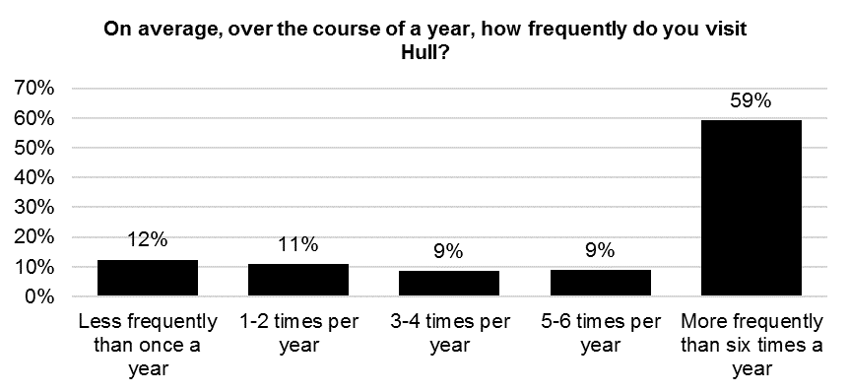
Base size: 546
Question not asked on ‘Blade’ audience survey

Of the visitors to Hull who had been to Hull prior to the visit when they saw the ‘Look Up’ artwork, 47% thought that the frequency of their visits to Hull over the course of a year would increase based on their experience during their visit when they saw the ‘Look Up’ artwork and 51% thought that the frequency of their visits to Hull over the course of a year would stay the same. Only 1% thought that the frequency of their visits to Hull over the course of a year would decrease.
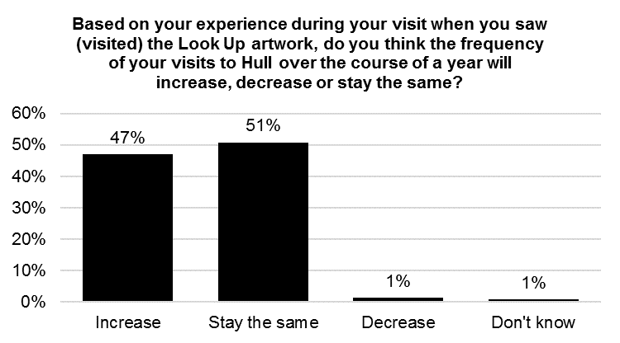
Base size: 546
Question not asked on ‘Blade’ audience survey

    - Intentions to return
Of the visitors to Hull who were visiting Hull for the first time when they saw the ‘Look Up’ artwork, 89% strongly agreed or agreed that they will visit Hull again in the future. Only 4% strongly disagreed or disagreed that they will visit Hull again in the future.
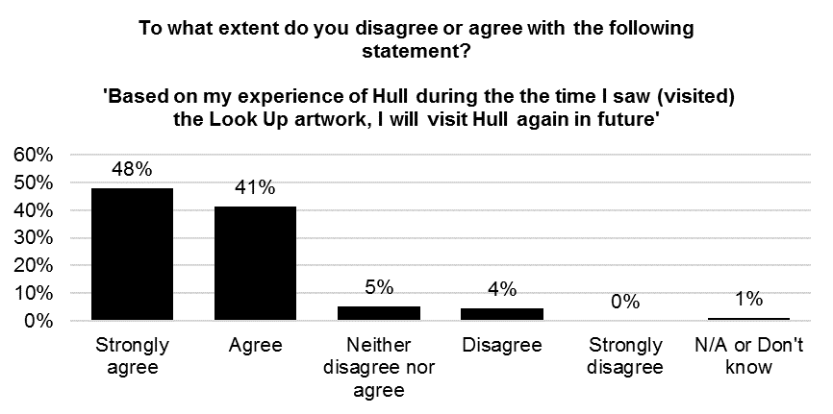
Base size: 75
Question not asked on ‘Blade’ audience survey
    - Visitor Satisfaction
Respondents from outside of Hull were asked to rate how satisfied they were with various aspects of Hull as a visitor. Hull was rated highly on overall visitor welcome and value for money with 85% of respondents satisfied with the general visitor welcome and 83% satisfied with overall value for money (a score of 4 or 5 out of 5). 73% of respondents were satisfied with the places to eat and drink and 63% were satisfied with city centre signposting. A high proportion of respondents answered ‘not-applicable’ when asked to rate public transport and accommodation. Of the respondents who thought public transport and accommodation were applicable to them, 86% were satisfied with the quality of accommodation and 80% were satisfied with public transport – see analysis in following paragraph.
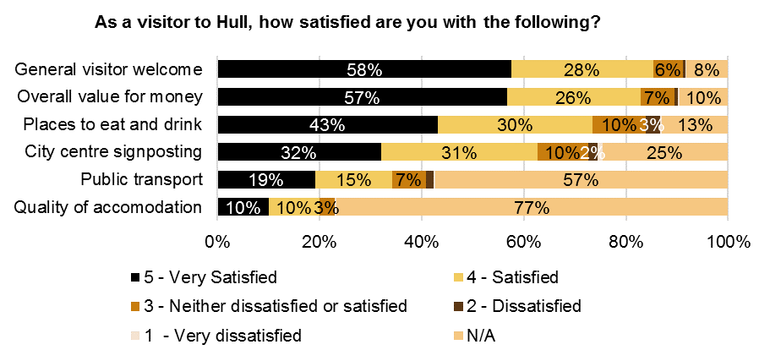
Base size: 1,127

This paragraph considers the results on satisfaction with various aspects of Hull again, but with respondents who indicated ‘not applicable’ excluded from the analysis. Respondents from outside of Hull rated Hull highly on visitor welcome and overall value for money with 93% of respondents satisfied with the general visitor welcome and 92% satisfied with overall value for money (a score of 4 or 5). 86% of respondents were satisfied with the quality of accommodation, 84% with the places to eat and drink, 83% with city centre signposting and 80% with public transport.
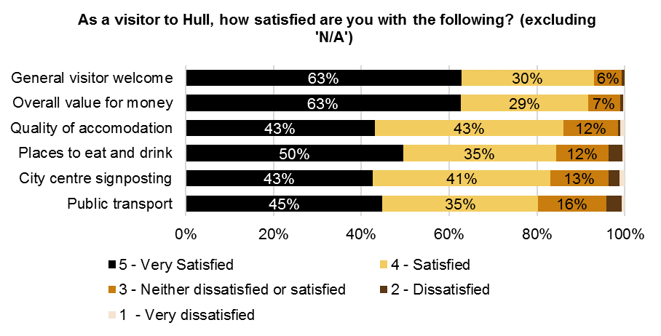
Base size: 261 – 1,034

There were significant differences in satisfaction with various aspects of Hull as a visitor by area. Respondents from East Riding were more likely to be satisfied with city centre signposting and public transport. Respondents from the rest of the UK were more likely to be satisfied with the general visitor welcome, overall value for money, places to eat and drink and quality of accommodation. A high proportion of respondents answered ‘not-applicable’ when asked to rate public transport and accommodation, so differences when respondents who indicated ‘not applicable’ are excluded from the analysis are also shown in the following paragraphs.
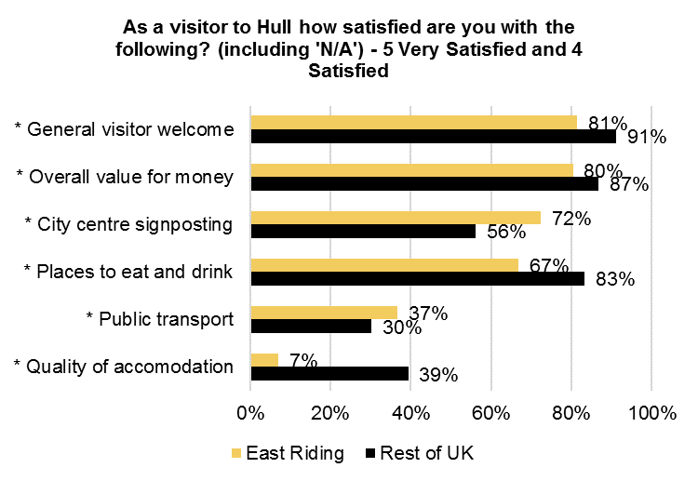
See Appendix B for Base Size
* = Significant differences by area

There were also significant differences in satisfaction with various aspects of Hull as a visitor by gender and age (when respondents who answered ‘not-applicable’ are included in the analysis). Men were more likely to be satisfied with the quality of accommodation, with 23% of men and 18% of women very satisfied or satisfied. Respondents age 35 and over were more likely to be satisfied with the overall value for money, with 72% of respondents aged 16 to 35, 85% of respondents aged 35 to 54 and 85% of respondents aged 55 and over very satisfied or satisfied. Younger respondents were more likely to be satisfied with city centre signposting, with 70% of respondents aged 16 to 35, 58% of respondents aged 35 to 54 and 64% of respondents aged 55 and over very satisfied or satisfied.
The table below shows satisfaction with various aspects of Hull as a visitor by the survey completed. There were significant differences in satisfaction with quality of accommodation, place to eat and drink, public transport and city centre signposting by survey completed.

As a visitor to Hull how satisfied are you with the following? (including 'N/A') - 5 Very Satisfied and 4 Satisfied
 | Blade | The City Speaks | Washed Up Car-Go | The Train Track and the Basket | Paper City | Bleached | This is a Freedom of Expression Centre | Elephant in the Room | A Hall for Hull | Floe
General visitor welcome | 81% | 100% | 100% | 97% | 97% | 93% | 96% | 95% | 94% | 96%
Quality of accommodation | 16% | 35% | 22% | 27% | 17% | 33% | 52% | 27% | 34% | 21%
Places to eat and drink | 69% | 97% | 91% | 76% | 90% | 88% | 96% | 82% | 85% | 83%
Public transport | 29% | 46% | 53% | 59% | 59% | 37% | 55% | 41% | 36% | 49%
Overall value for money | 79% | 100% | 91% | 91% | 96% | 91% | 100% | 92% | 93% | 92%
City centre signposting | 55% | 86% | 88% | 79% | 72% | 88% | 91% | 80% | 83% | 69%

When respondents who answered ‘not-applicable’ are excluded from the analysis, there are significant differences in satisfaction with various aspects of Hull as a visitor by age. Respondents aged 16 to 34 were more likely to be satisfied with places to eat and drink, while respondents aged 35 and over were more likely to be satisfied with overall value for money and public transport.

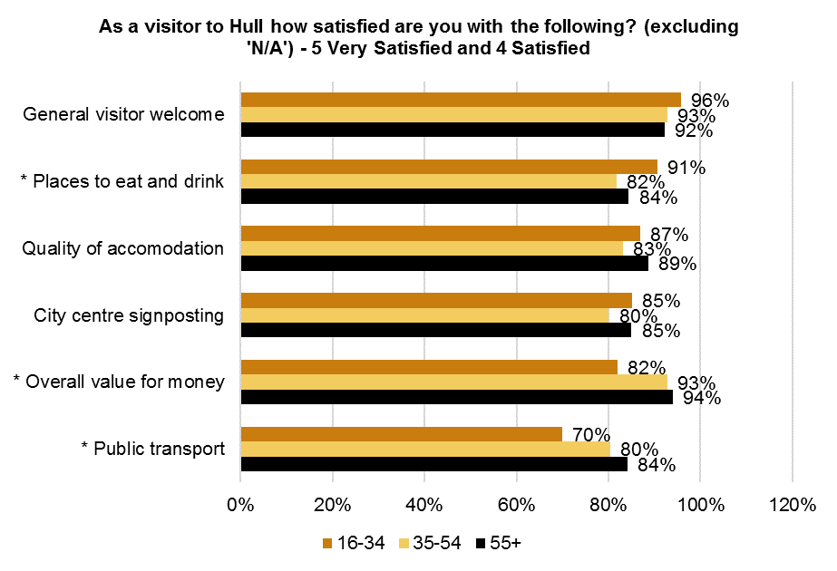
See Appendix B for Base Size
* = Significant differences by age

When respondents who answered ‘not-applicable’ are excluded from the analysis, there are significant differences in satisfaction with various aspects of Hull as a visitor by area. Respondents from outside of Hull and the East Riding were more likely to be satisfied with places to eat and drink and quality of accommodation.
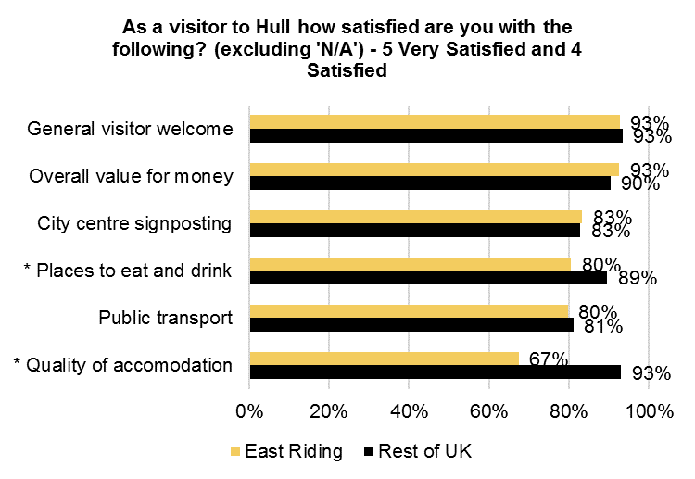
See Appendix B for Base Size
* = Significant differences by area

    - Overnight Visitors
Eighty-two percent (82%) of respondents who were visitors to Hull were just in Hull for the day and 18% were staying overnight. As would be expected, respondents from the rest of the UK were significantly more likely to have stayed overnight, with less than 1% of respondents from East Riding and 45% of respondents from the rest of the UK staying overnight.
The table below shows whether visitors to Hull were in Hull just for the day or staying overnight by the survey completed. There were significant differences by survey completed.
Did you visit just for the day, or did you stay overnight when you last saw (visited) the Look Up artwork(s)?
 | Blade | The City Speaks | Washed Up Car-Go | The Train Track and the Basket | Paper City | Bleached | This is a Freedom of Expression Centre | Elephant in the Room | A Hall for Hull | Floe
Just for the day | 86% | 81% | 84% | 79% | 76% | 53% | 57% | 70% | 60% | 80%
Stayed overnight | 14% | 19% | 16% | 21% | 24% | 47% | 43% | 30% | 40% | 20%
The overnight visitors had stayed in Hull for a mean of 2.09 nights and 2.77 days and spent a mean of £100 on accommodation.
Forty-seven percent (47%) of overnight visitors to Hull had stayed in a hotel and 41% had stayed with friends or family.
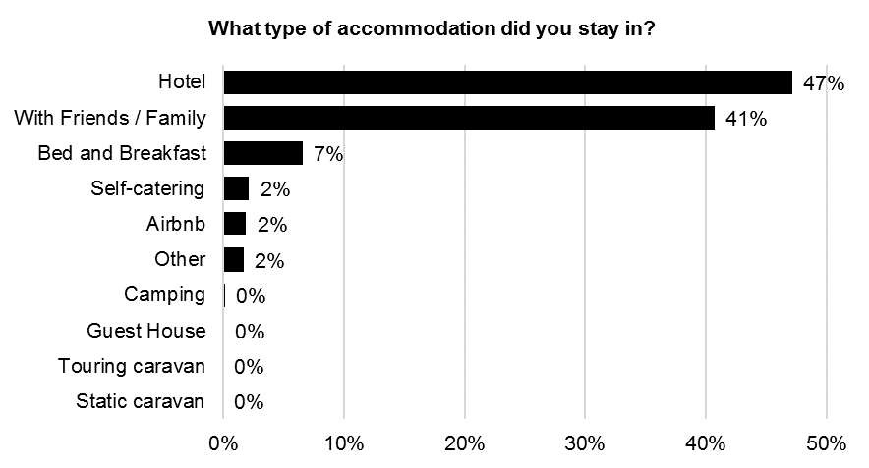
Base size: 205

There were significant differences in the type of accommodation overnight visitors to Hull had stayed in by age. Older respondents were more likely to have stayed in a hotel while younger respondents were more likely to have stayed with friends or family.
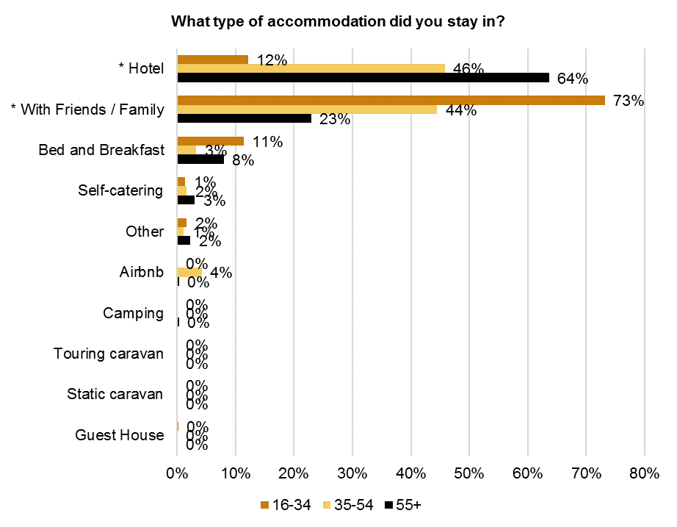
See Appendix B for Base Size
* = Significant differences by age
    - Estimated Spend
Respondents were asked to estimate how much they had spent in Hull on themselves and on others with them during their visit to Hull when they saw the ‘Look Up’ artwork. Respondents estimated that they spent a mean of £57.71 on themselves and others with them in Hull during their visit to Hull when they saw the ‘Look Up’ artwork. 41% of this spend was on food and drink, 39% on shopping and 9% on travel and transport.
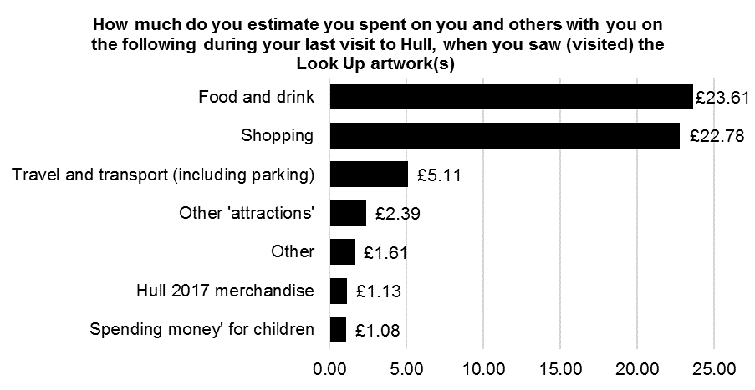
Base size: 2,103

There was a significant difference in respondents’ estimated spend on themselves and others with them in Hull during their visit to Hull when they saw the ‘Look Up’ artwork by area. Respondents from outside of Hull and the East Riding had a higher mean estimated spend.
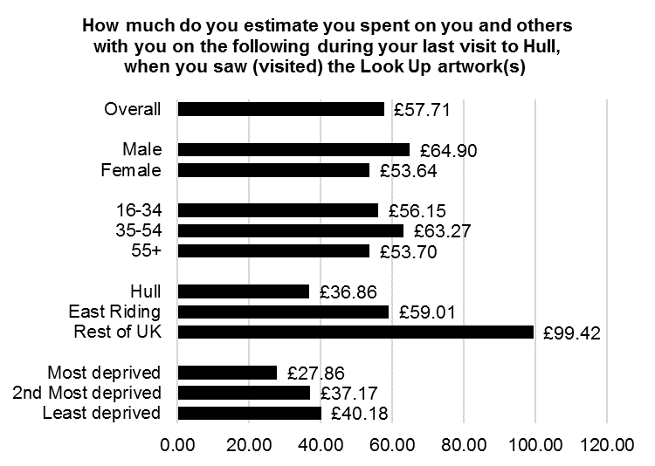
See Appendix B for Base Size
Significant differences by area

Within the estimated spend data, there are significant differences in estimated mean spend on different categories of spend by age and area. Respondents aged 55 and over had a higher mean estimated spend on Hull 2017 merchandise. Respondents from outside of Hull and East Riding had a higher mean estimated spend on food and drink, shopping, travel and transport and ‘other attractions’.

Estimated spend in Hull during visit to Hull when saw the ‘Look Up’ artwork (mean)

 | Hull 2017 merchandise | Food and drink | Shopping | Travel and transport (including parking) | Other 'attractions' | Spending money' for children | Other
Male | 1.13 | 25.05 | 25.66 | 5.12 | 2.57 | 1.45 | 3.92
Female | 1.12 | 22.74 | 21.20 | 5.10 | 2.29 | 0.87 | 0.32
16-34 | 0.57 | 21.51 | 24.89 | 4.93 | 3.01 | 1.15 | 0.10
35-54 | 0.67 | 26.08 | 23.82 | 5.79 | 2.01 | 1.13 | 3.77
55+ | 1.81 | 22.46 | 20.92 | 4.59 | 2.41 | 1.01 | 0.49
Hull | 0.93 | 14.75 | 15.92 | 2.60 | 1.40 | 1.05 | 0.21
East Riding | 1.27 | 22.12 | 24.74 | 4.36 | 2.10 | 0.87 | 3.56
Rest of UK | 1.32 | 44.79 | 33.97 | 11.67 | 4.91 | 1.50 | 1.26
Most deprived | 0.85 | 10.34 | 12.79 | 2.00 | 0.68 | 1.05 | 0.15
2nd Most deprived | 0.79 | 14.92 | 16.91 | 2.31 | 0.69 | 1.24 | 0.31
Least deprived | 1.04 | 16.48 | 16.56 | 2.95 | 2.05 | 0.91 | 0.19

The table below shows the estimated spend data by the survey completed. There were significant differences in spend by survey completed.
Estimated spend in Hull during visit to Hull when saw the ‘Look Up’ artwork (mean)
 | Blade | The City Speaks | Washed Up Car-Go | The Train Track and the Basket | Paper City | Bleached | This is a Freedom of Expression Centre | Elephant in the Room | A Hall for Hull | Floe
Hull 2017 merchandise | .16 | 2.68 | 1.91 | 1.71 | 3.78 | 2.23 | 4.00 | 2.54 | 4.95 | 1.29
Food and drink | 20.00 | 31.21 | 21.21 | 27.01 | 22.33 | 35.26 | 31.56 | 31.20 | 37.89 | 23.45
Shopping | 25.90 | 9.60 | 4.50 | 16.53 | 5.63 | 13.69 | 21.95 | 33.74 | 26.09 | 10.84
Travel and transport (including parking) | 4.08 | 5.11 | 4.77 | 6.64 | 3.99 | 8.77 | 11.67 | 10.24 | 8.72 | 4.46
Other 'attractions' | 1.71 | 5.05 | 4.93 | 1.97 | 0.18 | 3.94 | 3.00 | 3.64 | 5.75 | 1.05
Spending money' for children | .76 | 0.81 | 2.84 | 0.38 | 1.00 | 1.48 | 0.96 | 6.44 | 1.35 | 0.27
Other | 2.07 | 0.01 | 2.34 | 1.38 | 0.11 | 0.63 | 0.55 | 1.35 | 0.38 | 0.06
Total spend | 54.68 | 54.46 | 42.50 | 55.60 | 37.03 | 66.00 | 73.69 | 89.15 | 85.13 | 41.42
  - Conclusions
The ‘Look-up’ artworks were successful in attracting large audiences in many cases. The ten artworks had a combined audience of almost 685,000 people with Blade, Train Track and the Basket, City Speaks, Hall for Hull and Elephant in the room being most visited.
The results broken down by socio-demographics indicate that younger people and those from the most deprived areas of Hull were less likely to have seen a number of the ‘Look up’ artworks. This difference is less pronounced where the installation was in particular locations, for example, the Interchange and Princess Quay.
Given the nature of some of the artworks within ‘Look up’, a large proportion of visitors had seen the artwork because ‘they were in the area anyway’ where the artwork was installed. Having said this, some of the 10 artworks reported on here were visited due to it being part of Hull 2017 or because it was a unique experience; most notable amongst these was Washed-up Car-go. It is important to note that reasons for visiting the Look Up artworks changed over time (between the initial installation Blade, and later installations). For example, only 7% visited Blade because it was part of Hull 2017 compared with 44% who visited Floe (which took place late in the year).
As in previous evaluations, the ‘volunteer welcome’ was rated highly by visitors to the ‘Look up’’ artworks. None-out-of-ten felt that they had been welcomed by Hull 2017 volunteers.
Overall, recommendation scores for the nine ‘Look up’ artworks ranged from a low of 36% up to a high of 70%. When ranked, recommendation was highest for Floe and lowest for Train Track and the Basket.
Recommendation | % | Rank
Blade | 70% | 1
Floe | 69% | 2
Paper City | 68% | 3
This is a Freedom of Expression Centre | 63% | 4
The City Speaks | 59% | 5
A Hall for Hull | 57% | 6
Bleached | 52% | 7
Washed Up Car-Go | 51% | 8
Elephant in the Room | 40% | 9
The Train Track and the Basket | 36% | 10

Some of the artworks in ‘Look Up’ had high ‘interest’ scores – particularly Blade, City Speaks and This is Freedom of Expression Centre (all had scores of over 70%). Train Track and the basket ranked lowest at 38%.
Recommendation | % | Rank
Blade | 81% | 1
Floe | 72% | 2
Paper City | 71% | 3
This is a Freedom of Expression Centre | 64% | 4
The City Speaks | 63% | 5
A Hall for Hull | 60% | 6
Bleached | 51% | 7
Washed Up Car-Go | 50% | 8
Elephant in the Room | 45% | 9
The Train Track and the Basket | 38% | 10

Overall, visitors were most likely to have found out about the artwork they were visiting from either TV or word of mouth. There were significant variations in sources of information between the artworks. TV was the most commonly source of information for Blade, but Hull 2017 website was more commonly used as a source for the other 9 artworks. Word of mouth via family, friends and colleagues was most common for City Speaks and Paper City. Hull 2017 social media sites were most commonly used as a source for Paper City. Other sources, including coming across the artwork or it being in a space used by visitors was most common for Train Track and the Basket and Elephant in the Room.
The findings from the ‘Look Up’ evaluation emphasise the wide-ranging engagement in Hull 2017 by visitors and residents. Over four-out-of-five visitors to ‘Look up’ were planning to attend or take part in other events within the Hull 2017 programme. The ‘Look up’ programme also appears to have had a positive overall impact on visitors to Hull (those from outside of the city). Almost a half said their experience of the visit (when they saw a ‘Look Up’ artwork) would increase the frequency of their visits to Hull in the future. This is supported by the satisfaction scores recorded amongst visitors. Large proportions rated the general visitor welcome and the overall value for money highly.

Just under one-fifth of the ‘Look up’ audience interviewed from outside of Hull were overnight visitors – with nearly a half staying in a hotel. Overall average estimated spend by visitors to ‘Look up’ was £57.71. For those from outside of Hull and the East Riding, average spend was £99.42. Using the mean spend per party for each installation separately, gives an estimated total spend from visitors of £15,138,772 (see the table below).
Artwork | Estimated Audience | Mean spend per party member | Estimated  spend
Blade | 420,888 | 20.34 | 8,559,677
The City Speaks | 49,547 | 15.84 | 784,983
Washed Up Car-Go | 21,044 | 16.79 | 353,282
The Train Track and the Basket | 73,320 | 26.93 | 1,974,226
Paper City | 21,299 | 14.48 | 308,319
Bleached | 6,603 | 31.27 | 206,451
This is a Freedom of Expression Centre | 1,177 | 33.26 | 39,147
Elephant in the Room | 32,616 | 34.78 | 1,134,448
A Hall for Hull | 48,329 | 33.24 | 1,606,503
Floe | 10,151 | 16.92 | 171,738
Total | 684,974 |  | 15,138,772

  - Appendix A – Profile of Respondents – WEIGHTED DATA
Employment Status | Count | Column N %
Employed / working full or part time | 1210 | 54%
Self-employed | 149 | 7%
Unemployed | 61 | 3%
On a government scheme for employment training | 3 | 0%
Looking after family / home | 71 | 3%
Unable to work | 35 | 2%
Retired | 613 | 28%
Student | 70 | 3%
Prefer not to say | 9 | 0%
Total | 2220 | 100%

Gender | Count | Column N %
Male | 791 | 36%
Female | 1,421 | 64%
Transgender | 0 | 0%
Gender non-conforming | 0 | 0%
Other | 1 | 0%
Prefer not to say | 8 | 0%
Total | 2,220 | 100%

Ethnic group | Count | Column N %
White British | 2,132 | 97%
White Other | 52 | 2%
Mixed/multiple ethnic groups | 10 | 0%
Asian/Asian British | 8 | 0%
Black/ Black British: | 1 | 0%
Other ethnic background | 4 | 0%
Total | 2,207 | 100%

Age Group | Count | Column N %
16-17 years | 14 | 1%
18-19 years | 28 | 1%
20-24 years | 113 | 5%
25-29 years | 130 | 6%
30-34 years | 172 | 8%
35-39 years | 332 | 15%
40-44 years | 45 | 2%
45-49 years | 339 | 15%
50-54 years | 90 | 4%
55-59 years | 351 | 16%
60-64 years | 133 | 6%
65-69 years | 313 | 14%
70-74 years | 76 | 3%
75+ years | 74 | 3%
Prefer not to say | 10 | 0%
Total | 2,220 | 100%

Day-to-day activities limited because of a health problem or disability
 | Count | %
Yes - limited a lot | 75 | 3%
Yes - limited a little | 118 | 5%
No | 2,012 | 91%
Prefer not to say | 15 | 1%
Total | 2,220 | 100%

  - Appendix B – Base Sizes for Subgroups
Gender | Sample Size not including ‘Blade’ | Sample Size | Sample Size for visitors to Hull
Male | 514 | 791 | 421
Female | 1,019 | 1421 | 702

Age | Sample Size not including ‘Blade’ | Sample Size | Sample Size for visitors to Hull
16-34 | 284 | 456 | 171
35-54 | 467 | 806 | 441
55+ | 852 | 948 | 511

Area | Sample Size not including ‘Blade’ | Sample Size | Sample Size for visitors to Hull
Hull | 798 | 985 | -
East Riding | 479 | 779 | 679
Rest of UK | 324 | 446 | 444

Hull IMD | Sample Size not including ‘Blade’ | Sample Size
Most deprived | 94 | 152
2nd Most deprived | 275 | 325
Least deprived | 402 | 488

  - Appendix C – Base Sizes for Surveys (unweighted)
Survey | Sample Size
Blade | 600
The City Speaks | 122
Washed Up Car-Go | 134
The Train Track and the Basket | 89
Paper City | 139
Bleached | 84
This is a Freedom of Expression Centre | 59
Elephant in the Room | 269
A Hall for Hull | 316
Floe | 408

This is the percentage who gave a score of 9 or 10 on the likelihood to recommend scale.

