<https://www.globalintergold.info/en/the-mysterious-gold-nose-of-green-ginger-has-been-found-gdn139/>

The Mysterious Gold Nose of Green Ginger has been found!

29.05.2017

|  |  |
| --- | --- |
|  | [Share](https://vk.com/share.php?url=https%3A%2F%2Fwww.globalintergold.info%2Fen%2Fthe-mysterious-gold-nose-of-green-ginger-has-been-found-gdn139%2F) |

[inShare](javascript:void(0);" \t "_blank)

**Have you heard about the discovery of a strange piece of gold in Bransholme, England? The only sure thing about it is that its shape resembles that of a ginger root and a nose at the same time.**

**But experts argue over various theories as to its usage and origin. Meet the story of the Gold Nose of Green Ginger!**

## **Found with no evidence**

The English writer Mike Covell made a fascinating discovery in the Land of Green Ginger: what they later called the “Gold Nose of Green Ginger.”

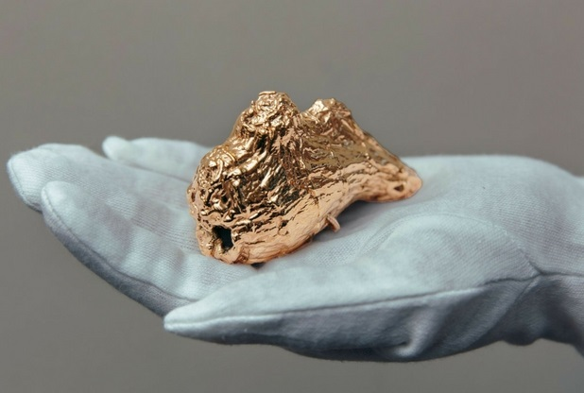

No one knows about its origins or history, but many ascribe inexplicable good luck to it. Mr. Covell said: “No one knows why, but some reports claim that those who came into contact with it were blessed with inexplicable and plentiful good luck, so it was hidden from public interest until it could be fully understood.”

There's no evidence either when or where the Gold Nose was first documented, but experts could somehow track it back enough to know that it got lost / disappeared twice due to its mysterious good luck:

“People say it was firstly stolen by someone who wanted to be exclusively imbued with good luck, while others believe it was quite simply lost. We'll never know exactly quite what the complete story is, but it seems that now we've been offered another rare chance to find out more about it.”

Mike Covell added.

## **What could the Gold Nose of Green Ginger be?**

Some theories go back to the Roman period and compare the Gold Nose with the so-called Roman “golden eyes”:

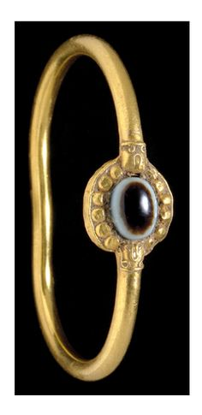

The golden eyes are believed to have healing powers to those suffering from eyes problems. They were also an offering to the gods. Experts say that it would be interesting to note whether the Gold Nose could be something similar because several Roman discoveries have been made across the region.

Mike Covell compares the Gold Nose to an amulet known as a 'Bulla', also dating from the Roman-period: “it was given to male children in Ancient Rome 9 days after birth. Meant to protect against evil spirits and forces, these would often be made of different materials depending on social status; usually lead or leather, but gold in wealthy families. There have been suggestions that the Gold Nose could be a variation on this, but this has so far been impossible to prove.”

Mystery continues, but gold will always be a symbol of wealth and prosperity.