**FACILITATING THE CONVERSATION**

**WHAT IS FACILITATION?**

To facilitate is defined by the Oxford Dictionary as ‘Make (an action or process) easy or easier’. Thus, facilitation in the context of ‘Where Do We Go From Here?’ is to help stimulate and manage the conversation with members of the public visiting the event. You will guide people in discussing the question ‘Where Do We Go From Her?’, determining what this question means to different individuals, and aiming to maximize their time and energy by keeping the conversation about this topic on track.

As a facilitator your role will also be to encourage as many different types of people to participate in some way, shape, or form. This includes approaching people of different ages, genders, backgrounds, and abilities. In doing so, you will help ensure that we get to hear as many voices as possible in the stories and opinions coming back.

**TOP TIPS FOR EFFECTIVE FACILITATION**

To be a good facilitator, please keep in mind the following when speaking to individuals:

* **Value people and their ideas**: The question ‘Where Do We Go From Here?’ is likely to mean different things to different people, and we’re interested to hear all of these ideas.
* **Be objective**: Although you may have your own opinion on the question, your role at the event is as a facilitator. This means you should take a neutral stance, remove your own personal views from the discussion, and focus on gathering as much information from the individual / group about their thoughts as you can.
* **Think quickly and logically**: To explore individuals’ thoughts and ideas effectively, it is important to respond with open-ended questions, encouraging people to provide clarification, give reasons for what they say, and think about their role in achieving their ideas in the future.
* **Communicate clearly:** try to only ask one question at a time and use simple English to make the conversation as easy and accessible as possible.
* **Be prepared:** before starting your shift for ‘Where Do We Go From Here?’ think about the “who, what, why, and where” of the event, i.e. who will you be interviewing; what will you be talking about; why are you talking about it; and where will the conversations take place? **Practice** with members of your family, friends, and other volunteers to get into the habit of talking about this question, understanding different viewpoints, and thinking on the spot.

**GOOD PRACTICE vs. BAD PRACTICE (TASK)**

The following video clips are examples of what, in the world of market research, is known as a qualitative depth interview. In effect this is what you will be doing with members of the public in your role as a facilitator, though for ‘Where Do We Go From Here?’ it will be much more informal.

One clip shows the interview done badly and the other done well. Watch each clip and make a note of what you think was done well and what was done badly.

[**Clip 1**](https://www.youtube.com/watch?v=U4UKwd0KExc)

[**Clip 2**](https://www.youtube.com/watch?v=eNMTJTnrTQQ&t=100s)

|  |  |
| --- | --- |
| **GOOD PRACTICE** | **BAD PRACTICE** |
| * Introduces herself * Gives interviewee good attention * Speaks slowly * Makes eye contact * Asks open-ended questions * Values answers given by interviewee * Explore answers in further detail * Talks clearly * Keeps questions focused | * Acting like she’s ticking off a list * Speaking quickly * Question wording is complicated * Distracted * Little eye contact made * Uses mainly closed questions * Challenges interviewee’s answers * Doesn’t explore reasons for answers * Gives examples of other interviewee answers – this is “leading”, i.e. other opinions are used to influence the way someone answers |

**OPEN-ENDED QUESTIONS vs. CLOSED- ENDED QUESTIONS**

An open-ended question is designed to encourage a full, meaningful answer using the subject's own knowledge and/or feelings. Open-ended questions tend to be more objective and less leading than closed-ended questions.

Open-ended questions typically begin with words such as "Why" and "How", or phrases such as "Tell me about...". Often they are not technically a question, but a statement which implicitly asks for a response.

Closed-ended questions can be answered with “Yes” or “No,” or they have a limited set of possible answers.

**DO** use **OPEN-ENDED QUESTIONS**

**AVOID** using **CLOSED-ENDED QUESTIONS**

**GUIDE TO FACILITATING ‘WHERE DO WE GO FROM HERE?’**

In terms of facilitating conversations for ‘Where Do We Go From Here?’ aim to think about following a simple four-step process:

1. **CONTEXT:   
   “**Tell me what the question ‘Where Do We Go From Here?’ means to you?”
2. **OPINION:**  
   “So, based on your understanding of the question, ‘Where Do We Go From Here?”
3. **REASONS:**  
   “I’m interested in what you said about [x], can you tell me more about why you think that?
4. **NEXT STEPS**“How do you think that we can get to that point?” and / or  
   “What will you do to make that happen?”

**FEEDING BACK**

After completing your shift “in the field” you will be asked to return to the Volunteer Centre. Here you will find a ‘Download Zone’. A variety of feedback methods will be provided in this zone, so that we can get a sense of the conversations you had with members of the public during your shift. In recognition of this, you may therefore find it useful to carry a notebook with you during you shift to note down some reminders.

The feedback methods provided are likely to include:

* iPads, loaded with a short Survey Monkey questionnaire  
  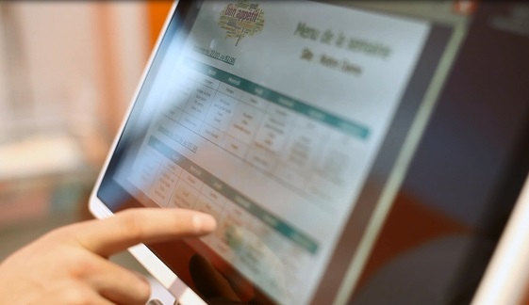
* Feedback wall

 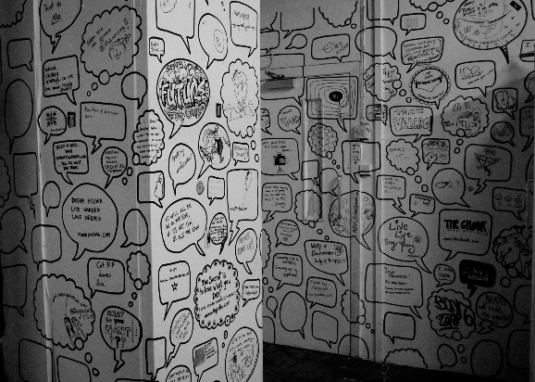

* Dictaphone / iPad, to provide a verbal digest

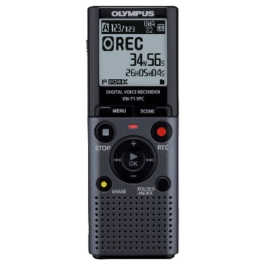 

To support the feedback task, we’ll provide some prompt cards in the zone (with a series of questions) to aid your recall.