[BACK OF BOOK]

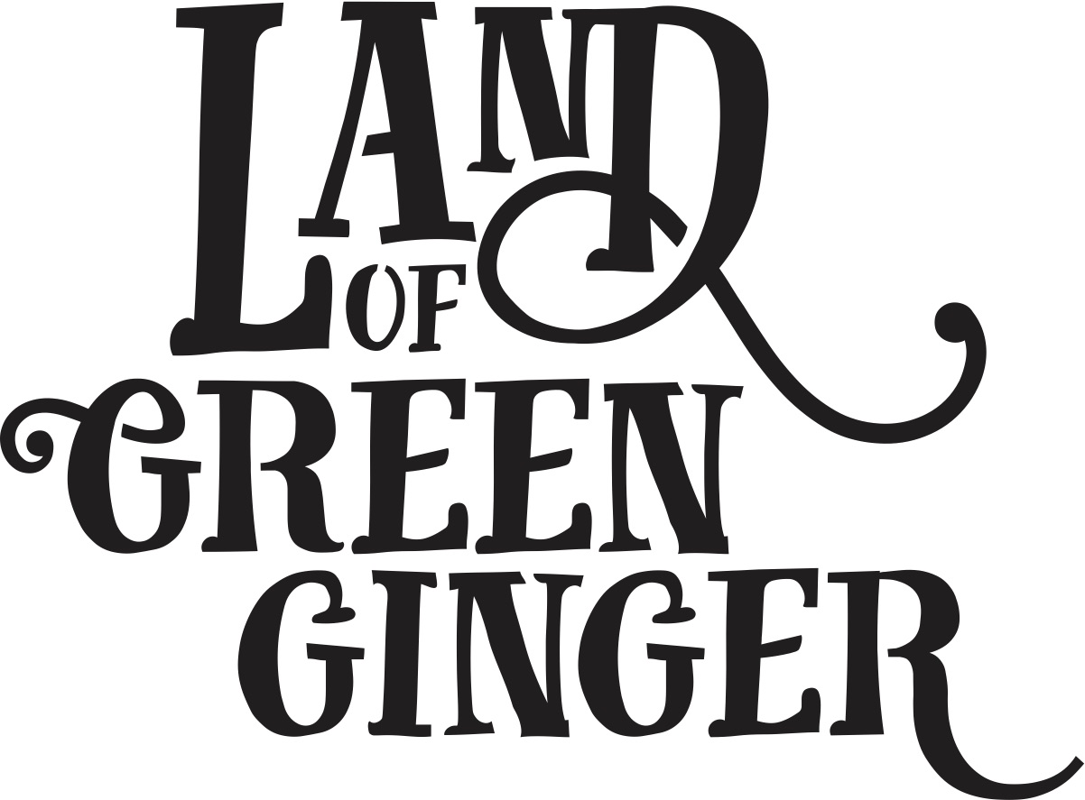

[FRONT COVER]

*There once was a Land that nobody believed existed.  And every day people passed by it or around it or over it or through it, but never once saw it or felt it or heard it or knew any person or thing in it.*

[Illustration of street scene – cross section slice through. Above ground people going about daily life, underground vault of crates with magic coming off them]

Until one day the land revealed itself…

*[Baffled looking workman in the vault of crates. Lid opened “Acts of Wanton Wonder are coming… on inside of smoky lid]*

**ACT I: 7 ALLEYS**

Text

Text

Text

Text

Text

Text

Text

Text

[ILLUSTRATION]

Text

Text

Text

Text

Text

Text

Text

Text

[ILLUSTRATION]

Text

Text

Text

Text

Text

Text

Text

Text

[ILLUSTRATION]

PUNCTUATION

[ILLUSTRATION]

**ACT II: GOLD NOSE OF GREEN GINGER**

Text

Text

Text

Text

Text

Text

Text

Text

[ILLUSTRATION]

Text

Text

Text

Text

Text

Text

Text

Text

[ILLUSTRATION]

Text

Text

Text

Text

Text

Text

Text

Text

[ILLUSTRATION]

PUNCTUATION

[ILLUSTRATION]

**ACT III: THE LONGHILL BURN**

Text

Text

Text

Text

Text

Text

Text

Text

[ILLUSTRATION]

Text

Text

Text

Text

Text

Text

Text

Text

[ILLUSTRATION]

Text

Text

Text

Text

Text

Text

Text

Text

[ILLUSTRATION]

PUNCTUATION

[ILLUSTRATION]

ACT IV: VOICE PARK

Text

Text

Text

Text

Text

Text

Text

Text

[ILLUSTRATION]

Text

Text

Text

Text

Text

Text

Text

Text

[ILLUSTRATION]

Text

Text

Text

Text

Text

Text

Text

Text

[ILLUSTRATION]

PUNCTUATION

[ILLUSTRATION]

ACT V: MICROPOLIS

Text

Text

Text

Text

Text

Text

Text

Text

[ILLUSTRATION]

Text

Text

Text

Text

Text

Text

Text

Text

[ILLUSTRATION]

Text

Text

Text

Text

Text

Text

Text

Text

[ILLUSTRATION]

PUNCTUATION

[ILLUSTRATION]

ACT VI: LOGG UNLEASHED

Text

Text

Text

Text

Text

Text

Text

Text

[ILLUSTRATION]

Text

Text

Text

Text

Text

Text

Text

Text

[ILLUSTRATION]

Text

Text

Text

Text

Text

Text

Text

Text

[ILLUSTRATION]