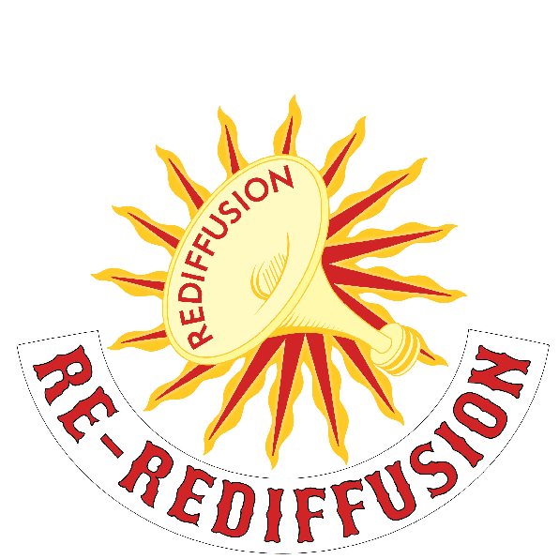

**What’s Happening? Who is doing it?**

A team of people from Re-Rediffusion have been interfering with local amenities for the last month or so… I assume that they are behind any interruptions.

What exactly did you see?

Can you explain it to me in detail so that we can look into it?

**Who are Re-Rediffusion?**

As far as I know they are a new organisation inspired by the original Hull-based Rediffusion. Do you remember them? They used to provide radio and TV networks for Hull…

This year is the 30 year anniversary since the HQ closed in Hull.

It used to be where ASDA is now on Beverly Road.

It’s probably something to do with that…

**Is it a part of City of Culture?**

Not as far as I know. There seems to be a whole team of people in uniforms working on it though…

**Background information if needed:**

Hull was one of the first cities in the UK to receive relayed Radio Channels via the Rediffusion Network as early as 1928 and it was the one of the first cities in the UK to have a cable network.

<http://www.rediffusion.info>