Appendix 5: Artist Consultation

  - Introduction
The Artists were responsible for responding to the creative briefs supplied by the CCT, using archive footage (where appropriate) at their specified location; and to be present at the live delivery of the event.
    - The Artists
In order to gain feedback from all artists involved in ‘Made in Hull’, consultation was undertaken both before and after delivery of the live ‘Made in Hull’ event.
Data was collected via online surveys, supplemented by in-depth telephone interviews, mirroring the research with the CCT. The templates for the surveys and discussion guides are provided in Appendices 6 – 8:
- Artist (Pre-Event) Survey: carried out as a combined online survey and telephone interview
- Artist (Post-Event) Survey: carried out as an online survey
- Artist (Post-Event) Depth Interview Discussion Guide: carried out a one-to-one telephone interview.
The focus of this research was to undertake two types of evaluation:
- Process Evaluation: motivations, creative process, and project and production management.
- Outcomes Evaluation: artistic quality of the event; the extent to which diversity was explored and / or represented within their work; the presentation, interpretation and learning linked Hull’s history and heritage; audience profile, reaction and feedback; skills and knowledge development; collaboration and partnership development; and perception changes towards Hull.
It was not possible to consult with all the artists on each occasion - 7 responded to the pre-event survey, 9 to the post-event survey, and 5 participated in a post-event telephone depth interview.
  - Artists Profile
    - Demographic Profile
As a key funder of Hull 2017, Arts Council England (ACE) are not only interested in the demographic profile of the audiences for ‘Made in Hull’. They also wish to know the demographic profile of the artists involved in delivering the event, to inform the Creative Case for Diversity.
As such, all 13 individual artists / artist organisations were asked to complete an Equal Opportunities Monitoring Form. 6 provided a response.
One of the respondent artists was a Hull resident, with the remainder residing in Otley, Worthing, Leeds and Oxford, indicating a good level of representation of artists from the Yorkshire region and influence from other national artists in the project.
The responses show that there was a good mix of age groups, with 4 aged between 25 and 44 years and two aged 50-54 years. The majority of respondent artists were male.
Diversity was lacking to some extent, in terms of disability and ethnicity. No one self-identified as disabled (as per the definition provided by the Equal Opportunities Act 2010), although one artist did state they had learning difficulties. Almost all stated they were ‘White: Welsh / English / Scottish / Northern Irish / British’, with one artist stating ‘White: Any other white background’ and specifying they were a mix of English, Irish, Slovakian, and Hungarian.
Figure X: Age of Artists
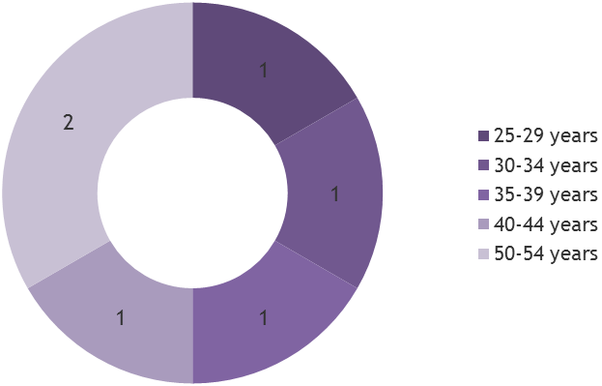
Figure X: Gender of Artists
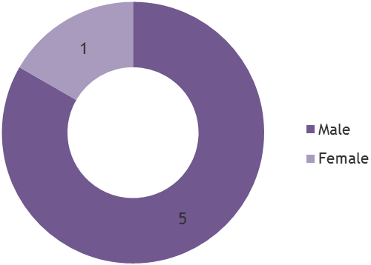
    - Profile Working on Similar Events
Some artists were approached and selected to produce artwork for the ‘Made in Hull’ event because of their track record and position as up and coming artists; whilst others were matched to the project via Hull 2017’s Creative Communities Programme. Their level of experience on such events therefore varied.
Equally, experience was a mixed when looking at their previous work on projects where heritage or commemoration, and Hull (the city and / or its people) were a source of inspiration:
- 3 of 6 stated that they had previously worked on projects where heritage or commemoration were a source of inspiration;
- 2 of 5 stated that they had previously worked on projects where Hull (the city and / or its people) were a source of inspiration; and
- 1 stated they had both worked on projects where heritage or commemoration were a source of inspiration and on projects where Hull (the city and / or its people) were a source of inspiration.
Figure X: Experience Working on Similar Projects
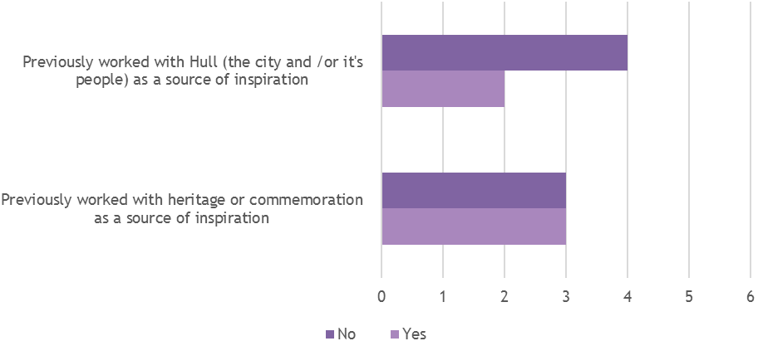
    - Personal Connections to Hull
3 artists who responded during the Pre-Event consultation stated they had one or more personal connections to the city:
- 1 stated ‘My family come from Hull’, ‘I was born in Hull’, ‘I grew up in Hull’, and ‘I studied at the University of Hull’;
- 1 stated ‘My family come from Hull’, ‘I grew up in Hull’ and ‘I currently live in Hull’;
- 1 stated ‘I currently live in Hull’.
Figure X: Artists Personal Connections to Hull
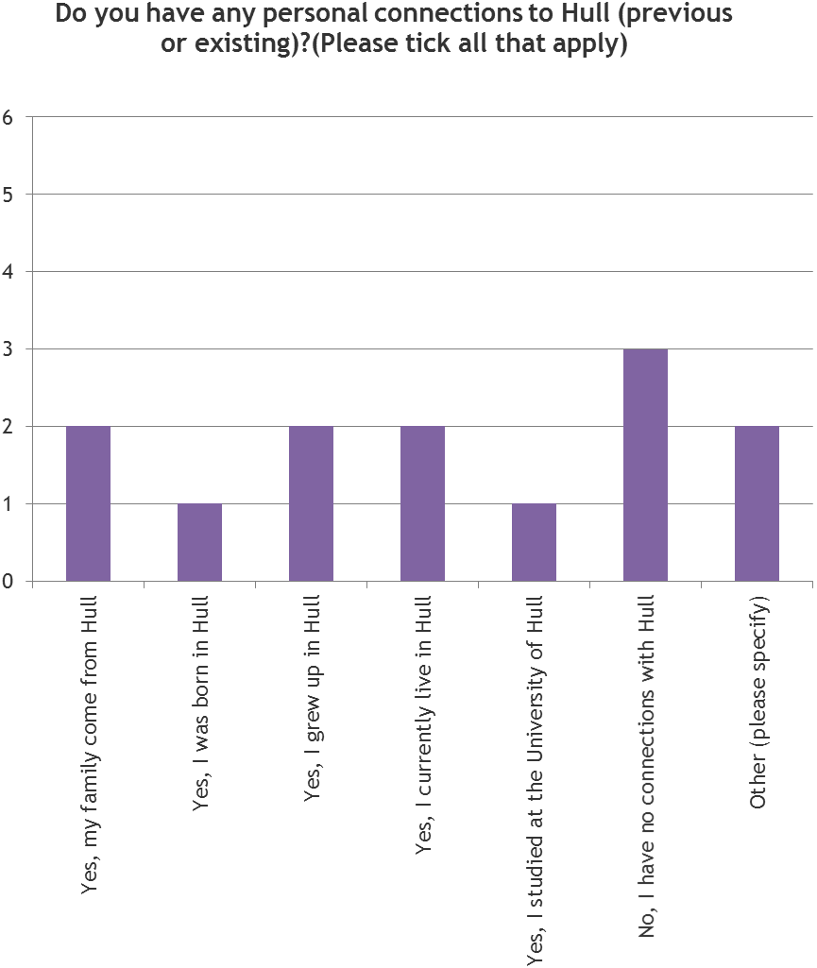
  - Process Evaluation
In order to inform the planning, development and delivery of future projects, a series of questions were asked linked to the process of ‘Made in Hull’. These concentrated primarily on:
- Motivations: What attracts artists to produce artwork for a project such as ‘Made in Hull’?
- Creative Process: How did the concept for their artwork come about and develop? What approach did artist take to the subject matter and how did this change over the course of the project? How did they collaborate with the Core Creative Team (from hereon in CCT)? How did they use historical / heritage based resources to develop their ideas or art work and use this as content in the piece?
- Project and Production Management: What were the strengths and weaknesses in relation to the project and production management of ‘Made in Hull’, and what should be done differently?
    - What was it About ‘Made in Hull’?
6 out of 7 artists, who responded to the Pre-Event Survey, reported that they had heard about Hull becoming UK City of Culture 2017 before being involved in the project. Those that had heard about it felt it was a great opportunity for the city to show what it could do and ultimately enhance its reputation.
‘A great opportunity for the city to create a legacy which could make a lasting effect.’
‘I was very happy to think that at last Hull could be recognised as a city of some worth and not just a city to be ridiculed at every opportunity in the media.’
‘A fantastic boost to the city and local arts infrastructure and a great opportunity to create work in the city with Hull people.’
‘Good for the City and interesting to see what such a City would do. Perceptions of Hull just being a 'dock City' and fairly 'grey' need to be shattered over the coming year.’
‘It is great to have exciting cultural buzz outside of the big cultural centres.’
When asked how much the city’s “status” as UK City of Culture influenced their decision to work on the project, the responses were mixed. Half gave a score that indicated it had a significant influence, whilst the other half were less interested in this status.
Figure X: Influence of UK City of Culture on Artist Involvement
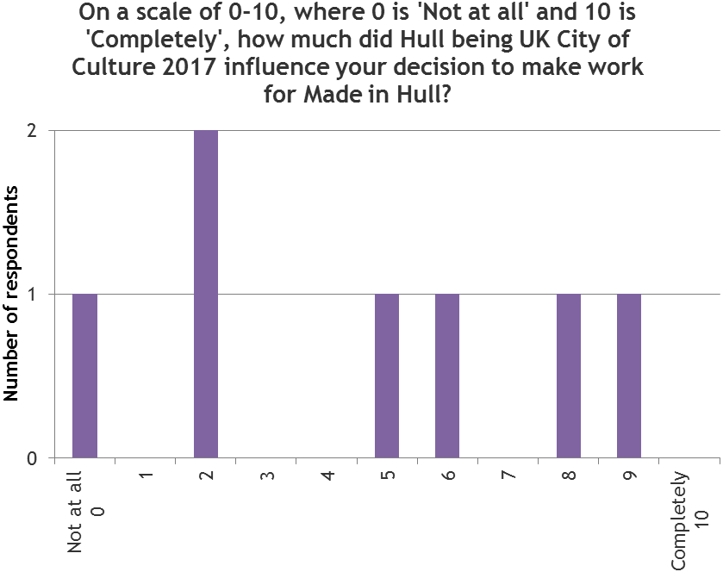
Motivations were very individual to each artist, though a couple of more common motivations were ‘Made in Hull’ being an interesting concept / subject matter; and growing their profile with a broad audience. Other motivations included:
- The challenge of the brief;
- The opportunity to produce large-scale work;
- Personal connections to Hull;
- The project being different to their usual work; and
- Because they were invited to take part.
    - Creative Process for ‘Made in Hull’ Installations
Interpreting the creative brief
Artists generally felt the ‘Made in Hull’ brief had given them enough freedom to explore a wide range of ideas relating to the subject matter. The brief was also cited, by some artists, as both the most exciting and challenging aspect of working on the project. The main challenge linked to the aim to appeal to as broad a range of people as possible.
Other artists felt the scale of the event was the main challenge of working on the project, especially because of the challenge of not being able to predict the audience numbers for the event.
‘I wouldn’t say it was a particularly challenging brief but I underestimated the scale of the event and the sheer number of people that would be coming.’
When asked how the concept for their artwork for ‘Made in Hull’ came about, artists gave a range of answers. With those artists who were directly commissioned by the CCT to produce this artwork, it was the broad ideas suggested that was the starting point. From this point the artists were then influenced by their existing artistic practice and the new subject matter they were working with.
In some instance the new subject matter was clearly linked to Hull’s history and heritage, whereas in other instances this was less obvious.
The nature of the building on which they were projecting work was also mentioned by one artist as influencing the artwork’s concept.
‘The broad ideas were suggested by the artistic directors of the project - but the nature and content of the piece came about through the conceptualisation of an unrealised performance piece for the event which then morphed into the final piece. As with all work it was a slow mutation of ideas, some used in previous work and some inspired by this new subject matter. The two main contributing factors though were the actual form of the building we were to project onto and the nature of the history.’
‘The brief…came from the creative team…the concept for the piece evolved from there and filled in more dots to create a web or triangulation of some topics like innocence, self-expression, freedom, protection, loss, memory, life, death, light and darkness. I also expanded the region from "in Hull" to a more inclusive and worldly "of humans"…I feel it is important to challenge or question all forms of identity including where one lives.’
For those artists who received support from the Creative Communities Programme, the idea was one that already existed, but which found a home as part of ‘Made in Hull’.
Where the history and heritage of Hull was significant in the creative brief, artists read about the subject matter and met experts in the field to inform the process; or used historical fact to create an artistic fiction.
Subject Matter
The artists approached the subject matter in a number of ways, in the beginning, principally:
- To explore one of Hull's dominant stories or histories in a new way;
- To showcase the contribution that Hull has made to the world;
- To celebrate Hull's sons and daughters; and
- To showcase Hull's historic buildings and public spaces.
To mark or explore a moment in time for Hull, explore unknown stories or histories of Hull, and celebrate and collaborate with Hull’s people (its greatest asset) were also approaches that individual artists selected.
All of the artists (except one) said they had developed their piece to ensure they engaged with Hull’s rich history and heritage (8.9 out of 10 on average).
Two artists said they had changed their approach to this subject matter during the creative process, which was mainly due to limitations on resources or the availability of historical material (e.g. archive footage), or just because it was a natural part of the artistic process.
‘We were asked to include archive video footage in the piece but research proved that there was very little to find - so we switched to the use of archive photography instead.’
‘There is no way you can create art and not learn and grow as you go along! It's always like solving a puzzle or surfing a wave - you have to go with the flow and figure it out, keep an open mind.’

Figure X: Approach to Subject Matter by Artists
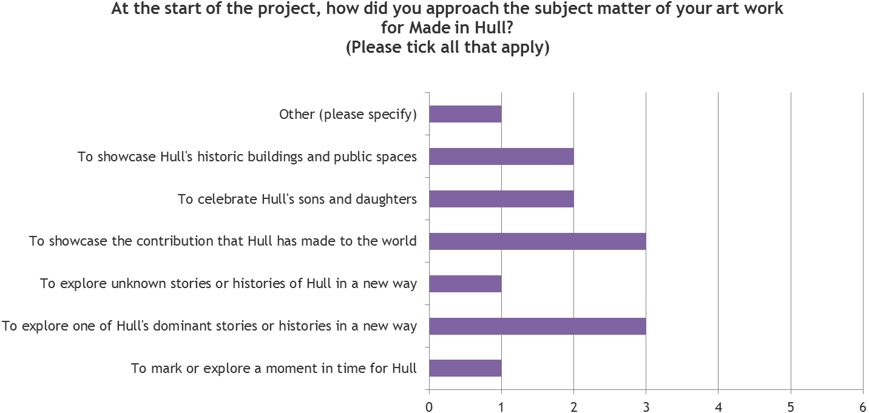
CCT Contribution to Creative Development
In general, the CCT appear to have made valuable contributions to the creative development process of each artists’ art work. Specific ways this was so, included:
- Developing and focusing ideas at the conception stage;
- Offering production advice and resources;
- Providing information about Hull’s history and heritage; and
- Ensuring artists were on track to deliver on time and within budget.
A couple of the artists had never worked with a CCT before and found it difficult to adjust their methods accordingly. For example, some had found it difficult to communicate their ideas to the team, whilst others were frustrated their work was continually scrutinised.
‘[The CCT] had a system and a process and that’s what they stuck to. We needed more flexibility.’
Overall Conceptual Narrative
Most artists agreed that the conceptual narrative of ‘Made in Hull’ was clear from the nature of the installations. Some pieces were perhaps more ‘obvious’ than others in this respect, but there was generally admiration for the other artists’ work. Despite this, a couple of artists said they would have liked the opportunity to meet other the other artists involved. They believed this might have developed their own and the overall concept further, thus strengthening the overall narrative.
    - Project and Production Management
Overall, feedback on the project and production management of ‘Made in Hull’ was positive.
Project Management
Prior to the event, the artists were asked to rate the project management of ‘Made in Hull’ to date. An average rating of 4.2 out of 5 stars (n=6) was awarded.
Figure X: Project Management of ‘Made in Hull’
Illustration of 4 stars
Top-level aspects of the project management of ‘Made in Hull’ were assessed at pre-event delivery stage, as were some of the more detailed aspects. At the top-level:
- Communications were good; whilst
- Contracting and development meetings were seen as average to good.
Figure X: Project Management – Top Level Feedback
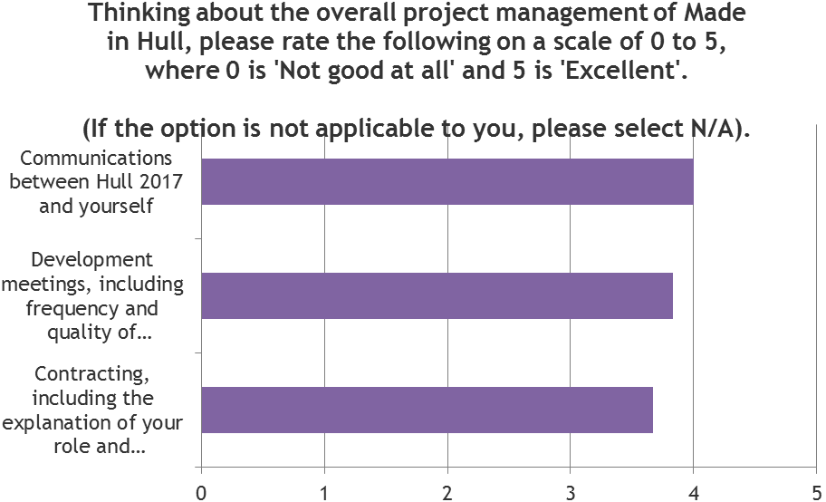
The more detailed exploration of the Project Management showed that, on average, all elements were handled well with the majority of aspects gaining a rating of good to excellent. The only two scoring below good was individuals’ feeling they had been provided with sufficient time to produce their work, and their sense that they had been able to deliver their work to a high standard because of the support provided by Hull 2017. This is illustrated in the figure overleaf.
Feedback on the Project Management from artists showed that the main concern at the start of the project had been a lack of clarity about the project milestones. Some felt they would have benefited from knowing more about what was expected from artists and when.
Other issues encountered during the development phase were the amount of time given to artists to develop their piece and the level of paperwork required by the Hull 2017 team.

Figure X: Project Management – The Detail
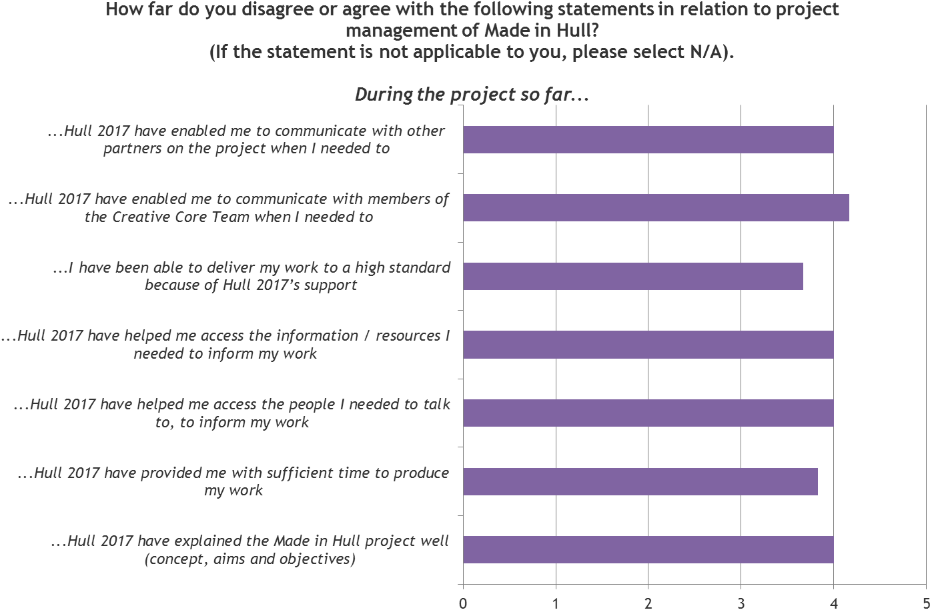
Production Management
After the event was delivered, artists were asked to rate the Production of ‘Made in Hull’, where ‘Production’ referred to the live delivery of the event from 1-7 January. An average rating of 4.7 out of 5 stars (n=9) was awarded.
Figure X: Production of ‘Made in Hull’
Illustration of 4 stars
There were some mixed feelings about the quality of the installations in terms of sound and lighting. Some artists said this had stemmed from a lack of communication about the type of equipment that was going to be used, and in some cases they had been forced to make alterations shortly before the event was launched. These issues had then impacted on the amount of preparation time.
Due to technical issues some installations were not ready for the launch of ‘Made in Hull’, which was clearly a source of frustration. In other instances, the start of an installation had to be delayed because of lighting issues (i.e. the sunset), which it was felt should have been anticipated by the production team. Despite this, most artists felt the final piece was delivered to a high standard and any issues would not have adversely affected the audience experience.
Artists who required extra technical support during the event were full of praise for the technical and operations crew, who were described as knowledgeable, flexible and proactive. Again, however, some artists would have liked better communication with the ground crew.
‘Communication between on the ground production staff and artists wasn't always great - that would certainly have improved the smooth running of the project both before and during installation.’
As previously mentioned, the sheer number of people that came to the event presented some unforeseen challenges in terms of the live delivery, especially for installations that were more interactive in nature. Despite this, the production team were helpful in providing these artists with extra resource in the form of volunteers or technical support.
A couple of artists said they would have liked to see more street art or smaller scale artworks from local artists and community groups within the overall production of the event
‘The only thing I would have suggested would be to have more smaller scale things in between the large scale productions, maybe some community arts and dance or something, but that’s just a retrospective thing.
Figure X: Production of ‘Made in Hull’
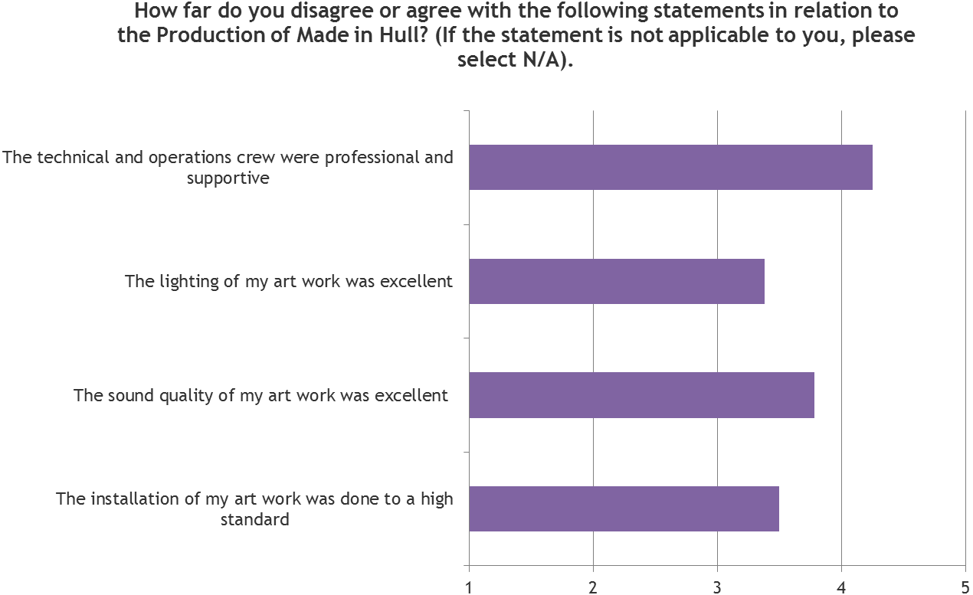
  - Expectations & Outcomes
During the pre-event consultation process, the artists were asked about their expectations for the event in regard to a range of outcomes and outcomes, whilst post-event they were asked about what they believed had been delivered in terms of outcomes and impacts.
The key areas of focus were:
- Artistic Quality: of their own artwork in regard to how much they were challenging themselves, the originality of their work, and the example set by their work.
- Creative Case for Diversity: how they believed they were exploring or representing diversity within their work.
- Hull’s Heritage and History: the success of their art work and the event as a whole in presenting and interpreting the heritage and history of Hull to audiences.
- Audiences: observations and perceptions of the audience profile, audience reaction to their work and outcomes for audiences.
- Skills and knowledge development: new and existing skills, knowledge and learning, in regard to professional skills and the heritage and history of Hull, resulting from artists’ work on ‘Made in Hull’.
- Collaboration and partnerships: new and existing collaborations and partnerships built or developed as a result of working on ‘Made in Hull’.
- Perceptions of Hull: shifts in the perceptions of Hull amongst artists, as a result of working on ‘Made in Hull’.
    - Artistic Quality
Arts Council England (ACE) has developed a number of metrics to measure the artistic quality of an event. The artists were asked to provide a response to a number of these. When comparing the results at these two points in time, the data shows that:
- Pre-event, the average score across all of the quality metrics was 8 out 10 or above – the lowest scoring metric being the extent to which artists felt their artwork would be the best example of its type (8 out of 10), followed by its originality in engaging with Hull’s history and heritage 8.5 out of 10 (on average), and then the extent to which artists felt they were challenging themselves (8.8 out of 10).
- Post-event, the average score across all of the quality metrics was 7.9 out 10 or above – the lowest scoring metric being the extent to which artists felt challenged by the project (7.9 out of 10) and the highest metric being the extent that artists developed their piece to ensure they engaged with Hull’s history and heritage (8.9 out of 10).
As audience members, the artists were full of praise for the work of their peers. The installations at The Deep and Queen Victoria Square were seen as particularly impressive.
    - Creative Case for Diversity
Artists interpreted the question of whether diversity was explored or represented in the artwork differently to one another. Some pointed out they were from a BAME background, whilst others said that it was reflected in their piece, e.g. through the story of immigration in Hull.
Some said their artwork was or had explored diversity by allowing a wide range of people to participate.
    - Presentation and Interpretation of History and Heritage
Before the event was delivered, artists hoped their artworks would inspire, engage and teach people about Hull’s history and heritage. This was mainly referencing how the history of immigration in the city had made for a more diverse population than might be perceived, and the breadth of the city’s cultural heritage.
‘Hull has a very broad, and interesting cultural heritage, spanning literature, pop music, acting and many other forms of the arts.’
Post-event, the majority of artists agreed that their contribution to ‘Made in Hull’ had contributed to the development of artistic practice in celebrating the city’s past, and enhanced audiences understanding of the city’s past. An average score of 7 to 7.3 out of 10 for level of agreement (where 10 was Strongly Agree) was awarded to all three statements:
‘My contribution to Made in Hull presented Hull’s history and heritage in a way that…
- ...enhanced audiences' understanding of the city's past.’
- ...improved audiences' experience of engaging with the city's past.’
- ...contributed to the development of artistic practice in celebrating the city's past.’
Speaking to artists after the event, they all felt they had achieved their ambitions to inspire, engage and teach people about Hull’s history and heritage. They were generally pleased with how the audience had reacted to their pieces.
Figure X: Pre-Event – Artist Response to Quality Metrics
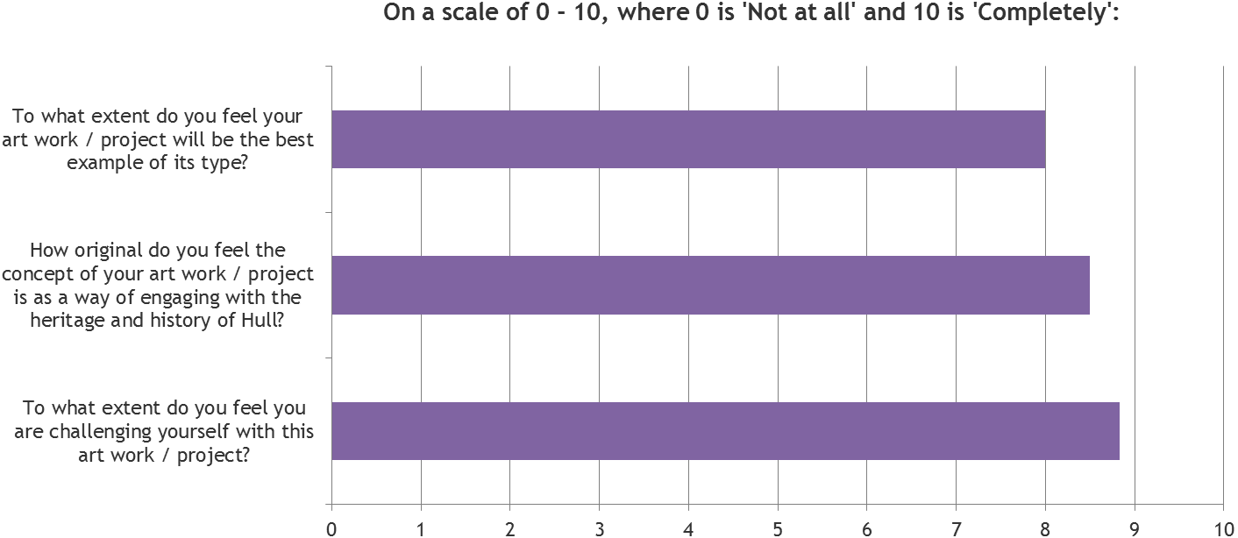

Figure X: Post-Event – Artist Response to Quality Metrics
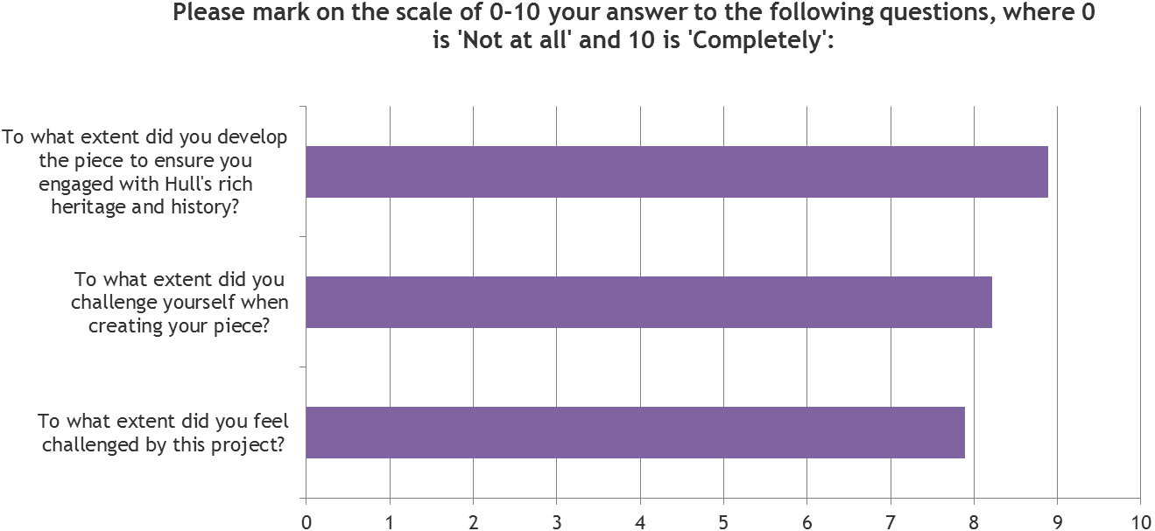

Figure X: Made in Hull – Interpretation and Presentation of History and Heritage (Post-Event)
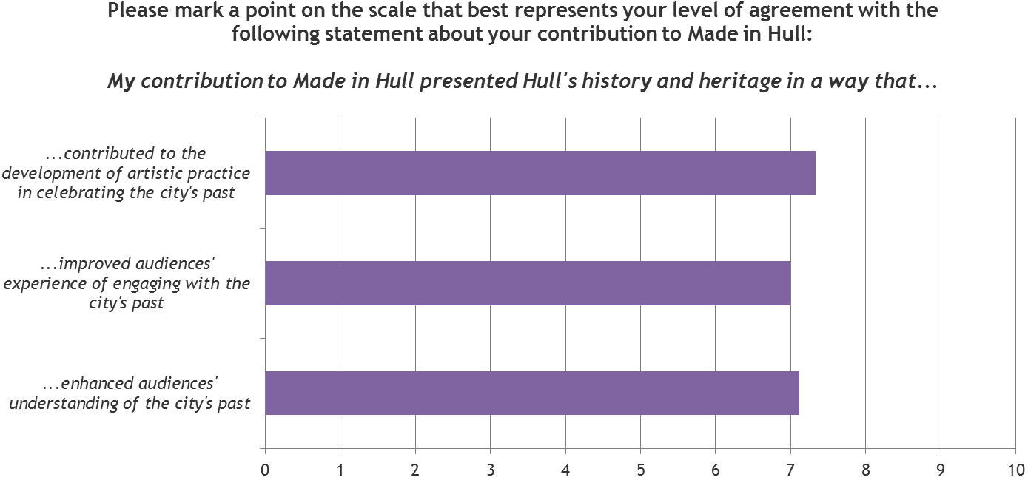
When asked to give a star rating out of 5 for the project’s success in presenting Hull’s history and heritage to audiences, artists gave an average score of 4.7 out of 5 on average.
Figure X: Success Presenting History & Heritage
Illustration of 4.5 stars
    - Audience Outcomes
Prior to the event artists were asked how they hoped the project would provide the audience with a new perspective on Hull. Some wanted to highlight aspects of the city and its past that audience might not previously have contemplated, reflecting on it in a modern context; others wanted to instil pride, and open up dialogues.
‘I hope that people will watch it and perhaps take a moment to consider the roll that a migrating population has had in the makeup of the community and see that it's a natural phenomenon which has always been present.’
‘I hope the audience will, perhaps, research some of the cultural events that I have highlighted, and learn a little more about the subject matter.’
‘I hope to help bring a sense of pride in people.’
‘I hope we've created something that moves people and that it opens up dialogue.’
‘Bringing together the perceptions of Hull, held by the older and younger residents.’
Attendances and audience engagement were seen as the main creative successes of ‘Made in Hull’.
When asked to give a star rating out of 5 for the audience’s reaction to their piece, artists gave themselves 4.8 out of 5 on average.
Figure X: Audience Reaction to ‘Made in Hull’
Illustration of 4.8 stars
Some artists talked about how successfully the project had managed to both entertain and educate the audience about Hull’s rich history and heritage. Others said they were most pleased with the civic pride it had inspired amongst local people.
A number of artists mentioned that the event had attracted visitors of all ages and backgrounds, including many people who might previously thought that ‘culture’ wasn’t for them.
‘It wasn’t just the amount of people, but it was the fact that people were taking their time, visiting installations multiple times, not just walking through. People were really absorbing each and every piece.’
In that respect they hoped it would encourage more people to take an interest in cultural events and projects throughout 2017 and beyond.
‘People will now pay attention to what’s going on, and I think in that sense it’s been similar to Place Des Anges. It’s really broadened people’s horizons and got them excited about the coming year.’
    - Skills and Knowledge
Professional Skills and Knowledge
All the artists said they had increased existing skill / knowledge and 7 of 9 stated they gained new professional skills from working on ‘Made in Hull’.
Most said they had gained or developed project development, project management or artistic / creative skills, with a significant number also stating community engagement skills.
Most artists said the experience had taught them how to collaborate with a wider creative team, whilst a number said they had learnt practical skills and techniques that had helped them deliver a piece on a large scale.
‘As this was my first project since my degree show I had a lot to learn. Above all to maintain full control of my work, how I want it presented and lit. With all best intentions no one other than the artist knows exactly how their work should be or look.’
‘The project had to negotiate a lot of cultural and political issues and this really challenged us both in terms of creative development and project management.’
‘An increased knowledge of the software used and how to produce work that worked on large-scale buildings, from both an artistic and practical point of view.’
Those who said they had developed their community engagement skills said they had learnt how to develop a piece that would engage audience members and make them feel part of the installation. Some also talked about their research on the project which involved speaking to local people, community leaders and historians.
Figure X: Skills and Knowledge Gained and / or Developed
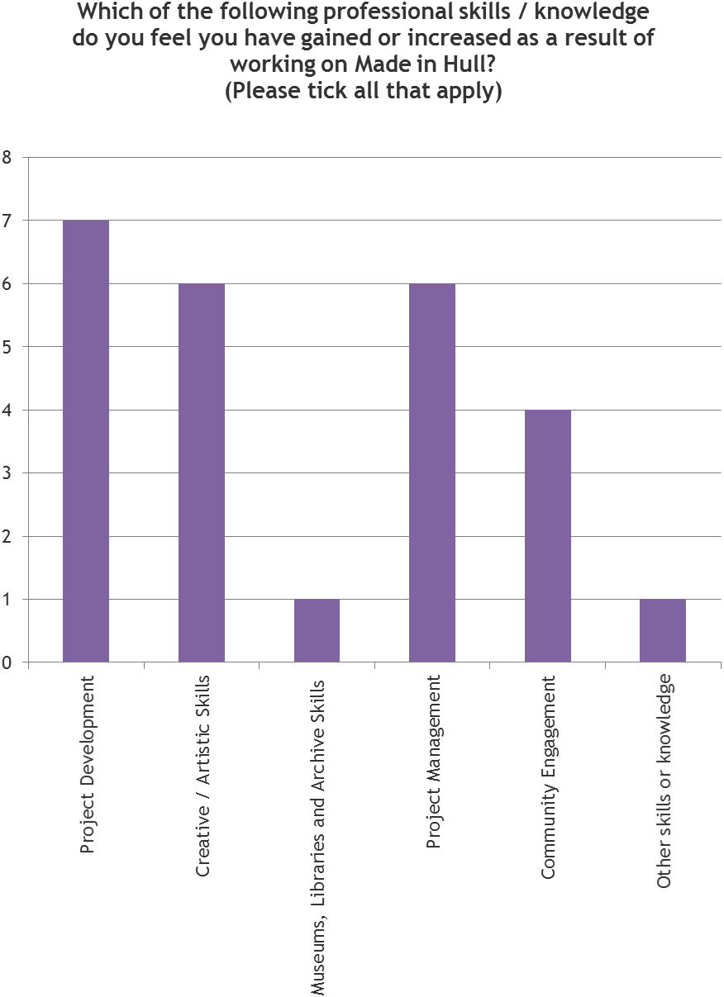
Knowledge of Hull’s History and Heritage
Since working on ‘Made in Hull’ almost all the artists said they had learnt a lot about the history and heritage of the city:
- On average, artists gave an average score of 7.1 out of 10 in relation to how much they had learnt about Hull’s heritage working on the project; and
- On average, artists gave an average score of 8.1 out of 10 in relation to how much they had learnt about Hull’s history working on the project.
For the purposes of the survey:
- Heritage was defined as valued objects and qualities such as historic buildings and cultural traditions that have been passed down or preserved from previous generations.
- History was defined as past events connected with a person, thing or place.
Artists stated they learnt a lot about various aspects of Hull’s history. Indeed, some said they had been surprised that the city had such a rich and diverse past.
‘I've learnt a huge amount about the history of the people of Hull and the roll that migration, immigration and transmigration have played in the makeup of the community.’
‘Through my research, I have unearthed many cultural events or moments that I hadn't previously known.’
‘There's more to Hull that the Docks.’
6 of 9 said they would like to work on heritage-inspired events in the future, and the other 3 were not sure.
    - Other Artist Outcomes
Working on ‘Made in Hull’ has had a number of other positive outcomes for artists. The project has enabled them to reach new audiences and increase their profile, and most said they felt better equipped to work on outdoor or heritage-inspired arts projects in the future.
Artists were asked post-event what they felt were the main creative successes of working on ‘Made in Hull’. The answers provided linked predominantly to Hull and its people, and the emotional engagement of the audiences.
‘The connection with the participants we engaged with and their response and to work.’
‘It really engaged the people of Hull who seemed to love the whole exhibition and ensured Made in Hull was such a success.’
‘It engaged so many people and they learnt so much about themselves and their city. It really did provide a context to Hull's history.’
‘Engaging with the local people.’
Other answers talked of the chance to engage with artists of other genres, and the opportunity to work and deliver on a project of such a size.
‘It challenged us both in terms of creativity and production scale - it certainly developed our skills working on public work of this size.’
Working on a project of this scale was new to many of the artists, and the experience has given them the confidence and skills to take on more ambitious projects in the future.
Many of the artists said they were more confident in expressing and developing their ideas (since working with the CCT), and some said they were now more ambitious in terms of the scope and scale of their work.
‘It's given me such a huge confidence boost, I now feel confident to voice my opinions and suggest big ideas and think on a grander scale. Very motivating experience.’
In terms of take-out learning from the project, many of the artists said they would ensure more frequent and thorough communications on future projects. Some said they would be more forthright with their ideas, rather than allowing others to change their vision. Others said they would aim to be more involved in the technical setup so they could pre-empt any issues before the launch.
‘Communicating with the logistics and operations team as early as possible, to discuss delivery requirements, is very important. If you haven't been asked it doesn't always mean it is not necessary and therefore you should have your own foresight.’
‘To be thorough throughout, and continually communicate with the people you're working with.’
Figure X: Learning Linked to Hull’s Heritage & History
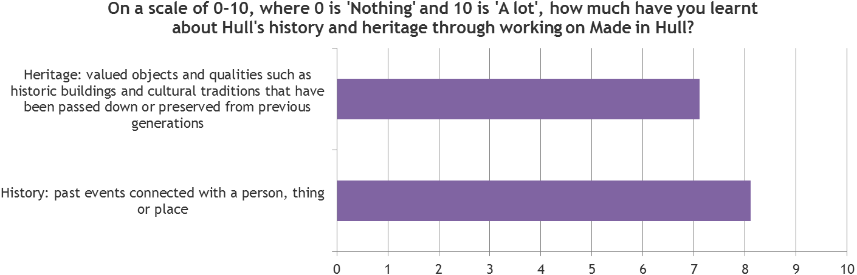

Figure X: Outcomes for Artists
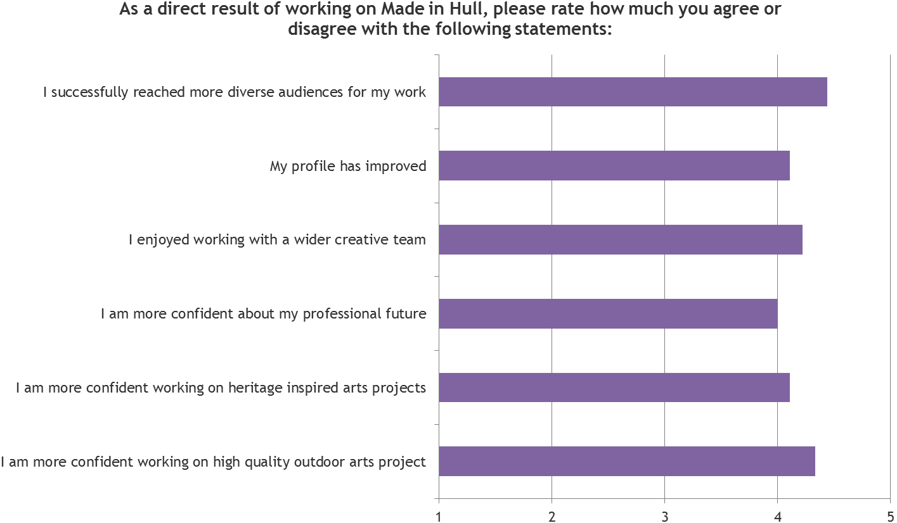
    - Collaboration & Partnerships
The majority of artists (8 out of 9) said that working on ‘Made in Hull’ had provided them with the opportunity to collaborate with individuals and / or organisations.
The same number of artists also stated they had been enabled to build new relationships and to develop existing relationships with other individuals / organisations.
Figure X: Collaborative Opportunities
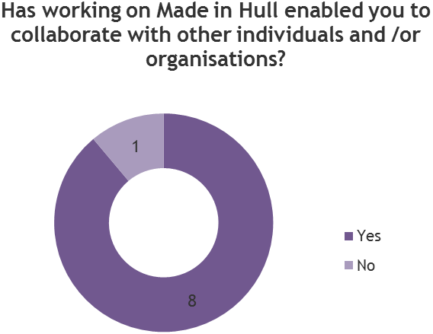
Figure X: New Relationship Building Opportunities
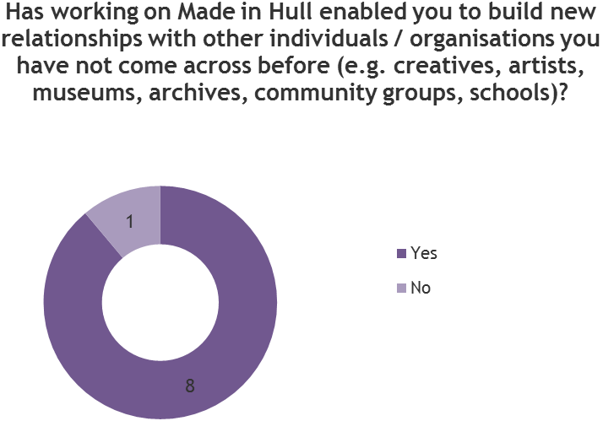

Figure X: Existing Relationship Building Opportunities
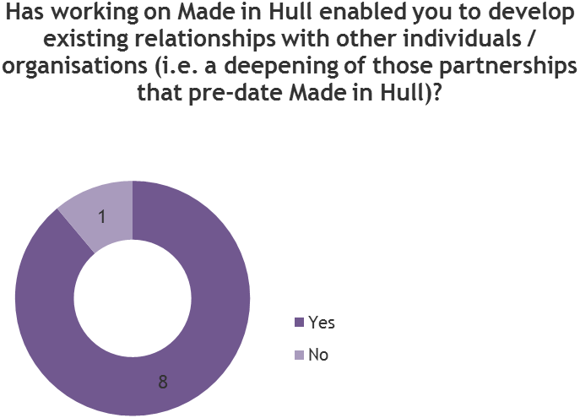
Artists stated that these relationships were largely positive and some had even started new projects working alongside members of the CCT. Others said they would be keen to work with members of the team in the future.
    - Perceptions of Hull
Prior to working on ‘Made in Hull’ artists would have described Hull in a variety of ways, though in nearly all cases the focus of the description was on its people, whilst one artist focused more on its physical aspects.
‘I certainly wouldn't have known the community was as diverse as it is, or that there was so much public facing culture already established within the community.’
‘A friendly, bustling town, with a healthy community spirit.’
‘Amazing, interesting and friendly.’
‘A City by surrounded by water and docklands.’
2 of the artists surveyed before the event said they would talk more positively about Hull as a result of working on the project. This rose to 6 out of 9 after the event; whilst 3 said they would not change the way they would talk about it, mainly because they were positive about it anyway.
‘Hull is my home town, I enjoy living here, have said so in the past and would continue in the same way.’
‘Since leaving Hull, I have always talked positively about the city.’

Figure X: Perceptions of Hull Amongst Artists Pre- and Post-Event
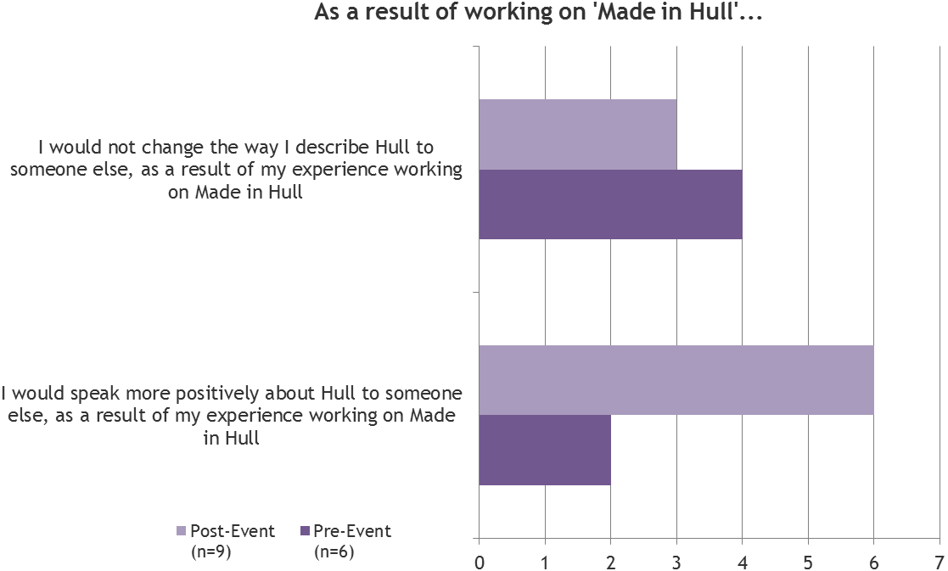
Those who said they would speak more positively about Hull pre-event said this was either the result of seeing the audience’s reaction or discovering more about Hull’s cultural offering.
‘If art can make you feel something about yourself or your city then that’s amazing. People from Hull are quite humble and this was an amazing way to get people to take pride in where they’re from.’
‘Hull people care about Hull.’
‘The people of Hull are magnificent fun loving crazy mavericks and I love them!’
Post-event reasons for people speaking more positively about the city linked to the reaction that ‘Made in Hull’ had received, particularly in terms of the audiences.
‘The project showed the cultural and historical depth of the city and the audience response was so warm and generous. An excellent event.’
‘The people of Hull really surprised me. They were so engaged and enthusiastic. Before I thought people were quite negative and dismissive of culture, but I think we've managed to show them it's not just for an elite audience, it's for them as well.’
‘Positive and very warm people. Very proud people and an evolving, cosmopolitan city.’
‘It was a joy being part of such a successful event, which will be talked about for decades to come, and it leaves me wanting to contribute more to Hull's cause to become a city that many outsiders will want to visit.’

